**Jenkins:**

How to download Jenkins master?

Go to > jenkins.io  
Download Generic Java Package (.war)

Copy to Local Drive

Create a folder Jenkins and copy the downloaded war file in it.

Go to folder level and run cmd java -jar Jenkins.war

We will get Jenkins is up and running.

Go to password folder and enter the password.

Give the username and password.

In Jenkins project is nothing but Job.

Black duck -

How to create a Job?

Click on create new job

Give name and Description and enter the windows batch command, save

Click on Build now and Click on the latest build. Click on Console Output.

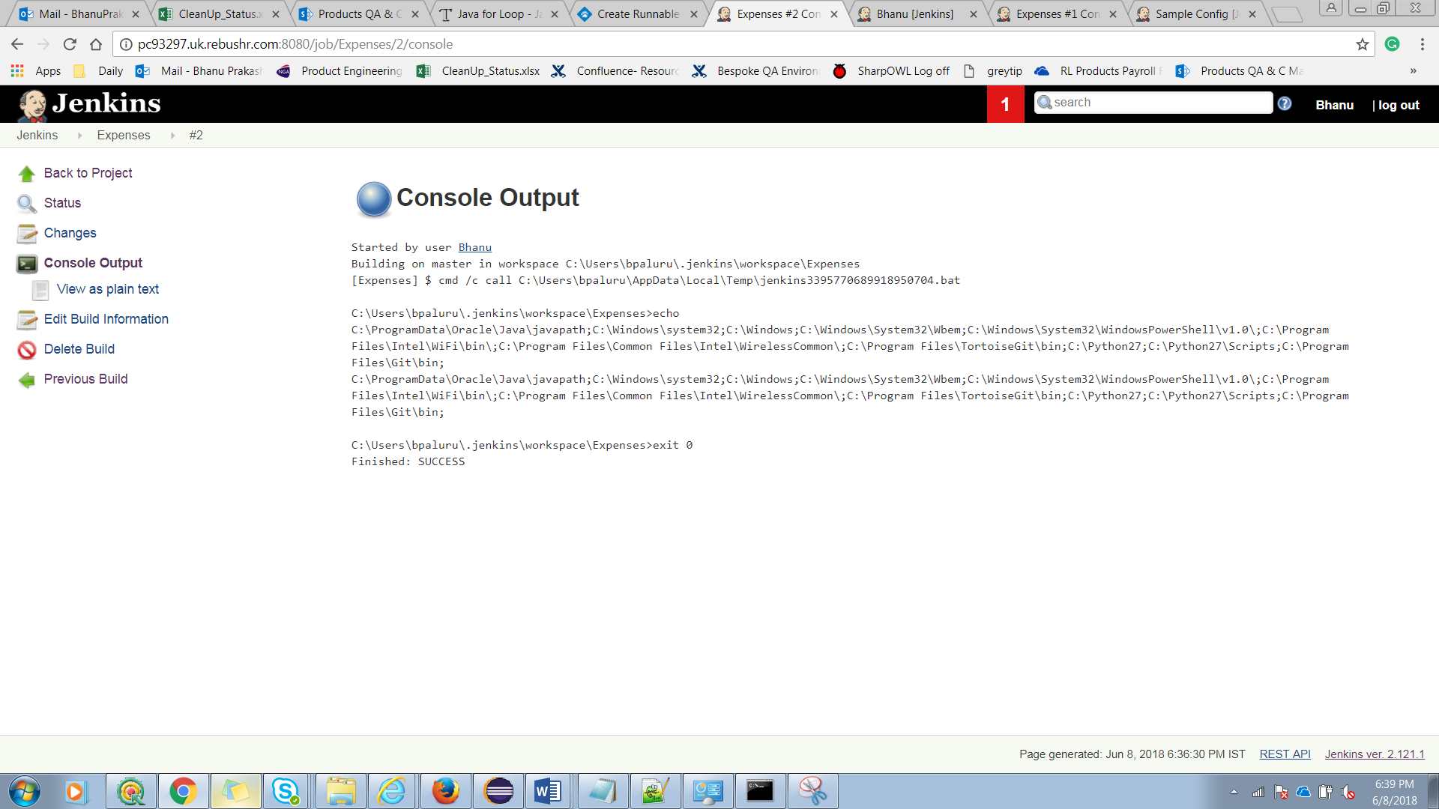

**FAQ:**

1. How will you run the same job concurrently?  
   A: Execute concurrent builds if necessary.
2. How many ways we can disable job?  
   A: Disable Project or disable builds
3. Is there a mechanism to kill the jobs when it goes beyond the expected time?

A: Yes, check abort the build

1. What is Jenkins home folder or Heart of Jenkins?

A: Where ever the Jenkins workspace is created

1. How many ways to install Jenkins?

A: 3 ways

1. Install from .war file
2. Install from .exe file
3. Via Tomcat
4. What is the restore and backup of Jenkins

A: Jenkins Home Directory (Continues Backing up of this folder)

1. What is Difference between open source and Free?

A: Open Source: Anything which can be mold   
Free: They will only release and we need to use it.

1. What is Jenkins?

A: Jenkins is a Continuous Integration Tool

1. What are the benefits of using Jenkins?
2. What are the Pre-requisites of using Jenkins?
3. Mention some useful plugins of Jenkins?
4. What are the basic commands that we use in Jenkins?
5. Explain how you can set a job in Jenkins?
6. Explain how to create Back up and copy files in Jenkins?
7. How to create Secure Jenkins?
8. Explain how to deploy a custom build of a core plugin?
9. What made Hudson to change its name to Jenkins?
10. What you do when you see a broken build for your project in Jenkins?
11. Explain how you can move or copy Jenkins from one server to another?
12. What are the various ways in which build can be scheduled in Jenkins?
13. What is the difference between Maven, ant and Jenkins?
14. To which components the Jenkins are Mainly integrated?

A: 1) Version control systems like GIT SVN

2) Build tools like Apache Maven