Locators Identifiers:

<http://www.techbeamers.com/use-locators-selenium/>

1. ID – Direct Identifier
2. Name
3. Class – We can use this in X-path
4. Link – For links it always starts with a tag, look for <href>
5. Partial Link Text – We should always use contains ()
6. XPATH
7. CSS
8. DOM -Document object model

Tagname

Id: here id is custom_html-11

Usage: id= custom_html-11



Name:

Usage: name=username

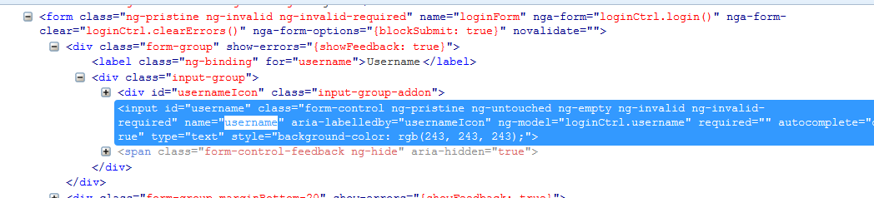

Class:

Usage: //div[@class='form-group marginBottom-20']



Link:

Usage: link=Selenium Q&A-1

Or

//a[text()=’Selenium Q&A-1’]



Partial Link Text:

Usage: //a[contains(text(),'Q&A-1')]



XPATH:

1)Absolute XPATH – starts with ‘/’

2)Relative XPATH – starts with ‘//’

* Relative X-path Is best way to use and it is less time consuming

a) Forward-sibling:

//a[text()=’Selenium Q&A-1’]/..//following-sibling::li//a

Here u r picking immediate sibling of li contains link text ‘’Selenium Q&A-1’’

/.. - One level parent kindhaki

// - Lopaliki pothadi

/../../../ - 3 level parent

b) Preceding-Sibling:

//a[text()=’Selenium Q&A-1’]/..//preceding-sibling::li//a

c) Normalize-space:

//a[normalize-space()='My Team AAP']

d) Ancestor:

//div[@class=’ inner-content clearfix’]//ancestor::div[@id=’ left-sidebar’]

e) Descendant:

instead of // we can also use /descendant::

f) contains:

//input[contains(@id,’username’) and contains(@type,’tex’)]

//label[contains(text(),’username’)]

g) self:

CSS:

For ID: CSS = <HTML tag><#><value of ID attribute>

//input#username  
css=div#value

For Class: css=div.class

Css=input.users[type=’text’]