**RESNET18 with MNIST**

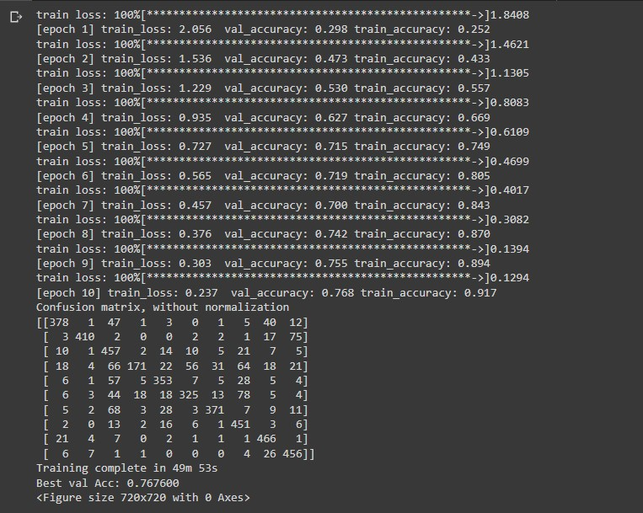

**RESNET18 with CIFAR**

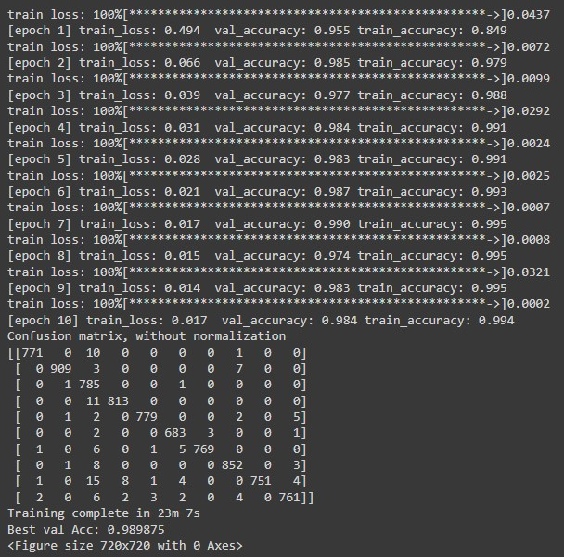

**RESNET34 with MNIST**



**RESNET34 with CIFAR**

