**S3**

* Amazon Simple Storage Service (Amazon S3) is an object storage service that offers industry-leading scalability, data availability, security, and performance.
* Amazon S3 provides management features so that you can optimize, organize, and configure access to your data to meet your specific business, organizational, and compliance requirements.
* Objects are the fundamental entities stored in Amazon S3.
* You can use **S3 Versioning** to keep multiple variants of an object in the same bucket. With S3 Versioning, you can preserve, retrieve, and restore every version of every object stored in your buckets. You can easily recover from both unintended user actions and application failures.
* For Recovering from **archive the files it takes 48 hrs**
* Amazon S3 is an object storage service that stores data as objects within buckets. **An object is a file and any metadata that describes the file**. **A bucket is a container for objects.**
* The total volume of data and number of objects you can store in Amazon S3 are unlimited. **Individual Amazon S3 objects can range in size from a minimum of 0 bytes to a maximum of 5 TB.**
* **Each AWS account can create 100 buckets,** and users can request a service limit increase to obtain more.
* Accessing S3 -> 4 different ways like using Amazon management console , SDKs, Command line interface , Rest APIs
* Bucket name should be unique.
* Amazon S3 Object Lock is a feature that allows you to prevent objects from being deleted or overwritten for a fixed amount of time or indefinitely.
* Controlling access to Amazon S3 buckets and objects is critical for securing your data and ensuring that only authorized users and applications can interact with your S3 resources. Amazon S3 offers several mechanisms to manage and enforce access control: Bucket policies , IAM policies , ACLs
* In Bucket each object has it URI -> is the location of the object

How to Create a bucket in the AWS console ?

Step-1 (after log in) Select S3

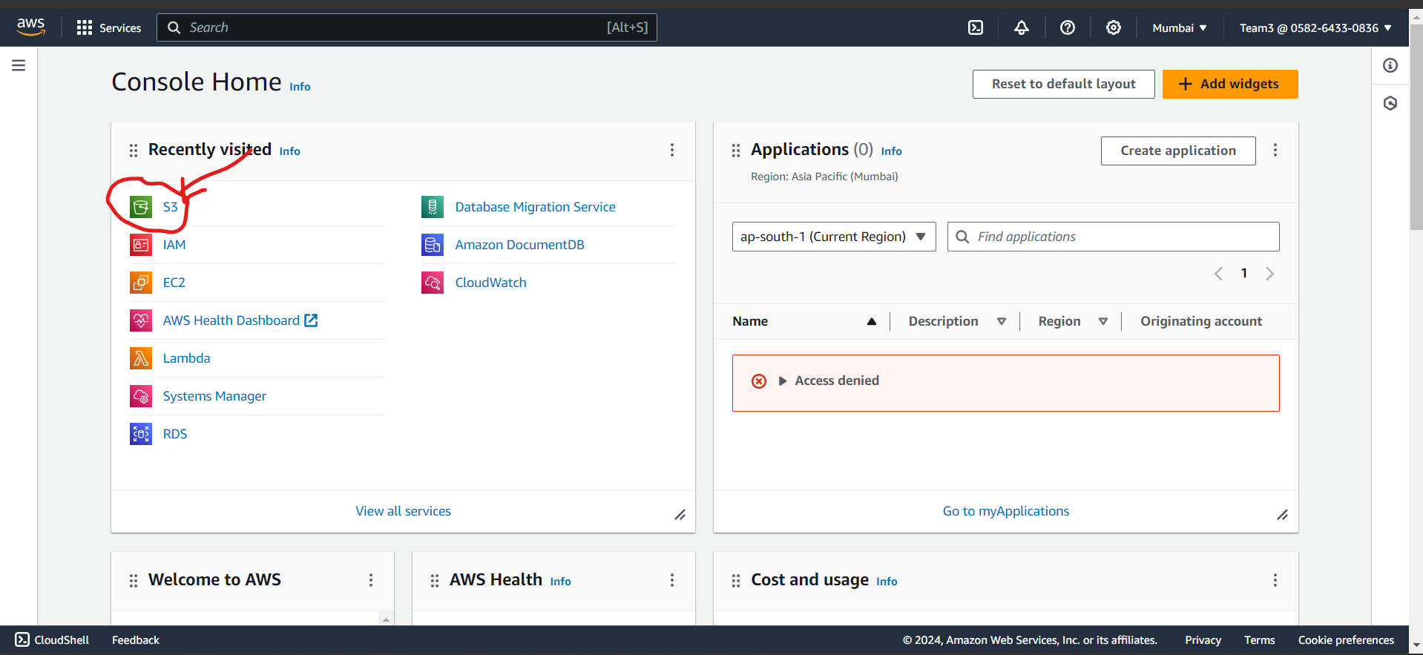

Step-2: After opening S3 We can see this page: (click on Create Bucket)

Step-3 Give a Unique name for the Bucket and check region as well

Step-4 Object ownership ACLs(Access control list)

Amazon S3 access control lists (ACLs) enable you to manage access to buckets and objects. By default, Object Ownership is set to the Bucket owner enforced setting, and all ACLs are disabled. you can use to both control ownership of the objects that are uploaded to your bucket and to disable or enable ACLs.

When ACLs are disabled, the bucket owner owns all the objects in the bucket and manages access to them exclusively by using access-management policies.

Basic

Step-5 Block all the public access (remove that check box)

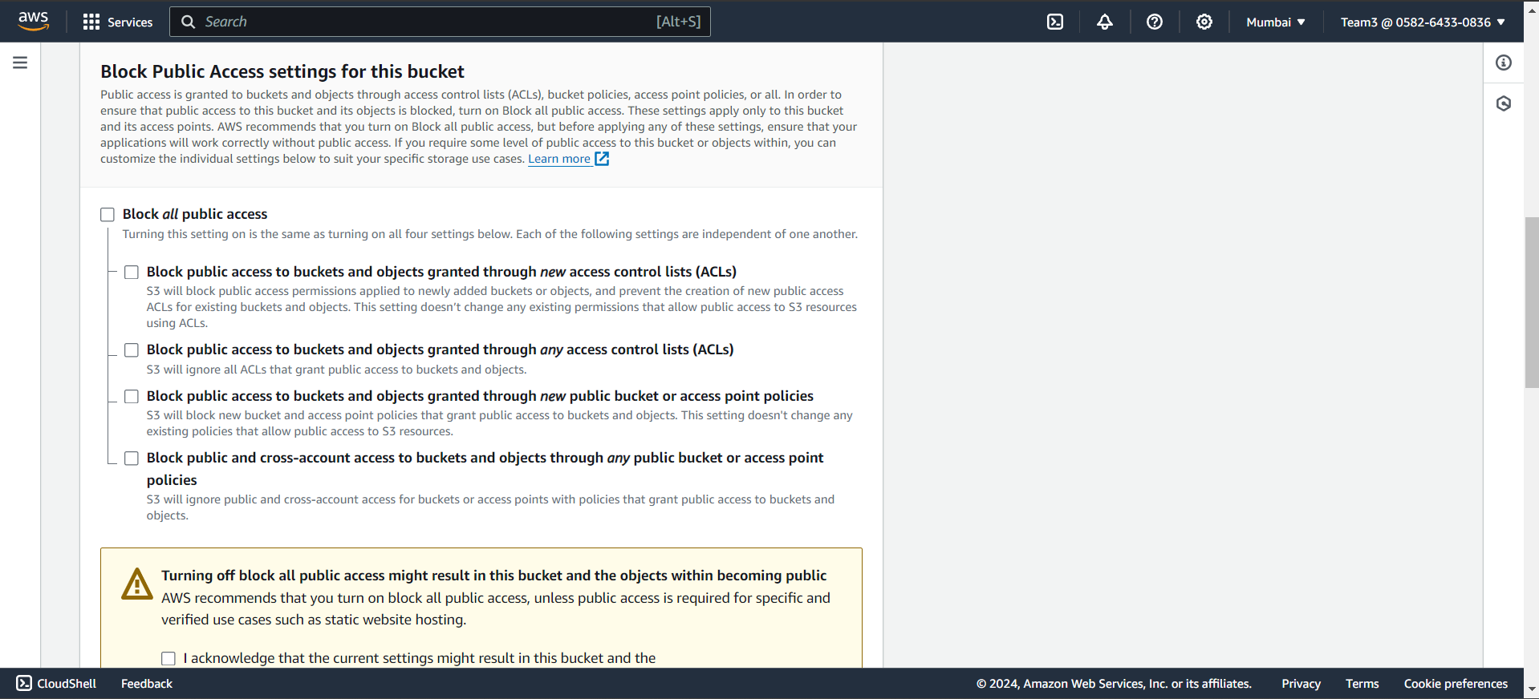

Step-6 Bucket versioning (Versioning: Versioning refers to **maintaining multiple variants of an object in the same Amazon S3 bucket**. It is used for the preservation, retrieving and restoration of every version of each object that is stored in the S3 bucket **Versioning can be used to recover from unintended user actions and application failure easily**.).

Step-7 : Don’t change any setting

Step-8: After creating Bucket We will see this

Different ways to upload the files in the bucket

1st way using SDK uploading file

2nd way uploading management console

3rd way upload using CLI ( Command line interface)