OS Assignment 1

1) man ls

2) uname

3) pwd

4) hostname

5) date

6) cal

7)ls -R

8) cat > test.txt

9) cat >> test.txt

10) cp test.txt copyFile.txt

cp -r dir1 dir2
11)mv test.txt dir1 --> moves the file ‘test.txt’ into ‘dir1’ directory

12) mv -- Rename a File
--> mv test.txt newFile.txt --> Renames the files ‘test.txt’ to ‘newFile.txt’

13) tac, rev
--> tac copy.txt
--> rev copy.txt

14) wc -- count the words, characters and lines in a file
--> wc copy.txt

15) mkdir
--> mkdir -p dir1/dir3

Screenshots for Q1-15

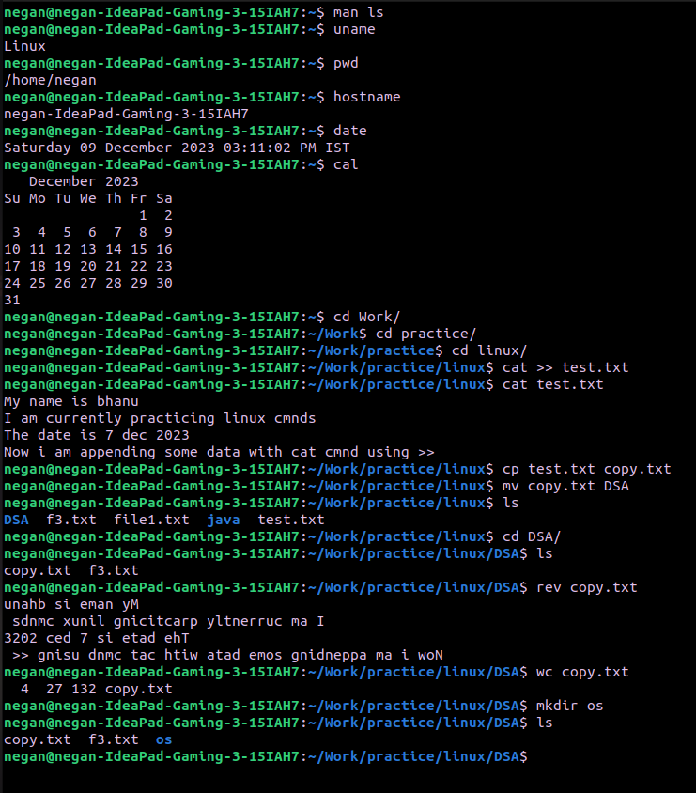

16) cd
--> cd dir1/

17) rm (with -r)
--> rm -r dir1/

18) rmdir
--> rmdir dir3/
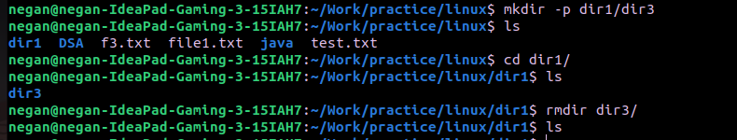

19) touch
--> touch test.txt test1.txt test2.txt test3.txt

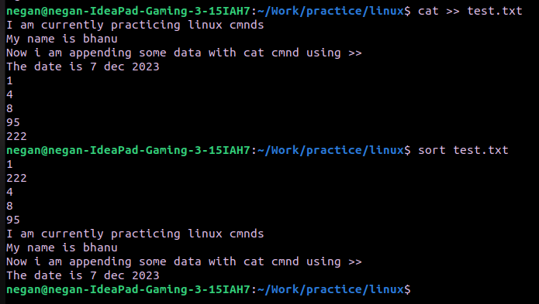

20) sort
sort test.txt

21) uniq – to avoid repetition in a file
--> sort test.txt | uniq

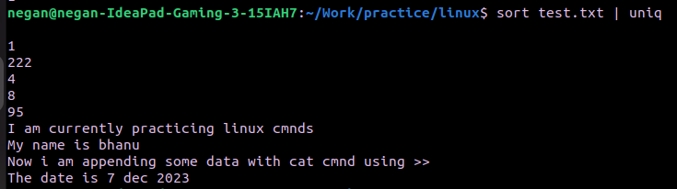

22) head
--> head -2 test.txt

23) tail
--> tail -2 test.txt

24) factor
--> factor 24

25) alias
--> alias x=”ls”

26) unalias
--> unalias x
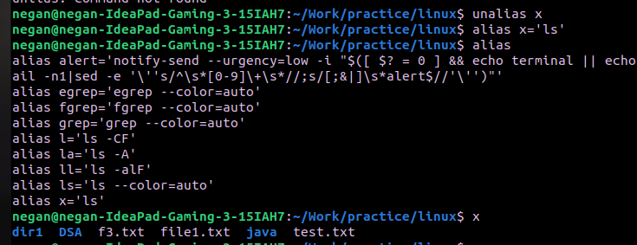
27) echo
--> echo $SHELL

28) ps
--> ps
29) kill
--> pkill code
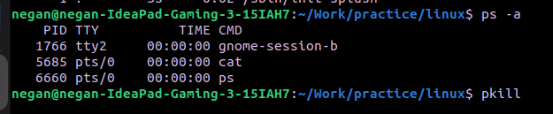

30) env
