OS Assignment 2

1) Sort by a date
ls -t
2) sort by size
--> ls -S
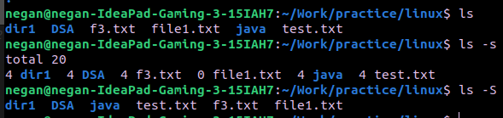
3) list files with thier inode no.
--> ls -i
4) list the contents of the subdirectory
--> ls dir/1

--> ls */
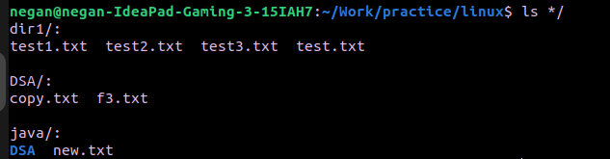

5)
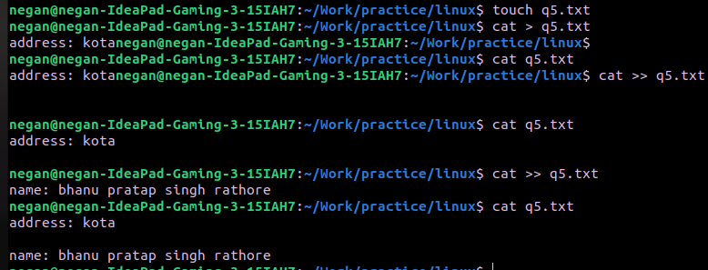
6) Change the timeStamp of a file
--> touch -t 202203160430.30 q5.txt
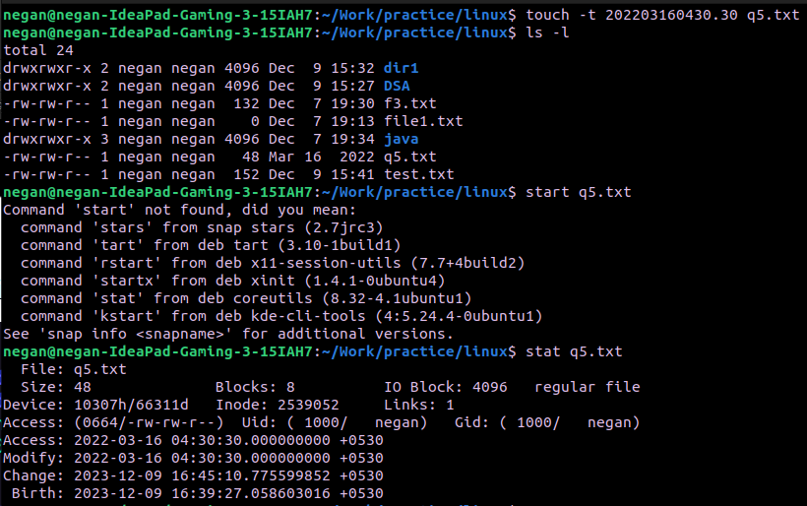

7)

mkdir one
cd one
touch 1.txt 11.txt 111.txt
mkdir two
cd two
touch 2.txt 22.txt 222.txt
mkdir three
cd three
touch 3.txt 33.txt 333.txt
mkdir four
cd four
touch 4.txt 44.txt 444.txt
mkdir five
cd five
touch 5.txt 55.txt 555.txt
cd ~
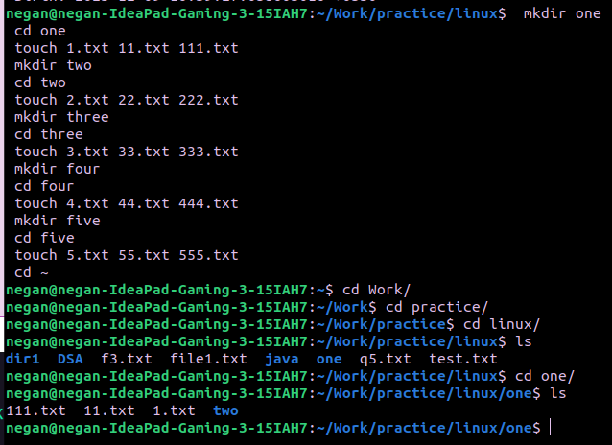
8)
i) ls Work/practice/linux/one/two/three/four/five

ii) cat > Work/practice/linux/one/two/three/four/44.txt
iii) rm Work/practice/linux/one/two/three/four/five/555.txt

iv) cd Work/practice/linux/one/two/three/four/five

v) cat > ../../../three/3.txt
-> cat ../../../three/3.txt
vi) ls ../../../../two
vii) rm ../../../../two/222.txt
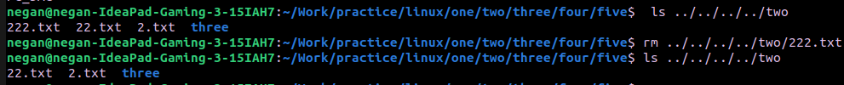
viii) cd ../../../../../one
ix) rm two/three/four/five/*
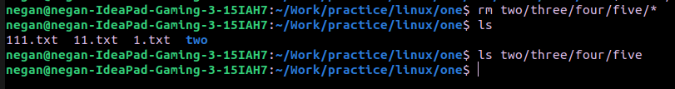
x) rmdir two/three/four/five

xi) rm -r two/three/four

xii) cd ~

9)
