1,2,3
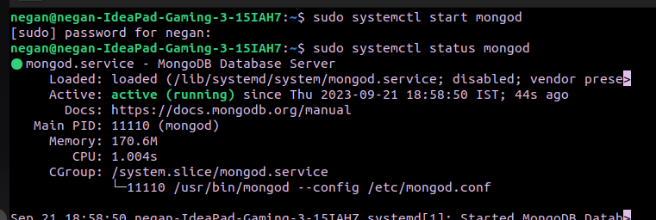
4, 5. mongosh

6. show dbs

7. use CDAC

8. show collections

9. db.createCollection("library")

10. db.library.insert({title:'MongoDB programming', author:'Sameer', likes:100})

11. db.library.find()

Answer 6,7,8,9,10,11 in below screenshot
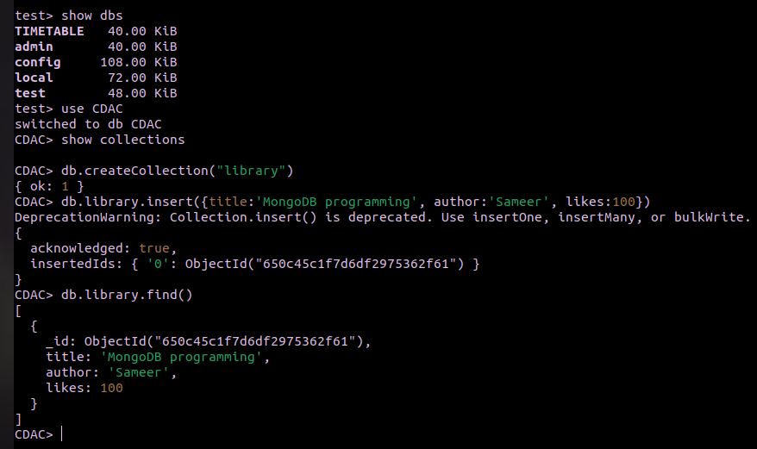

12. db.library.insert({title:'MySqlprogramming', authors:['Jack', 'Jill'], likes:200})

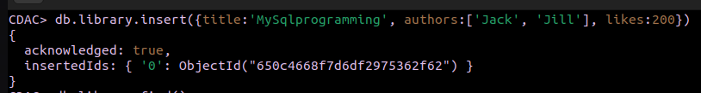
13. db.library.find()

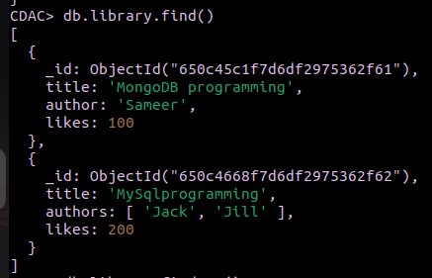

14. db.library.findOne()

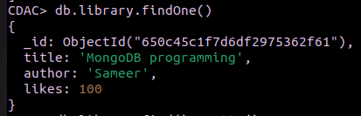

15. db.library.find().pretty()
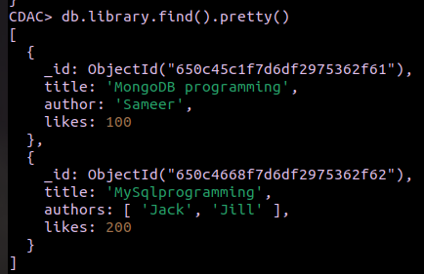

16. db.library.updateOne({author:'sameer'}, {$set :{author:'Sameer Dehadrai'}})
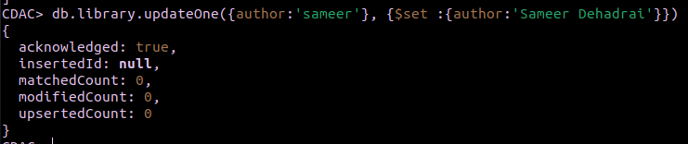
17. db.library.deleteOne({likes:100})
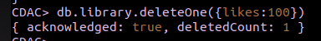

18. db.library.remove()
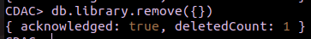

19. db.dropDatabase()

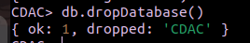

20. exit
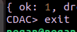

21. To Stop MongoDB server:sudo service mongod stop

To start MongoDB server: sudo systemctl status mongod

