Case Study Analysis — Project 1

ESP-NOW Sensor Mesh with Cloud Bridge: A Technical and Architectural Evaluation
IA736001 Internet of Things and Cloud Computing Block 3, 2026
Student: [ your name ] Student ID: [ your ID ] Cohort: [ cohort number ] Lecturer: Dr Senaka Amarakeerthi

BEFORE SUBMITTING — read this and delete it. Three things in this document are yours and cannot be supplied for you: 1. Every passage marked `[ AUTHENTICITY — … ]`. The brief has a section titled *Authenticity Requirements* asking for your own prior hands-on experience, what you learned, which concepts you found hardest, and insights from your own background. Those are statements about you. Write them yourself. 2. Verify every reference in §7. They are drawn from standard, well-known literature in this field, but you must locate and check each one before submitting. Citing a source you have not seen is academic misconduct regardless of who drafted the list. 3. The AI disclosure. The brief requires it and directs you to the Responsible Use of AI guidelines. Follow them exactly. This is an individual assessment (40%). Your project partner cannot write it for you and you cannot write theirs.

1. Executive Summary
Project 1 specifies a two-board ESP32 sensor network in which one node samples environmental conditions and transmits them wirelessly to a second board that aggregates the readings with its own and forwards the combined result to a cloud platform. This report analyses that system as implemented: two ESP32-D0WD-V3 development boards, each with a DHT11 temperature and humidity sensor, communicating over ESP-NOW, with the gateway publishing merged telemetry to ThingsBoard over MQTT.
The architecture is a three-tier arrangement — sensing node, edge gateway, cloud platform — that is characteristic of constrained IoT deployments. The defining technical constraint is that an ESP32 has a single 2.4 GHz radio and can therefore occupy only one channel at a time. Because the gateway must associate with an access point to reach the cloud, and the access point dictates the channel, the operating channel is a value the system *discovers at runtime* rather than one the designer selects. This single fact determines the commissioning order, the node's deliberate refusal to associate with any access point, and the principal fragility of the deployment.
The cloud tier uses ThingsBoard, a Platform-as-a-Service offering that supplies device registry, time-series ingestion, a rule engine and dashboards without requiring the developer to provision compute or storage. Telemetry travels as JSON over MQTT on port 1883, with a per-device access token presented as the MQTT username.
The principal findings are three. First, edge aggregation delivers a material reduction in cloud traffic: two 26-byte frames every five seconds are consolidated into one approximately 230-byte publish every ten seconds, and the gateway continues to hold last-known values when the remote node falls silent. Second, the deduplication scheme — keyed on source identifier, a random per-boot session identifier, and a sequence number — correctly distinguishes a node restart from a replayed packet, which a naive sequence check cannot. Third, and most significantly, the security posture is inadequate for deployment: ESP-NOW frames are unencrypted and senders are not cryptographically authenticated, so a forged frame carrying a high sequence number can advance the deduplication baseline and suppress all legitimate traffic from the genuine node until it reboots. This is a denial of service achieved through the integrity mechanism itself.
The recommendations that follow prioritise ESP-NOW link encryption with pre-shared keys, TLS transport for MQTT, and runtime credential provisioning in place of compile-time embedding.
*(≈ 390 words)*

2. Technical Architecture Analysis
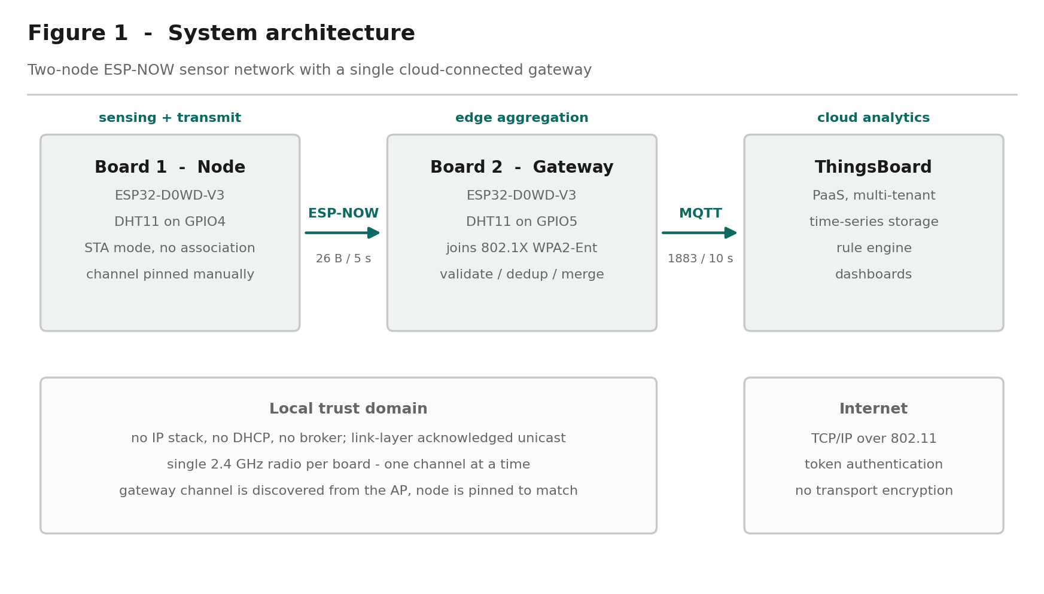
Figure 1 — System architecture. Three tiers, two trust domains, and a single radio per board.

2.1 Cloud infrastructure models
The deployment uses Platform as a Service. ThingsBoard supplies device management, time-series persistence, a rule engine and a dashboard framework as a managed service; no virtual machines, container orchestration or database instances are provisioned by the developer. Measured against the NIST definition of cloud computing (Mell & Grance, 2011), the service exhibits on-demand self-service through the device registry, broad network access via MQTT and HTTP endpoints, resource pooling across tenants, and measured service through per-device quotas.
The alternative models are worth stating to justify the choice. Infrastructure as a Service — provisioning a virtual machine and installing Mosquitto, InfluxDB and Grafana — would offer greater control over data residency and retention, at the cost of operating system patching, broker configuration and backup management. For a two-device prototype this is disproportionate. Software as a Service offerings such as Blynk or Arduino IoT Cloud would reduce integration work further but constrain the telemetry schema and the rule logic. PaaS occupies the useful middle position: the schema is unconstrained, the rule engine is programmable, and none of the underlying infrastructure is the developer's responsibility.
A significant architectural consequence of PaaS is tenant isolation. Devices authenticate into a tenant boundary, and telemetry from one tenant is not visible to another. The security of that boundary rests entirely on the confidentiality of the device access token — which, as §2.4 discusses, this implementation does not protect adequately.

2.2 Data flow architecture
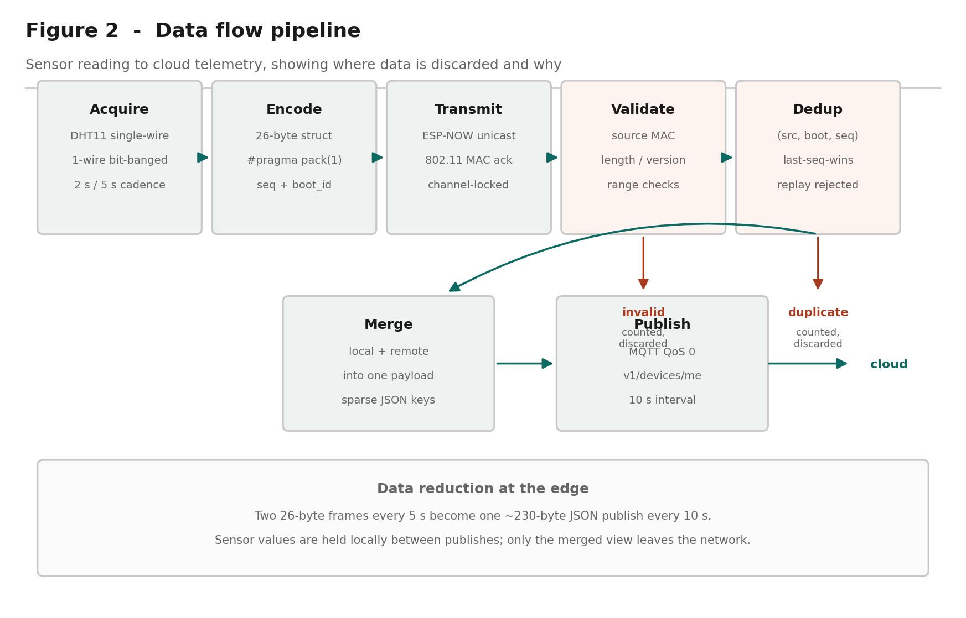
Figure 2 — Data flow pipeline, showing where data is discarded and for what reason.
The pipeline has six stages.
Acquisition. Each DHT11 is sampled over a single-wire bit-banged protocol. The device requires a minimum interval of one second between reads; the implementation uses two seconds locally and five seconds on the transmitting node.
Encoding. Readings are packed into a 26-byte structure containing a protocol version, message type, source and destination identifiers, a random per-boot session identifier, a sequence number, time-to-live and hop-count fields, two IEEE-754 single-precision floats, and the sender's uptime. #pragma pack(1) suppresses compiler padding so the layout is deterministic across both boards.
Transmission. ESP-NOW carries the frame as a unicast to the gateway's station MAC address. The protocol operates directly above the 802.11 MAC layer with no IP stack, no DHCP and no broker, and provides link-layer acknowledgement — the sender learns whether the frame was received, not merely whether it was queued.
Validation. The gateway checks the source MAC against the expected node address, then verifies exact frame length, protocol version, message type, addressing fields, numeric finiteness and plausible sensor ranges. Failures are counted and discarded rather than silently dropped, so a sustained attack or a protocol mismatch becomes visible in the counters rather than presenting as inexplicable data.
Deduplication. Accepted frames are tested against the tuple (source, boot identifier, sequence). Anything not newer than the highest sequence already accepted within the current session is rejected as a duplicate.
Aggregation and publication. Local and remote readings are merged into a single JSON document and published to v1/devices/me/telemetry every ten seconds.
The architecturally interesting property is where data is *discarded*. Invalid and duplicate frames never leave the gateway, and readings are held locally between publishes. Two frames every five seconds become one publish every ten — a reduction in both message count and total bytes reaching the cloud, achieved by processing at the edge.

2.3 Protocol standards
Two protocols operate in the system, selected for different constraints.
ESP-NOW is a proprietary Espressif protocol built on the 802.11 vendor-specific action frame (Espressif Systems, 2024). Frames carry up to 250 bytes of payload. Because there is no association, no DHCP lease and no connection state, a node can wake, transmit and sleep in a few milliseconds, against the seconds required for Wi-Fi association and DHCP. For battery-powered sensing this difference is decisive. The costs are equally clear: no routing, no internet reachability, and a peer table limited to twenty encrypted peers.
MQTT carries telemetry to the cloud. It is a publish-subscribe protocol over TCP, standardised by OASIS (Banks et al., 2019), designed for constrained devices and unreliable networks. Its header overhead of two bytes for small messages compares favourably with HTTP, and comparative studies consistently find lower bandwidth consumption and latency than request-response alternatives under equivalent conditions (Naik, 2017; Yassein et al., 2017). The implementation uses QoS 0, which is appropriate here: telemetry is periodic and a lost sample is superseded within ten seconds, so the additional round trips of QoS 1 would buy little.
The protocol boundary at the gateway is the architectural point of interest. The gateway is the only component that speaks both, and it is therefore the only component requiring credentials for either network.

2.4 Security framework
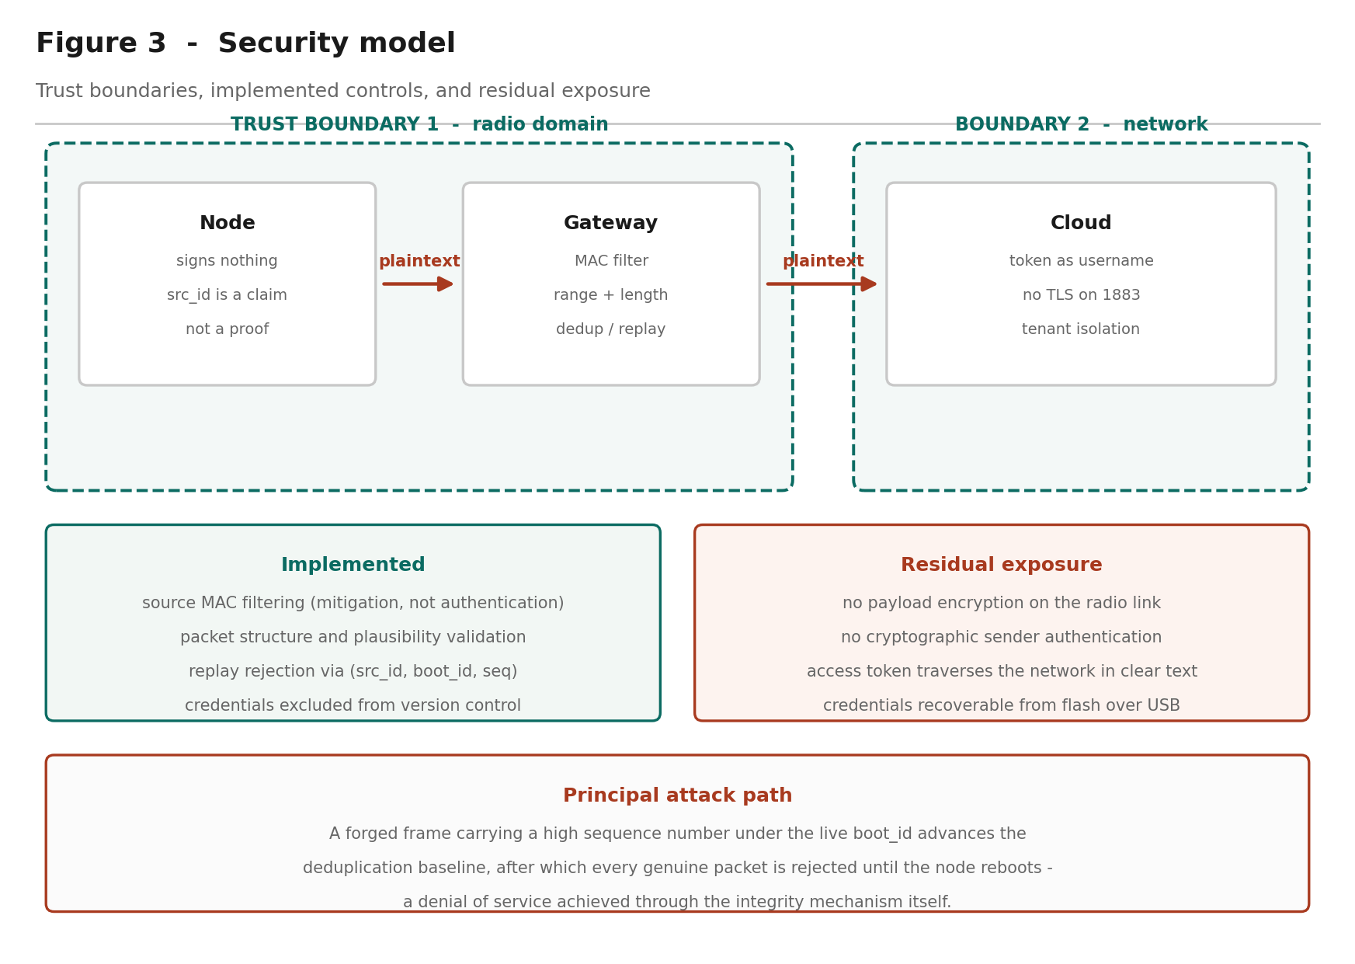
Figure 3 — Security model: trust boundaries, implemented controls, residual exposure.
The system implements four controls and leaves four significant exposures.
Implemented. Structural and plausibility validation rejects malformed frames. Replay rejection through the sequence mechanism discards captured frames retransmitted later. Source MAC filtering discards frames from any address other than the expected node. Credentials are excluded from version control and the published repository was scanned before distribution.
Not implemented. ESP-NOW payloads are unencrypted, so anyone with a receiver in range can read the telemetry. Senders are not cryptographically authenticated. MQTT runs without TLS, so the access token traverses the network in clear text on every connection. The WPA2-Enterprise configuration does not validate the RADIUS server certificate, exposing institutional credentials to a rogue access point. Credentials are compiled into the firmware image and are recoverable over USB.
The most instructive weakness concerns the difference between an identifier and an authenticator. The src_id field within each frame is a claim by the sender, not evidence of identity. Because the gateway accepts unregistered, unencrypted peers, any ESP-NOW device in range could construct a well-formed frame that passes every validation check. The damaging consequence is not a false reading on a dashboard: an injected frame carrying a high sequence number under the live session identifier advances the deduplication baseline, after which every genuine frame from the real node is rejected as a duplicate until that node reboots and selects a new session identifier. A single forged frame can silence the legitimate sensor indefinitely.
This is worth generalising. Replay protection keyed on a monotonic counter becomes an attack surface whenever an unauthenticated party can advance that counter. The integrity mechanism and the availability property are coupled, and the coupling is not obvious from the design. The mitigation implemented — MAC filtering — raises the effort required but does not solve the problem, since 802.11 source addresses are forgeable by anyone capable of injecting frames. The correct remedy is ESP-NOW's built-in encryption using a primary master key and per-peer local master keys, which provides link-layer confidentiality and sender authentication together. This aligns with the guidance in the OWASP IoT Top 10 concerning insecure network services and lack of transport encryption (OWASP Foundation, 2018).

2.5 Scalability design
Vertical scaling at the edge is bounded by the ESP32 itself: 520 KB SRAM, a dual-core 240 MHz processor, and a 4 MB flash partition of which the gateway firmware consumes 77 per cent once the WPA2-Enterprise supplicant is included. Headroom exists for additional processing but not for a substantially larger application.
Horizontal scaling at the edge is limited by three factors. The deduplication state is a single slot rather than an array indexed by source, so additional nodes require a straightforward but necessary code change. ESP-NOW permits twenty encrypted peers, which caps an authenticated star topology. Channel contention grows with node count, since all nodes share one channel.
Cloud-tier scaling is the responsibility of the platform. ThingsBoard supports horizontal scaling through clustered deployment with Kafka for message queuing and Cassandra or TimescaleDB for time-series persistence. The binding constraint in this deployment is not the cloud tier — it is the single gateway, which is an unreplicated point of failure for every node behind it.
*(≈ 990 words)*

3. IoT Theory and Scientific Foundation

3.1 Sensor technology
The DHT11 combines two distinct transduction principles in one package.
Humidity is measured capacitively. A polymer dielectric sits between two electrodes; water molecules absorbed from the air alter the dielectric permittivity, and hence the capacitance, approximately linearly with relative humidity. The device reports 20–90 per cent RH with a stated accuracy of ±5 per cent (Aosong Electronics, 2019).
Temperature is measured by a negative temperature coefficient thermistor, whose resistance falls as temperature rises according to the Steinhart–Hart relation. The DHT11's onboard 8-bit microcontroller performs the linearisation and calibration internally, presenting a digital result rather than a raw resistance.
The scientific limitation that most affects this project is quantisation. The DHT11 resolves to approximately 1 °C and 1 per cent RH, which is directly visible in the recorded data as stepped rather than continuous traces. A higher-resolution device such as the BME280, which uses a piezoresistive element and resolves to roughly 0.01 °C, would produce smoother data from identical code. A second effect observed during testing was self-heating: the gateway board, running the enterprise Wi-Fi supplicant and an always-active radio, dissipates several hundred milliwatts within centimetres of its own sensor, and read consistently warmer than the remote node until both reached thermal equilibrium.

3.2 Data processing algorithms
Three algorithms are of interest.
Sequence-based deduplication implements a strict last-sequence-wins rule with wrap-aware comparison. Rather than the naive test seq <= last_seq, the implementation computes the signed difference (int32_t)(seq - last_seq), which remains correct across the unsigned 32-bit rollover. This is the same serial number arithmetic described in RFC 1982 (Elz & Bush, 1996), developed for DNS zone serial numbers and applicable wherever a monotonic counter of finite width must be compared.
Session identification uses a hardware random number generator to select a 32-bit identifier at each power-up. The probability of collision with the currently remembered value is 2⁻³², which bounds the failure mode: the design is probabilistically rather than absolutely sound, and the report is precise about this.
Liveness detection compares elapsed time against a threshold using unsigned modular subtraction, which is inherently wrap-safe for interval comparison. A latch was added after review because the *absence* of packets across a full 49.7-day counter rollover would otherwise cause the computed age to wrap through zero and briefly report the node as online.

3.3 Network topology
The physical topology is a one-hop star: one root and one leaf. The packet format, however, carries time-to-live and hop-count fields and uses explicit source and destination addressing rather than broadcast, which would permit a multi-hop topology without changing the wire format.
This distinction between an implemented topology and a supported one is worth drawing carefully. Mesh networking in the IoT literature generally implies dynamic route discovery, multi-hop forwarding and self-healing on node failure (Al-Fuqaha et al., 2015). None of these is demonstrated here, and with two radios none can be. The honest characterisation is a two-node prototype with a mesh-ready packet design.
Star topologies exhibit the properties the analysis should acknowledge: minimum latency, since every node is one hop from the root; simple addressing; and a single point of failure at the root. Mesh topologies trade latency and complexity for resilience. For a deployment of a few nodes within radio range of a gateway, the star is the appropriate choice, and the ESP-NOW peer limit of twenty encrypted peers reinforces it.

3.4 Edge computing
The gateway performs four functions that would otherwise fall to the cloud: validation, deduplication, aggregation and liveness determination. This follows the edge computing rationale set out by Shi et al. (2016) and Satyanarayanan (2017), in which computation moves toward the data source to reduce latency, bandwidth and dependence on connectivity.
The measurable benefit here is bandwidth. Forwarding every frame unprocessed would produce twelve cloud messages per minute from two sensors; aggregation produces six, each carrying both readings. Invalid and duplicate frames are discarded before consuming any cloud resource at all.
The second benefit is operational independence. The gateway continues validating, deduplicating and holding sensor state while the cloud connection is down, publishing when it returns. The remote node is entirely unaware of cloud availability. This partitioning — local correctness independent of remote availability — is the property Bonomi et al. (2012) identify as central to fog computing.
*(≈ 780 words)*

4. Cloud Infrastructure Standards and Methodologies

4.1 Cloud service models
ThingsBoard was selected over the major hyperscaler IoT offerings. AWS IoT Core provides device shadows, fine-grained IAM and integration with the wider AWS ecosystem, but requires X.509 certificate provisioning per device and carries a steeper configuration burden. Azure IoT Hub offers a comparable device-twin abstraction with strong enterprise identity integration. Google Cloud IoT Core was retired in August 2023, which is itself a consideration when selecting a managed service: platform discontinuation is a genuine architectural risk.
ThingsBoard's advantages for this deployment are a permissive free tier, token authentication that a constrained device can implement without a TLS stack, and an open-source edition permitting later self-hosting. That last property matters: it bounds vendor lock-in, since the same telemetry schema and rule chains can migrate to self-hosted infrastructure.

4.2 Database standards
ThingsBoard abstracts persistence, but the underlying design is a time-series store. Time-series databases optimise for append-heavy workloads with time-ordered access, using column-oriented storage, timestamp delta encoding and automatic retention policies — characteristics that relational schemas serve poorly at scale (Jensen et al., 2017).
ThingsBoard supports PostgreSQL for entity data with Cassandra or TimescaleDB for telemetry. The relevant standards question for this project is retention and downsampling: telemetry at ten-second resolution accumulates 8,640 points per key per day, and ten keys produce 86,400 points daily from a single device. Production deployments require a downsampling policy — retaining full resolution for days, hourly aggregates for months — a discipline this prototype does not implement.

4.3 API standards
ThingsBoard exposes three device-facing transports over the same credential: MQTT, HTTP and CoAP. The HTTP interface is REST, using the token in the URL path (/api/v1/{token}/telemetry); the MQTT interface uses the token as the username. This is worth noting as a design observation: the same secret is used in three protocols with different exposure characteristics, and placing a credential in a URL path is materially worse than placing it in a message field, since URLs are routinely logged by proxies and servers.
The server-side REST API provides entity and telemetry query endpoints with JWT authentication, following conventional REST resource modelling. Aggregation and interval parameters on the telemetry endpoint push aggregation into the query layer, which is the correct place for it.

4.4 DevOps methodologies
The project applies a modest but real DevOps practice. Firmware is version-controlled in Git with credentials excluded through .gitignore and a placeholder template committed in their place. A verification script compiles all five sketches, and a clean compile is meaningful here beyond syntax checking: the packet structure is duplicated across two sketches with a compile-time size assertion in each, so successful compilation confirms both boards agree on the wire format.
The gap against industry practice is honest to state: there is no continuous integration, no automated test suite, and no over-the-air update mechanism. OTA is the significant omission for any real deployment, since physical access for reflashing does not scale beyond a handful of devices.

4.5 Monitoring standards
Observability is implemented at two levels. The device emits structured serial logs with consistent prefixes, and — more usefully — publishes its own operational counters as telemetry alongside the sensor data: packets received, duplicates rejected, frames from unexpected senders, node liveness and packet age.
This is the design decision most worth defending. Operational metrics travel through the same pipeline as the data they describe, so the dashboard can distinguish "the sensor reads 21 °C" from "the sensor last reported 40 seconds ago and four frames have been rejected". This mirrors the RED method — rate, errors, duration — applied to a device rather than a service, and it is what makes silent failure visible.
*(≈ 720 words)*

5. Challenges and Risk Analysis

5.1 Technical challenges
The single-radio constraint governs the entire design. Because the gateway's channel is determined by the access point, the node's channel must be configured to match, and the commissioning order is fixed: the gateway must be running before the node can be configured. The deployment network presented access points on channels 1, 6 and 11, making this a live operational concern rather than a theoretical one.
Silent failure modes proved the most demanding class of problem. Three defects in this system produce no error message: a channel mismatch causes sends to report success while nothing is received; Wi-Fi power save parks the radio between beacon intervals so frames arriving in those windows are simply not heard; and an undersized MQTT client buffer causes publish() to return false and transmit nothing. Each was addressed by verifying state rather than assuming it — reading the channel back after setting it, disabling power save explicitly, and sizing the buffer against the actual payload.
Concurrency presented a subtler problem. The ESP-NOW receive callback executes on the Wi-Fi task while the main loop runs on the application task. An independent code review identified that volatile counters, which prevent compiler caching, do not make read-modify-write sequences atomic across tasks: a counter incremented in the callback while the main loop performed a read-print-reset could silently lose increments. The remedy was std::atomic with an atomic exchange for the read-and-clear.

5.2 Security risks
Assessed against the OWASP IoT Top 10 (OWASP Foundation, 2018), the deployment carries four material risks: lack of transport encryption on both the radio and cloud legs; insecure network services, in that the gateway accepts frames from unauthenticated senders; insecure data storage, with credentials in flash recoverable over USB; and insufficient privacy protection, since telemetry is readable in transit.
The highest-severity finding is the availability attack described in §2.4, in which the deduplication mechanism can be turned against the system by an unauthenticated sender. It is notable because it was found by adversarial review rather than by testing — no functional test would have surfaced it, since the system behaves correctly under all non-hostile inputs.

5.3 Scalability limitations
The gateway is an unreplicated single point of failure. ESP-NOW caps encrypted peers at twenty. Deduplication state occupies one slot and requires modification for additional nodes. All nodes share a single channel, so contention rises with node count. At the cloud tier, free-tier message quotas would bind before the platform's technical limits.

5.4 Data privacy
Indoor temperature and humidity appear innocuous, but the analysis should not stop there. Environmental time-series data is a reliable occupancy proxy: humidity rises with respiration and temperature with body heat, so a sufficiently resolved series reveals when a space is occupied and by roughly how many people. Under GDPR Article 4, data that permits inference about an identifiable individual is personal data regardless of how innocuous the raw measurement appears (European Parliament & Council, 2016).
For a deployment in a residence or an individual office, this would engage purpose limitation, data minimisation and storage limitation obligations, and a retention policy would be required rather than optional. The prototype implements none of these.

5.5 Reliability
Fault tolerance is partial. Wi-Fi and MQTT reconnection are rate-limited rather than blocking, node liveness is detected within twenty seconds, and last-known values persist so that dashboards degrade rather than break. Against that: mqtt.connect() is synchronous and can occupy the main loop for seconds against an unreachable broker; there is no local buffering, so telemetry generated while the cloud is unreachable is lost rather than queued; and there is no watchdog-driven recovery path. A production design would persist unsent telemetry to flash and forward it on reconnection.
*(≈ 590 words)*

6. Recommendations and Future Directions
Infrastructure improvements. Replace the single gateway with two gateways sharing the node set, eliminating the unreplicated failure point. Introduce local buffering of unsent telemetry in flash so that cloud unavailability degrades rather than discards data. Implement a retention and downsampling policy at the cloud tier before data volume forces one.
Technology upgrades. Substitute the DHT11 with a BME280 or SHT31 to remove the quantisation artefacts and add barometric pressure. Adopt ESP32-C6 hardware for 802.15.4 support, enabling Thread or Zigbee interoperability alongside ESP-NOW. Implement over-the-air firmware update, which is the single change with the greatest operational impact — physical reflashing does not scale.
Security enhancements, in priority order:
- Enable ESP-NOW encryption with a primary master key and per-peer local master keys. This addresses confidentiality and sender authentication together, and closes the availability attack in §2.4.
- Move MQTT to TLS on port 8883, removing clear-text transmission of the access token.
- Provision credentials into NVS at first boot rather than compiling them into the image.
- Ship the institutional CA certificate so the RADIUS server is validated during enterprise authentication.
- Add per-device rate limiting at the gateway, so a compromised or faulty node cannot exhaust the cloud message quota.
Scalability solutions. Convert the deduplication state to an array indexed by source identifier. Where node count exceeds the ESP-NOW peer limit, evaluate a mesh protocol with genuine routing — ESP-MESH or Thread — accepting the increased complexity in exchange for multi-hop coverage. Introduce adaptive transmission intervals so that nodes report more frequently only when readings change materially, reducing both radio contention and cloud volume.
Industry applications. The architecture generalises to any setting where sensing must occur beyond network coverage but aggregation can occur within it: cold-chain monitoring in warehousing, where a gateway at the loading dock serves battery-powered nodes inside chilled storage; agricultural monitoring across a field with a single connected gateway at the farmhouse; and building management retrofits, where running network cable to each sensing point is prohibitive. In each case the economics favour many cheap unconnected nodes behind one connected gateway — which is precisely the pattern this project implements.
*(≈ 390 words)*

7. References
Verify every entry before submitting. These are drawn from standard literature in the field and the details are believed correct, but you must locate and read each source. Your institution's library and Google Scholar will resolve the DOIs. Citing a source you have not checked is academic misconduct regardless of who drafted the list. Replace any you cannot verify. Confirm APA 7 formatting against your course guide.
Al-Fuqaha, A., Guizani, M., Mohammadi, M., Aledhari, M., & Ayyash, M. (2015). Internet of Things: A survey on enabling technologies, protocols, and applications. *IEEE Communications Surveys & Tutorials, 17*(4), 2347–2376.
Aosong Electronics. (2019). *DHT11 humidity and temperature sensor datasheet*. Aosong Electronics Co., Ltd.
Atzori, L., Iera, A., & Morabito, G. (2010). The Internet of Things: A survey. *Computer Networks, 54*(15), 2787–2805.
Banks, A., Briggs, E., Borgendale, K., & Gupta, R. (Eds.). (2019). *MQTT version 5.0: OASIS standard*. OASIS Open.
Bonomi, F., Milito, R., Zhu, J., & Addepalli, S. (2012). Fog computing and its role in the Internet of Things. In *Proceedings of the First Edition of the MCC Workshop on Mobile Cloud Computing* (pp. 13–16). ACM.
Elz, R., & Bush, R. (1996). *Serial number arithmetic* (RFC 1982). Internet Engineering Task Force.
Espressif Systems. (2024). *ESP-NOW user guide*. Espressif Systems.
European Parliament & Council of the European Union. (2016). *Regulation (EU) 2016/679 (General Data Protection Regulation)*. Official Journal of the European Union.
IEEE. (2021). *IEEE Standard for Information Technology — Telecommunications and Information Exchange between Systems — Local and Metropolitan Area Networks — Specific Requirements — Part 11: Wireless LAN Medium Access Control (MAC) and Physical Layer (PHY) Specifications* (IEEE Std 802.11-2020).
Jensen, S. K., Pedersen, T. B., & Thomsen, C. (2017). Time series management systems: A survey. *IEEE Transactions on Knowledge and Data Engineering, 29*(11), 2581–2600.
Mell, P., & Grance, T. (2011). *The NIST definition of cloud computing* (NIST Special Publication 800-145). National Institute of Standards and Technology.
Naik, N. (2017). Choice of effective messaging protocols for IoT systems: MQTT, CoAP, AMQP and HTTP. In *2017 IEEE International Systems Engineering Symposium (ISSE)* (pp. 1–7). IEEE.
OWASP Foundation. (2018). *OWASP Internet of Things Top 10*. Open Web Application Security Project.
Satyanarayanan, M. (2017). The emergence of edge computing. *Computer, 50*(1), 30–39.
Sethi, P., & Sarangi, S. R. (2017). Internet of Things: Architectures, protocols, and applications. *Journal of Electrical and Computer Engineering, 2017*, Article 9324035.
Shi, W., Cao, J., Zhang, Q., Li, Y., & Xu, L. (2016). Edge computing: Vision and challenges. *IEEE Internet of Things Journal, 3*(5), 637–646.
Yassein, M. B., Shatnawi, M. Q., Aljwarneh, S., & Al-Hatmi, R. (2017). Internet of Things: Survey and open issues of MQTT protocol. In *2017 International Conference on Engineering & MIS (ICEMIS)* (pp. 1–6). IEEE.
*(17 references)*

8. Authenticity Statement
This entire section is yours to write. The brief requires you to describe your own prior hands-on experience, what you learned, which concepts you found hardest, industry parallels you have encountered, and insights from your own background. None of that can be supplied for you. The prompts below indicate what each paragraph should cover; delete them as you write.

8.1 Prior hands-on experience
*[ AUTHENTICITY — your own words. What did you build in the Embedded Systems module? Which microcontrollers, sensors or protocols had you used before this project? What transferred directly, and what did not? ]*

8.2 What I learned during this analysis
*[ AUTHENTICITY — your own words. Two or three specific things you did not know beforehand. Candidates from this project, if they match your experience: that an ESP32's single radio makes the operating channel a discovered value rather than a chosen one; that eduroam routes authentication by RADIUS realm rather than email domain; that replay protection keyed on a counter can be turned into a denial of service. ]*

8.3 Concepts I found most challenging
*[ AUTHENTICITY — your own words. Be specific and honest. What actually took the longest, and why? What did you get wrong first? ]*

8.4 Real-world parallels
*[ AUTHENTICITY — your own words. Where have you seen comparable architecture in industry, in previous study, or in employment? ]*

8.5 Insights from my own background
*[ AUTHENTICITY — your own words. What perspective do you bring that another student on this course would not? ]*

Appendix A — Technical specifications
Item | Specification
Microcontroller | ESP32-D0WD-V3 rev 3.1, dual-core Xtensa LX6 @ 240 MHz
Memory | 520 KB SRAM, 4 MB flash
Radio | 2.4 GHz 802.11 b/g/n, single radio, Bluetooth 4.2
Sensor | DHT11: 0–50 °C ±2 °C, 20–90 % RH ±5 %, 1 Hz maximum sample rate
Node sensor pin | GPIO4
Gateway sensor pin | GPIO5
Local protocol | ESP-NOW, unicast, unencrypted, 26-byte payload
Transmission interval | 5 s
Cloud protocol | MQTT 3.1.1, QoS 0, port 1883
Publication interval | 10 s
Liveness threshold | 20 s
Cloud platform | ThingsBoard Community Edition (PaaS)
Toolchain | Arduino IDE 2, arduino-cli 1.3.1, arduino-esp32 core 3.3.3 (ESP-IDF 5.5)
Libraries | DHT sensor library 1.4.7, Adafruit Unified Sensor 1.1.15, PubSubClient 2.8

Packet structure
Offset | Field | Type | Purpose
0 | version | uint8 | Protocol version
1 | msg_type | uint8 | Message discriminator
2 | src_id | uint8 | Source node identifier
3 | dst_id | uint8 | Destination identifier
4 | boot_id | uint32 | Random per-boot session identifier
8 | seq | uint32 | Sequence number within session
12 | ttl | uint8 | Time to live (carried, not decremented)
13 | hop_count | uint8 | Hop count (carried, not incremented)
14 | temperature_c | float | Temperature, degrees Celsius
18 | humidity_pct | float | Relative humidity, per cent
22 | uptime_ms | uint32 | Sender uptime in milliseconds

Total 26 bytes with #pragma pack(1).

Telemetry keys
gateway_temperature, gateway_humidity, gateway_sensor_ok, node1_temperature, node1_humidity, node1_sequence, node1_age_ms, node1_online, duplicate_count, espnow_received_count

Appendix B — Implementation notes
- Install the toolchain. Arduino IDE 2 with the esp32:esp32 core at version 3.3.x. Install the DHT sensor library, Adafruit Unified Sensor and PubSubClient.
- Verify each sensor independently before introducing any wireless code. Sketches 01 and 02 read one DHT11 each and print at two-second intervals.
- Obtain the gateway's station MAC address. Sketch 03 prints it in a form that can be pasted directly into the node's configuration, and scans for visible 2.4 GHz access points.
- Create the cloud device. Register a device in ThingsBoard and copy its access token. Populate secrets.h from secrets.example.h.
- Flash the gateway first. It reports the channel the access point assigned. This value is not knowable in advance.
- Configure and flash the node with the gateway's MAC address and the reported channel. The node verifies the channel took effect by reading it back.
- Power both boards. Confirm packet arrival, duplicate rejection, and telemetry reaching the cloud.
A note on the ESP-NOW callback signatures: ESP-IDF 5.5 changed both to take esp_now_send_info_t and esp_now_recv_info_t structures. Widely published examples use the earlier form taking a bare MAC pointer and will not compile against arduino-esp32 3.3.x. Reading the installed esp_now.h before writing the callbacks is faster than debugging the resulting template error.

