P1 — ESP-NOW Sensor Mesh with Cloud Bridge
Course: [course code] Authors: [Member A], [Member B] Date: 3 August 2026

1. Introduction
This project implements a two-node wireless sensor system built from two ESP32 development boards. One board measures temperature and humidity and transmits its readings over ESP-NOW, a connectionless peer-to-peer protocol. The second board measures its own local environment, receives the first board's readings wirelessly, merges both datasets, and publishes the combined result to a ThingsBoard cloud instance over MQTT.
No wire connects the two boards. Each is powered independently over USB, and the only link between them is a 2.4 GHz radio.
Scope, stated up front. This is a two-node ESP-NOW prototype with a mesh-ready packet design. It is not a demonstrated multi-hop mesh network. With two radios the physical topology can only ever be one hop: a root and a node. The packet format carries ttl and hop_count fields and uses source/destination addressing rather than broadcast, so it would not have to change if a third board were added and forwarding logic written — but no packet in this project is ever forwarded, because there is nowhere to forward it to. This distinction is maintained throughout the report.
What the system does demonstrate:
Concept | How it appears
Peer-to-peer wireless without an access point | Board 1 never associates with the router, yet its data reaches the cloud
Root/gateway addressing | src_id/dst_id in every packet; unicast to a specific MAC
Edge aggregation | Board 2 merges two sensor sources before data leaves the network
Cloud fan-in | Two physical sensors, one cloud device, one telemetry stream
Duplicate detection | (src_id, boot_id, seq) key with a rejection counter
Liveness detection | node1_online flips false 20 s after the last valid packet

2. Hardware

2.1 Components
Item | Quantity | Notes
ESP32 DevKit (USB-C) | 2 | ESP32-D0WD-V3 rev 3.1, dual core, 240 MHz
DHT11 temperature/humidity module | 2 | Three-pin, integrated pull-up resistor
Breadboard | 2 | Half-size
Jumper wires | — | Female-to-female / female-to-male
USB data cables | 2 | Separate power for each board

No Raspberry Pi, no external LEDs or resistors, and no wired connection between the boards.

2.2 Wiring
Board 1 — Remote Sensor Node
Wire colour | ESP32 pin | DHT11 pin
Green | 3V3 | + / VCC
Orange | GND | − / GND
Yellow | D4 = GPIO4 | S / OUT / DATA

Board 2 — Root Gateway + Local Sensor
Wire colour | ESP32 pin | DHT11 pin
Green | 3V3 | + / VCC
Orange | GND | − / GND
Yellow | D5 = GPIO5 | S / OUT / DATA

The silkscreen labels D4 and D5 correspond to GPIO4 and GPIO5. The Arduino API takes the integer pin number, so the code uses 4 and 5 rather than the string labels.

2.3 Safety constraints observed
- Both ESP32 boards straddle the breadboard centre gap, so opposing pin rows are not shorted together.
- Nothing is connected to VIN or EN.
- Both sensors run at 3.3 V. The three-pin DHT11 modules carry their own data-line pull-up, so no external resistor was required.
- Only one board was connected during each firmware upload, to eliminate the risk of flashing the wrong image to the wrong board.
- Both boards are powered simultaneously for operation.

2.4 Photographic evidence
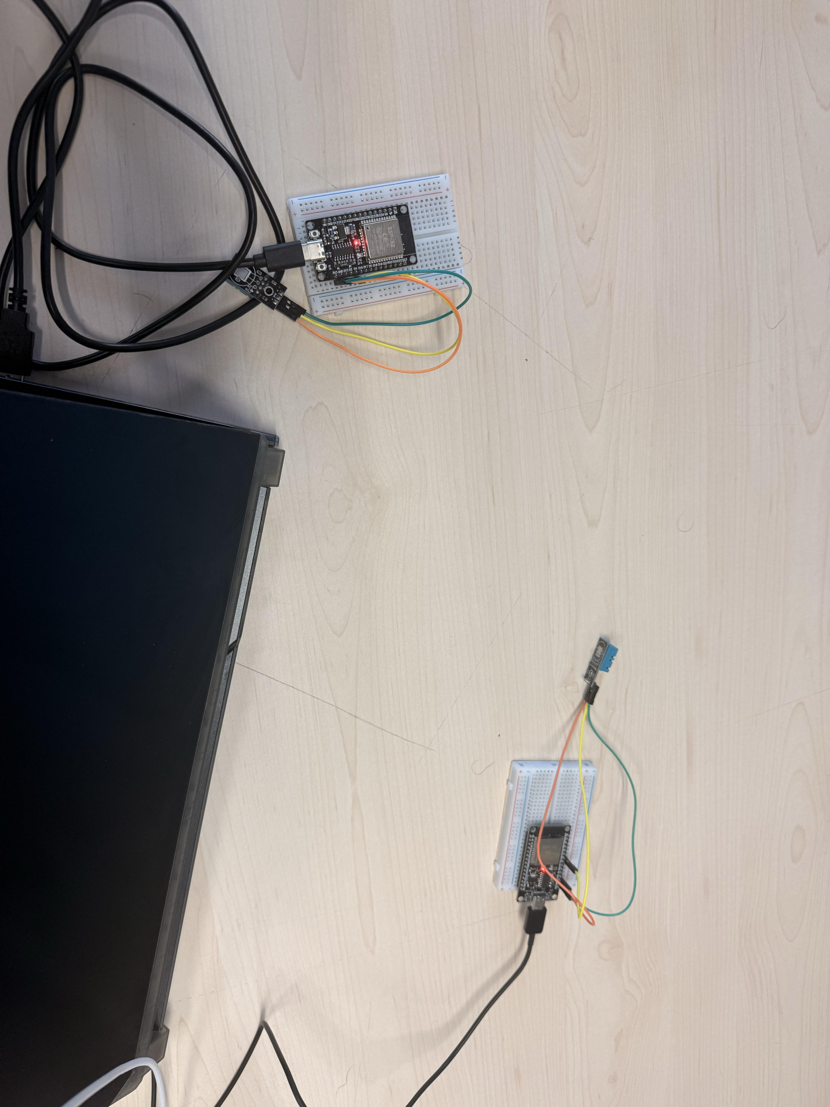
Figure 1 — Both boards operating, each powered from its own USB cable, with no wire between them. This is the primary evidence that the link is wireless: any data appearing on the gateway from the remote node can only have arrived by radio.
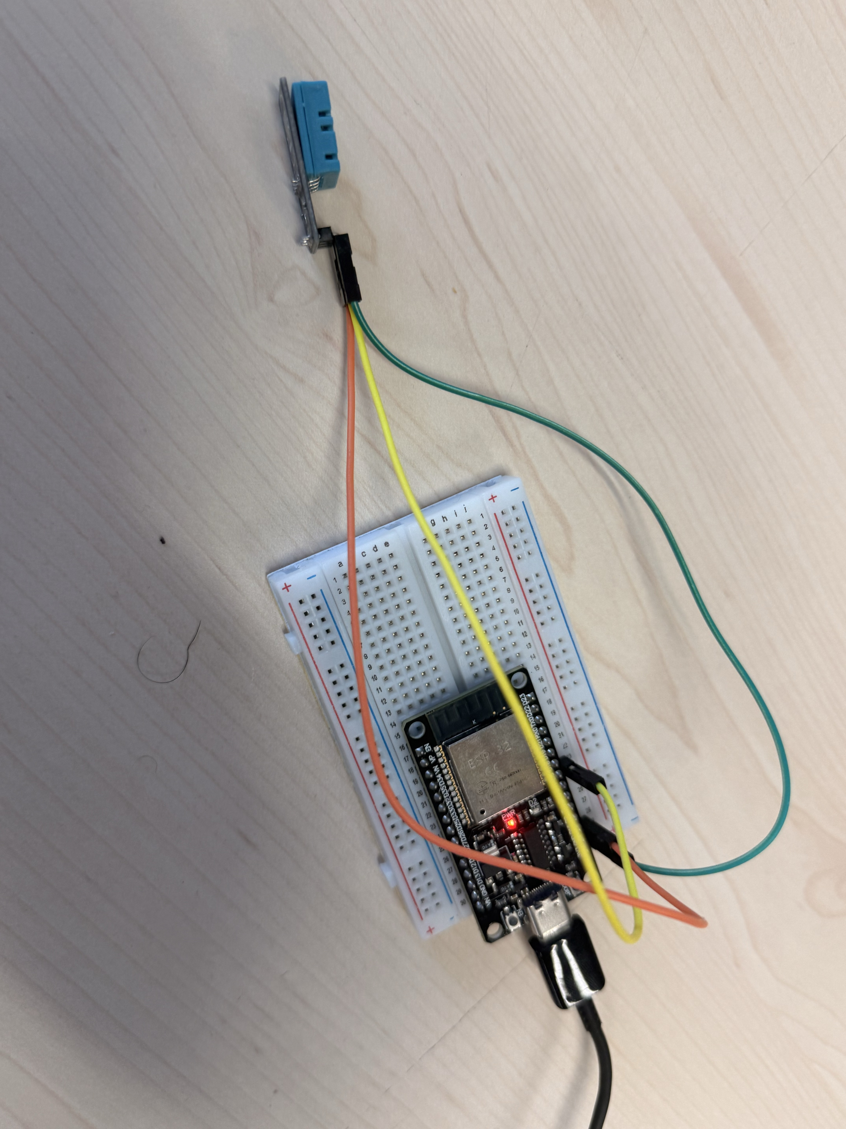
Figure 2 — Wiring detail. Green to 3V3, orange to GND, yellow to the data pin. The three-pin DHT11 module carries its own pull-up resistor, so no external component is needed.
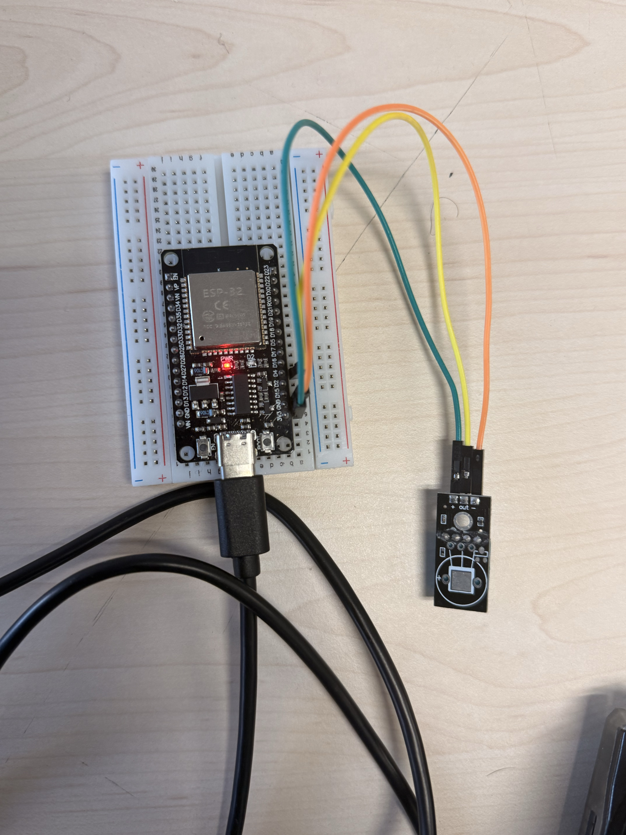
Figure 3 — The ESP32 straddles the breadboard centre gap so that opposing pin rows are not shorted together, and the pin labels remain legible for verification.

3. Hardware substitution: DHT11 in place of BMP280
The original project brief specified BMP280 pressure and temperature sensors. The hardware actually available was DHT11. This is a documented substitution, and it changes what the system measures.
Consequences:
- The measured quantities are temperature (°C) and relative humidity (% RH). No pressure is measured anywhere in this project, and no altitude is derived.
- The DHT11 uses a single-wire bit-banged protocol on one GPIO, not I²C. No I²C bus is used and no BMP280 libraries are installed.
- The DHT11 is a low-resolution part: approximately ±2 °C and ±5 % RH, with roughly 1 °C quantisation. This is visible in the results as stepped rather than smooth traces.
- The sensor must not be read more often than once per second. The implementation reads every two seconds.
What is unaffected. The substitution changes only the sensing layer. ESP-NOW transport, packet design, addressing, deduplication, aggregation, MQTT publishing and the cloud dashboard are all independent of which sensor supplies the numbers. Substituting humidity for pressure gave the system two measurands rather than one, which is arguably a slightly richer demonstration of the aggregation logic than temperature-plus-pressure would have been, since both quantities come from the same sensor and travel through the same code path.

3.1 Assessment: did the substitution weaken the demonstration?
On balance, no — but it moved the cost from one place to another rather than eliminating it.
What was genuinely lost. Two things. First, no I²C experience. A BMP280 is an I²C device, so the original brief would have required handling device addressing, bus pull-ups, and potentially two devices sharing one bus. The DHT11 is a single-wire bit-banged protocol on one GPIO with the pull-up already on the module, which is strictly simpler. That is a reduction in scope, and it is fair to say the sensing layer of this project is easier than the brief intended.
Second, resolution. The DHT11 quantises to roughly 1 °C, which is why the dashboard traces in §8 appear as staircases rather than curves. A BMP280 resolves to about 0.01 °C and would have produced visibly smoother, more convincing charts from identical code.
What was unaffected. Everything above the sensing layer. The packet carries two float values and does not care what physical quantity they represent; ESP-NOW transport, addressing, deduplication, aggregation, MQTT publishing and the dashboard are all identical regardless of sensor. Since the project's stated aims are about the *network and data path* rather than about sensing, the substitution leaves the assessed content intact.
What was arguably gained. Humidity turned out to be a better demonstration variable than pressure would have been. Indoor barometric pressure is very nearly static over the timescale of a live demonstration — it would have produced a flat line for several hours. Humidity responds within seconds to a hand or breath near the sensor. During testing, warming Board 1's sensor by hand drove its reading from 21.4 °C to 28.9 °C with humidity falling from 48 % to 31 %, and both relaxed back toward ambient once released (§8.7). That visible, controllable, bidirectional response makes it possible to prove the entire chain — sensor to ESP-NOW to gateway to MQTT to dashboard — live in about fifteen seconds. A pressure sensor could not have done that indoors.
The honest summary is that the substitution simplified the hardware interface, degraded the chart resolution, and improved the demonstrability. For a project assessed on the data path rather than on sensing, that is close to a neutral trade.

4. Architecture

4.1 Topology
BOARD 1 (Remote Sensor Node, node_id = 1)
MAC 44:1D:64:F5:FA:24
┌──────────────────────────────┐
│ DHT11 on GPIO4 │
│ Wi-Fi station mode, radio up │
│ NOT associated with any AP │
│ channel pinned manually │
└──────────────┬───────────────┘
│ ESP-NOW unicast, 26-byte packet, every 5 s
│ addressed to Board 2's station MAC
▼
BOARD 2 (Root Gateway + Local Sensor, root_id = 0)
MAC 44:1D:64:F4:F1:C8
┌──────────────────────────────┐
│ DHT11 on GPIO5 │
│ associated with 2.4 GHz AP │ ← the AP determines the channel
│ ESP-NOW receiver, same ch. │
│ validate → dedup → merge │
└──────────────┬───────────────┘
│ MQTT, port 1883, every 10 s
│ topic v1/devices/me/telemetry
▼
ThingsBoard Cloud

4.2 The single-radio constraint
This is the governing design constraint of the entire project.
An ESP32 has one radio and is therefore on one channel at any instant. ESP-NOW frames are only heard by a receiver sitting on that same channel.
Board 2 must associate with a Wi-Fi access point to reach the cloud, and the access point determines Board 2's channel. Board 2 cannot choose it. The channel is therefore a value that Board 2 *discovers at runtime and reports*, and Board 1 must be pinned to that value manually.
Two consequences follow directly:
- Board 1 must not associate with the access point. If it did, it would negotiate its own channel and DHCP lease for no benefit, and the two boards could independently drift onto different channels whenever the router moved either of them. Station mode without association gives Board 1 a working radio and full manual control of its channel.
- The upload order is fixed. Board 2's firmware must run first, because it is the only way to learn the channel. Only then can Board 1 be configured and flashed.
In testing, Board 2 associated on channel 1 and obtained IP 10.33.x.x. Board 1 was configured with ESPNOW_CHANNEL = 1 and confirmed the setting by reading it back:
[NODE] channel requested=1 actual=1
The read-back exists because a silently failed channel set produces the project's worst failure mode — sends that appear to be queued successfully but that nothing can ever hear.

4.3 Why two sensors
Board 1 alone would prove only that a radio link works. Board 2's local sensor is what makes the gateway do what a real gateway does: contribute its own data, merge it with data arriving from the field, and present a single coherent view upstream. That merge is the aggregation the project is about, and it is only observable because there are two independent sources.

5. Packet design

5.1 Structure
#pragma pack(push, 1)
typedef struct {
uint8_t version; // protocol version = 1
uint8_t msg_type; // 1 = sensor data
uint8_t src_id; // 1 = Board 1
uint8_t dst_id; // 0 = root/gateway
uint32_t boot_id; // randomised once per power-up
uint32_t seq; // monotonic within one boot
uint8_t ttl; // 3, carried but never decremented
uint8_t hop_count; // 0
float temperature_c;
float humidity_pct;
uint32_t uptime_ms; // sender's millis()
} mesh_packet_t;
#pragma pack(pop)
static_assert(sizeof(mesh_packet_t) == 26, "layout changed");
26 bytes against an ESP-NOW payload limit of 250. #pragma pack(1) removes compiler padding so the layout is deterministic.

5.2 Field justification
Field | Purpose
version | Allows the format to change without silently misinterpreting old packets
msg_type | Room for future message types (commands, acknowledgements) on one channel
src_id, dst_id | Addressing. Makes the packet routable in principle, not just broadcast
boot_id | Distinguishes a sender restart from a replay of old packets. See §6
seq | Ordering and duplicate detection within one sender session
ttl, hop_count | Mesh-ready. Carried but never acted on — see below
temperature_c, humidity_pct | The payload
uptime_ms | Lets the receiver observe sender liveness independently of its own clock

On `ttl` and `hop_count`: these are present so that the packet format would not have to change if the network grew a second hop. They are never decremented, because in a one-hop root/node topology there is nothing to forward to. Including them is a design decision about future-proofing, not a claim of implemented functionality.
No checksum field. 802.11 already CRC-checks every frame it delivers, so a corrupted frame is dropped by the radio before the application sees it. The gateway's length, version and range checks catch anything structurally wrong that survives. Adding an application-layer checksum would duplicate work already done in hardware.

5.3 The `static_assert`
The struct is duplicated verbatim in both sketches. Arduino sketch folders are separate compilation units with no shared-header mechanism, so there is no way to include it from one place. The assertion exists because a silent layout difference between the two copies would present at runtime as *"the gateway rejects every single packet on length"* — a failure that looks like a radio problem and is unpleasant to diagnose. The assertion converts it into a compile error instead. Both sketches compiling is proof that the two definitions agree.

5.4 Gateway validation
Every arriving frame must pass all of the following, or it is discarded and counted:
- length exactly sizeof(mesh_packet_t) — not "at least"
- version == 1
- msg_type == 1
- dst_id == 0
- src_id == 1
- neither float is NaN
- −40 ≤ temperature_c ≤ 80
- 0 ≤ humidity_pct ≤ 100
The bounds are deliberately wider than the DHT11's rated range so that an unusually cold room is not mistaken for corruption. Across 634 received packets in testing, the invalid count remained 0.

6. Deduplication

6.1 Key and strategy
The deduplication key is (src_id, boot_id, seq). The strategy is strict last-sequence-wins: within one sender session, any sequence number at or below the highest already accepted is treated as a duplicate.
Justification. ESP-NOW unicast is acknowledged at the 802.11 MAC layer and does not reorder over a two-radio link. A sequence number lower than the current baseline therefore indicates a retransmission or replay, not a late arrival. A sliding-window scheme would tolerate reordering at the cost of additional state and complexity, but would be solving a problem this link does not exhibit.
Forward jumps are gaps, not duplicates. If the sequence goes 5 → 9, packets 6–8 were lost, not repeated. The implementation accepts 9 and moves the baseline up. Getting this backwards is a common error: a receiver that demands contiguous sequence numbers stops working permanently after the first dropped packet.

6.2 Why `boot_id` is load-bearing
Board 1 randomises boot_id on every power-up using esp_random() and restarts its sequence numbering at 1.
Without boot_id, a restart would be indistinguishable from a replay of old packets. Every post-restart packet would carry a sequence number far below the stored baseline and would be rejected — permanently. The node would simply never come back.
With it, a changed boot_id tells the gateway "new session, rebase" and the sequence baseline resets. This was verified repeatedly: six distinct boot IDs were observed across the test session as the board was power-cycled by uploads and unplugs, and the gateway re-synchronised correctly every time without a single false duplicate.

6.3 The mirror case
During testing the *gateway* was restarted mid-stream, wiping its deduplication memory while Board 1 continued transmitting on an unchanged boot_id at seq = 475. A naive implementation has nothing to compare against in this situation and could either reject the stream or accept blindly.
The observed behaviour was correct: the !seen branch fired, the gateway rebased to 475, and accepted the stream immediately with duplicates = 0. The logic therefore handles restarts in both directions — node reboot and gateway reboot. Only the first was a stated requirement.

7. Implementation

7.1 Environment
Setting | Value
IDE | Arduino IDE 2 (arduino-cli 1.3.1 used for automated builds)
Board | ESP32 Dev Module (esp32:esp32:esp32)
Core | arduino-esp32 3.3.3, built on ESP-IDF 5.5
Serial | 115200 baud

Libraries: DHT sensor library 1.4.7 (Adafruit), Adafruit Unified Sensor 1.1.15, PubSubClient 2.8 (Nick O'Leary). Built-in headers: WiFi.h, esp_now.h, esp_wifi.h.

7.2 ESP-NOW callback signatures on this core
ESP-IDF 5.5 changed both ESP-NOW callback signatures. The installed header defines:
typedef void (*esp_now_send_cb_t)(const esp_now_send_info_t *tx_info, esp_now_send_status_t status);
typedef void (*esp_now_recv_cb_t)(const esp_now_recv_info_t *info, const uint8_t *data, int data_len);
The destination MAC is now reached via tx_info->des_addr and the sender MAC via info->src_addr. The widely published older form, taking a bare const uint8_t *mac, does not compile against this core. The installed headers were inspected before writing the callbacks rather than relying on published examples, and both sketches compiled without error on the first attempt as a result.

7.3 Three decisions that prevent specific failures
Each of the following is a bug avoided rather than a feature added.
Callback discipline. The ESP-NOW receive callback executes on the Wi-Fi task, not the Arduino task. It validates the frame, copies it into a FreeRTOS queue, and returns. It performs no MQTT operations, no sensor reads, no delays and no serial output. Blocking in that callback starves the Wi-Fi driver, drops frames queued behind the one being handled, and can trip the task watchdog. All deduplication, logging and publishing happens in loop(), where blocking is harmless. A queue was used rather than a shared struct and a flag because it provides correct cross-task handoff without hand-rolled locking.
`WiFi.setSleep(false)`. A connected ESP32 station enables power save by default, parking its radio between access point beacon intervals. A parked radio does not hear ESP-NOW frames arriving during those windows. The resulting failure is intermittent packet loss that resembles poor range rather than a configuration error. This single line is the difference between reliable reception and unpredictable loss.
`mqtt.setBufferSize(512)`. PubSubClient's default buffer is 256 bytes, above which publish() silently returns false and transmits nothing. The full MQTT packet here is approximately 259 bytes: a 23-byte topic, a 231-byte payload, and headers. Critically, the payload *grows* once remote data begins arriving — 144 bytes before Board 1 came online, 231 after. The default would therefore have worked during early testing and failed at precisely the moment the mesh started working, which is the most misleading possible failure timing.

7.4 NaN handling and sparse keys
snprintf renders a NaN float as the literal text nan, which is not valid JSON. ThingsBoard discards the *entire* message rather than the one malformed field, so a single failed sensor read would destroy an otherwise complete payload.
The implementation therefore omits a value key until a genuine reading exists for it. Before the first successful local read there is no gateway_temperature; before the first packet from Board 1 there are no node1_* value keys. The gateway_sensor_ok and node1_online booleans always ship, so a consumer can always distinguish "no data yet" from "data is stale".
Once a valid reading has been seen, the last known good value continues to be published while the flag carries the truth about freshness. This keeps dashboard charts continuous rather than gapped, without ever misrepresenting stale data as current.

7.5 Scheduling
All timing in the final sketches uses millis() comparison rather than blocking delay(). Board 1 transmits every 5 s; Board 2 reads its local sensor every 2 s and publishes every 10 s. Wi-Fi and MQTT reconnection are both non-blocking retry loops — a blocking wait would stall packet processing and local sensing for as long as the network stayed down.

7.6 Wi-Fi: WPA2-Enterprise
The deployment network is an institutional eduroam service using WPA2-Enterprise with 802.1X/PEAP rather than a pre-shared key. The installed core supports this (CONFIG_ESP_WIFI_ENTERPRISE_SUPPORT=y), and the gateway sketch selects between the personal and enterprise forms of WiFi.begin() at compile time via a flag in secrets.h.
The implementation passes NULL for the CA certificate bundle, so the RADIUS server's certificate is not validated. This is what allows the connection to succeed without shipping an institutional CA certificate, and it is also why the configuration would be unacceptable in production: a rogue access point advertising the same SSID could harvest the credentials.

7.7 Memory footprint
Sketch | Flash | % of 1.31 MB
01/02 — DHT test only | 284 KB | 21%
03 — adds WiFi.h | 885 KB | 67%
04 — ESP-NOW sender | 898 KB | 68%
05 — gateway, WPA2-Personal | 915 KB | 69%
05 — gateway, WPA2-Enterprise | 1012 KB | 77%

Two observations. First, adding WiFi.h costs roughly 600 KB — the radio stack, lwIP and the network event loop dominate the binary far more than application logic does. Second, enabling WPA2-Enterprise costs a further ~97 KB for the PEAP/TLS supplicant.

8. Testing and results

8.1 Method
The system was built and validated in stages, each stage establishing a fact the next stage depends on: individual sensor bring-up, gateway identity discovery, gateway cloud connectivity, then the ESP-NOW link. Serial output was captured to file at each stage.

8.2 Acceptance criteria
# | Criterion | Evidence | Result
1 | Both DHT11 sensors produce valid readings | 01_, 03_ | ✅ Board 1 19.4–28.9 °C / 31–53 %; Board 2 21.0–22.6 °C / 54–58 %
2 | Board 1 is not connected to the Wi-Fi AP | 03_ | ✅ Wi-Fi association: none (by design), status=6
3 | Board 1 sends readings through ESP-NOW | 03_ | ✅ send to 44:1D:64:F4:F1:C8 : OK (link-layer ack received)
4 | Board 2 receives them | 01_ | ✅ espnow_received_count=634
5 | Board 2 deduplicates | 01_ | ✅ duplicate_count=82, invalid=0
6 | Board 2 reads its own sensor | 01_ | ✅ local_ok=yes
7 | Both readings in one JSON payload | 01_ | ✅ 231-byte combined message
8 | ThingsBoard receives live telemetry | screenshots, 02_ | ✅ device State = Active, all 10 keys present
9 | Logs show node/gateway/ESP-NOW/Wi-Fi/MQTT status | all | ✅ [NODE] / [GATEWAY] prefixes throughout
10 | Losing Board 1 sets node1_online false | 05_ | ✅ transition at the 20 s threshold
11 | Restarting Board 1 does not break dedup | 03_, 04_, 06_ | ✅ new boot_id, sequence rebased, no duplicate flood

8.3 Combined payload
A representative published message:
{"gateway_temperature":21.4,"gateway_humidity":54.0,"gateway_sensor_ok":true,
"node1_temperature":28.0,"node1_humidity":36.0,"node1_sequence":12,
"node1_age_ms":686,"node1_online":true,"duplicate_count":0,
"espnow_received_count":76}
Both sensors, two physically separate boards, one message. Only one of those boards has any network connection.

8.4 Duplicate rejection
Duplicate transmission was deliberately enabled on Board 1 (SEND_DUPLICATE_FOR_DEMO), causing every reading to be sent twice with an identical sequence number:
[GATEWAY] ESP-NOW rx from 44:1D:64:F5:FA:24 node=1 seq=4 boot_id=2428029494 ...
[GATEWAY] DUPLICATE rejected node=1 boot_id=2428029494 seq=4 duplicates=1
...
received=18 duplicates=9 invalid=0
Exactly half of all received packets were rejected, across 164 transmissions. With the flag disabled, the duplicate counter froze while the received counter continued climbing — confirming the logic discriminates rather than rejecting indiscriminately.

8.5 Stale detection
Board 1 was physically disconnected while the gateway continued running:
node1_age_ms=11034 node1_online=true ← under the 20 s threshold
node1_age_ms=21034 node1_online=false ← crossed
node1_age_ms=61034 node1_online=false
node1_temperature=28.9 ← last known good value, still published
The boolean flips precisely at the threshold. Simultaneously, espnow_received_count remained frozen at 104 across all seven publishes, corroborating that nothing was arriving. The last known temperature continued to be published throughout, demonstrating the sparse-key design described in §7.4.

8.6 Recovery and reboot resilience
On reconnection, Board 1 came up with a new boot_id and its sequence restarted at 1. The gateway accepted the stream immediately:
boot_id=3091285013 seq=44..49 node1_online=yes duplicates=0 invalid=0
node_uptime=220025 ms
The capture contains a useful internal consistency check: 220025 ms of sender uptime at one packet every 5 s predicts sequence 44, which is exactly what arrived. Two independent counters on the sender agree, indicating neither the timer nor the sequence logic has drifted.

8.7 Sensor responsiveness
During testing the sensor on Board 1 was warmed by hand and then released. The reading rose from 21.4 °C to 28.9 °C with humidity falling from 48 % to 31 %, then relaxed back toward ambient at a comparable rate once released. Both directions tracked with similar lag, confirming the readings are live rather than cached at any point in the chain.

8.8 Cloud dashboard
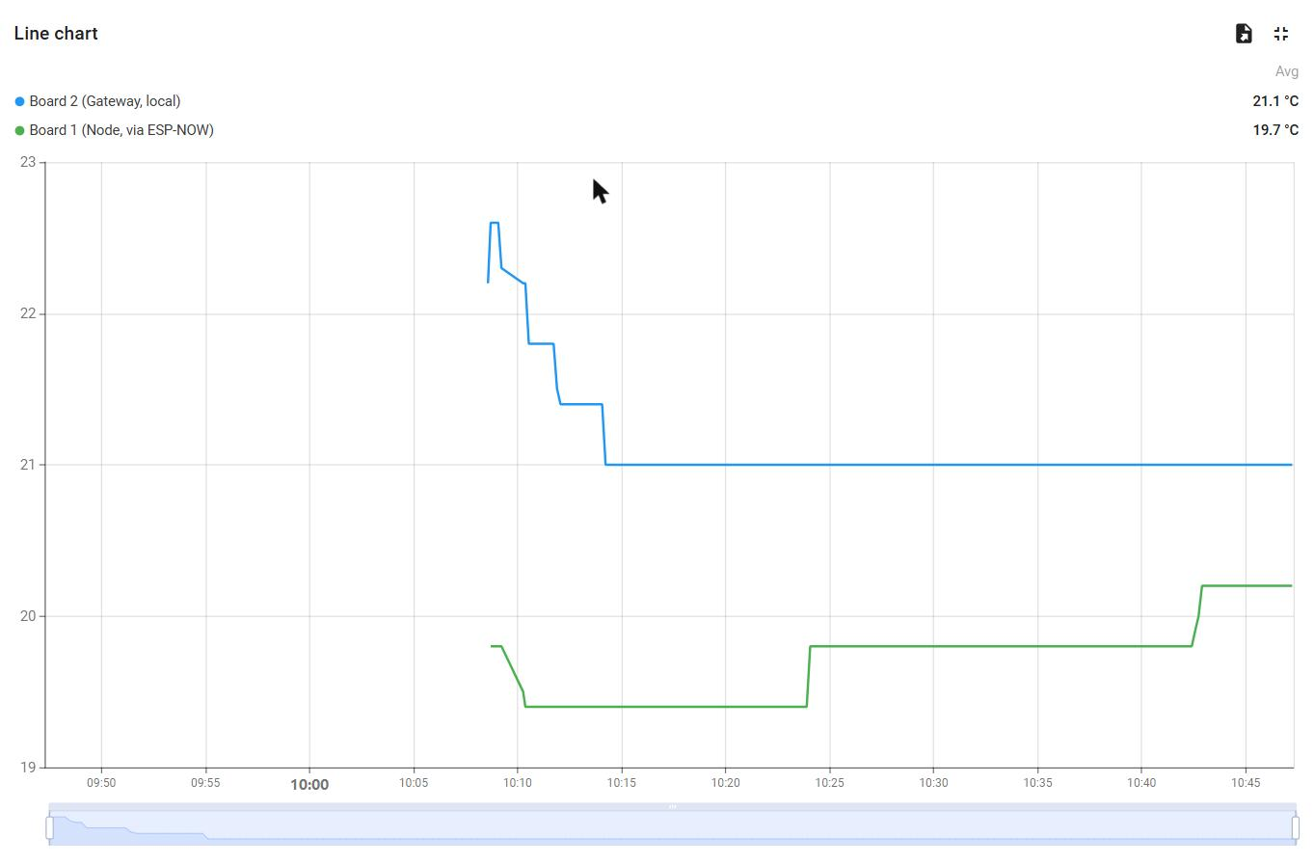
Figure 4 — Both temperature traces on one axis. Blue is the gateway's local sensor; green is the remote node, arriving via ESP-NOW. This is the clearest single visualisation of edge aggregation: two physically separate sensors, one of which has no network connection of its own, presented as a single cloud stream. The stepped appearance is DHT11 quantisation (§9), not a frozen sensor.
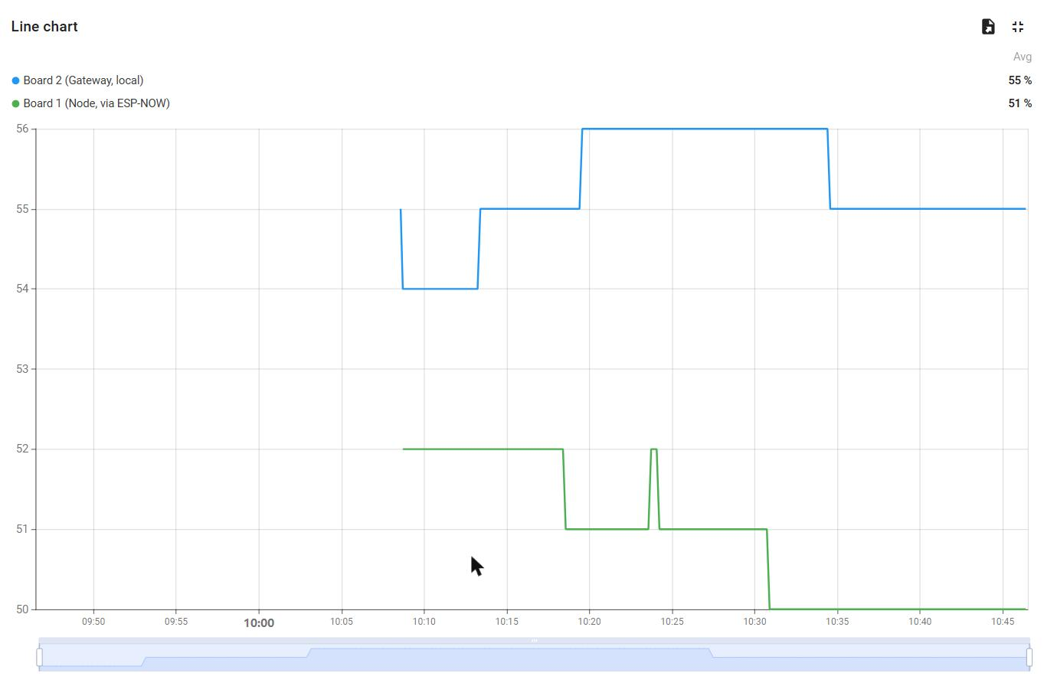
Figure 5 — Both humidity traces. The same two sources, second measurand.
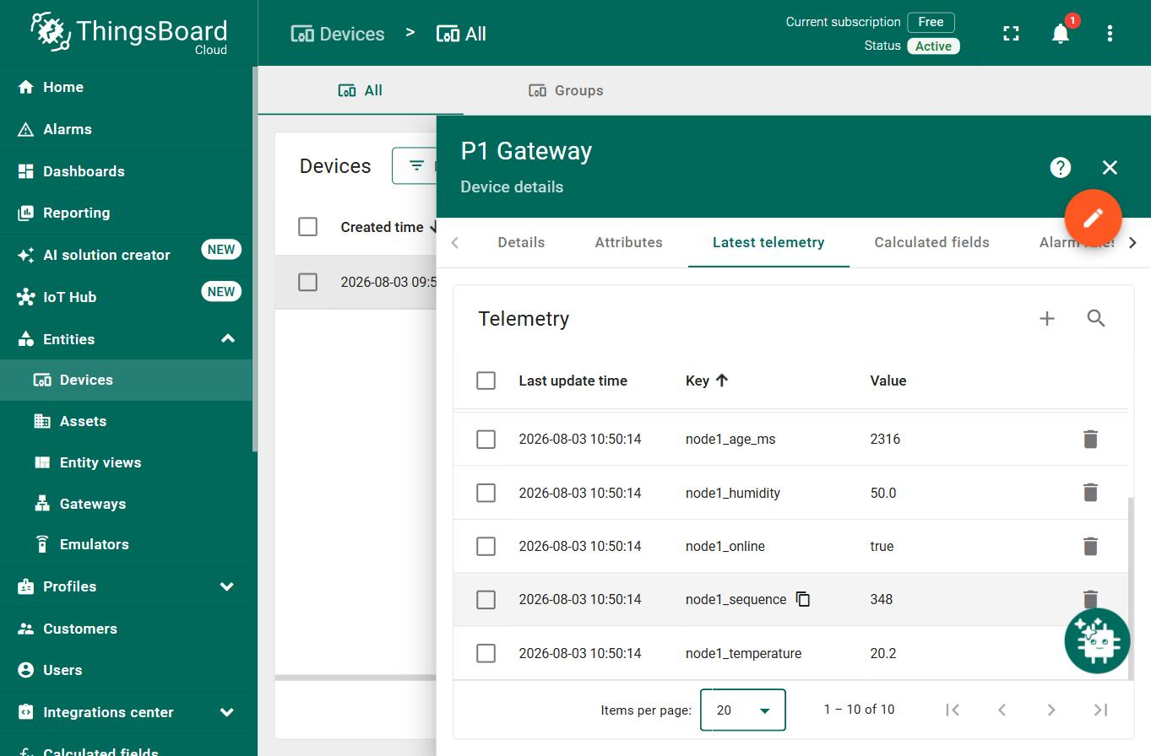
Figure 6 — Latest telemetry, showing all ten published keys with timestamps. Both the gateway_* and node1_* families are present in the same update, confirming that the merge happens at the edge rather than in the cloud.
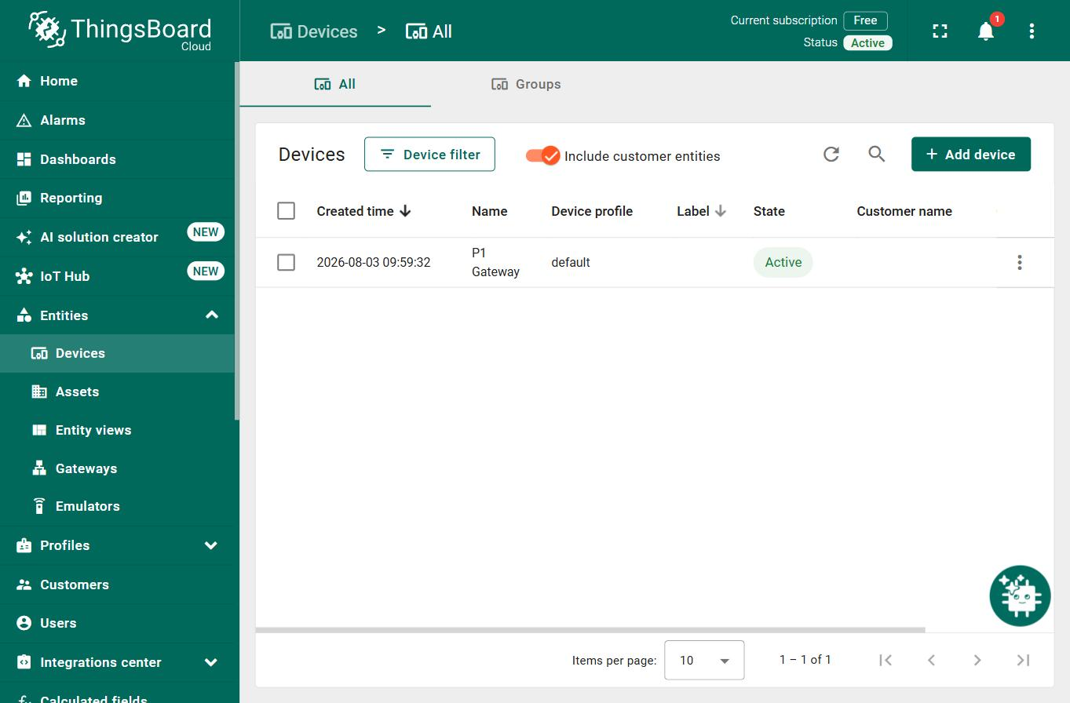
Figure 7 — The device registered as Active. ThingsBoard sets this state only on a live connection, so the badge is independent confirmation of cloud connectivity.

9. Limitations
One hop only. Two radios cannot demonstrate multi-hop forwarding. The ttl and hop_count fields are designed for but unexercised. Any claim of a working mesh would be unsupported by the evidence collected.
Sensor resolution. The DHT11 quantises to roughly 1 °C, which is why the dashboard traces appear as staircases rather than curves. The flat sections are quantisation artefacts, not a frozen sensor. A higher-resolution sensor would produce more convincing charts without changing anything else about the system.
Sensor self-heating. Board 2 consistently read 2–3 °C warmer than Board 1 early in testing. Board 2 runs the enterprise Wi-Fi supplicant and an always-on radio, dissipating a few hundred milliwatts within centimetres of its own sensor. The gap narrowed once both boards reached thermal equilibrium, indicating the effect is a combination of genuine self-heating, thermal lag, and DHT11 part-to-part tolerance (±2 °C rated).
No encryption. ESP-NOW is configured unencrypted, and MQTT uses port 1883 rather than TLS on 8883. The ThingsBoard access token crosses the network in clear text. Acceptable for a classroom prototype; unacceptable for deployment.
No RADIUS certificate validation. The enterprise Wi-Fi configuration does not verify the authentication server's certificate, leaving it vulnerable to a rogue access point advertising the same SSID.
Credentials compiled into firmware. Wi-Fi credentials and the cloud access token are compiled into the binary as plain text and are recoverable from the board over USB. A production design would store them in NVS, provisioned at first boot rather than at compile time.
Manual channel configuration. If the gateway roams to an access point on a different channel, the ESP-NOW link silently stops working while Wi-Fi and MQTT remain healthy. The gateway detects and warns about this, but recovery requires manually editing and re-uploading Board 1's firmware. On the institutional network used for testing, access points were visible on channels 1, 6 and 11, making this a realistic failure mode rather than a theoretical one.
Single remote node. The deduplication state is a single slot rather than an array indexed by src_id. Supporting additional nodes would require that change, though it is a small one.

10. Findings
Three results measured during development rather than assumed.
Outbound MQTT on port 1883 is permitted on the institutional network. This was in doubt, since campus networks commonly block non-web outbound ports. It was resolved by reading the MQTT return code precisely: the observed failure was state=5 (not authorised), which is a reply *from the broker*, whereas state=-2 would indicate the TCP connection never opened. A reply proves the packets completed a round trip through the firewall. The failure was therefore an authentication problem — a placeholder access token — not a connectivity one. Distinguishing these two codes turned an ambiguous failure into a precise diagnosis.
WPA2-Enterprise costs approximately 97 KB of flash. The gateway sketch grew from 69 % to 77 % of the available partition when PEAP was enabled (915 KB → 1012 KB). Enterprise authentication is not free, and on a smaller partition scheme this could be a genuine constraint.
eduroam authenticates by RADIUS realm, not by email domain. Authentication failed with the identity user@student.<institution> and succeeded with user@<institution>. eduroam routes authentication requests to a RADIUS server based on the domain following the @; an address that is valid for email is not necessarily a registered authentication realm. The failure mode is silent — the connection simply times out with no diagnostic distinguishing it from a wrong password.

11. Conclusion
The system meets all eleven acceptance criteria, with captured evidence for each. Two ESP32 boards, sharing no wired connection, deliver two independent sensor readings into a single cloud telemetry stream, with duplicate rejection, liveness detection, and correct recovery from restarts of either board.
The scope claim made in §1 is supported by the evidence and no further: this is a two-node ESP-NOW prototype with a mesh-ready packet design. Multi-hop forwarding is designed for in the packet format but is not demonstrated, and cannot be with two radios.
Further work, in rough order of value:
- A third node, to actually exercise ttl and hop_count and turn the mesh-ready design into a demonstrated one.
- Encrypted ESP-NOW and TLS MQTT on port 8883, closing the two plaintext paths.
- Credentials in NVS, provisioned at first boot rather than compiled in.
- Automatic channel recovery — the gateway could publish its current channel, and nodes could scan for the gateway rather than being hard-coded to one channel.
- A higher-resolution sensor (SHT31, BME280) to remove the quantisation artefacts.

11.1 Reflection
The hardest part was not the code — it was the network authentication.
Connecting the gateway to the institutional eduroam network consumed more time than the ESP-NOW protocol, the deduplication logic and the MQTT integration combined. The reason is that its failure mode carries no diagnostic information. Authentication with the identity user@student.<institution> failed with WiFi.status() == 6 (WL_DISCONNECTED), which is exactly the same status returned by a wrong password, a wrong SSID, or an out-of-range access point. There is no error code distinguishing "this realm does not exist" from "these credentials are wrong."
The resolution was to try the shorter realm user@<institution>, which connected within six seconds. The underlying cause is that eduroam routes authentication requests to a RADIUS server based on the domain following the @, and an address that is valid for *email* is not necessarily a registered *authentication realm*. Most users never encounter this because their device's Wi-Fi profile was configured for them by IT.
Two lessons follow. First, when a system offers no diagnostic, the fastest path is a controlled experiment rather than more analysis — changing one variable and re-testing found the answer in two upload cycles, where reasoning about it could have taken far longer. Second, enterprise network authentication should be tested at the *start* of a project that depends on it, not at the end. It was the last major integration step here and it could easily have blocked everything.
The second-hardest part was understanding a constraint rather than writing code.
An ESP32 has one radio and therefore one channel. Because the gateway must associate with an access point to reach the cloud, the access point *dictates* the gateway's channel — it is a value discovered at runtime, not chosen at design time. The sensor node must then be pinned to that same channel by hand.
This single fact determines the entire structure of the project: it is why the gateway must be flashed and run before the node can even be configured, why the node deliberately never joins the access point, and why the node reads its channel back after setting it. None of that is obvious from the ESP-NOW documentation, which presents channel as a simple configuration parameter. Recognising that it is a *discovered* value was the conceptual turning point in the design.
A trap avoided rather than a difficulty overcome.
Arduino-ESP32 3.3.x is built on ESP-IDF 5.5, which changed both ESP-NOW callback signatures. The widely published form taking a bare const uint8_t *mac does not compile against this core. Rather than copying a tutorial, the installed esp_now.h was read directly before any callback was written, and both sketches compiled without error on the first attempt as a result. Had this been discovered by trial and error instead, it would have presented as an obscure incompatible-pointer error with no obvious connection to the core version. Checking the installed headers cost a few minutes and saved an unknown but probably large amount of debugging.
What we would do differently.
- Test the network path first. Wi-Fi association and an MQTT round trip should have been proved before any ESP-NOW code was written. Both turned out to be the risky parts — ESP-NOW itself worked on the first attempt.
- Pin the gateway to a specific access point by BSSID. The institutional network has access points on channels 1, 6 and 11. If the gateway roams to a different channel, the ESP-NOW link silently dies while Wi-Fi and MQTT continue to look healthy — the worst kind of failure. The enterprise WiFi.begin() overload accepts a BSSID argument for exactly this purpose.
- Build the evidence-capture tooling earlier. A serial monitor that attaches *without* resetting the board proved essential for observing accumulated state such as stale detection and packet counters. Standard serial monitors reset the board on connect, which destroys precisely the state being measured. This was written partway through testing and should have existed from the start.
- Provision credentials at runtime rather than at compile time. Compiling institutional Wi-Fi credentials into the firmware means the board physically carries them and they are recoverable over USB. Storing them in NVS, entered once at first boot, would remove that exposure entirely.
What we learned.
The most transferable lesson is that in embedded networking, the difficult failures are the *silent* ones. Three separate issues in this project would have produced no error message at all: a mismatched ESP-NOW channel (sends report success, nothing arrives), Wi-Fi power save parking the radio (intermittent loss resembling poor range), and an undersized MQTT buffer (publish() returns false and nothing is transmitted). None would have thrown an exception or logged a warning by default.
The defence against all three is the same, and it is the habit this project most reinforced: verify state rather than assume it. Read the channel back after setting it. Print the discovered channel rather than trusting the configured one. Check the return value of publish(). Count invalid packets explicitly rather than assuming zero. Every diagnostic line in the final firmware exists because it converts a silent failure into a visible one — and during testing, several of them did precisely that.
[Both members] Adjust the emphasis above to match your own experience, and add a sentence each on what you personally took from the project.

Appendices
- A — Wiring tables (§2.2) and full pin assignments
- B — Serial capture logs: evidence/01_ through evidence/06_
- C — Source code: five Arduino sketches, secrets.example.h, build.ps1
- D — ThingsBoard device setup and dashboard telemetry key reference (README.md §10)

Telemetry key reference
Key | Type | Meaning
gateway_temperature | number | Board 2 local DHT11, °C
gateway_humidity | number | Board 2 local DHT11, % RH
gateway_sensor_ok | boolean | Last local read succeeded
node1_temperature | number | Board 1 DHT11, °C, via ESP-NOW
node1_humidity | number | Board 1 DHT11, % RH, via ESP-NOW
node1_sequence | number | Sequence number of the last accepted packet
node1_age_ms | number | Milliseconds since the last valid packet
node1_online | boolean | False once node1_age_ms exceeds 20000
duplicate_count | number | Packets rejected as duplicates since boot
espnow_received_count | number | Packets passing validation since boot

