## Scope of work

**Project name: R2 Digital MarketPlace**

**Version: 1.0 (Phase 1)**

Over View:

This is going to be a multivendor platform where vendors will be adding their dive related services to be booked. Services will be offered only on selected locations(Sites) and users will be able to book it using this platform.

Basic Details:

1. The website which we will build will be fully responsive and completely dynamic.
2. We will create PSD for every frontend pages and get those approved first before creating HTML for it.

As a reference for the design please follow [www.getyourguide.com](http://www.getyourguide.com)

1. After PSD approval, any design changes will be considered as a change request and will be charged accordingly.
2. We will be using stripe payment gateway

Software Specifications:

* HTML, Css, jQuery, MySQL, PHP, CI

Team Specifications:

* 1 Project Manager/Team Lead , 1 Developer, 1 Designer, 1 Tester/QA = 4 Members

Backend:

1. Admin Panel:
   1. We will create a login screen from where admin will be able to login and will have access to all the website data. (Done)
   2. Admin will be creation dive centers and pin it on the map. (Done)
   3. Admin will have option to manage every single module like vendor, users, listings, pages etc.(Done)
   4. Admin will be able to modify most of the information available on the frontend depending on the feasibility. (Done)
   5. Admin will be able to create, edit, delete/disable all the four user types. (Vendor, Normal user and Sub-admins (Done)
   6. Admin will also have his own profile from where he will be able to change their profile details. (Done)
   7. Admin will be able to view all the booking information (Not Done)
   8. Admin will define listing’s categories under which vendor will add the listings(Done)
   9. Admin will be able to view all the payment history and payment status (In Process)
2. Sub-Admin Panel
   1. Sub Admin will have their own profile and dashboard (Done)
   2. Subadmin’s capabilities will depend on admin. It means admin will be able to assign the capabilities to sub- admin. (Done)
   3. Sub admin will have only access to those modules which admin will provide for them. (Done)
3. Vendor registration and vendor Panel.
   1. Vendor will be able to register themselves using a registration form. (Done)
   2. Registration form will have some basic fields (8-10 fields). (Done)
   3. There will be only one plan which will be an annual plan and it will be mandatory (Not Clear)
   4. Once registered, admin will get notified. (Done)
   5. Admin/Sub-admin will have to verify the account from admin panel before vendor can login. (Done)
   6. On verification, vendor will receive an email that his account is verified and will also get a login link. (Done)
   7. Now vendor will be able to login through that link (Done)
   8. Vendor will have to fill all the details like bank accounts and other personal details before they can add any listings. (Done)
   9. Vendors will get access to add listings with all the related information (location, name, price, date, description, categories etc) once their profile is complete. (Done)
   10. Vendors will be assign their listing to any of the available dive sites. (Done)
   11. Vendors will have to provide booking date and slots. (Not Done)
   12. Vendors will also be able to add offer (discount percentage) for the listings (Not Done)
   13. Once listing detail is added and published, same listing will show up in the frontend. (Done)
   14. Vendors will also be able to see the booking information which any user has booked for the respective listings. (Not Done)
   15. Vendors will be able to cancel the booking anytime. (Not Done)
   16. Vendors will also be able to send emails to the users directly from the dashboard. (Not Done)
   17. Vendors will get notified in case of every new bookings or cancellation of bookings. (Not Done)
   18. Vendor will have a calendar view where vendors will be able to view all the bookings date wise with current status. (Not Done)
   19. Vendors will also be able to upload gallery for their profile page(frontend) (Done)
4. User registration and User panel:
   1. Users will be able to sign-up from register link(Done)
   2. User will fill some basic information while registration(Done)
   3. There will be 3 registration plans (Done)
   * 1. OPEN / Free for all (no registration needed)
   * 2. BASIC / Registration required / Free of charge / Limited Benefits (access to specific content - newsletter)
   * 3. PREMIUM / Registration required plus Annual auto renewal fee / Full member Benefits ( access to specific content - newsletter, discounts, offers, Freebies / samples )
   * * All types should have different badges/colors
   1. Not admin verification is needed for their profile (Done)
   2. User will get notification/welcome email after successful registration(Done)
   3. User will be able to login using the same credentials which was used for registration(Done)
   4. Once logged in, user will get their account page. (Done)
   5. In account page user will have below capabilities: (Done)
      1. Profile view and edit features(Done)
      2. Booking information and history (Not Done)
      3. Option to contact vendors using message(not live) and emails of which user has booked the service/listings (Not Done)
      4. Ability to cancel any bookings(Not Done)
      5. Calendar view for upcoming/ past bookings. (Not Done)
      6. Wishlisted products (Done)

Front End:

1. We will create a home page which will have 5-6 sections (Done)
   1. Header Menus
   2. Banners/Sliders
   3. Some categories of listings
   4. Some website information
   5. Testimonials
   6. Photo Gallery (Admin manageable)
   7. Footer Menu
2. We will have category page with some filters like (Done)
   1. Price Filter
   2. Location Filter
   3. Availability filter
3. Wil will have a all Listing page with some filters like (Done)
   1. Price Filter
   2. Category Filter
   3. Location Filter
   4. Availability filter
4. We will have a Testimonial Page where all the testimonials will be listed (Done)
5. We will have vendor specific profile page with below details: (Done)
   1. Vendor name
   2. Vendor location and contact details
   3. Vendor profile banner
   4. Vendor Description
   5. Image gallery
   6. Respective listings
6. We will have 4-5 static pages like About us, privacy policy, term and conditions etc. (Done)
7. There will be a listing detail page where all the information regarding the listings will be visible. (Done)
8. Users will be able to select the date and see the availability. (Not Done)
9. If available, user will click on book and will be redirected to checkout page (Done)
10. User will fill card related information and book the listing. (Not Done)
11. User will receive the email and same booking information will be accessible to their profile. (Not Done)

Assumptions:

* We are assuming that amount will be transferred to admin account at the time of booking and will be splited to other account after service is utilized.
* Vendor panel will be similar like admin panel.
* All content, high-res images / films and logo files will be provided by the client.
* Any link going to third party website we will just add that link and it will redirect to third party.
* The design layout for inner-pages will be in line with the home page and will follow the standard format for all the internal pages.
* Content pouring of 5- 10pages is included inside the scope of work. More than 10 will required extra efforts
* All the plugins/API's will be provided by client.
* Data importing is not included inside the scope. Like (Vendors, products, Clients etc)
* The content provided should be according to the layout of the pages designed.
* Anything which is out of the scope will be treated as extra and for that extra efforts are required.
* Client will provide the domain + hosting.

**Modified/Added Points:-**

**Vendor Feature: -**

* Vendors will be able to add products as per below flow chart

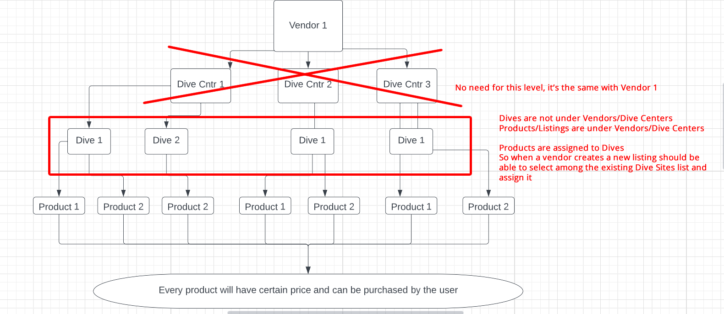

**Map :-** (Done)

We need to have a global map (google map) with some advanced filters. In that map we'll place 3 different things:

1. Dives with a small text and a colour pin

2. Dive Centres with a small text and a different colour pin

We need some filters so users can search by location/name/country/city

Map will be created by you with a couple of points from each category and after that we'll fill in the remaining points.

**Blog:-** (Done)

We need to integrate a normal Blog feature which will be manageable from admin panel. Blog will have below mentioned pages

1. Blog Listing page
2. Blog category pages
3. Blog detail page

**Featured Product:**

We will have add a feature in admin panel through which admin will be able to mark any product as “Featured” and these product will be visible in the frontend in a separate section.

**Rental Product Feature:**

* + Under this feature, admin will be able to add a few rental products like torch, camera etc.
  + Vendors will be able to see these lists while creating there dive and will be able to connect them as per their need.
  + Vendors will be able to provide rental price for the added products
  + Users will be able to see and book these products along with their actual dive booking.
  + These are optional products for the users and they may or may not select them.