**TRAFFIC FINE Management SYSTEM**

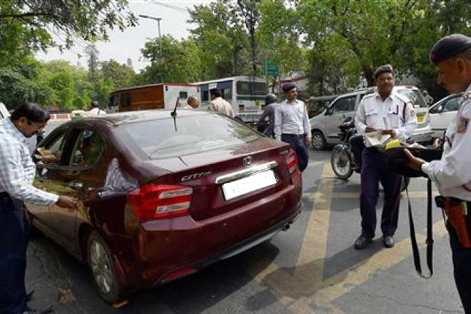

**BACK OFFICE SOLUTION FOR TRAFFIC FINES Proposal**

|  |  |  |  |  |  |
| --- | --- | --- | --- | --- | --- |
| **S. No.** | **Description** | **Qty** | **Unit Price** | **GST**  **%** | **Amount** |
|  | Android-POS-Terminal.png  **Terminal with 6" TFT LCD 540*960 pixel**  **Operation System:** Android 4.4  **Security CPU Rockchip :** 1.3GHz Quad Core Processors  **Memory** : 8GB  **Operation Memory :** 1GB DDR3  **Memory Ext Support** : MICRO SD, Supports up to 32G  **Connectivity :** Bluetooth, WIFI, supports 2G/3G/4G  **Magnetic Card Reader :** GSM900/DCS1800 frequency  **Camera :** 3MP auto zoom camera  **Scanner :** supports 1D 2D scanning  **Printer :**Thermal printer 57mm/40mm (width/Diameter)  **Ports :** Mini USB 5 pin, Micro USB OTG  **Power Supply :** AC Input 9V, 2A  **SIM card :** 1 slot 3V/1.8V  **PSAM card :** 1 slot 128-bit asymmetric encryption | 1 | 19500 | 18%  3510 | 23,010 |

|  |  |  |  |  |  |
| --- | --- | --- | --- | --- | --- |
| 2 | **Back Office Fine Management Web Application with Mobile Application - (Android App only)**  **INPUT Methods**   * Vehicle Number Entry Manually Data Collects form Central Server – All Activities stored in Cloud Server, SMS / Email Alert System. * Remarks entry form. * License Plate Recognition System (LPR) (optional) equipment (optional)   **PROCESSING AND WORKFLOW**   * Central Archiving of All Documentation * Paperless Environment * Unlimited Logins * User wise Reports * Location wise Reports * Instant & quick entry form and user-friendly UI. * Automated Handling of Correspondence. * Vehicles Data   **OUTPUT MANAGEMENT**  Instant Receipt print from Handheld device.  Public Access to Offence Details via Secure Web site with receipt printing option.  **TECHNICAL Support**  Technical helpline during office hours - online support.  Call Center Support (Optional) | 1 | 2,55,000 |  | 2,55,000 |
| 3 | Cloud Server – Web Services – VPN SSD  SSL Certificate  High Bandwidth – 1000 GB per month  Backup Server Management |  | 680 USD  Per Month |  | 5,30,400  Per Annum |
| 4 | Cloud Server Mobile App Server  Amazon / Google Aws / IBM  Google Play Store Account |  |  |  | 25000 |
|  | Grand Total : |  |  |  | 8,33,410 |

**Terms and conditions**

➢ 6 Months Support.

➢ 50% Advance with PO. At the time First Level Demo 25%, after deployment and delivery 25%.

➢ GST 18% on Cameras and Hardware Equipment.

➢ Hardware 1 Yr Manufacturer warranty.

➢  Project Duration 6o Days First Level after 20 Days.

➢ Any Reports Customization within 24 to 40 hrs we will update.

➢ This quotation is valid for 30 days from the date of submission.