**HW-13**

**Source Code –**

"""

This is creating a GUI having different coins and a button for calculating the

total value.It also validates the user input for the correct values.

"""

from tkinter import *

import tkinter.messagebox

r = Tk()

r.title("Change Counter")

lbl = Label(r, text="Enter the number of each coin type and hit,Compute:").grid(row=0,column=1)

dollars = Label(r ,text = "Dollars:").grid(row = 1,column = 1)

dollars1 = Entry(r)

dollars1.grid(row = 1,column = 2)

dollarscon = Label(r ,text = "Dollar Value:$").grid(row = 1,column = 4)

dollarscon1 = Label(r,text="0.00",width=5)

dollarscon1.grid(row = 1 , column = 5)

halfdollars = Label(r ,text = "Half Dollar:").grid(row = 2,column = 1)

halfdollars1 = Entry(r)

halfdollars1.grid(row = 2,column = 2)

halfdollarscon = Label(r ,text = "Half Dollar Value:$").grid(row = 2,column = 4)

halfdollarscon1 = Label(r,text="0.00",width=5)

halfdollarscon1.grid(row = 2 , column = 5)

quarters = Label(r ,text = "Quarters:").grid(row = 3,column = 1)

quarters1 = Entry(r)

quarters1.grid(row = 3,column = 2)

quarterscon = Label(r ,text = "Quarter Value:$").grid(row = 3,column = 4)

quarterscon1 = Label(r,text="0.00",width=5)

quarterscon1.grid(row = 3 , column = 5)

dimes = Label(r ,text = "Dimes:").grid(row = 4,column = 1)

dimes1 = Entry(r)

dimes1.grid(row = 4,column = 2)

dimescon = Label(r ,text = "Dime Value:$").grid(row = 4,column = 4)

dimescon1 = Label(r,text="0.00",width=5)

dimescon1.grid(row = 4,column = 5)

nickels = Label(r ,text = "Nickels:").grid(row = 5,column = 1)

nickels1 = Entry(r)

nickels1.grid(row = 5,column = 2)

nickelscon = Label(r ,text = "Nickel Value:$").grid(row = 5,column = 4)

nickelscon1 = Label(r,text="0.00",width=5)

nickelscon1.grid(row = 5,column = 5)

pennies = Label(r ,text = "Pennies:").grid(row = 6,column = 1)

pennies1 = Entry(r)

pennies1.grid(row = 6,column = 2)

penniescon = Label(r ,text = "Penny Value:$").grid(row = 6,column = 4)

penniescon1 = Label(r,text="0.00",width=5)

penniescon1.grid(row = 6,column = 5)

totalchangevalue = Label(r ,text = "Total Change Value:$").grid(row = 7,column = 4)

totalchangevalue1 = Label(r,text="0.00",width=5)

totalchangevalue1.grid(row = 7,column = 5)

def computeTotal():

dollar = (dollars1.get())

halfdollar = (halfdollars1.get())

quarter = (quarters1.get())

dime = (dimes1.get())

nickel = (nickels1.get())

pennies = (pennies1.get())

total=0.00

if((dollar.isdigit() or halfdollar.isdigit() or quarter.isdigit() or dime.isdigit() or nickel.isdigit() or pennies.isdigit()) and

(dollar != "" and halfdollar!="" and quarter!="" and dime!="" and nickel!="" and pennies!="")):

if(float(dollar)>0.0):

total = total+(float(dollar))

a = float(dollar)

dollarscon1.configure(text= round(a,2))

if(float(halfdollar)>0.0):

total = total+(float(halfdollar)*0.50)

b = float(halfdollar)*0.50

halfdollarscon1.configure(text= round(b,2))

if(float(quarter)>0.0):

total = total+(float(quarter)*0.25)

c = float(quarter)*0.25

quarterscon1.configure(text= round(c,2))

if(float(dime)>0.0):

total = total+(float(dime)*0.10)

d = float(dime)*0.10

dimescon1.configure(text= round(d,2))

if(float(nickel)>0.0):

total = total+(float(nickel)*0.05)

e = float(nickel)*0.05

nickelscon1.configure(text= round(e,2))

if(float(pennies)>0.0):

total = total+(float(pennies)*0.01)

f = float(pennies)*0.01

penniescon1.configure(text= round(f,2))

totalchangevalue1.configure(text=round(total,2))

return True

else:

tkinter.messagebox.showwarning("Wrong Data","Invalid Data,Numbers are only allowed and Enter all the values")

dollars1.delete(0,END)

halfdollars1.delete(0,END)

quarters1.delete(0,END)

dimes1.delete(0,END)

nickels1.delete(0,END)

pennies1.delete(0,END)

return False

btn = Button(r, text="Compute", command=computeTotal).grid(row=8,column=2)

r.mainloop()

Output –

1. If all the fields are blank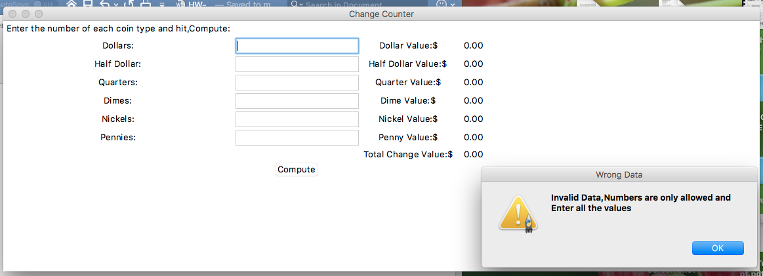
2. If any of the fields are blank

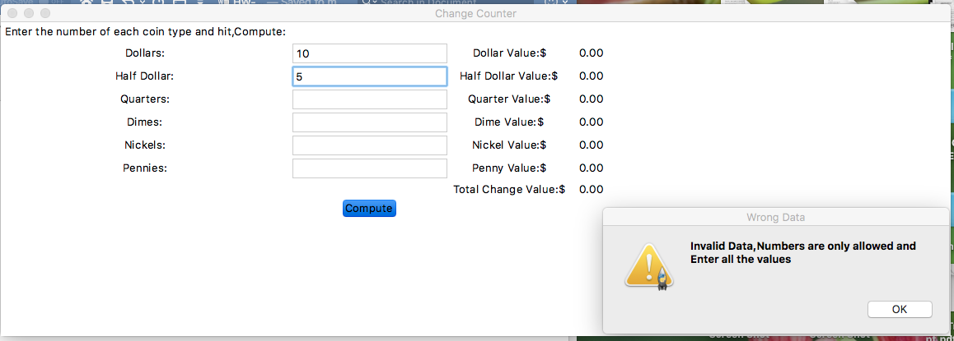

1. If the input is not numeric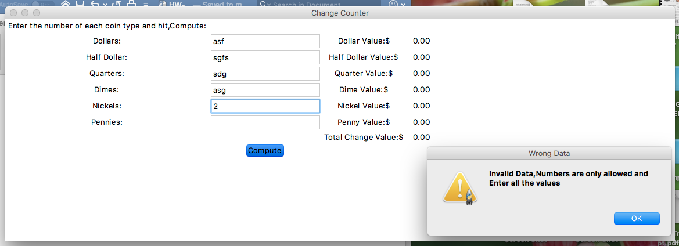
2. Correct Values

