**Question 1:**

**Source Code:**

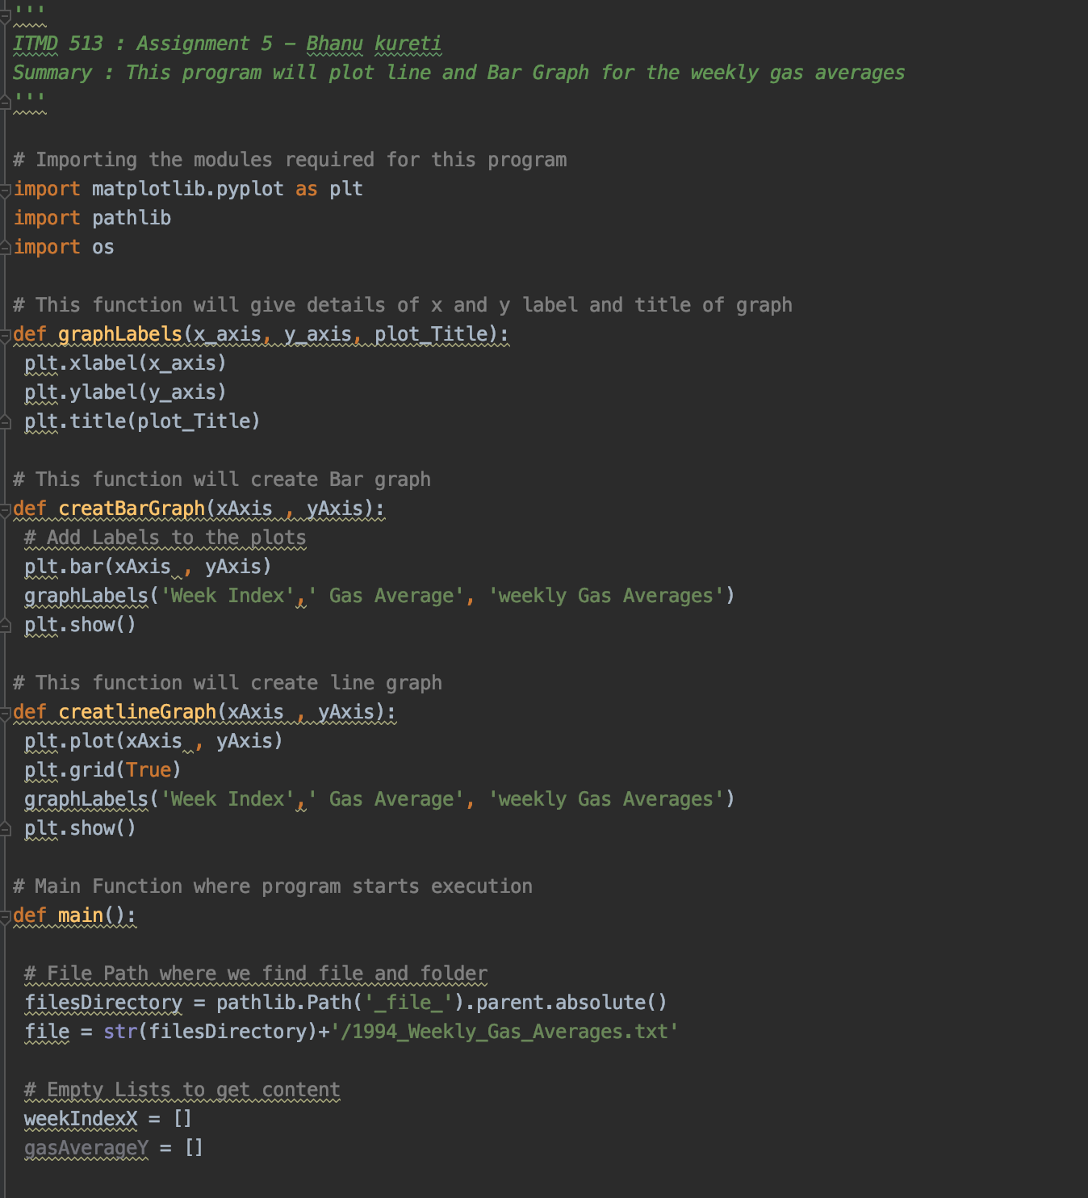

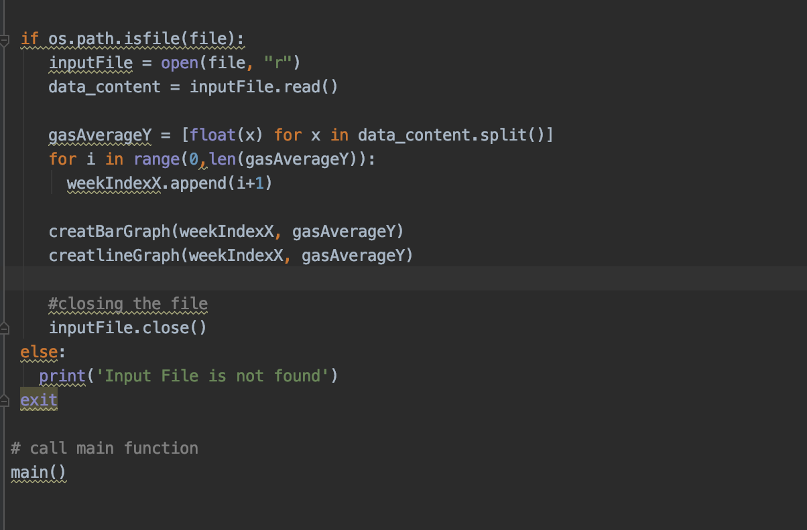

Graph Plot **Outputs:**

Bar graph: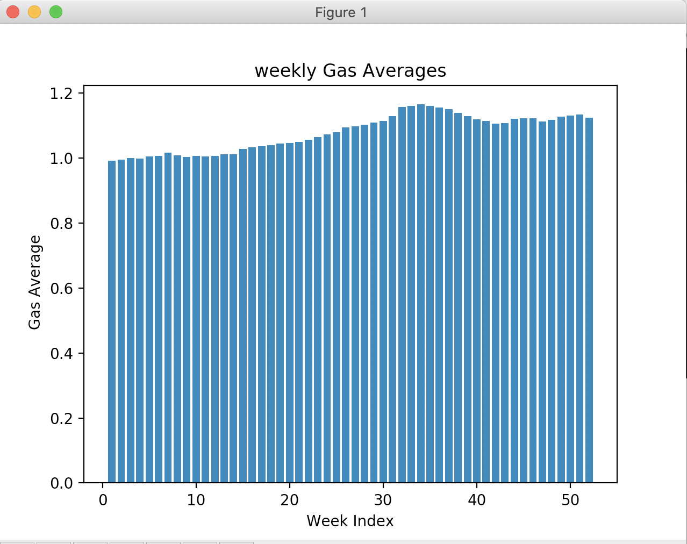

**Line Graph:**

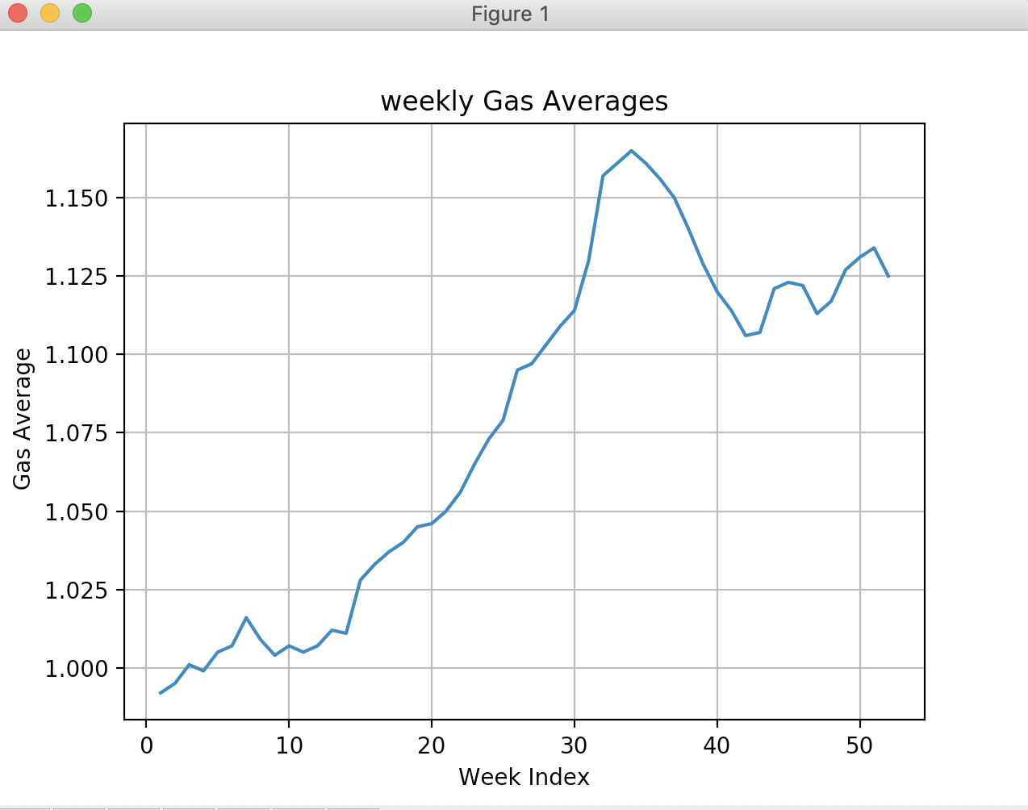

**Question 2:**

**Source code:**

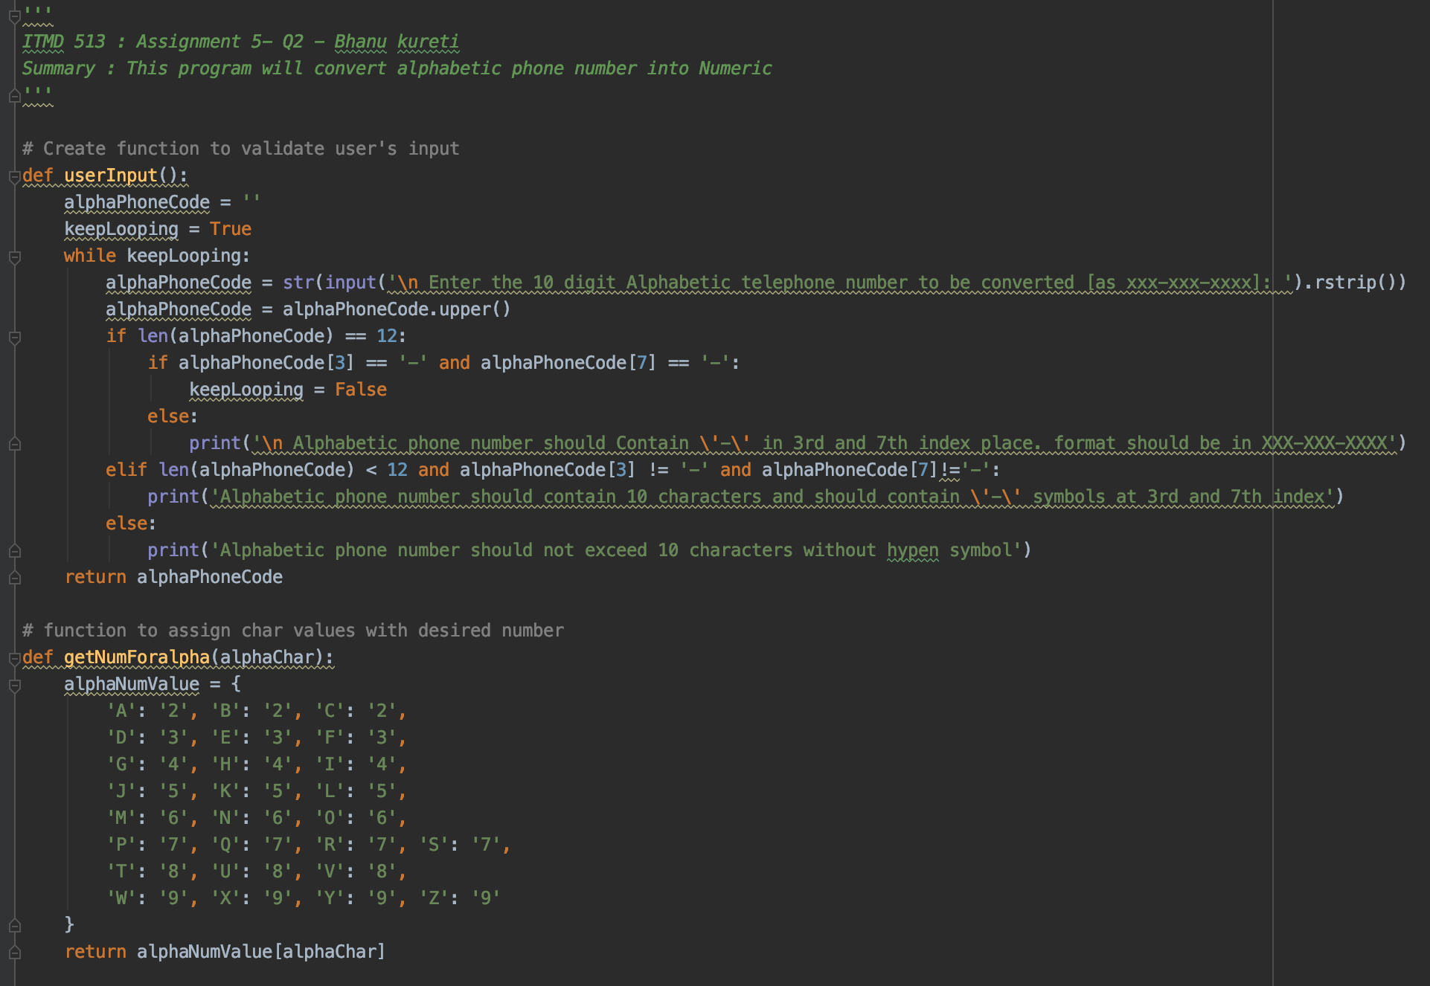

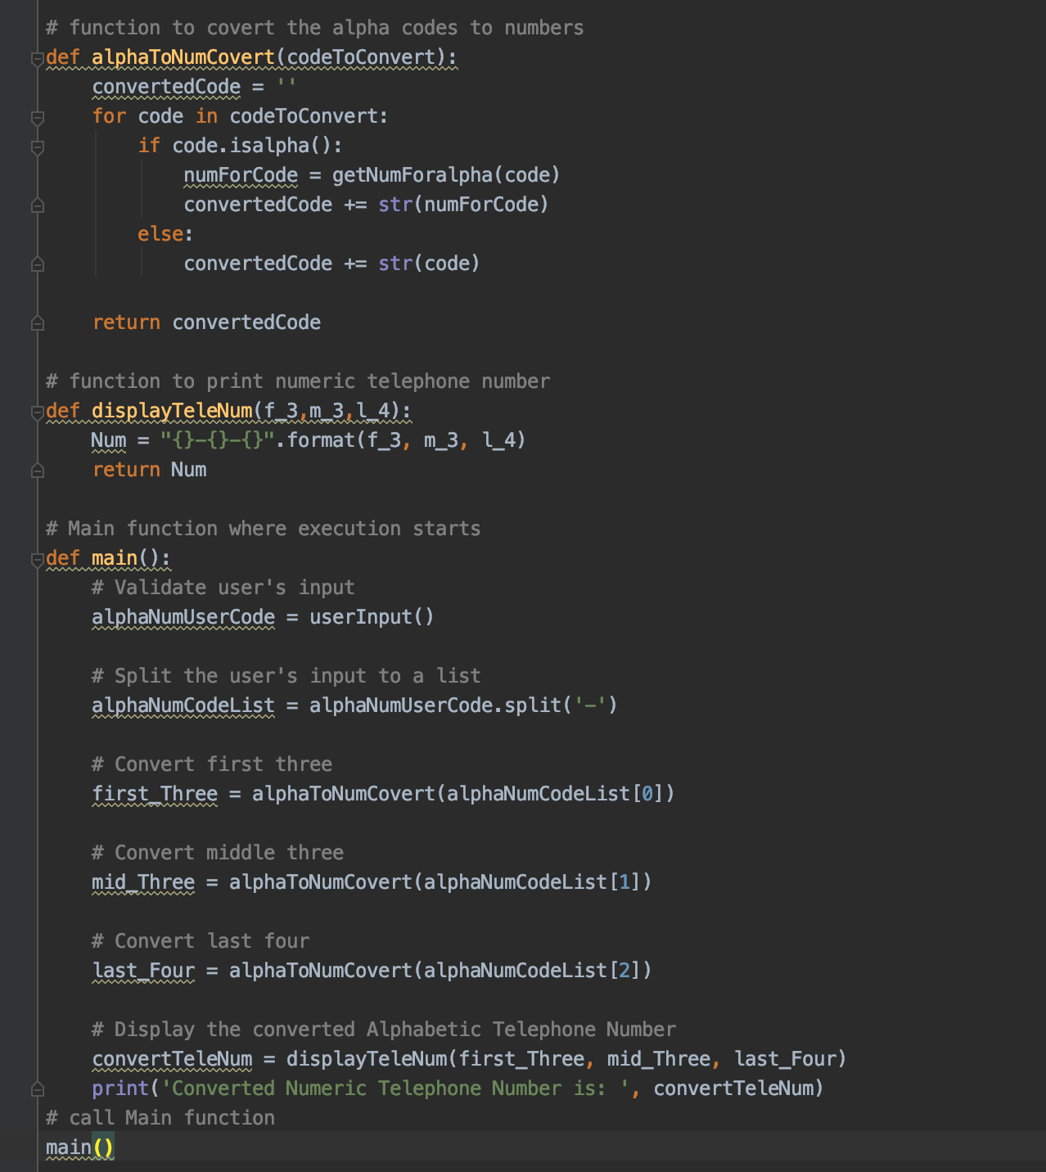

**OUTPUTS:**

1. If user enter more than 10 characters:

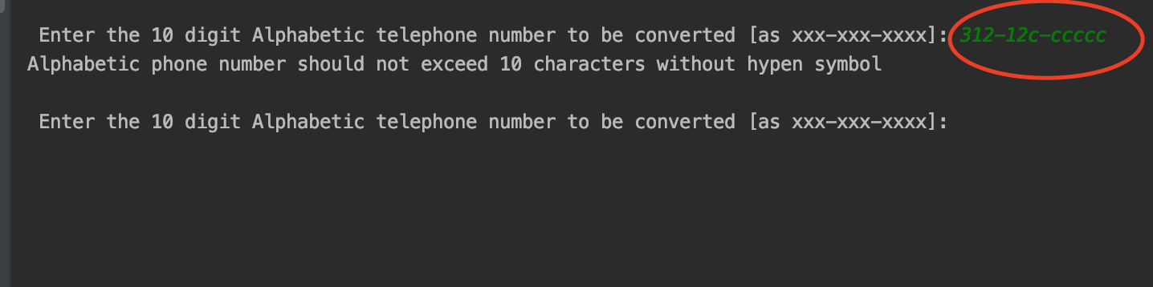

1. If user misses hipen(-) symbols at 3 and 7 position:

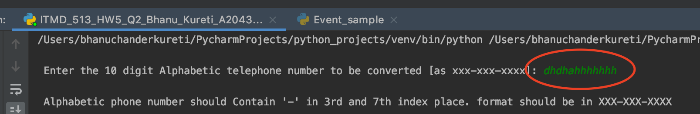

1. If user enter wrong syntax:

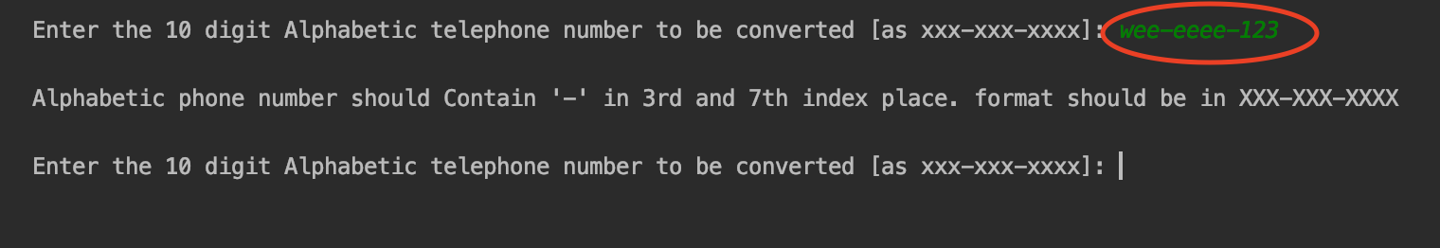

1. If User enters correct syntax with 10 characters:

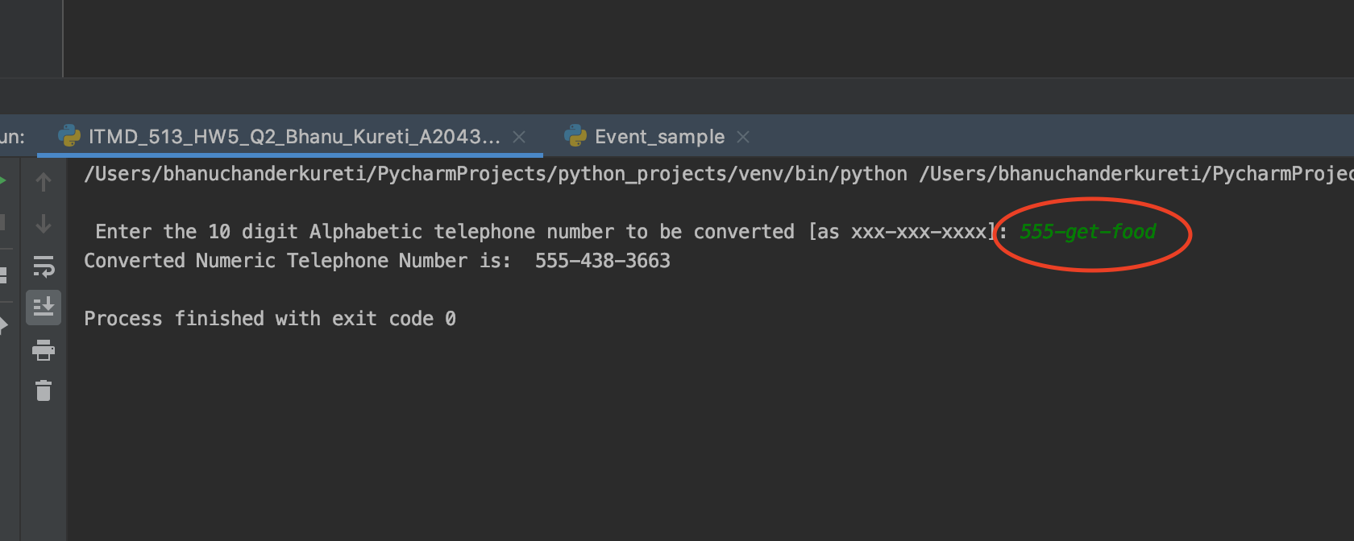

5) if User enter all alphabets with correct syntax

