Name : BHANU KURETI

ID : A20432559

Title: HW_7_Seaborn_data_visualizations

Source_code:

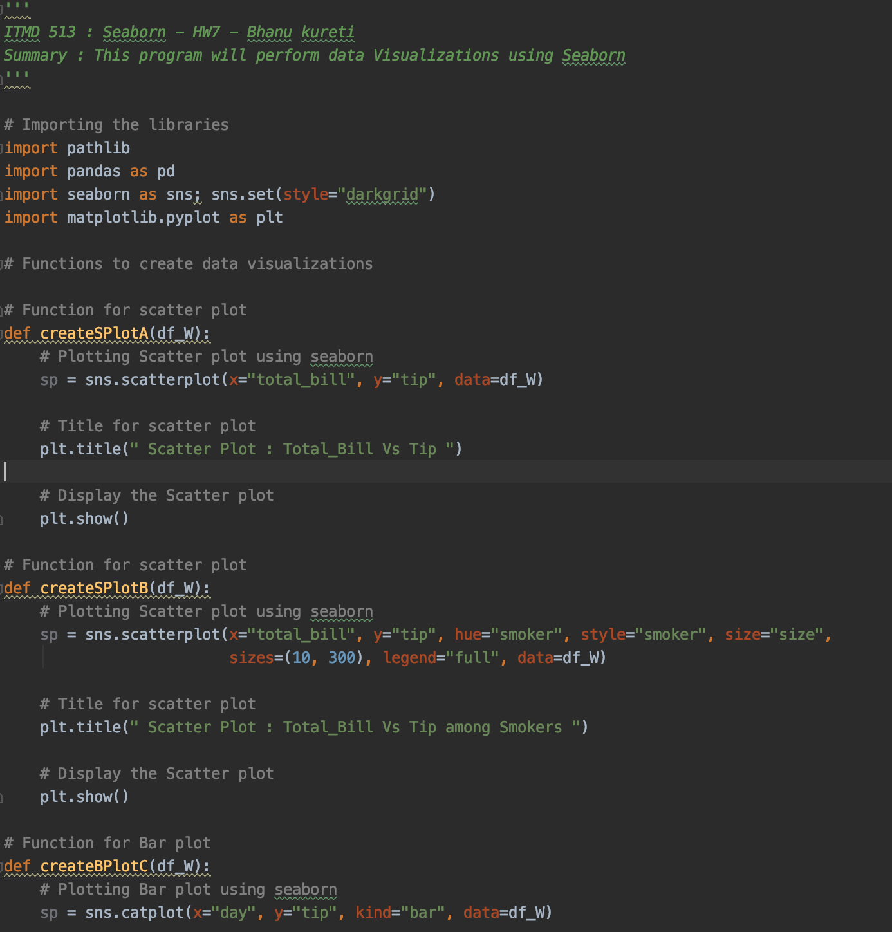

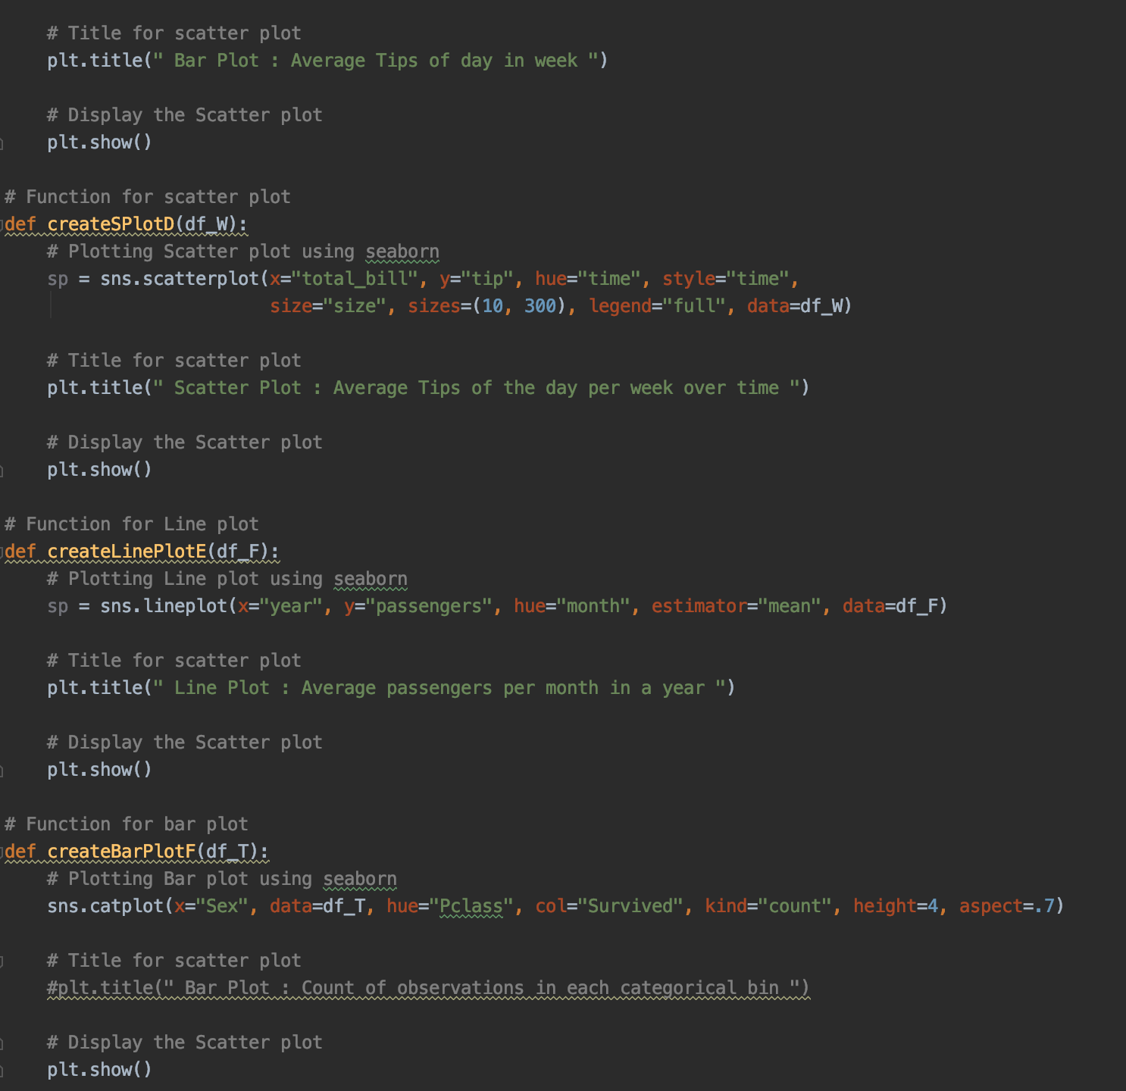

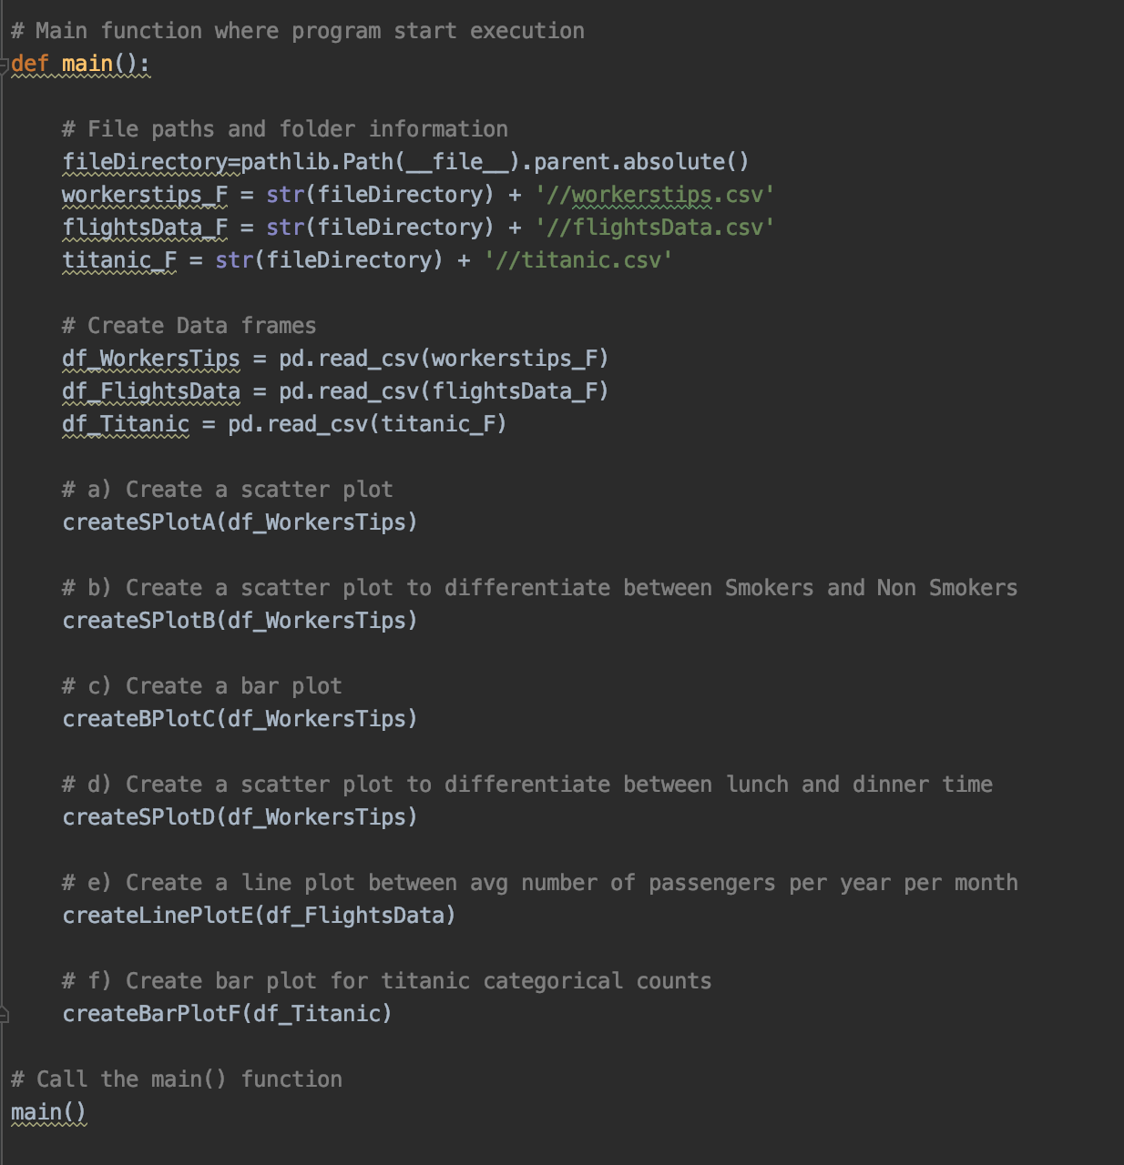

Outputs:

1. Scatter plot between the Total_bill and Tips

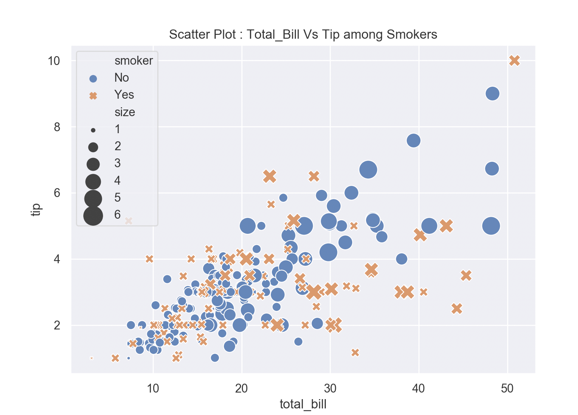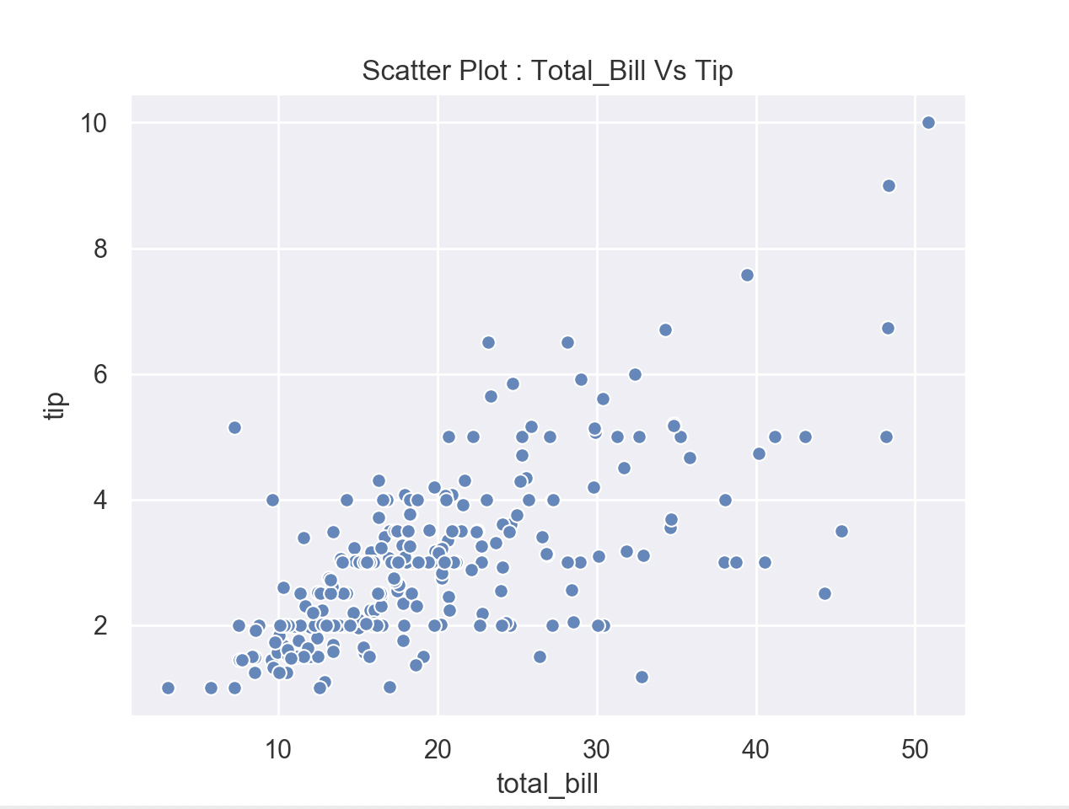

B) Scatter plot with differentiation with smoker and non-smoker

C) Bar plot which shows average tips per day of a week.

**As per the Bar plot Sunday has the Highest average Tips in a week.**

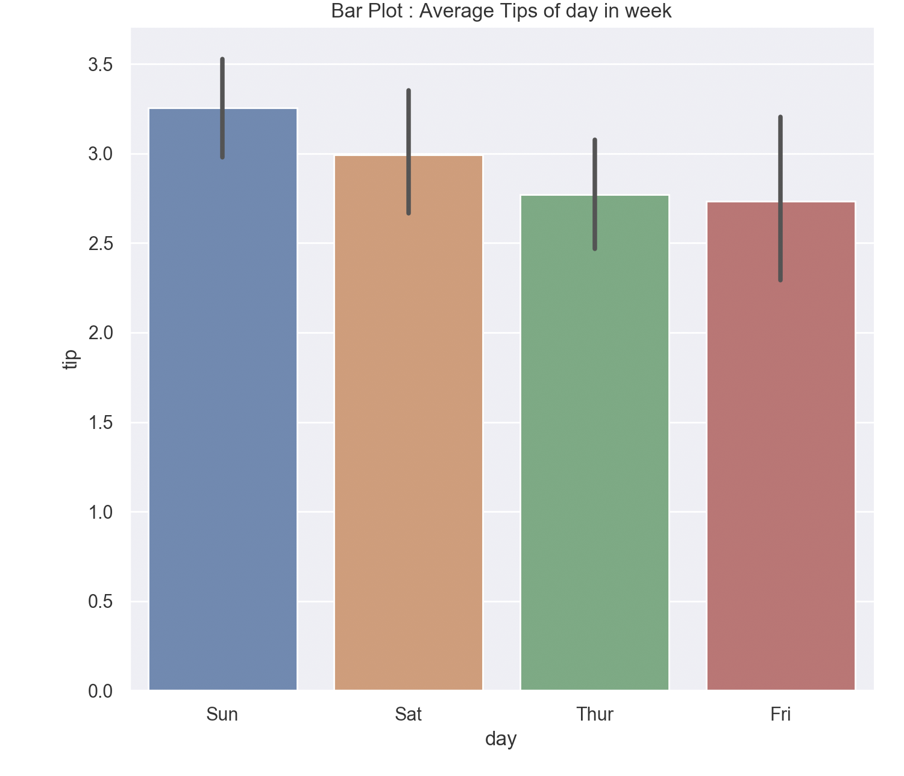

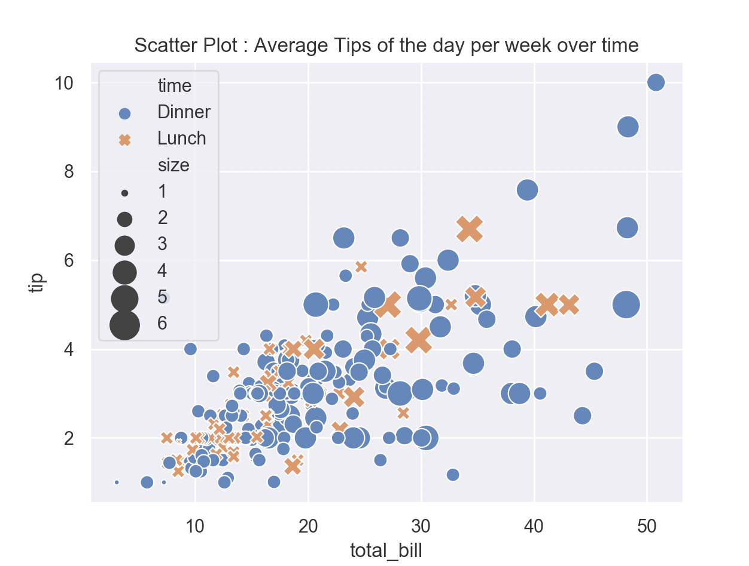D) scatter plot with time distribution i.e lunch and dinner

E) Line plot for Average number of passengers per year per month

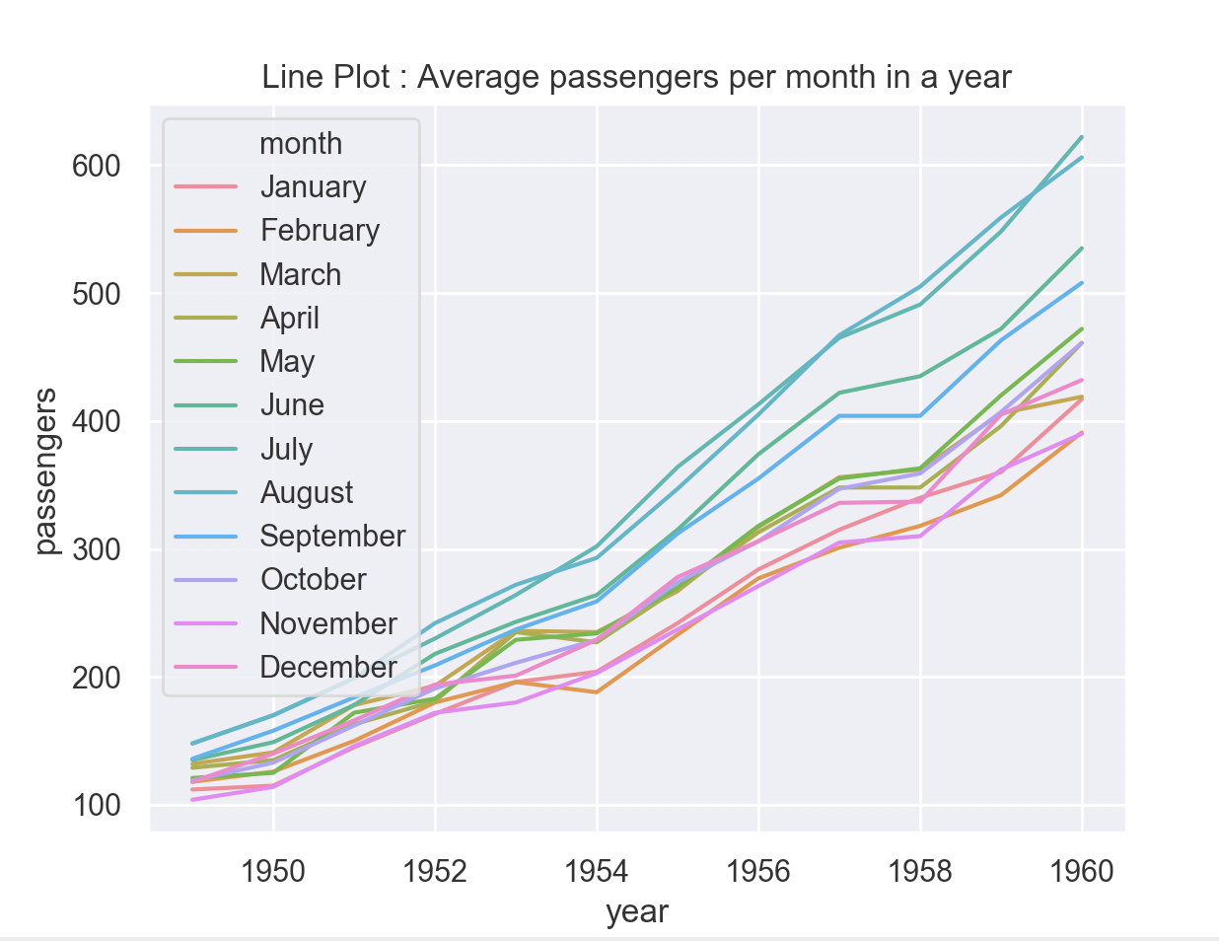

F) Bar plot which shows the observations in each categorical bin

