**Spring 2024: CS5720 Neural Networks & Deep Learning - ICP-2**

**Bhanu Chandrika Lakkimsetti (700747439)**

GitHub Link: <https://github.com/bhanuchandrika99/NNDL_ICP_2>

1. Write a program that takes two strings from the user: first_name, last_name. Pass these variables to fullname function that should return the (full name).

For example:

First_name = “your first name”, last_name = “your last name”

Full_name = “your full name”

Write function named “string_alternative” that returns every other char in the full_name string. Str = “Good evening”

Output: Go vnn

**Solution:**

1. Write a python program to find the wordcount in a file (input.txt) for each line and then print the output. Finally store the output in output.txt file.

Example:

Input: a file includes two lines:

Python Course

Deep Learning Course

Output:

Python Course

Deep Learning Course

Word_Count:

Python: 1

Course: 2

Deep: 1

Learning: 1

**Solution:**

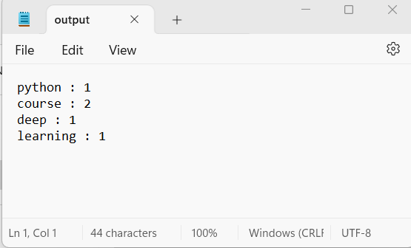

3. Write a program, which reads heights (inches.) of customers into a list and convert these heights to centimeters in a separate list using:

1) Nested Interactive loop.

2) List comprehensions

