# MAJOR PROJECT REPORT

## On

**ONLINE ADMISSION MANAGEMENT SYSTEM**

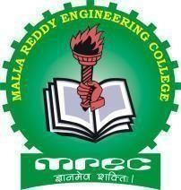*Submitted in partial fulfillment of the requirements for the award of degree of*

### BACHELOR OF TECHNOLOGY

In

**COMPUTER SCIENCE AND ENGINEERING**

By

|  |  |  |
| --- | --- | --- |
| **Mr. CH. BHANU** | **:** | **17J41A0510** |
| **Mr. Y. SUSHANTH** | **:** | **17J41A0560** |
| **Mr. G. DARVISH** | **:** | **16J41A05E2** |
| **Mr. A. VISHWATEJA** | **:** | **18J45A0501** |

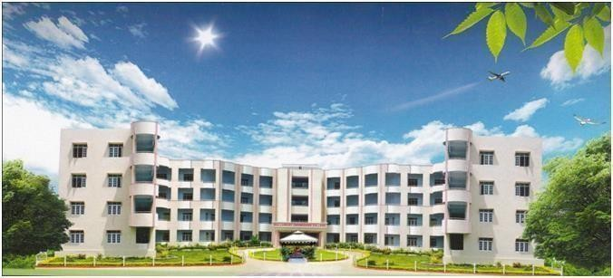Under the guidance of **Ms. S. GRACE MANASA Assistant Professor**

**DEPARTMENT OF COMPUTER SCIENCE AND ENGINEERING**

### MALLA REDDY ENGINEERING COLLEGE (AUTONOMOUS)

(An UGC Autonomous Institution, Approved by AICTE and Affiliated to JNTUH Hyderabad, Recognized under section 2(f) &12(B) of UGC Act 1956, Accredited by NAAC with ‘A’ Grade (II Cycle) and NBA Maisammaguda, Dhulapally (Post Via Kompally), Secunderabad-500 100

Website: [www.mrec.ac.in](http://www.mrec.ac.in/) E-mail: [principal@mrec.ac.in](mailto:principal@mrec.ac.in)

## 2017-2021

**MALLA REDDY ENGINEERING COLLEGE (AUTONOMOUS)**

**Maisammaguda, Dhulapally (Post Via Kompally), Secunderabad – 500 100 Telangana State**



**DEPARTMENT OF COMPUTER SCIENCE AND ENGINEERING CERTIFICATE**

This is to certify that the project work titled “**ONLINE ADMISSION MANAGEMENT SYSTEM**” is a bonafide work done by **Mr. Ch. Bhanu (17J41A0510), Mr. Y.Sushanth (17J41A0560), Mr.G.Darvish** (**16J41A05E2), Mr. A. Vishwateja (18J45A0501)** in the partial fulfillment of **Bachelor of Technology** in **Computer Science and Engineering** of the **Malla Reddy Engineering College(Autonomous)** affiliated to JNTUH, Hyderabad and that this has not submitted for the award of any other degree of any Institution/University.

**Internal Guide Head of the Department**

Ms. S. Grace Manasa Dr. N. Lakshmipathi Anantha

Assistant Professor