GTM Analyst SoP — Cold Call to GMeet Fixed
Your half of the funnel: from an untouched lead to a booked technical meeting
This covers everything you own. The moment you log GMeet Fixed, the deal leaves you and becomes the Lead Manager's.
You are the PoC on every deal you call. That never changes, even after the deal moves on — your name stays attached to the outcome all the way to Closed/Won.
⛔ Never make up data.
No number, no name, no answer → leave it blank and write a note saying why. A blank is correct. An invented value is a bug someone else will act on.

Nothing here is enforced by HubSpot.
HubSpot will happily let you drag a deal anywhere, with no note and no task. Every rule in this document is a working agreement between us, not a system check — which is the whole reason it is written down. If you skip a step, nothing will stop you and nobody will be told.

1. Your half of the funnel
Everything from an untouched lead to a booked meeting. Blue boxes are stages a deal sits in, amber boxes are actions you take rather than stages, and red boxes are dead ends. Each part is explained in the sections that follow.
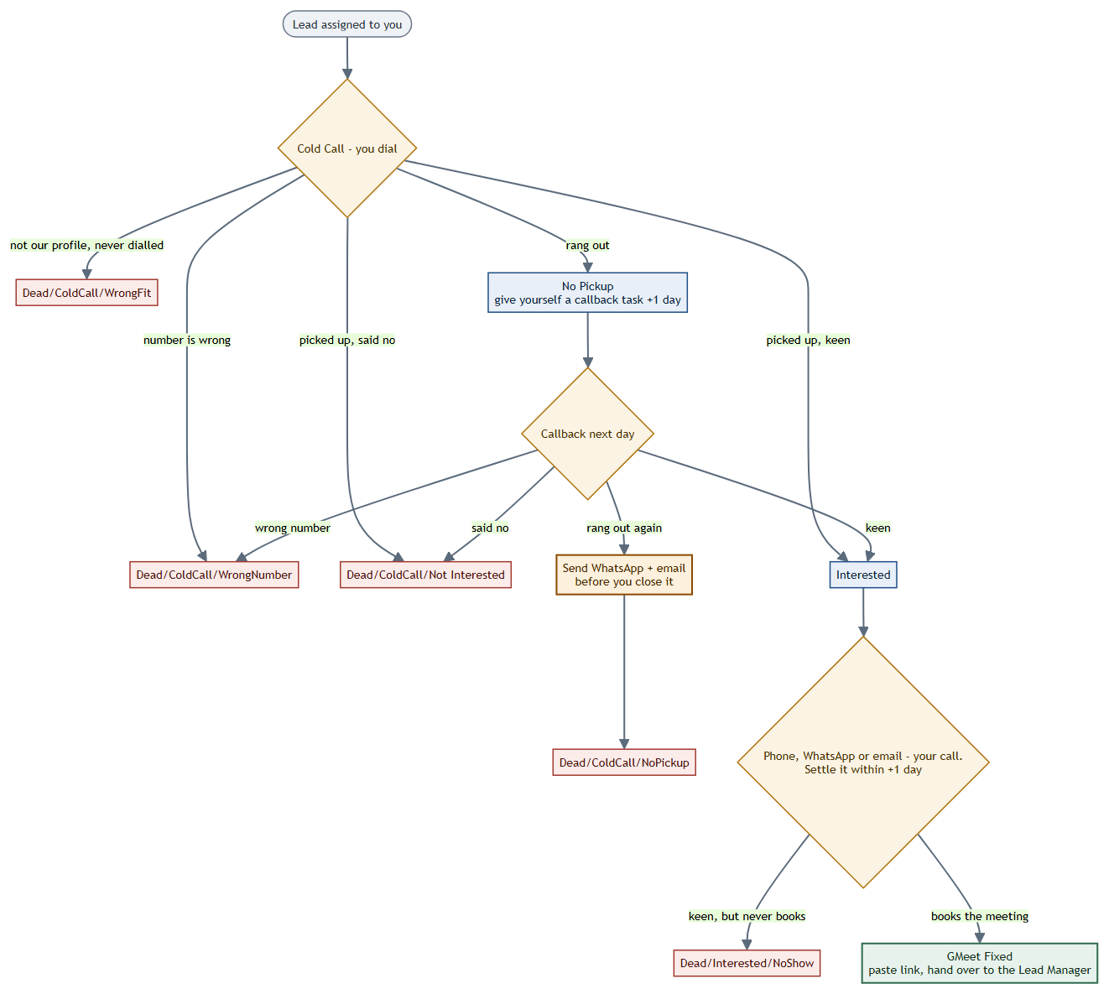

2. Start of your day
- HubSpot → CRM → Deals → your pipeline, Board view.
- Filter Deal owner = you. Save it as "My Deals" so it is one click tomorrow.
- Work Cold Call first, then anything with a callback task due today.
- Do not set Priority. That is set after the GMeet, by the Lead Manager.

3. The cold call — five outcomes
Every dial ends in exactly one of these five. Move the deal the same day you make the call — the dashboard counts the day a deal reached a stage, so a stage moved late records your work on the wrong day, or not at all.
What happened | Move the deal to | What you do
Not our profile — you decided before dialling | Dead/ColdCall/WrongFit | Note why. No call was made, so this is not counted as a call attempt.
The number is not theirs | Dead/ColdCall/WrongNumber | Look for a better number first — LinkedIn, their website, Apollo. Only close it once you have tried. Note what you tried.
Picked up, not interested | Dead/ColdCall/Not Interested | Note the reason in their words. "Not interested" on its own is not a note.
Picked up, wants to know more | Interested | Go to Section 5. You now have one day to settle the next step.
Rang out, nobody answered | No Pickup | Give yourself a callback task, due +1 day. See Section 4.

4. No Pickup — the callback loop
No Pickup is a live stage, not a dead end. A deal sitting there is still yours and still workable — nobody has said no, we simply have not reached them yet. This is the biggest leak in the funnel, which is why it has three explicit steps rather than one.

Step 1 — the moment it rings out
Move the deal to No Pickup, then immediately give yourself a callback task due the next day. On the deal: Create task → Type: Call → Assigned to: yourself → Due: tomorrow. Put the company name in the title so your task list is readable at a glance.
Do this before you dial the next number. A deal moved to No Pickup without a task is a lead nobody will ever come back to — it looks worked, and it is silently abandoned. Most callback tasks currently open are already past their due date, and that is the habit this step exists to break.

Step 2 — the callback, the next day
Work the task on the day it is due. Call at a different time of day from your first attempt — if you tried mid-morning, try late afternoon, since a founder who cannot pick up at 11am often can at 5pm. The callback has the same four outcomes as the first dial:
Callback outcome | Move the deal to
The number is not theirs | Dead/ColdCall/WrongNumber
Picked up, not interested | Dead/ColdCall/Not Interested
Picked up, wants to know more | Interested
Rang out again | Dead/ColdCall/NoPickup — but only after Step 3

Step 3 — before you close it as NoPickup
Two rings-out is not a no. It means we failed to make contact, and that is a different thing entirely. Before this deal is closed, send both a WhatsApp and an email — they cost nothing, they arrive when the person is free rather than when you happened to call, and a share of them come back as replies.
Send both, log both on the deal, then move it to Dead/ColdCall/NoPickup with a note saying what you sent and when. If they reply later, move the deal back to Interested — a dead stage is not permanent.
WHATSAPP TEMPLATE — to be filled in
Must include: who you are, LH2, why you are calling them specifically, and one clear ask — a time to talk. Keep the first line short enough to read in the notification preview, because that decides whether it is opened at all.

EMAIL TEMPLATE — to be filled in
Must include: a subject line that says something specific, who you are, what LH2 does, why them, and one call to action.
Subject:

Body:

5. Interested → GMeet Fixed
They are keen. Your job now is to turn that into a booked meeting, and how you do it is deliberately left to you — phone, WhatsApp, email, or any mix of the three. Use whatever you judge will land with that particular person; you have spoken to them and nobody else has.
The one hard rule: settle the next stage within +1 day.
Within a day of them saying they are interested, the deal must move — either to GMeet Fixed or to Dead/Interested/NoShow.
It must not sit at Interested. Warm interest goes cold quickly, and a deal parked here is the most expensive kind of leak there is: someone said yes, and we let it lapse.

If they book — GMeet Fixed
- Send the meeting invite with the GMeet link.
- Paste that GMeet link into the deal — the Lead Manager has no other way to find it.
- Move the deal to GMeet Fixed.
- Reassign Deal Owner → the Lead Manager. This is the handoff.
You stay the PoC; only the owner changes. Note that GMeet Fixed means the meeting is booked, not that it happened — whether they actually turn up is the Lead Manager's to record, not yours.

If they never book — Dead/Interested/NoShow
Someone can say yes and still never convert. That is exactly what this stage is for: they were keen, you followed up, and no meeting ever came of it. It is a different outcome from someone who booked and then failed to show, and it belongs to you rather than to the Lead Manager.
Before you close it, note what you tried and over how long — "called twice and WhatsApped over four days, no reply after the first yes" tells the next person something. "No show" on its own does not.

6. Notes — what a good one looks like
Every Dead/* stage needs a note. The test is simple: could a colleague pick this deal up in three months and know exactly what happened, without calling you to ask?
Not acceptable | Acceptable
not interested | Spoke to the founder. They sold their services arm in March and have no codebase left to sell. Hard no.
no answer | Rang out 4 Aug 11:20 and 5 Aug 16:40. WhatsApp and email sent 5 Aug, no reply. Number verified against their website.
wrong number | Number on the sheet reaches a logistics firm. Checked LinkedIn and their site — no alternative number listed anywhere.

