Lead Manager SoP — GMeet Fixed to Script Results Received
Your half of the funnel: from a booked technical meeting to a returned script output
A deal reaches you the moment the GTM Analyst logs GMeet Fixed and hands over ownership. It leaves you when you log Script Results Received and hand it to the Lead Closer.
You are not the PoC. Whoever made the first call keeps that field for the life of the deal — if you need context on the company before the meeting, they are who to ask.
⛔ Never make up data.
No number, no name, no answer → leave it blank and write a note saying why. A blank is correct. An invented value is a bug someone else will act on — and at your stage the numbers you enter are what the offer gets built on.

Nothing here is enforced by HubSpot.
HubSpot will let you move a deal anywhere, with no note, no numbers and no follow-up. Every rule in this document is a working agreement between us, not a system check — which is the whole reason it is written down.

1. Your half of the funnel
Blue boxes are stages a deal sits in, amber diamonds are decisions rather than stages, red boxes are dead ends, and green is the handoff out of your half. Each part is explained in the sections that follow.
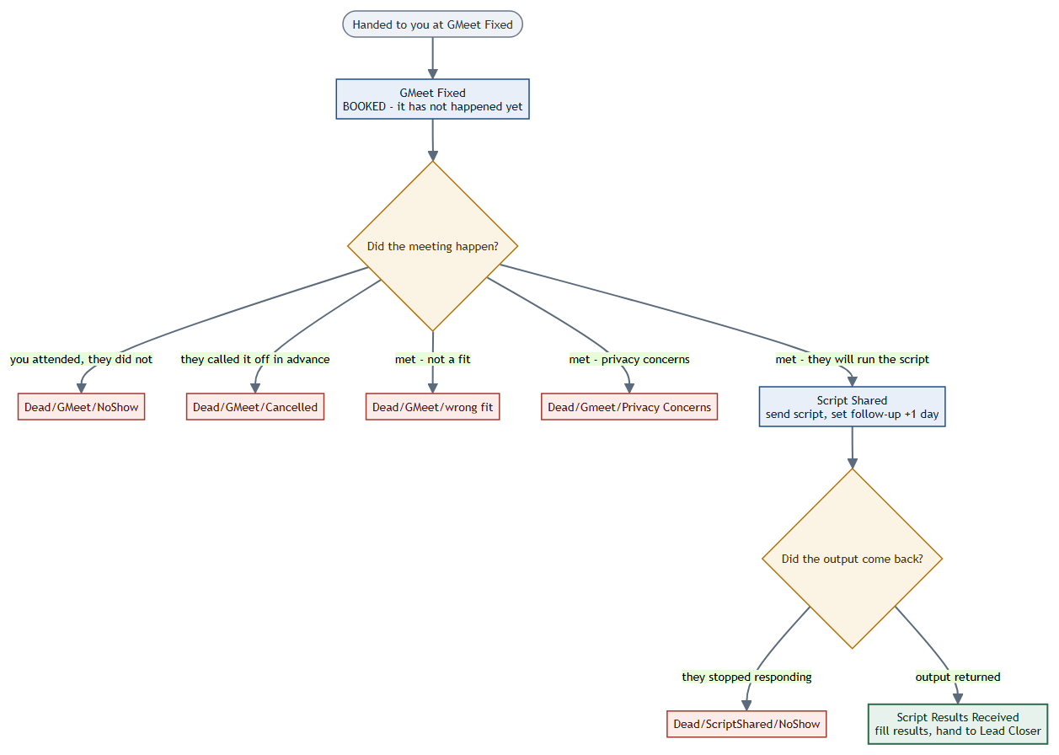

2. Start of your day
- HubSpot → CRM → Deals → Board view. Filter Deal owner = you, save it as "My Deals".
- Check today's meetings first — anything at GMeet Fixed with a date today.
- Then work anything at Script Shared whose follow-up is due.
- Last, sweep GMeet Fixed deals whose meeting date has already passed. If the date is behind us and the deal has not moved, it needs an outcome logged today.
A deal at GMeet Fixed with a date in the past is the one thing to never leave.
GMeet Fixed means booked, not attended. If the meeting has been and gone, the stage is now telling everyone something untrue. Move it the same day — to a dead stage or to Script Shared.

3. Before the meeting
The GTM Analyst has pasted the GMeet link on the deal. Read their notes before you dial in — they have already spoken to this person and the note will tell you who you are meeting and what was promised. Turning up cold to a meeting someone else booked wastes the goodwill they built.
Send a reminder the day before. A booked meeting that nobody confirms is where most no-shows come from, and a one-line message costs nothing.
MEETING REMINDER MESSAGE — to be filled in
Must include: the date and time in their timezone, the GMeet link again, who will be joining from our side, and roughly what the call will cover so they can bring the right person.

4. The meeting — five outcomes
Every booked meeting ends in exactly one of these. Log it the same day — the dashboard counts the day a deal reached a stage, and your attendance number is built from these moves.
What happened | Move the deal to | What you do
You joined; they never turned up | Dead/GMeet/NoShow | Note how long you waited and whether you chased. This still counts as a meeting you attended — your time was spent.
They called it off in advance | Dead/GMeet/Cancelled | Note the reason and whether they offered to rebook. If they rebook, move it back to GMeet Fixed instead of closing it.
Met — the codebase is not a fit | Dead/GMeet/wrong fit | Note specifically what disqualified it. This is the note that stops us calling them again in six months.
Met — they will not share code on privacy grounds | Dead/Gmeet/Privacy Concerns | Note whether it is a hard policy or a solvable objection (NDA, redaction, sub-set of repos). Solvable ones are worth revisiting.
Met — they agreed to run the script | Script Shared | Send the script the same day. See Section 5.

NoShow and Cancelled are different, and the difference matters.
A no-show means you sat in the meeting and waited — that time was spent, and it counts towards the meetings you attended.
A cancellation received in advance means the time was never spent, and it does not count. Logging one as the other makes your own workload read wrong.

After the meeting
Whatever the outcome, write the note while the call is fresh. Then, on deals that are still alive, enter the Deal Value Range so the commercial conversation later has a starting point. You also set Priority on the deal at this point — high, medium or low — which is what tells the Lead Closer where to spend their time first.

5. Script Shared — getting the output back
We send an evaluation script; they run it on their own codebase and send back the output. Nothing leaves their machine except the output itself, and there is no NDA at this point — that is usually the objection you will need to answer, so say it plainly and early.

Step 1 — send it the same day
Momentum from the call is the only thing carrying this. Send the script while they still remember agreeing to it, with instructions plain enough that a developer who was not on the call can run it without asking questions.
SCRIPT-SHARING EMAIL — to be filled in
Must include: what the script does and explicitly what it does NOT do (no code leaves their machine), how to run it, roughly how long it takes, what to send back, and who to reply to with questions.
Subject:

Body:

Step 2 — set a follow-up for the next day
Give yourself a task on the deal, due the next day. One day is deliberate: the meeting is still fresh in their mind, and a script that has not been run within a day is usually one that has been put down rather than one still in progress. Chasing early catches it before that happens.

Step 3 — chase, then close it honestly
Work the follow-up when it is due. If there is no reply, chase on a second channel — if you emailed, try WhatsApp. Ask whether they hit a problem running it rather than whether they have run it; it is easier to answer and it surfaces the real blocker.
If they have gone quiet after a fair effort, move the deal to Dead/ScriptShared/NoShow and note what you sent and when. Do not leave it sitting at Script Shared — a stalled deal parked in a live stage makes the funnel look healthier than it is.
SCRIPT FOLLOW-UP NUDGE — to be filled in
Must include: a reminder of what was agreed on the call, an offer to help if they hit a problem, and one specific ask. Keep it short — this is a nudge, not a re-pitch.

6. Script Results Received — the handoff
The output is back and the code quality has been reviewed. This is where the deal leaves you, and it is the most important entry in your half of the funnel — everything the Lead Closer does is built on these numbers.
What to enter | Why it matters downstream
# Repos | Scope of what we are buying
# Projects | Scope of what we are buying
Cumulative LoC | The single biggest driver of the offer
Total PRs | A read on whether the code was actively worked or dumped
Script Results link | So the Lead Closer can see the raw output, not just your summary

Fill all five, then hand over. Not before.
Reassign Deal Owner → the Lead Closer once the numbers are in.
Handing over a deal with blank numbers moves the work to someone who was not on the call and cannot fill them in. If a number genuinely is not in the output, leave it blank and say so in the note — that is different from forgetting.

7. Notes — what a good one looks like
Every Dead/* stage needs a note, and so does every handoff. The test: could a colleague pick this deal up in three months and know exactly what happened, without asking you?
Not acceptable | Acceptable
wrong fit | Met the CTO. Codebase is three WordPress sites and a Shopify theme — no proprietary application. Nothing here to acquire.
privacy | Will not run anything against their repos without an NDA in place. Not a flat refusal — worth revisiting if we can offer one.
no show | Joined at 15:00, waited 20 minutes, messaged on WhatsApp, no reply. Second time this has happened with this contact.
script sent | Script sent 4 Aug, follow-up 6 Aug, WhatsApp 8 Aug. No reply to any. Their lead dev was reportedly on leave.

