Lead Closer SoP — Script Results Received to Closed/Won
Your half of the funnel: from a returned script output to a paid, closed deal
A deal reaches you the moment the Lead Manager logs Script Results Received and hands over ownership. You own it from there to the end.
You are not the PoC. Whoever made the first call keeps that field for the life of the deal, and the Lead Manager ran the technical call — both are worth talking to before you make an offer.
⛔ Never make up data.
No number, no name, no answer → leave it blank and write a note saying why. A blank is correct. At your stage an invented number becomes an offer, a contract and a payment — it does not stay a data-quality problem for long.

Nothing here is enforced by HubSpot.
HubSpot will let you move a deal to Closed/Won with no cost recorded and no confirmation that anything was delivered. Every rule in this document is a working agreement between us, not a system check.

1. Your half of the funnel
Blue boxes are stages a deal sits in, amber diamonds are decisions rather than stages, red boxes are dead ends, and green is a closed-won deal. Each part is explained in the sections that follow.
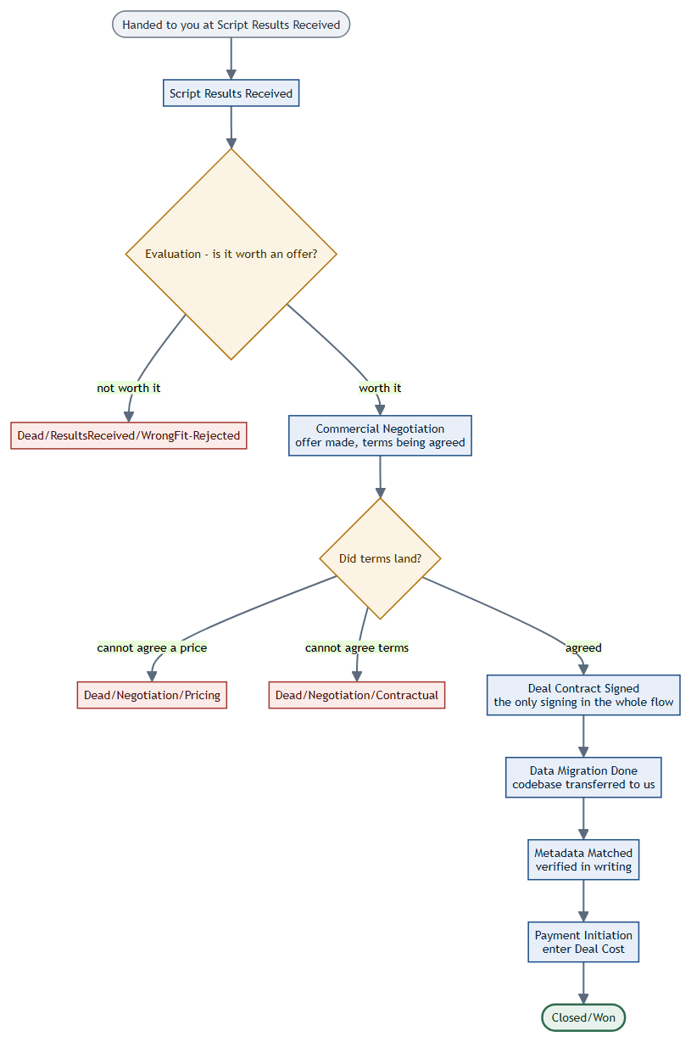

2. Start of your day
- HubSpot → CRM → Deals → Board view. Filter Deal owner = you, save it as "My Deals".
- Work anything newly handed to you at Script Results Received first — a deal that has just arrived is the one where their side is still warm and waiting.
- Then anything at Commercial Negotiation with a follow-up due.
- Last, sweep post-signature deals: Data Migration Done, Metadata Matched and Payment Initiation. These stall quietly because nobody is chasing them.

3. Evaluating the script output
The evaluation is done jointly with the Lead Manager — you both look at the same output and agree whether it is worth an offer. That is deliberate: it is the decision with the most money attached, and it should not rest on one reading.
Read the raw output on the Script Results link, not only the summary numbers on the deal. Cumulative LoC tells you the scale, but Total PRs tells you whether the code was actively worked or dumped in one commit, and those are very different assets.
Outcome | Move the deal to | What you do
Not worth an offer | Dead/ResultsReceived/WrongFit-Rejected | Note specifically what disqualified it — scale, quality, licensing, or ownership. This is what stops us paying to look at the same codebase again.
Worth an offer | Commercial Negotiation | Make the offer, then record it on the deal. See Section 4.

4. Commercial Negotiation
You have made an offer and are agreeing price and terms. This stage is where deals sit longest, so it is also where they quietly die from neglect rather than disagreement.

Step 1 — make the offer and write it down
Put three things in the deal notes: what we offered, what they asked for, and where it currently stands. Update that note every time the position moves. A negotiation you carry in your head cannot be picked up by anyone else, and it cannot be reviewed.
OFFER EMAIL — to be filled in
Must include: what we are acquiring and its scope in their terms, the figure, what happens after they accept, and a date by which you would like an answer.
Subject:

Body:

Step 2 — keep a live follow-up on it
Never leave this stage without a dated next action on the deal. Silence in a negotiation is almost never a decision — it is usually an internal conversation happening without us, and a scheduled nudge is what keeps us in it.

Step 3 — close it honestly, either way
Outcome | Move the deal to
Terms agreed | Deal Contract Signed
Could not agree a price | Dead/Negotiation/Pricing
Could not agree terms — liability, IP, timelines | Dead/Negotiation/Contractual

Splitting the two dead reasons matters. A deal lost on price tells us our number was wrong; a deal lost on contract terms tells us our paperwork is wrong. Those need different fixes, and lumping them together hides both.

5. After signature — delivery to payment
Four stages, in order, and none of them should be skipped. This is the part of the funnel where a deal is effectively won but can still go wrong, and where a stage left stale is most expensive — we may already be committed to paying.

Deal Contract Signed
Terms are agreed and the contract is signed. This is the only contract signing anywhere in the flow. Attach the signed copy to the deal, then arrange the transfer.

Data Migration Done
Their codebase has been transferred to us. Once it lands, request the metadata match in writing and wait for a written confirmation back. Do not advance the stage on a verbal or a chat message — this is the check that what arrived matches what we agreed to buy, and it needs to be auditable later.
METADATA MATCH REQUEST — to be filled in
Must include: the deal and company, where the delivered code sits, the agreed metadata to check it against (LoC, repos, PRs), and an explicit ask for written confirmation.
Subject:

Body:

Metadata Matched
Delivered code has been verified against the agreed metadata and confirmed in writing. Move the stage only once that confirmation exists, and keep it on the deal.
If the metadata does not match, stop.
Do not advance to Payment Initiation and sort it out afterwards. A short delay before payment is recoverable; a payment made against a shortfall is a commercial conversation nobody wants to have.
Note the discrepancy on the deal and take it back to them.

Payment Initiation
Payment is being processed to the client. Enter the Deal Cost — the amount we are actually paying for the codebase — before you move the stage. That figure is what every report on what the pipeline cost is built from, and it is the one number nobody else can reconstruct later.

Closed/Won
Paid and delivered. Move it once the money has actually gone out, not when it was approved.

6. Notes — what a good one looks like
Every Dead/* stage needs a note, and so does every position change in a negotiation. The test: could a colleague pick this deal up in three months and know exactly what happened, without asking you?
Not acceptable | Acceptable
rejected | 1.2M LoC but 90% is vendored dependencies and generated code. Real hand-written surface is roughly 40k LoC across two repos. Not worth an offer at any price we would pay.
price | Offered $X. They came back at $Y, held firm across two calls citing a competing offer. Gap was too wide to close.
contract | Agreed on price. Could not agree indemnity — they wanted uncapped liability on our side. Their counsel would not move.
waiting | Contract signed 2 Aug. Migration completed 6 Aug. Metadata match requested 6 Aug, confirmation still outstanding — chased 8 Aug.

