E-Voting System Using Ethereum Blockchain
Abstract: In this project we are implementing Blockchain based E-Voting system which works as a decentralized server where multiple nodes will maintain user’s voting data and if one node crashed or down then users can get voting data from other working nodes. In existing application single centralized server were managing all voting data and if this server hacked or down then all voting details will be unavailable and this server can be attacked or hacked and can alter vote counting data. Blockchain storage support immutable data storage which means data cannot be alter or hacked as each node in the Blockchain will verify each Block storage with the help of hashcodes. Blockchain store each record as transaction/block and associate each block with unique hashcode and this hashcode will be verified against any malicious data tamper which makes Blockchain secured and tamper proof.
Algorithms: Ethereum is the public Blockchain software and include multiple algorithms such POW (proof of work), Hashcode verification, proof of stake (POS), ripple protocol consensus algorithm (RPCA), delegated proof of stake (dPOS), stellar consensus protocol (SCP), and proof of importance (POI). All data will be stored in Blockchain using Paillier encryption. Each hashcode for verification will be generated using SHA256.
To implement this project we have designed following modules
- Admin will login to system using username and password as ‘admin and admin’ and then add candidate details
- Admin will add voter details and give username and password to voter for future login to cast votes. All candidates and voters will be verified using AADHAR card and this card details will be saved using ECC encryption and can be authenticated using Sha256.
- Admin will add election date
- Admin can view count of votes secured by each candidate
- User can login to system and then can view election date, if today is election date then only user can cast vote, if user already casted vote and try to recast then system will report error, only one time allow to cast vote.
We can save and get data from ETHEREUM Blockchain using Smart Contracts which will contains function to be called for data management. This contract function can be called from any programming languages and to implement Voting System we have designed below VOTING contract.
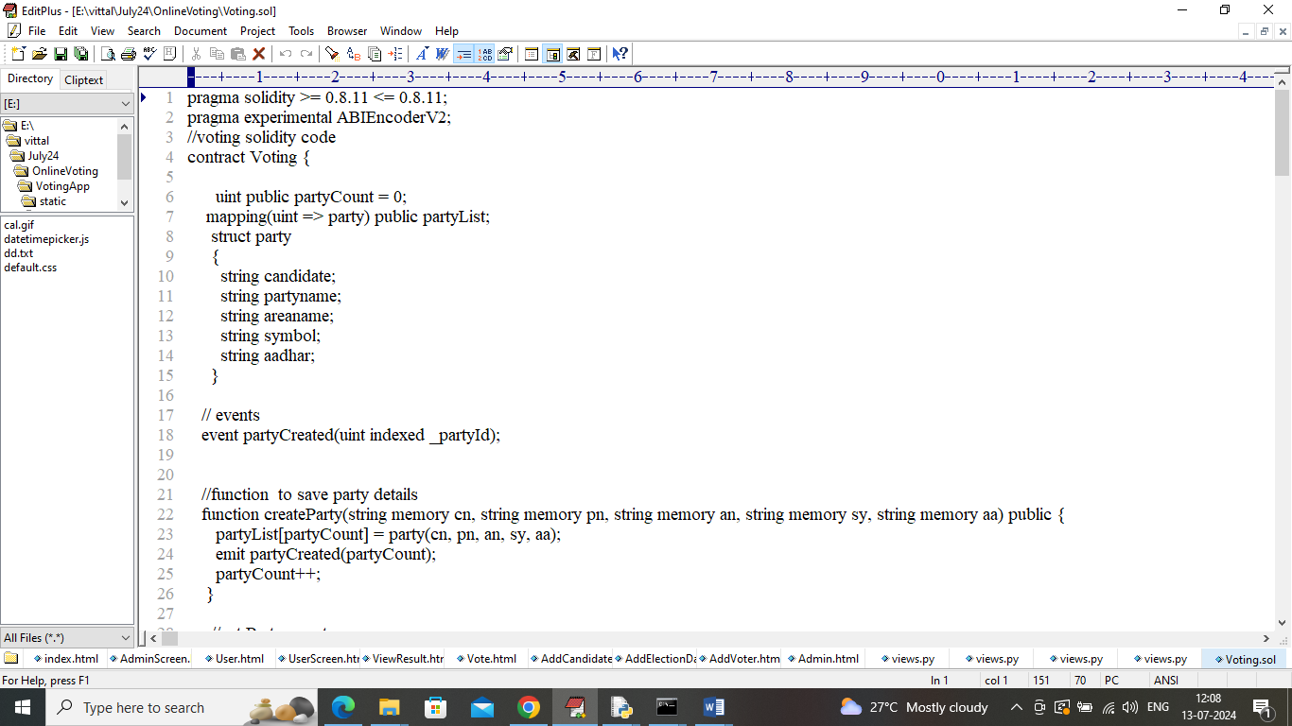
In above contract we have defined functions to save and get voting data and now this contract need to be deployed in Blockchain ETHEREUM tool using below steps
- First go inside ‘hello-eth/node-modules/bin’ folder and then look and find for ‘runBlockchain.bat’ file and then double click on that file to get below page
- 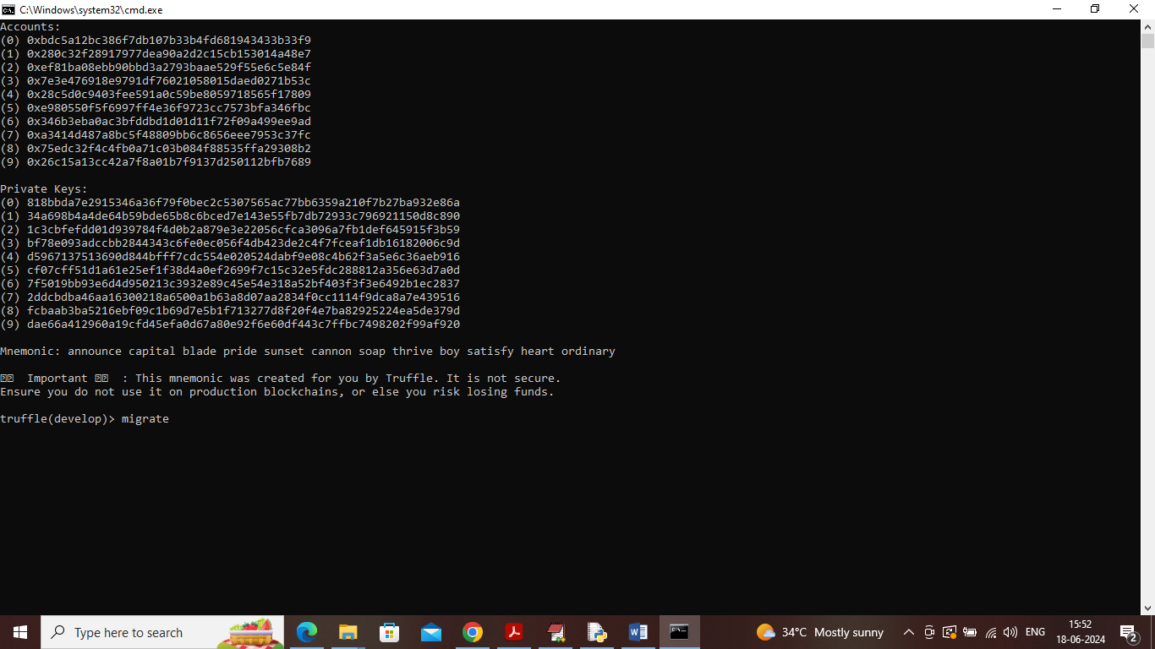
- In above screen Blockchain started with default private keys and accounts and now type command as ‘migrate’ and press enter key to deployed contract and get below page
- 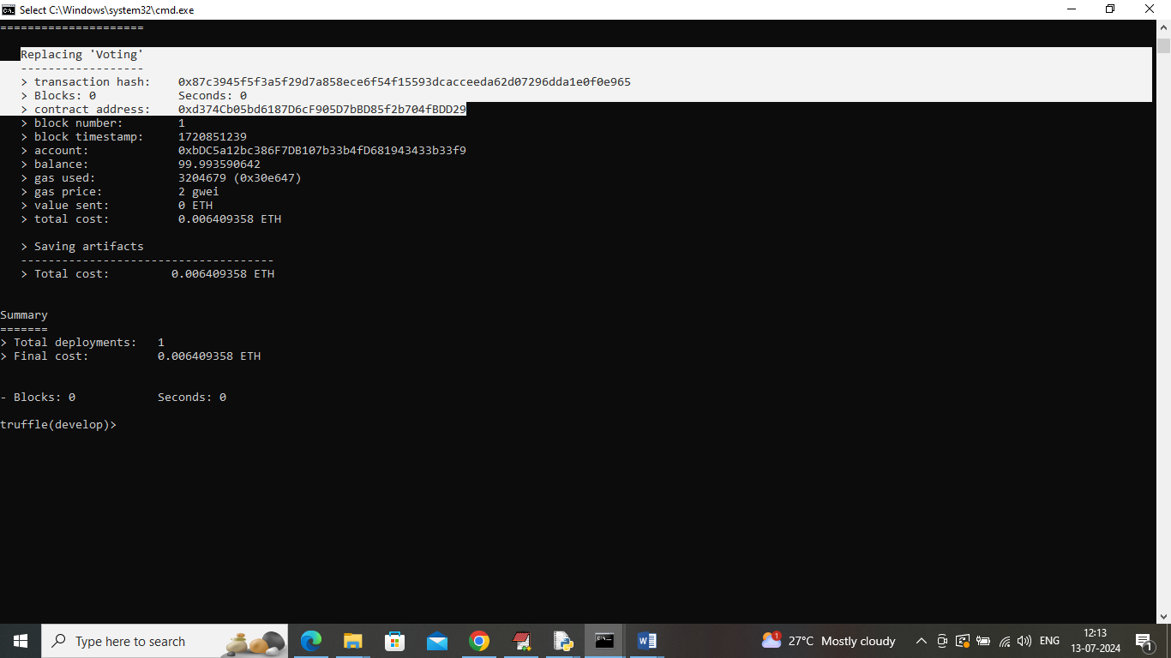
In above screen in white colour text can see ‘Voting’ contract deployed and running and got contract address also and this address need to specify in python program to call contract to manage voting data. In below screen showing python code calling contract using contract address
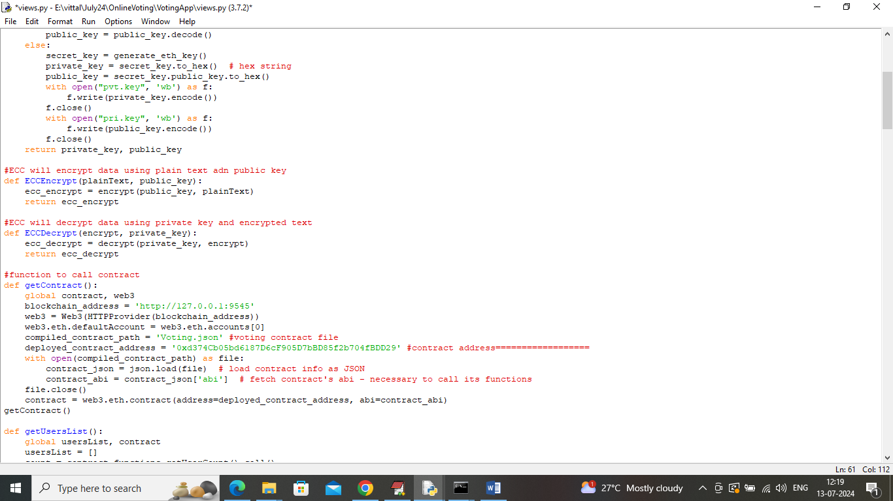
In above screen read red colour comments to know about Blockchain contract calling from PYTHON.

SCREEN SHOTS
In above screen Voting contract deployed in Blockchain and now double click on ‘run.bat’ file to start python server and get below page
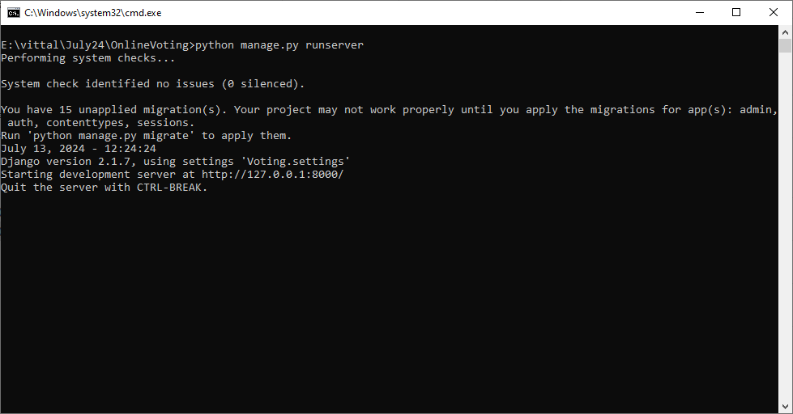
In above screen python server started and now open browser and enter URL as http://127.0.0.1:8000 and press enter key to get below page
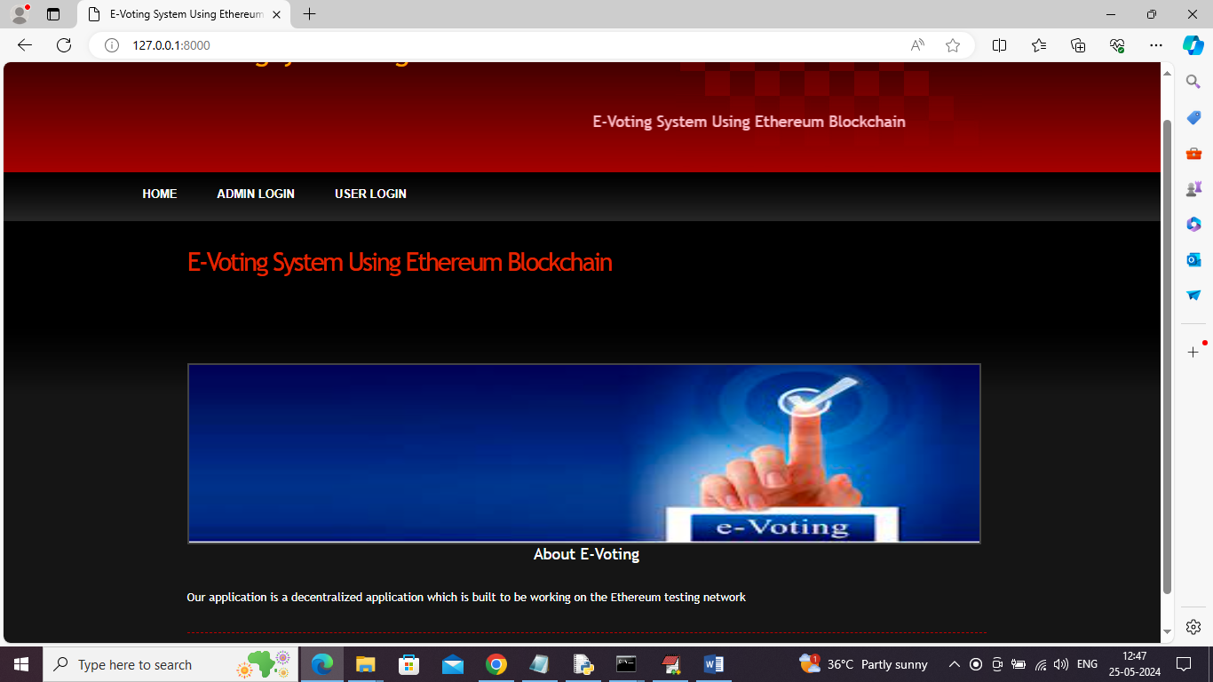
In above screen click on ‘Admin Login’ link to get below page
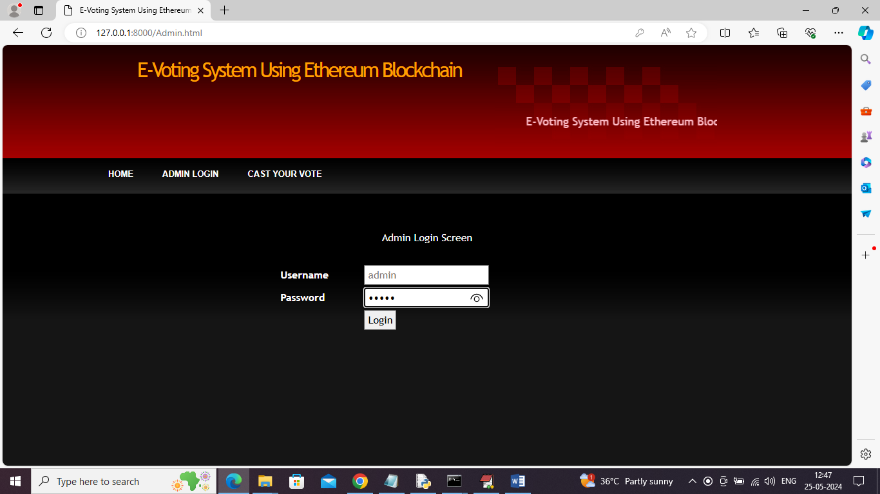
In above screen admin is login and after login will get below page
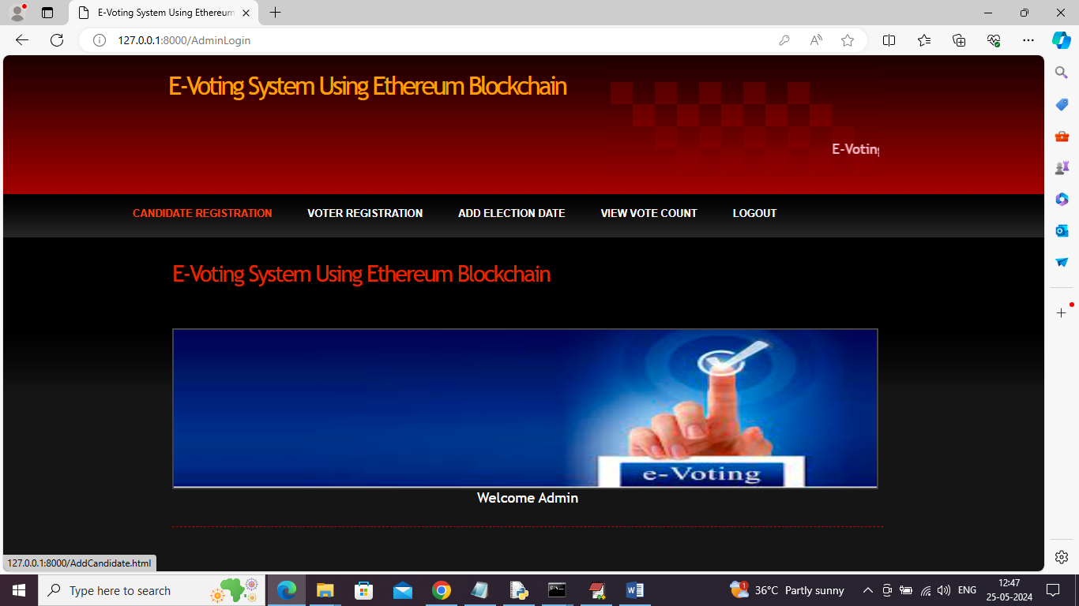
In above screen admin can click on ‘Candidate Registration’ link to get below page
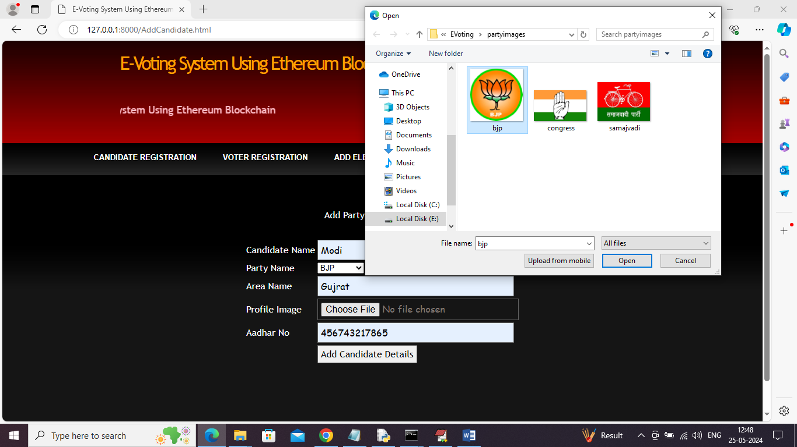
In above screen adding candidate details and then uploading party symbol and then click on ‘Add Candidate Details’ button to add details to Blockchain and then get below details
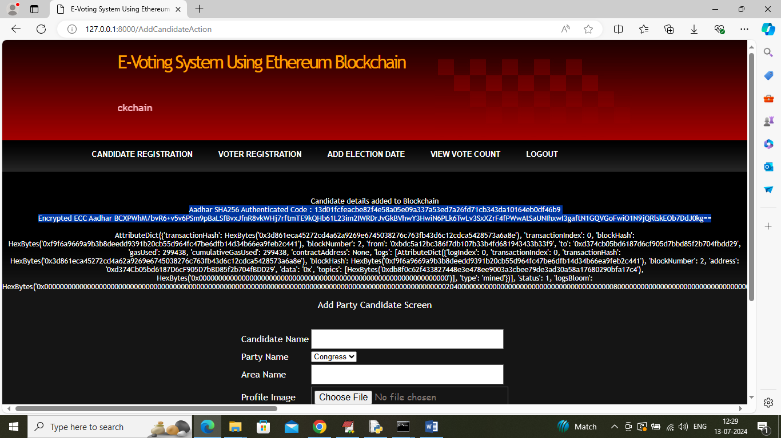
In above screen in blue color second and third line can see AADHAR SAH256 authenticated code along with ECC encrypted data. In white color text can see candidate details added to Blockchain and I am displaying all log details obtained from Blockchain after storing details and in above log can see Blockchain transaction no, block no, transaction hash code and many other details and similarly you can add any number of candidates. In below screen adding another candidate
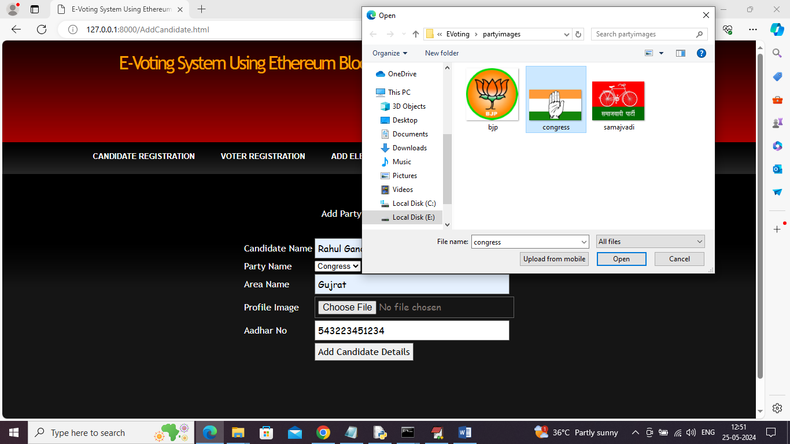
In above screen admin adding another candidate details and press button to get below page
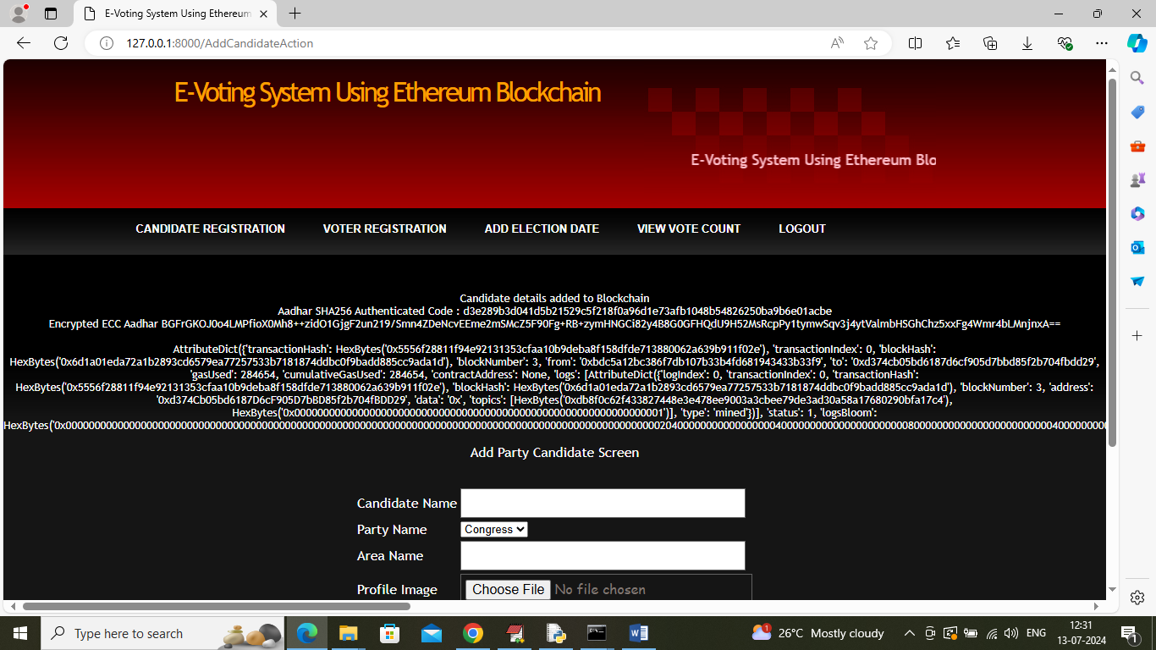
In above screen another candidate details added and now click on ‘Voter Registration’ link to get below page
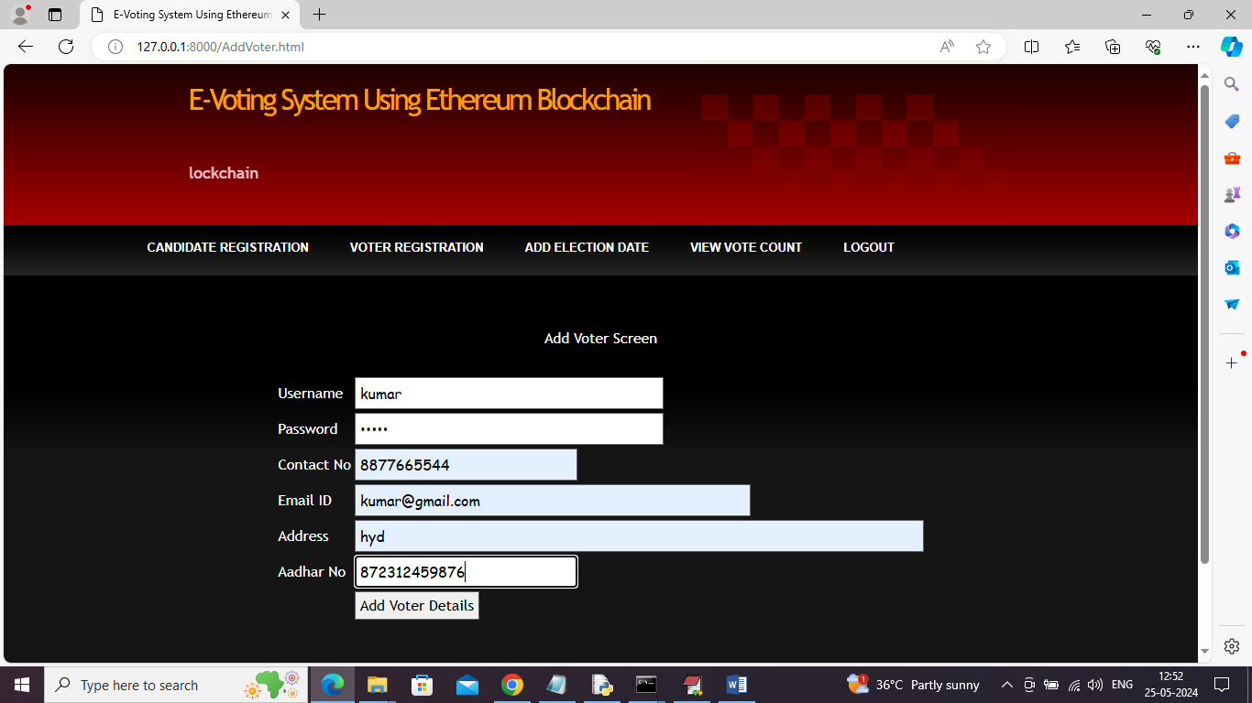
In above screen admin adding voter details along with username and password and then press button to get below page
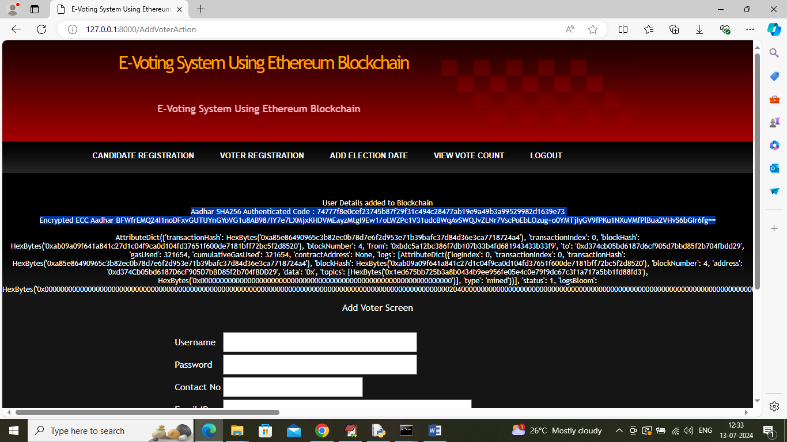
In above screen user details added and similarly you can add any number of users and now click on ‘Add Election Date’ link to get below page
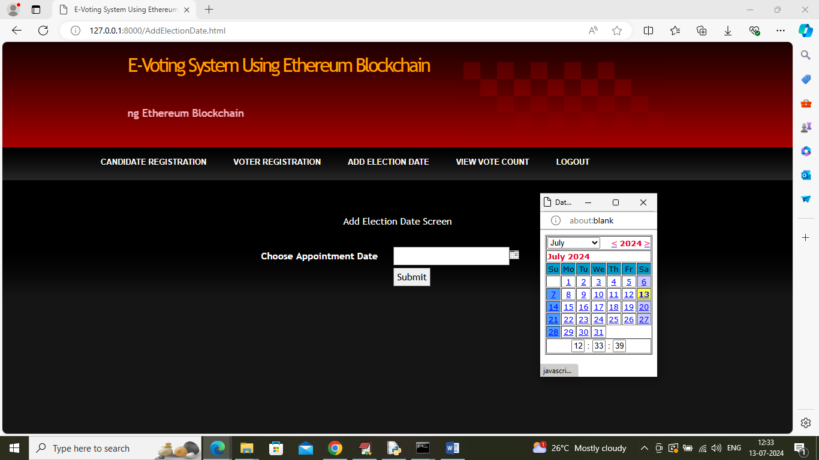
In above screen admin will select desired date from calendar to get below page
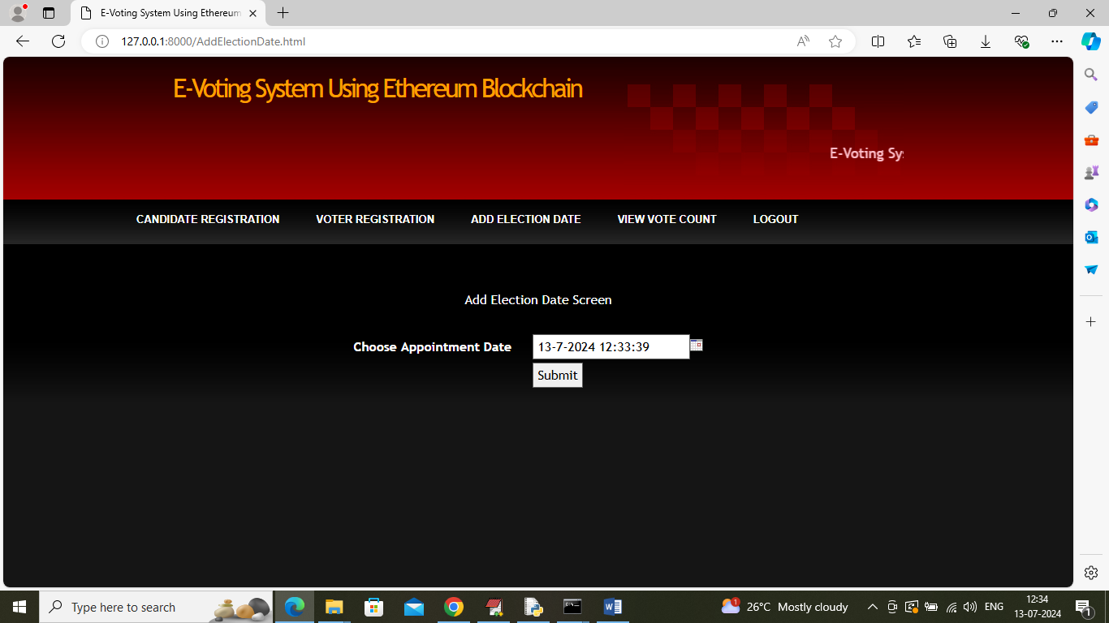
In above screen click on button to add election date and get below page
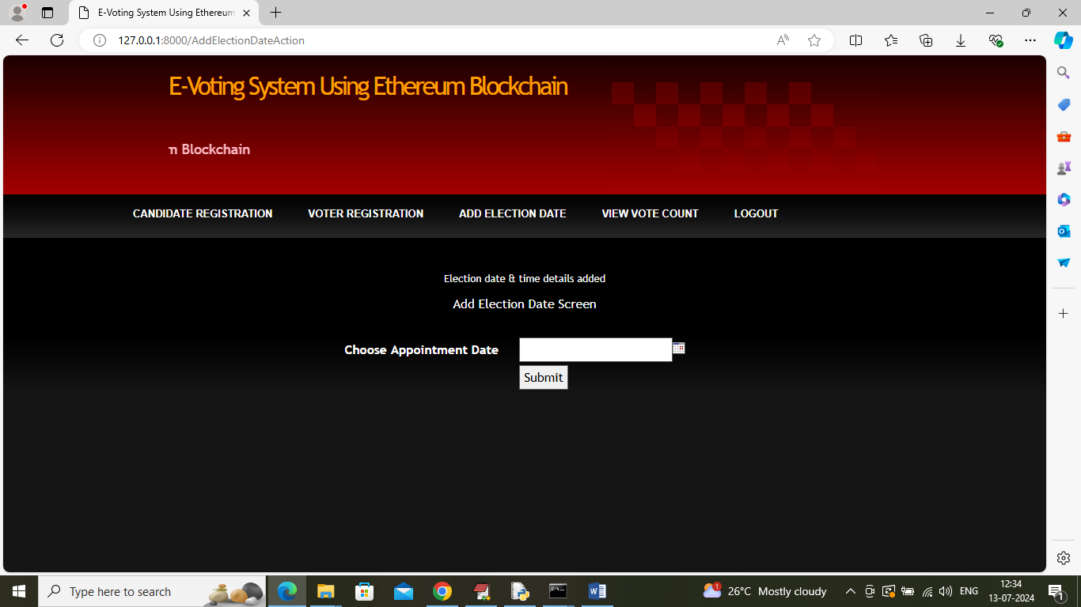
In above screen election date added and now click on ‘View Vote Count’ link to view all parties and their vote count
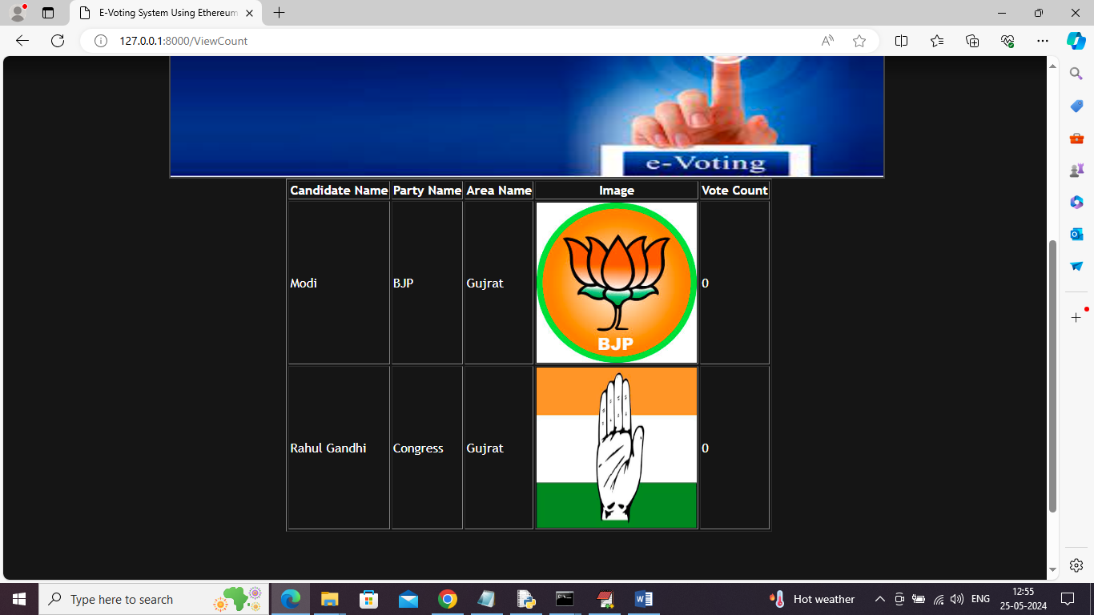
In above screen admin can view all candidate details and count is 0 as no vote casted yet and now logout and login as user
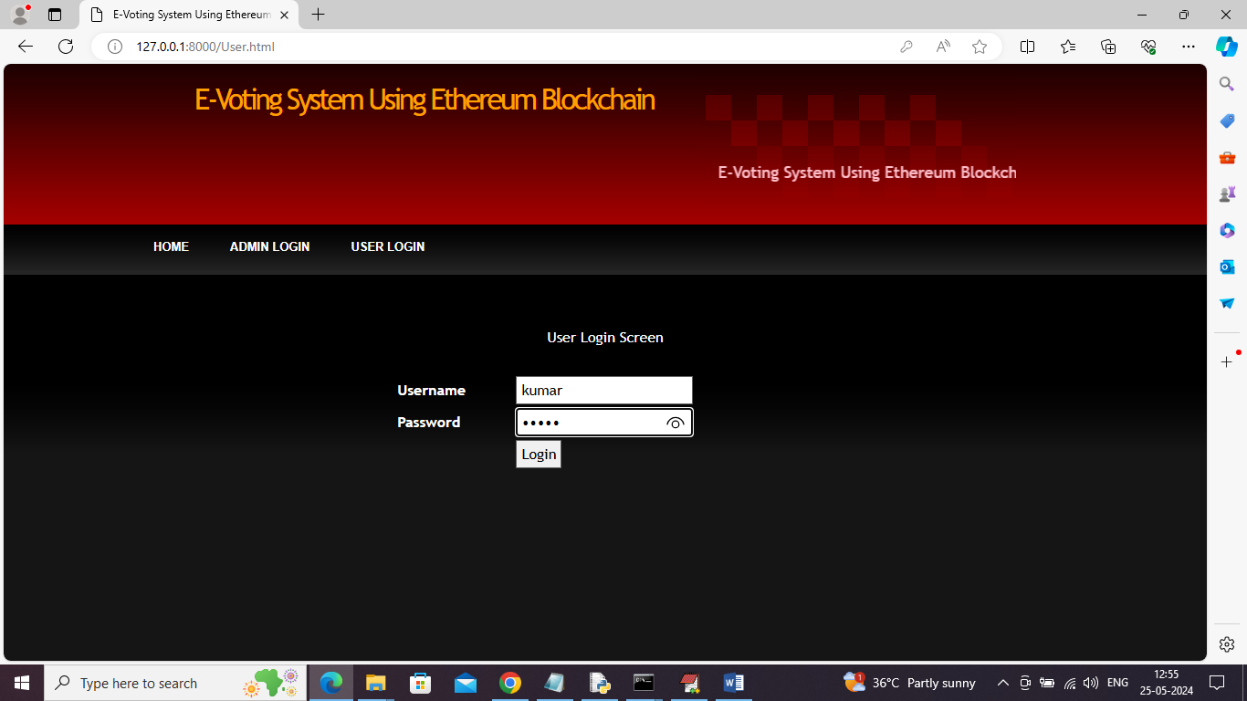
In above screen user is login and after login will get below page
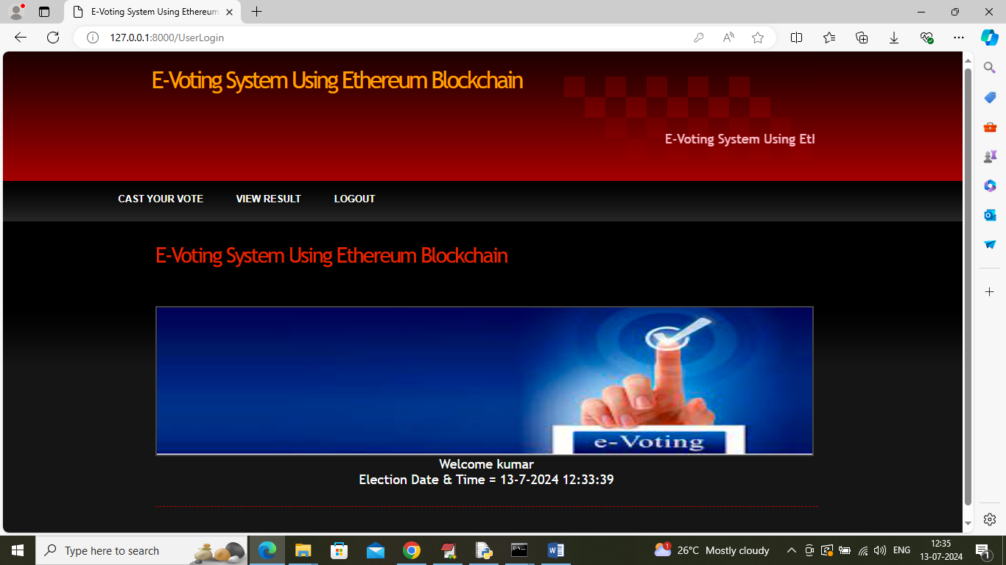
In above screen in last two line user can see welcome message along with election date and today is 13th july only so he can cast vote and now click on ‘Cast Your Vote’ link to get below page
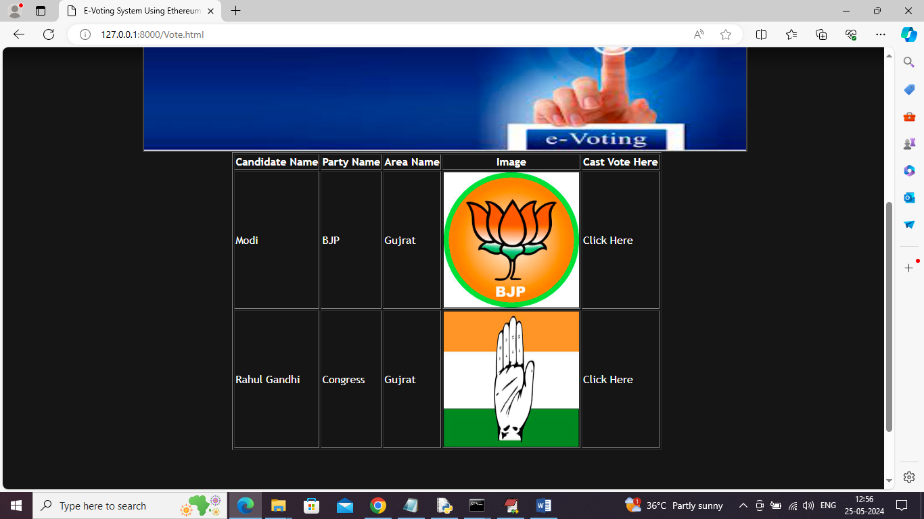
In above screen user can view list of all candidates and then click on ‘Click Here’ link beside any desired candidate name to cast vote and get below page
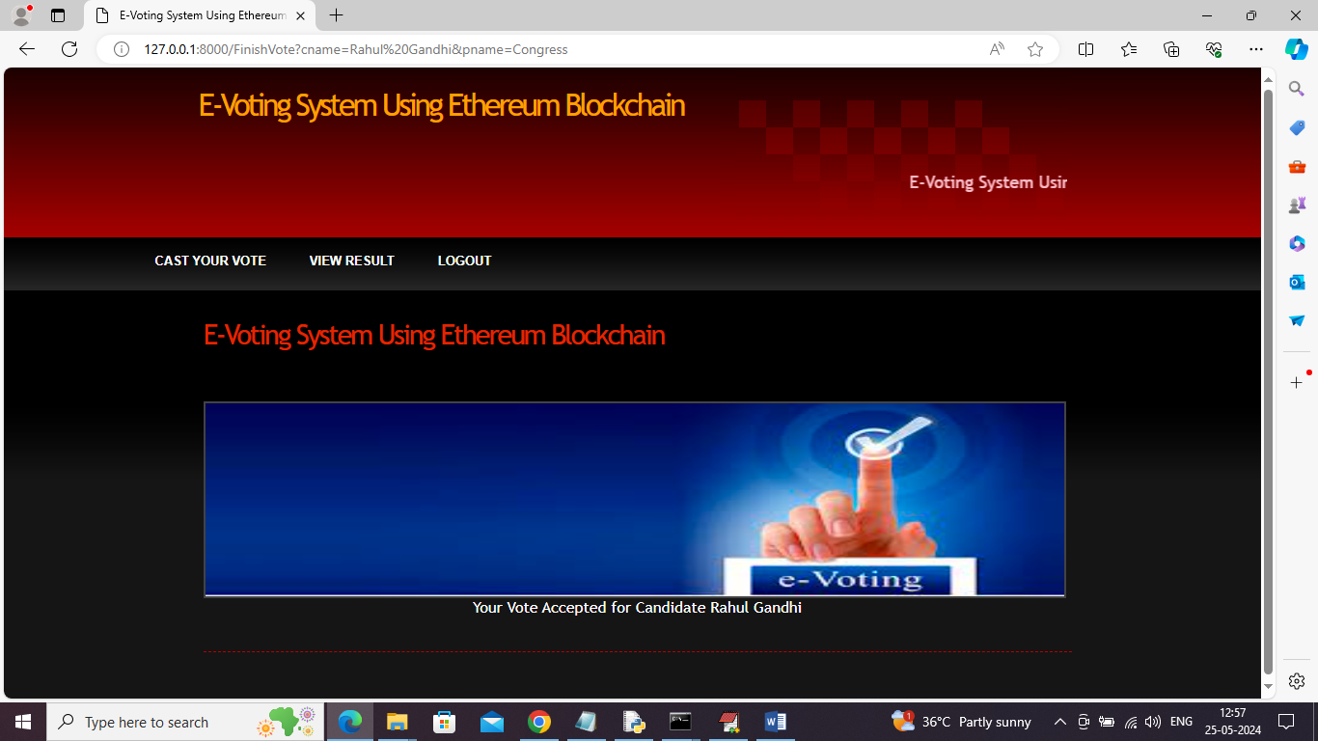
In above screen in last line user can see ‘Vote Accepted’ and if user try to cast again then will get below error
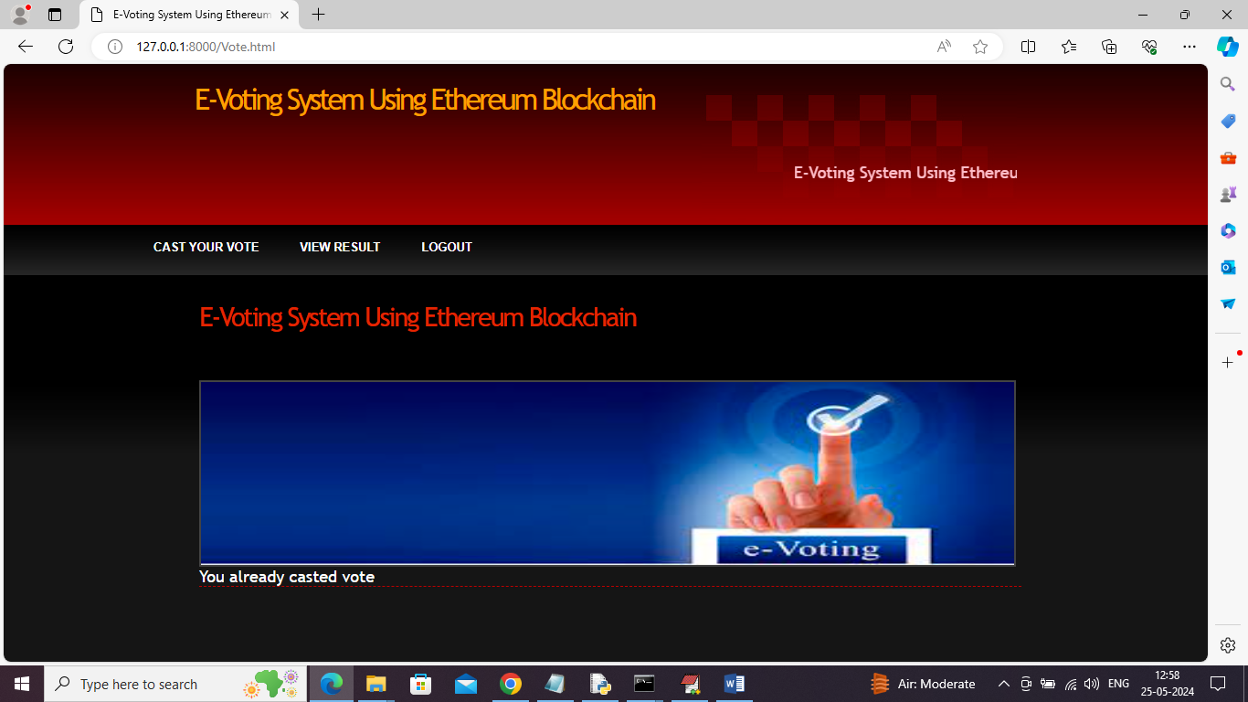
In above screen user got error as ‘Vote already casted’ and now user or admin can click on ‘View Result’ link to get count details
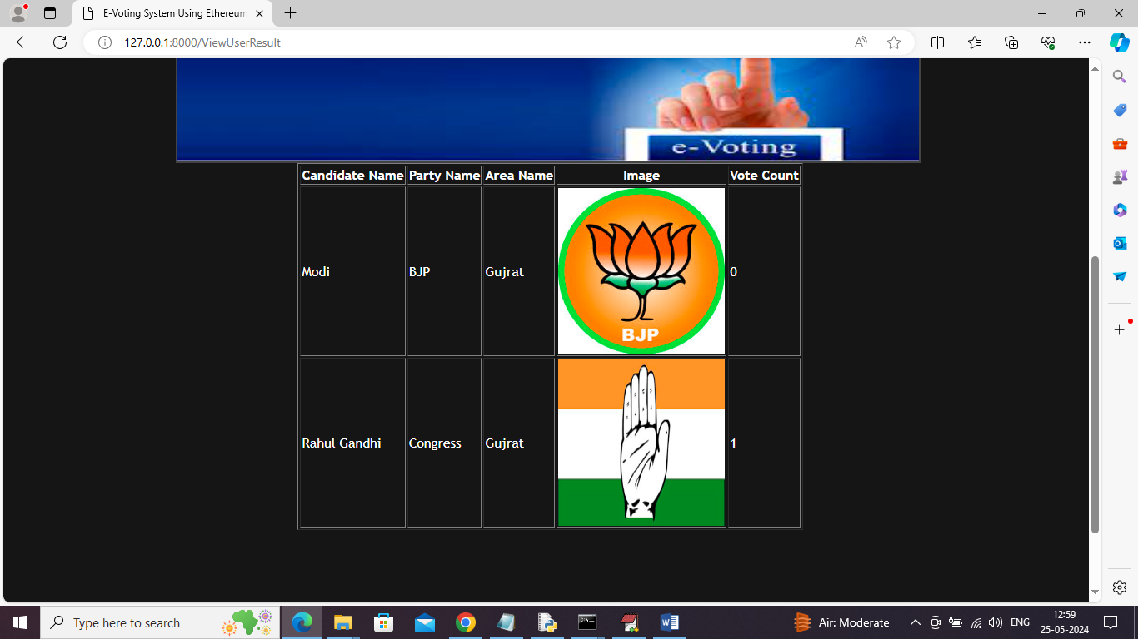
In above screen can see vote count for each candidate and in above screen Rahul Gandhi count increase from 0 to 1.
Similarly by following above screens you can add candidate, voter and cat vote details to manage voting online

