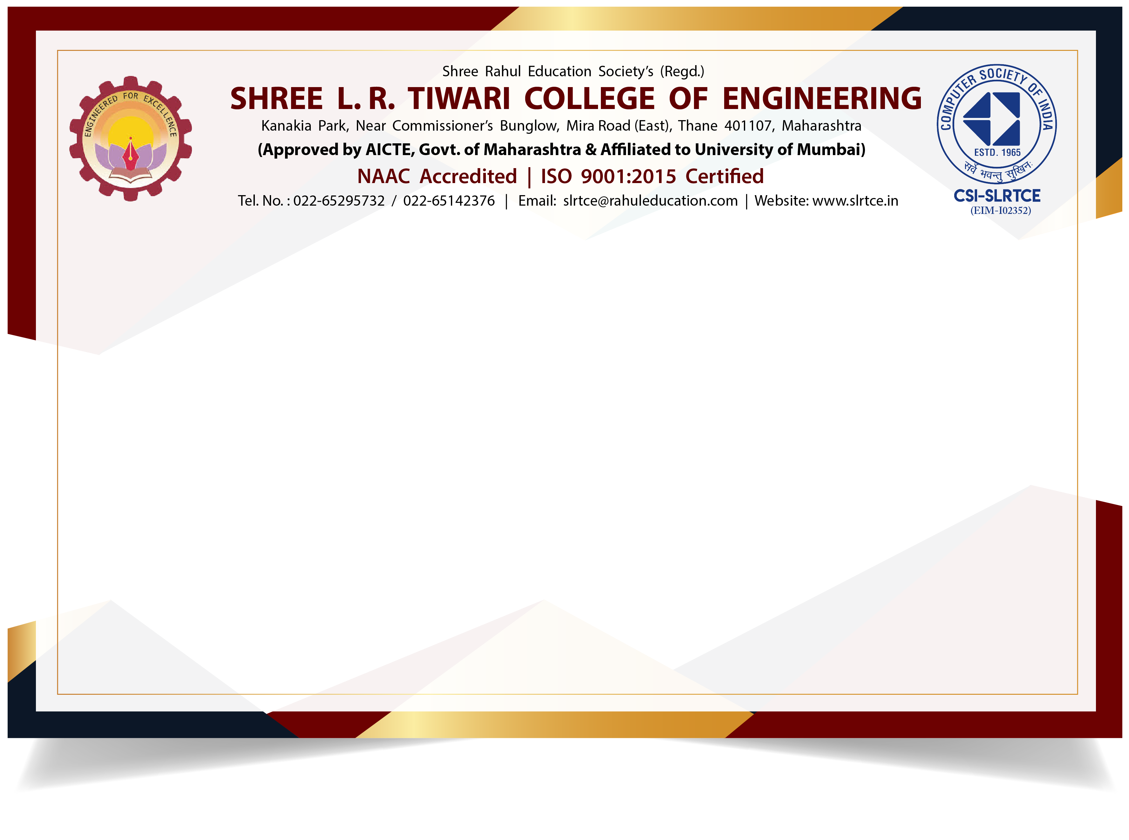

Certificate Of Participation

This ***Certificate*** is presented to

***Dharmik Joshi***

for participating in ***“C.S.I.-SLRTCE CODERS”*** coding competetion

held on ***15th May,2020*** organized by ***Department of Computer Engineering***

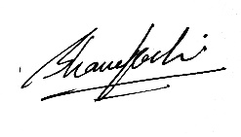 Under ***CSI-SLRTCE STUDENT BRANCH*** at **Shree. L. R. Tiwari College Of Engineering**,Thane-401107.

 

**Bhanu Joshi Mrs. Aabha Patil Dr. Vinayak D. Shinde Dr. S. Ram Reddy**

CSI-SLRTCE Student Branch-ChairpersonCSI- Faculty Co-ordinator Head Of Department (CS) Principal

CSI-ID EM-102352