YuvaIntern — Week 5 Task
Deep Learning Application in Data Science
Fashion-MNIST Multiclass Image Classification using CNN
Framework: TensorFlow / Keras
Candidate: CH. Bhanu Prakash

1. Introduction
This project demonstrates a practical deep learning workflow for multiclass image classification. The publicly available Fashion-MNIST dataset is used to train a Convolutional Neural Network (CNN) that recognizes ten categories of clothing and footwear from 28×28 grayscale images. The project covers problem definition, data preparation, neural-network architecture, training, validation, evaluation, visualization, challenges, and possible improvements.

2. Problem Statement
The task is to classify each Fashion-MNIST image into one of ten classes: T-shirt/top, Trouser, Pullover, Dress, Coat, Sandal, Shirt, Sneaker, Bag, or Ankle boot. This is a multiclass classification problem because every input image belongs to one class.

3. Objectives
- Select a publicly available dataset appropriate for deep learning.
- Preprocess image data for neural-network training.
- Design and implement a CNN using TensorFlow/Keras.
- Train the network and monitor validation performance.
- Evaluate the model using suitable classification metrics.
- Analyze challenges such as overfitting and class confusion.
- Document the complete deep learning process and possible improvements.

4. Dataset — Fashion-MNIST
Fashion-MNIST is an image-classification dataset containing grayscale images of fashion items. Each image has a spatial size of 28×28 pixels and belongs to one of ten categories. The dataset is commonly used as a practical benchmark for machine-learning and deep-learning experiments.

5. Data Preprocessing
- Pixel values are converted to floating-point format.
- Pixel intensities are normalized from 0–255 to 0–1 by dividing by 255.
- A single channel dimension is added, producing an input shape of 28×28×1.
- A validation subset of 5,000 images is separated from the original training data.
- The final test set is kept separate for final evaluation.

6. CNN Architecture
A Convolutional Neural Network is selected because convolutional layers can learn local spatial patterns such as edges, shapes, textures, and combinations of these features. Pooling reduces the spatial representation while retaining important information. A dense layer then combines learned features for final classification.
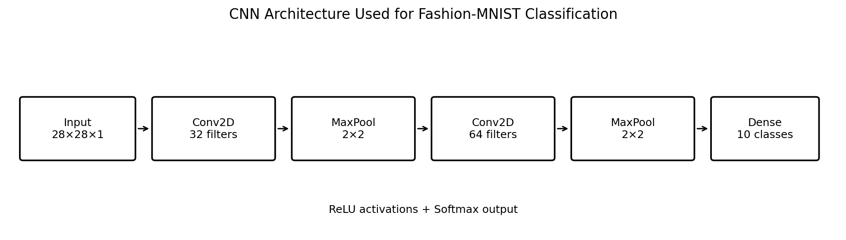
Figure 1. CNN architecture used in the implementation. The actual model also includes Flatten and Dropout between the second pooling stage and the final dense layers.
Layer | Configuration | Purpose
Input | 28×28×1 | Accept grayscale image
Conv2D | 32 filters, 3×3, ReLU | Learn low-level visual features
MaxPooling | 2×2 | Reduce spatial dimensions
Conv2D | 64 filters, 3×3, ReLU | Learn deeper visual patterns
MaxPooling | 2×2 | Further spatial reduction
Flatten | — | Convert feature maps to a vector
Dense | 128, ReLU | Learn higher-level combinations
Dropout | 0.30 | Regularization
Output | 10, Softmax | Produce class probabilities

7. Training Configuration
Setting | Value | Rationale
Optimizer | Adam | Adaptive and widely used for neural-network training
Learning rate | 0.001 | Standard starting point for this experiment
Loss | Sparse categorical cross-entropy | Suitable for integer-encoded multiclass targets
Batch size | 128 | Balances memory use and gradient stability
Maximum epochs | 10 | Allows learning while keeping training practical
Early stopping | patience=2 | Stops when validation loss stops improving
Random seed | 42 | Improves reproducibility

8. Training and Validation
The network is trained on the training partition while validation loss and validation accuracy are monitored after each epoch. Early stopping restores the best validation weights when validation loss fails to improve for two consecutive epochs. This helps control unnecessary training and provides a simple defense against overfitting.
The actual number of completed epochs and performance values are generated at runtime and saved in outputs/training_history.csv and outputs/test_metrics.csv.

9. Evaluation Metrics
- Accuracy: proportion of test images classified correctly.
- Precision: proportion of predicted examples of a class that are actually that class.
- Recall: proportion of actual examples of a class that are correctly identified.
- F1-score: harmonic mean of precision and recall.
- Confusion matrix: shows class-by-class correct and incorrect predictions.

10. Generated Visualizations
- accuracy_curve.png — training and validation accuracy across epochs.
- loss_curve.png — training and validation loss across epochs.
- confusion_matrix.png — class-level prediction errors.
- sample_predictions.png — examples of model predictions and true labels.
- cnn_architecture.png — network architecture diagram.

11. Runtime Results
The supplied Python program produces the final test loss, test accuracy, class-level classification report, and training history. These values must be taken from the actual execution. No performance values are fabricated in this report.
After running the script, the main files to inspect are outputs/test_metrics.csv, outputs/classification_report.txt, outputs/training_history.csv, and outputs/deep_learning_summary.txt.

12. Challenges and Overfitting Considerations
- CNN training can overfit when training performance continues to improve while validation performance stops improving.
- Fashion categories such as Shirt, T-shirt/top, Coat, and Pullover can have visually similar patterns, leading to class confusion.
- The image resolution is low, so fine-grained visual details may not always be available.
- Neural-network training requires more computation than a simple classical machine-learning model.
- Hyperparameters such as learning rate, batch size, architecture depth, dropout, and number of epochs affect performance.

13. How the Challenges Are Addressed
- Pixel normalization improves numerical stability during optimization.
- Dropout reduces reliance on individual hidden units and can reduce overfitting.
- Validation monitoring provides an independent signal during training.
- Early stopping prevents unnecessary epochs after validation loss stops improving.
- A confusion matrix identifies specific classes that require further investigation.

14. Strengths of the Approach
- CNNs are well suited to image data because convolution preserves spatial structure.
- The model learns features automatically rather than requiring manual image descriptors.
- The architecture is compact enough to train on a standard computer in a reasonable experiment.
- The evaluation includes both overall performance and class-level diagnostics.

15. Possible Improvements
- Tune the learning rate, batch size, dropout rate, and architecture depth.
- Add data augmentation such as small translations or rotations.
- Use batch normalization to stabilize deeper networks.
- Experiment with additional convolutional blocks.
- Compare the custom CNN with transfer-learning approaches when suitable pretrained image models are available.
- Use a learning-rate scheduler and more systematic hyperparameter search.

16. Reproducibility Instructions
From the Week 5 project directory, run:
pip install -r requirements.txt
python week5_deep_learning.py
The script downloads Fashion-MNIST through TensorFlow/Keras, trains the CNN, evaluates the test set, and saves all generated results under outputs/. A terminal screenshot showing successful execution should be added as runtime evidence if required by the internship portal.

17. Conclusion
This Week 5 project demonstrates a complete practical deep-learning workflow for image classification. The CNN architecture combines convolution, pooling, dense representation, dropout, and softmax classification. The project also demonstrates the importance of normalization, validation monitoring, regularization, and class-level evaluation. The generated runtime outputs provide evidence for assessing model quality, while the documented limitations and improvement strategies provide a path for further experimentation.

18. References
Fashion-MNIST dataset documentation and TensorFlow/Keras dataset utilities.
TensorFlow/Keras documentation — Conv2D, MaxPooling2D, Dense, Dropout, Adam, and model training.
Scikit-learn documentation — classification_report and confusion matrix utilities.

