YuvaIntern — Week 6 Task
Integrative Capstone Project and Evaluation
End-to-End Data Science Pipeline using Python
Dataset: UCI Adult / Census Income Dataset
Candidate: CH. Bhanu Prakash

1. Executive Summary
This capstone integrates the principal data-science stages practiced during the internship into one end-to-end project. The UCI Adult dataset is acquired and cleaned, explored through descriptive statistics and visualizations, segmented using K-Means clustering, and modeled as a binary classification problem using Logistic Regression. A TensorFlow/Keras dense neural network is included as a deep-learning comparison. The project emphasizes reproducibility, leakage-aware preprocessing, multiple evaluation metrics, visual diagnostics, and critical discussion of limitations.

2. Problem Statement
The project investigates patterns in demographic and employment-related data and develops models for two complementary purposes. First, unsupervised learning is used to discover groups of similar records without using the income label. Second, supervised learning is used to classify whether an individual's income is greater than 50K or less than or equal to 50K.

3. Project Objectives
- Acquire a public dataset using Python.
- Clean and preprocess mixed numerical and categorical data.
- Perform exploratory data analysis and visualization.
- Discover data segments with K-Means clustering.
- Build and evaluate a supervised classification baseline.
- Apply a neural-network model as a deep-learning comparison.
- Compare model behavior using multiple evaluation metrics.
- Document insights, limitations, challenges, and future improvements.

4. Methodological Approach
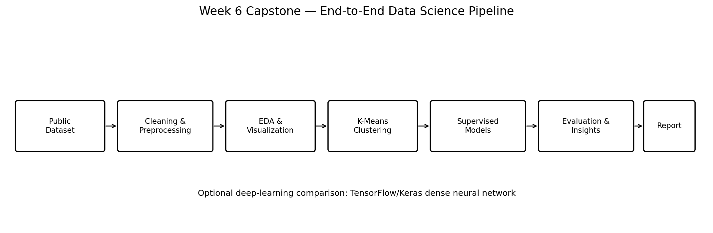
Figure 1. End-to-end capstone workflow.

5. Data Collection
The UCI Adult / Census Income dataset is acquired through the ucimlrepo Python package. The dataset contains demographic, education, employment, and financial-related attributes and a categorical income field.
Public source: UCI Machine Learning Repository — Adult dataset.

6. Data Cleaning and Feature Engineering
- Column names are standardized to consistent Python-friendly names.
- Question-mark placeholders are treated as missing values.
- Text fields are stripped of unnecessary whitespace.
- Numerical fields are converted using safe numeric conversion.
- net_capital = capital_gain − capital_loss.
- is_full_time = 1 when hours_per_week is at least 35, otherwise 0.
- Numerical missing values are handled with median imputation during modelling.
- Categorical missing values are handled with most-frequent imputation.

7. Exploratory Data Analysis
EDA is performed before modelling to understand the structure of the data. The analysis records dataset shape, missing-value counts, target distribution, descriptive statistics, age distribution, and the relationship between average weekly working hours and the income category.
- target_distribution.png
- age_distribution.png
- hours_by_income.png
- eda_summary.txt
Runtime numerical findings should be taken from outputs/eda_summary.txt after executing the script. This report intentionally does not invent numerical findings before execution.

8. Unsupervised Learning — K-Means
K-Means is used to discover groups of records without using the income target. The selected numerical and categorical features are transformed using imputation, scaling, and one-hot encoding. Candidate values of k from 2 through 7 are evaluated. Inertia is used for the Elbow Method and the Silhouette Score is used as an additional separation diagnostic.
The final k is selected by the highest Silhouette Score in the supplied implementation, while the elbow curve is considered as a complementary diagnostic. PCA is used only to visualize the high-dimensional clusters in two dimensions.
- kmeans_elbow.png
- kmeans_silhouette.png
- cluster_pca.png
- cluster_sizes.csv
- cluster_numeric_profile.csv

9. Supervised Learning — Logistic Regression
The income field is transformed into a binary target: <=50K is class 0 and >50K is class 1. The dataset is split into training and test partitions using stratification. A ColumnTransformer performs numerical imputation/scaling and categorical imputation/one-hot encoding inside a Pipeline.
Logistic Regression is used as the interpretable supervised baseline. Five-fold StratifiedKFold cross-validation is applied to the training partition. The final model is evaluated on the unseen test partition using accuracy, precision, recall, F1-score, and ROC-AUC.

10. Deep-Learning Comparison
To connect the capstone with the deep-learning work completed earlier in the internship, a TensorFlow/Keras dense neural network is trained on the same classification problem. After preprocessing, the tabular feature matrix is passed through Dense layers with ReLU activation, dropout regularization, and a sigmoid output for binary classification.
Layer | Configuration | Purpose
Input | Processed tabular features | Accept encoded feature vector
Dense | 128 units, ReLU | Learn nonlinear feature combinations
Dropout | 0.30 | Regularization
Dense | 64 units, ReLU | Learn deeper representation
Dropout | 0.20 | Regularization
Output | 1 unit, sigmoid | Binary class probability
Early stopping monitors validation loss and restores the best weights. The model is evaluated using the same main classification metrics as the Logistic Regression baseline.

11. Evaluation Framework
Component | Metrics / diagnostics | Purpose
Clustering | Inertia, Silhouette Score, PCA | Assess cluster structure and visualize segments
Classification | Accuracy, Precision, Recall, F1 | Measure prediction quality
Ranking | ROC-AUC | Assess discrimination across thresholds
Error analysis | Confusion Matrix | Identify false positives and false negatives
Deep learning | Training/validation curves | Inspect learning behavior and possible overfitting

12. Model Comparison
The script creates outputs/model_comparison.csv containing the test-set metrics for Logistic Regression and the TensorFlow dense neural network. The comparison should be interpreted across several metrics rather than by accuracy alone. The appropriate interpretation depends on the application's tolerance for false positives and false negatives.
Actual runtime results should be inserted from outputs/model_comparison.csv after execution.

13. Insights and Interpretation
The capstone supports two types of insight. Cluster analysis identifies groups of observations with similar feature representations, while supervised models identify patterns associated with the income target. These outputs are descriptive and predictive rather than causal. A cluster or model coefficient should not be interpreted as proof that one demographic or employment attribute causes an income outcome.

14. Challenges Encountered
- Mixed numerical and categorical features require different preprocessing operations.
- Missing values need to be handled without leaking information from the test set.
- K-Means is sensitive to feature scaling and the selected number of clusters.
- Class imbalance means accuracy alone does not fully describe classifier behavior.
- The neural network introduces additional training and hyperparameter considerations.
- PCA provides only a two-dimensional view of a much higher-dimensional feature space.

15. How the Challenges Were Addressed
- ColumnTransformer separates numerical and categorical preprocessing.
- Preprocessing is placed inside model pipelines for supervised learning.
- StandardScaler is applied to numerical features before distance-based clustering.
- Several k values are evaluated rather than assuming one cluster count.
- Cross-validation and multiple classification metrics are used.
- Dropout and early stopping are used for the neural network.

16. Limitations
- The selected dataset and its historical context limit how broadly results can be generalized.
- K-Means assumes centroid-based structure and can be sensitive to initialization and feature representation.
- Logistic Regression may not capture complex nonlinear relationships.
- A dense neural network may require more computation and tuning than the baseline.
- Model performance does not establish causal relationships.
- Sensitive demographic attributes require careful interpretation and responsible use in real applications.

17. Recommendations for Further Analysis
- Compare additional supervised models such as Random Forest and Gradient Boosting.
- Tune model hyperparameters using a validation strategy.
- Test alternative clustering methods such as hierarchical clustering or DBSCAN.
- Investigate feature importance and model explainability methods.
- Perform calibration and threshold analysis for the classifier.
- Evaluate fairness-related metrics before considering real-world deployment.
- Use domain knowledge to validate whether discovered clusters have meaningful interpretations.

18. Reproducibility Instructions
From the Week 6 project directory:
pip install -r requirements.txt
python week6_capstone.py
The script generates all runtime statistics, model metrics, charts, cluster profiles, and the model comparison inside outputs/. Add a genuine terminal screenshot and selected generated plots to the final report if the portal requires visual execution evidence.

19. Final Conclusion
The Week 6 capstone demonstrates an end-to-end data science workflow using Python. It combines data acquisition, cleaning, feature engineering, EDA, unsupervised clustering, supervised classification, deep-learning comparison, evaluation, visualization, and critical interpretation. The project is designed to be reproducible and to provide evidence at each stage of the pipeline. The final conclusions should be based on the actual outputs generated by the script and should consider both model performance and the limitations of the dataset and methods.

20. References
UCI Machine Learning Repository — Adult Dataset.
Scikit-learn documentation — preprocessing, KMeans, LogisticRegression, cross-validation, and metrics.
TensorFlow/Keras documentation — Dense layers, Dropout, Adam, and model training.
Pandas and Matplotlib documentation.

