**TOPIC NAME:**

**STUDENT NAME:**

**UNIVERSITY NAME:**

**COURSE NAME:**

**INSTRUCTOR NAME:**

**DATE OF SUBMISSION:**

**INTRODUCTION**

Our project, "SmartWaste," is a machine learning approach that revolutionizes garbage image classification in the face of growing urban waste. Our technology employs sophisticated algorithms and neural networks to precisely classify waste photos into recyclables, non-recyclables, organics, and hazardous items, thereby mitigating the inefficiencies associated with manual sorting. Our goals in automating this process are to decrease the environmental effect, increase sustainability, and improve the efficiency of trash management. As a technologically advanced solution to optimize resource allocation, reduce landfill waste, and support worldwide environmental conservation efforts, SmartWaste represents an important step towards smart city initiatives.

**DATASET DESCRIPTION**

Presenting the "TrashType_Image_Dataset," a large assemblage of eight discrete categories: "hazardous," "medical waste," "cardboard," "glass," "metal," "paper," "plastic," and "trash." This dataset, which comes in at a manageable 62.33 MB and has 3177 files in total, offers a sophisticated viewpoint on waste recycling. In contrast to traditional datasets that only provide a few classes, our set facilitates the sorting process by providing a more thorough breakdown. This fine-grained classification is essential for streamlining the recycling process and offers a chance to greatly increase the proportion of recycled household waste. The "TrashType_Image_Dataset" proves to be a useful tool for improving environmental conservation by means of thorough and effective garbage sorting.

**METHODOLOGY**

This project includes a thorough machine learning approach for classifying junk images. We started by looking through the "TrashType_Image_Dataset," which is a carefully selected set of 3177 photos divided into eight categories: hazardous, medical waste, cardboard, glass, metal, paper, plastic, and general rubbish. In order to comprehend class imbalances, a careful analysis of the dataset's content distribution was carried out, which exposed the different file counts for each category. To further understand the diversity of the dataset, we conducted exploratory data analysis (EDA) and then showed example photos from several categories such as 'paper,''metal,' and 'plastic'. We then used color histogram computing to extract features, obtaining crucial data for every picture.

Histograms of the photos were created to create the dataset, which served as the foundation for training the model. We performed thorough model training and evaluation using the Random Forest Classifier, Support Vector Machine (SVM), Logistic Regression, and k-Nearest Neighbors (KNN) methods. The training and testing sets of the dataset were divided, and feature scaling was done for SVM. After the models underwent training and accuracy testing, each model was assigned a classification report.

This methodology fosters a strong understanding of trash image classification by encapsulating a systematic approach from dataset exploration and feature extraction to model training and evaluation. Because of the variety of models used, a thorough evaluation of their performance is ensured, providing the foundation for future optimization and use in actual waste management situations.

**RESULT AND ANALYSIS**

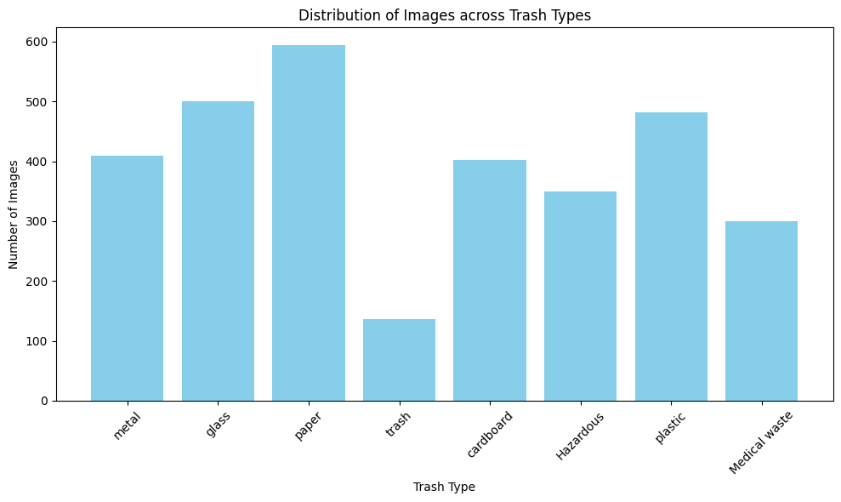

**Figure 1:Distribution of trash(created by author)\**

**Figure 2:Segregation of products(created by author)**

**Figure 3: More segregation(created by author)**

**Figure 4: More segregation(created by author)**

**Conclusion:**

In summary, the "SmartWaste" project introduces a pioneering machine learning solution for efficient garbage image classification in the face of growing urban waste. Through the comprehensive "TrashType_Image_Dataset," featuring eight distinct categories, our approach streamlines recycling processes, contributing to environmental conservation. The methodology, spanning dataset analysis, feature extraction, and model training with various algorithms, ensures a robust understanding of trash image classification. SmartWaste aligns with smart city initiatives, offering a technologically advanced solution to enhance overall trash management efficiency. The fine-grained classification not only improves recycling but also supports global sustainability efforts.