Name : Bhanu Dixit

Roll Number:- 2023DSS1009(MSDSM/01/08)

BSE200(2016-20)

1.Plat for BSE 200 data. As we can see that this plot has a trend initially as follows:

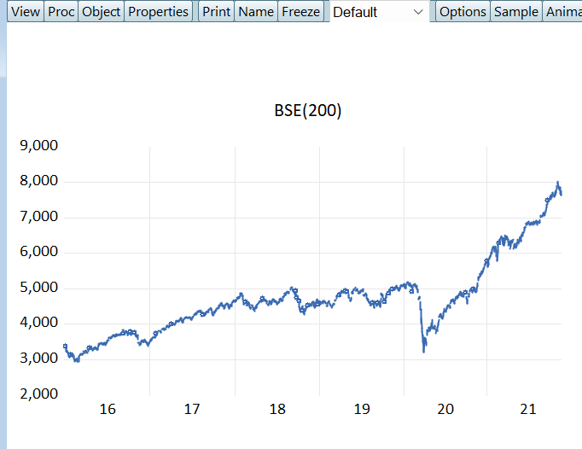

But after one logarithmic difference it plots is as follows:-

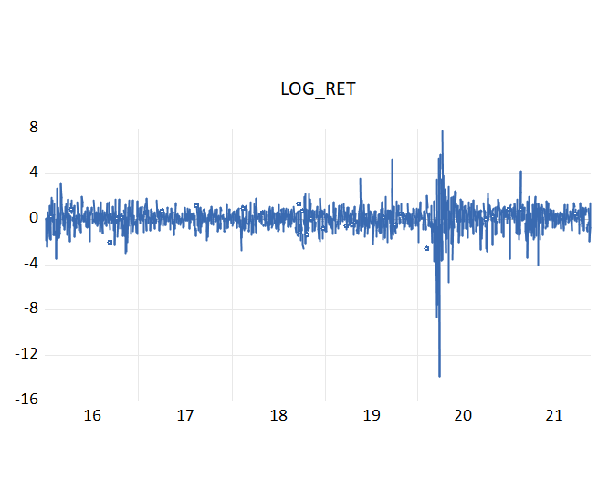

2. Descriptive statsistc as as follows:

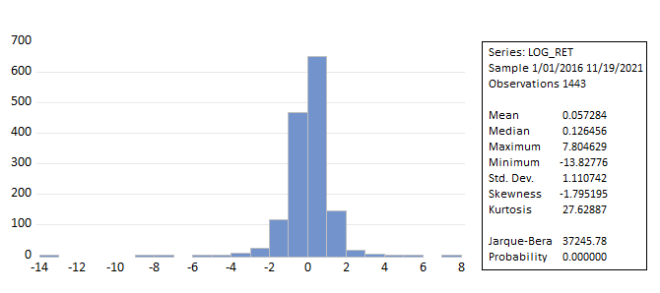

**Max :**

* This indicates that the maximum return in one day is 7.8 %

**Min**: -13.82776

* This indicates that the maximum negative return is one day is 13.8 %

**Mean** :

* The average value of log returns is 0.057 slightly positive, suggesting a small upward trend in returns over the observed period.

**Median**:

* The median is slightly higher than the mean, indicating a slight positive skew with value of 0.12.

**Standard Deviation**:

* Indicates a moderate level of volatility in the log returns with a value of 1.110742.

3. AR, MA , and ARIMA model are applicable to stationary series and we need to check the log returns are stationary or not. Therefore we will run a unit root test.

Fig :- One root Unit Test

As we can see, the p-value is less than the significance level, which means it is stationary.

To find the value of p , for AR and MA model we need to plot the Correlogram

As we can see I the above graph we p=5 or p=6 could be chosen.

1. p= 5

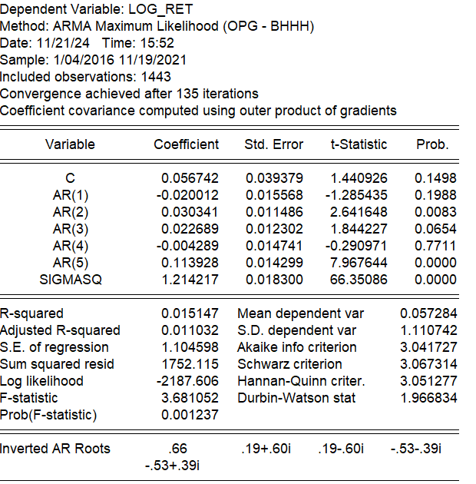

1. **Durbin-Watson Statistic:**
   * Value = 1.966834
   * This statistic is close to 2, indicating little evidence of autocorrelation in the residuals.
2. **F-statistic:**
   * Value = 3.681052, with a p-value = 0.001237.
   * Indicates the model as a whole is statistically significant.

Now we will check residuals

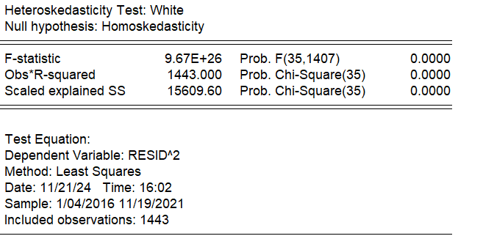

This means this is heteroskedastic and we need to find some other model and we are getting similar results for p=6.

B) For MA model we take q= 6 based on correlogram

The model seems to be significant, but we need to check Residuals as well.

This means residuals are heteroskedastic.

C) For Arima we run auto arima and found results as follows:

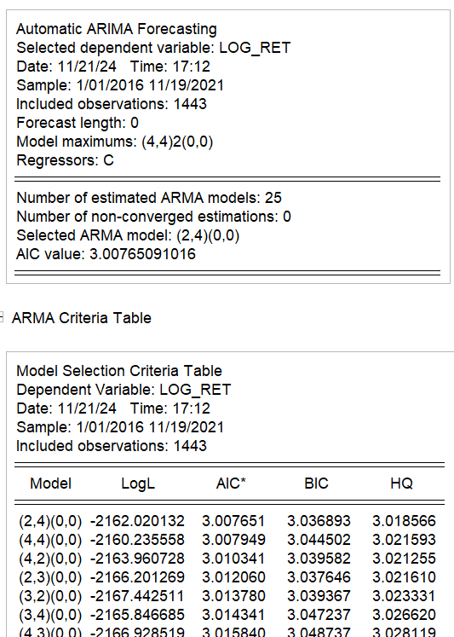

So we have some models with as(2,4),(4,4.)and (4,2) as minimum value of AIC.

So will make an equation dor each of them then check if they are valis or not.

For (2,4)

And Residuals

For (4,4)

And Residuals

For (4,2)

For residuals

In all the above combinations of p and q, we got a provability value less than significant level but they are heteroskedastic

4.

We have check ar for 3 ,odels as (1,1) (1.,0) and (0,1) and results are as follows.

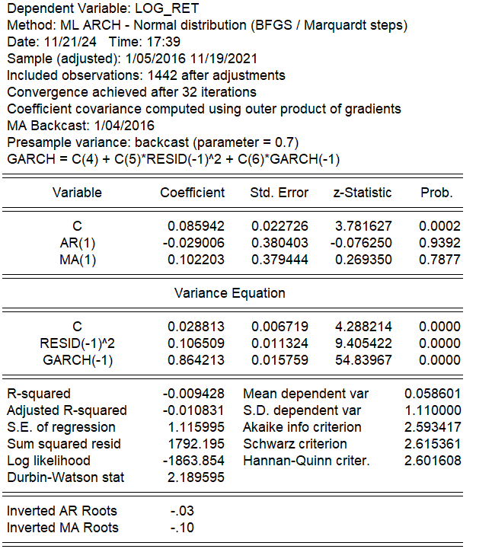

Only the (0 1 ) model is able to justify homoscedastic . Else. All others are there heteroskedastic even after having a p-value less than the significance level.

•**R-squared**: −0.009303-0.009303−0.009303

* Indicates poor explanatory power for the mean equation. This is common in financial return models where the focus is on modeling volatility rather than returns.

**Log-likelihood**: −1865.704-1865.704−1865.704

* Used to compare model fit across specifications.

**Akaike (AIC) and Schwarz Criterion (SIC):**

* AIC = 2.592798, SIC = 2.611074
* Lower values indicate better model fit.

**Durbin-Watson Stat (2.18):**

* Close to 2, indicating little to no autocorrelation in residuals.

This output summarizes the results of a GARCH (1,1) model for the dependent variable LOG_RET\text{LOG\_RET}LOG_RET, which appears to be a time series of log returns. Here's the interpretation of the key results:

**Mean Equation**

The mean equation is modeled as:

LOG_RET=C+MA(1)+ϵt\text{LOG\_RET} = C + \text{MA(1)} + \epsilon_tLOG_RET=C+MA(1)+ϵt​

* **C (Constant):**
  + Coefficient = **0.085637**
  + ppp-value = **0.0002** (significant at the 1% level).
  + Interpretation: The constant term is positive and statistically significant, indicating a positive average return over the period.
* **MA(1) (Moving Average):**
  + Coefficient = **0.073219**
  + ppp-value = **0.0121** (significant at the 5% level).
  + Interpretation: The MA(1) term is significant, suggesting that the model accounts for short-term dependencies in the time series data.

**Variance Equation (GARCH Model)**

The variance equation is modeled as:

σt2=C+α⋅ϵt−12+β⋅σt−12\sigma_t^2 = C + \alpha \cdot \epsilon_{t-1}^2 + \beta \cdot \sigma_{t-1}^2σt2​=C+α⋅ϵt−12​+β⋅σt−12​

Where:

* ϵt−12\epsilon_{t-1}^2ϵt−12​: Lagged squared residual (ARCH term)
* σt−12\sigma_{t-1}^2σt−12​: Lagged conditional variance (GARCH term)
* **C (Constant in variance):**
  + Coefficient = **0.028992**
  + ppp-value = **0.0000** (significant).
  + Interpretation: This represents the long-term variance. It is positive and statistically significant, indicating the baseline level of volatility.
* **RESID(-1)^2 (ARCH term):**
  + Coefficient = **0.106301**
  + ppp-value = **0.0000** (significant).
  + Interpretation: The ARCH effect is significant, meaning that past shocks to returns influence current volatility.
* **GARCH(-1) (GARCH term):**
  + Coefficient = **0.863915**
  + ppp-value = **0.0000** (significant).
  + Interpretation: The GARCH effect is dominant, suggesting a strong persistence of volatility over time.

**Sum of ARCH and GARCH coefficients (α+β\alpha + \betaα+β):**

* α+β=0.106301+0.863915=0.970216\alpha + \beta = 0.106301 + 0.863915 = 0.970216α+β=0.106301+0.863915=0.970216
* This is less than 1, satisfying the stationarity condition of the GARCH model. However, the high value indicates persistent volatility.

**Model Diagnostics**

* **R-squared**: −0.009303-0.009303−0.009303
  + Indicates poor explanatory power for the mean equation. This is common in financial return models where the focus is on modeling volatility rather than returns.
* **Log-likelihood**: −1865.704-1865.704−1865.704
  + Used to compare model fit across specifications.
* **Akaike (AIC) and Schwarz Criterion (SIC):**
  + AIC = 2.592798, SIC = 2.611074
  + Lower values indicate better model fit.
* **Durbin-Watson Stat (2.18):**
  + Close to 2, indicating little to no autocorrelation in residuals.

**Conclusion**

* The mean equation shows a significant constant and MA(1) term, indicating modest predictability in returns.
* GARRCH is better than ARIMA as it id homoscsdic.
* The variance equation effectively captures volatility clustering, with significant ARCH and GARCH terms and persistent volatility.
* Diagnostic statistics suggest that the model is well-specified for modeling volatility but has limited explanatory power for returns, as expected in financial time series analysis.