Serverless Architectures with Amazon DynamoDB and Amazon Kinesis Streams with AWS Lambda

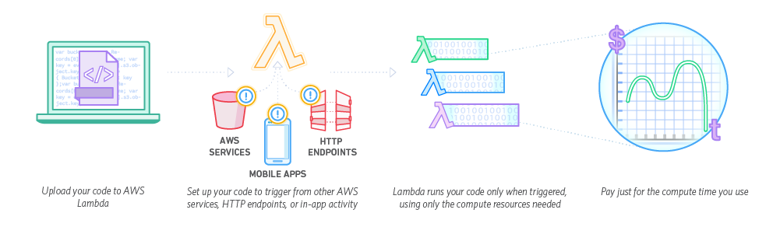

**Steps:**

1. Creating a kinesis stream

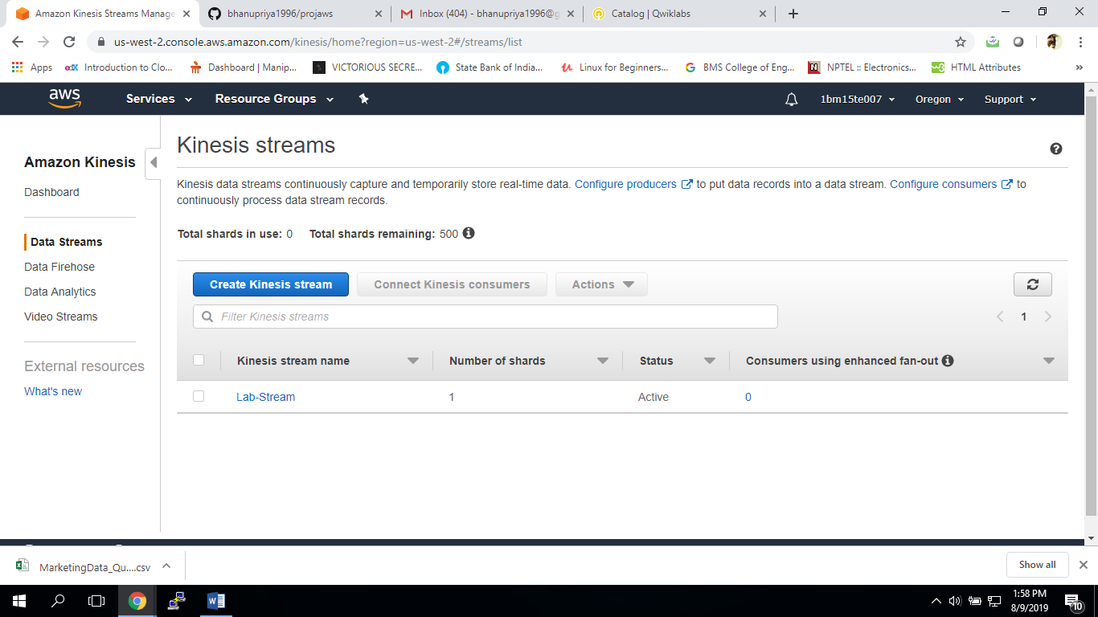

1. Creating a lambda function named as bhanu-ProcessKinesisRecords

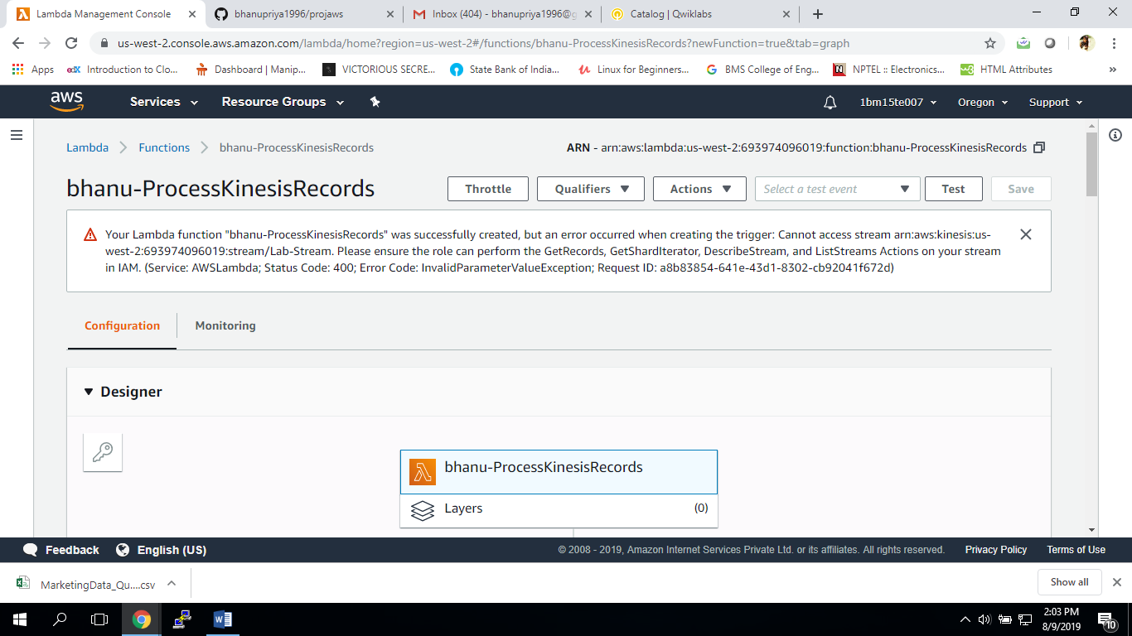

1. Testing the function

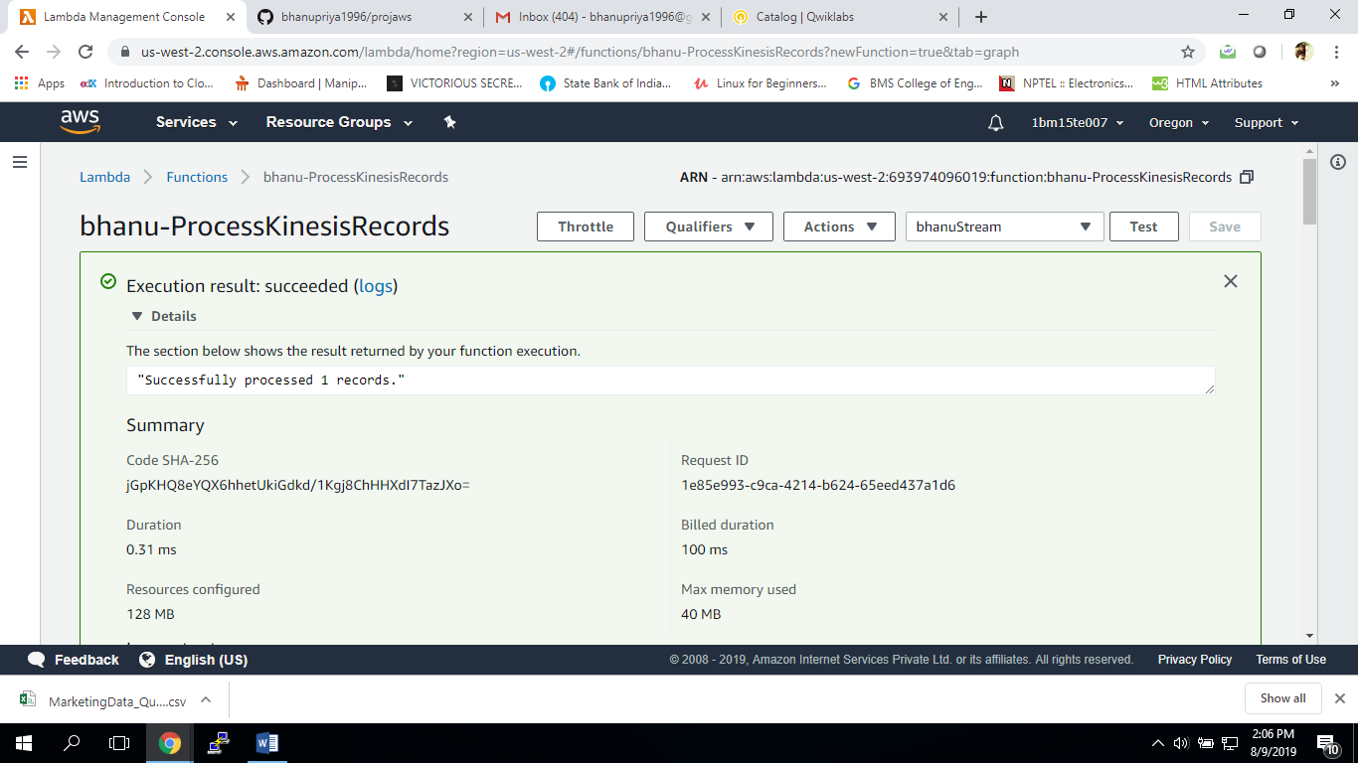

1. 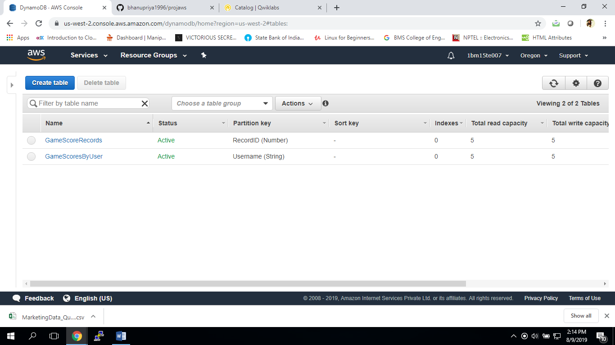Under event driven programming, we have to use DynamoDB and Lambda. First we create two tables in DynamoDB.
2. Creating a lambda function which will be triggered by updates in the DynamoDB table.

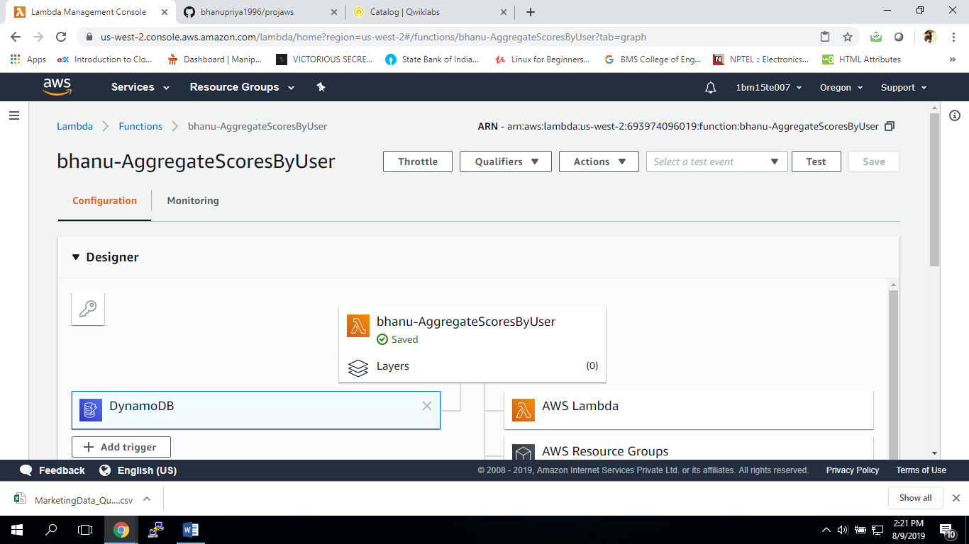

1. Adding data to table “game scores of users’

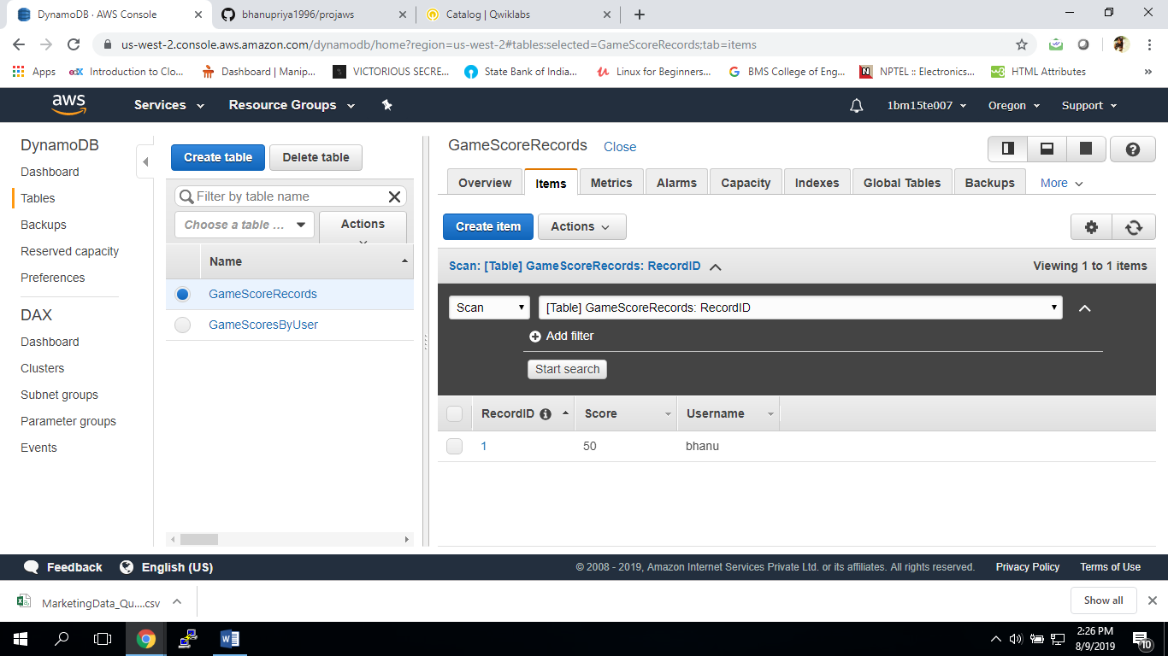

1. On making entries in table “game scores records”, the records are added in the table “game scores by users” as well.

