NAME:p.bhanu vardhan reddy

Reg no: 192110104

Write an assembly language program to find factorial of n in the given number.

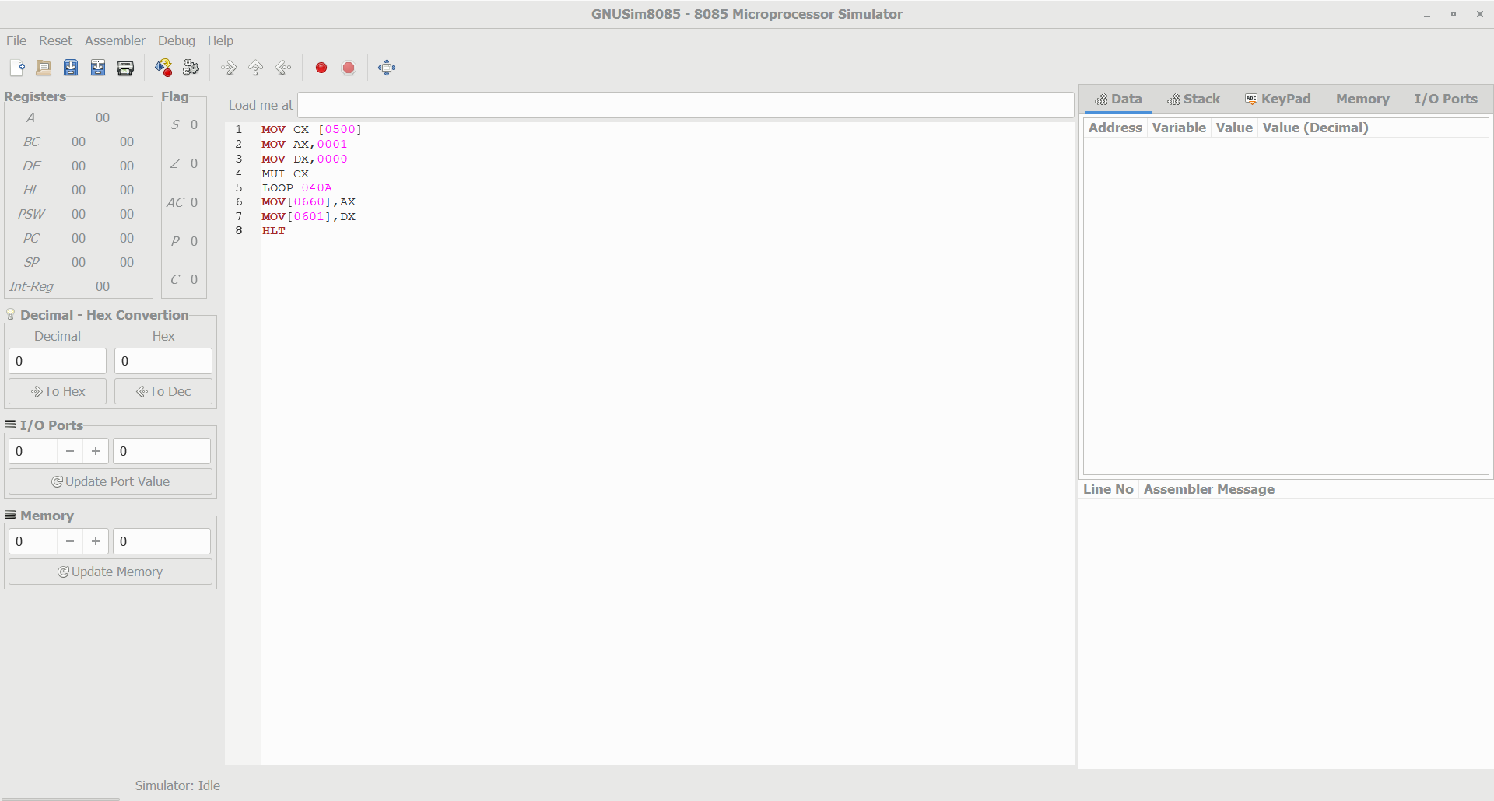

1. Write a program to convert Binary to Hexadecimal number to number using any high level language.

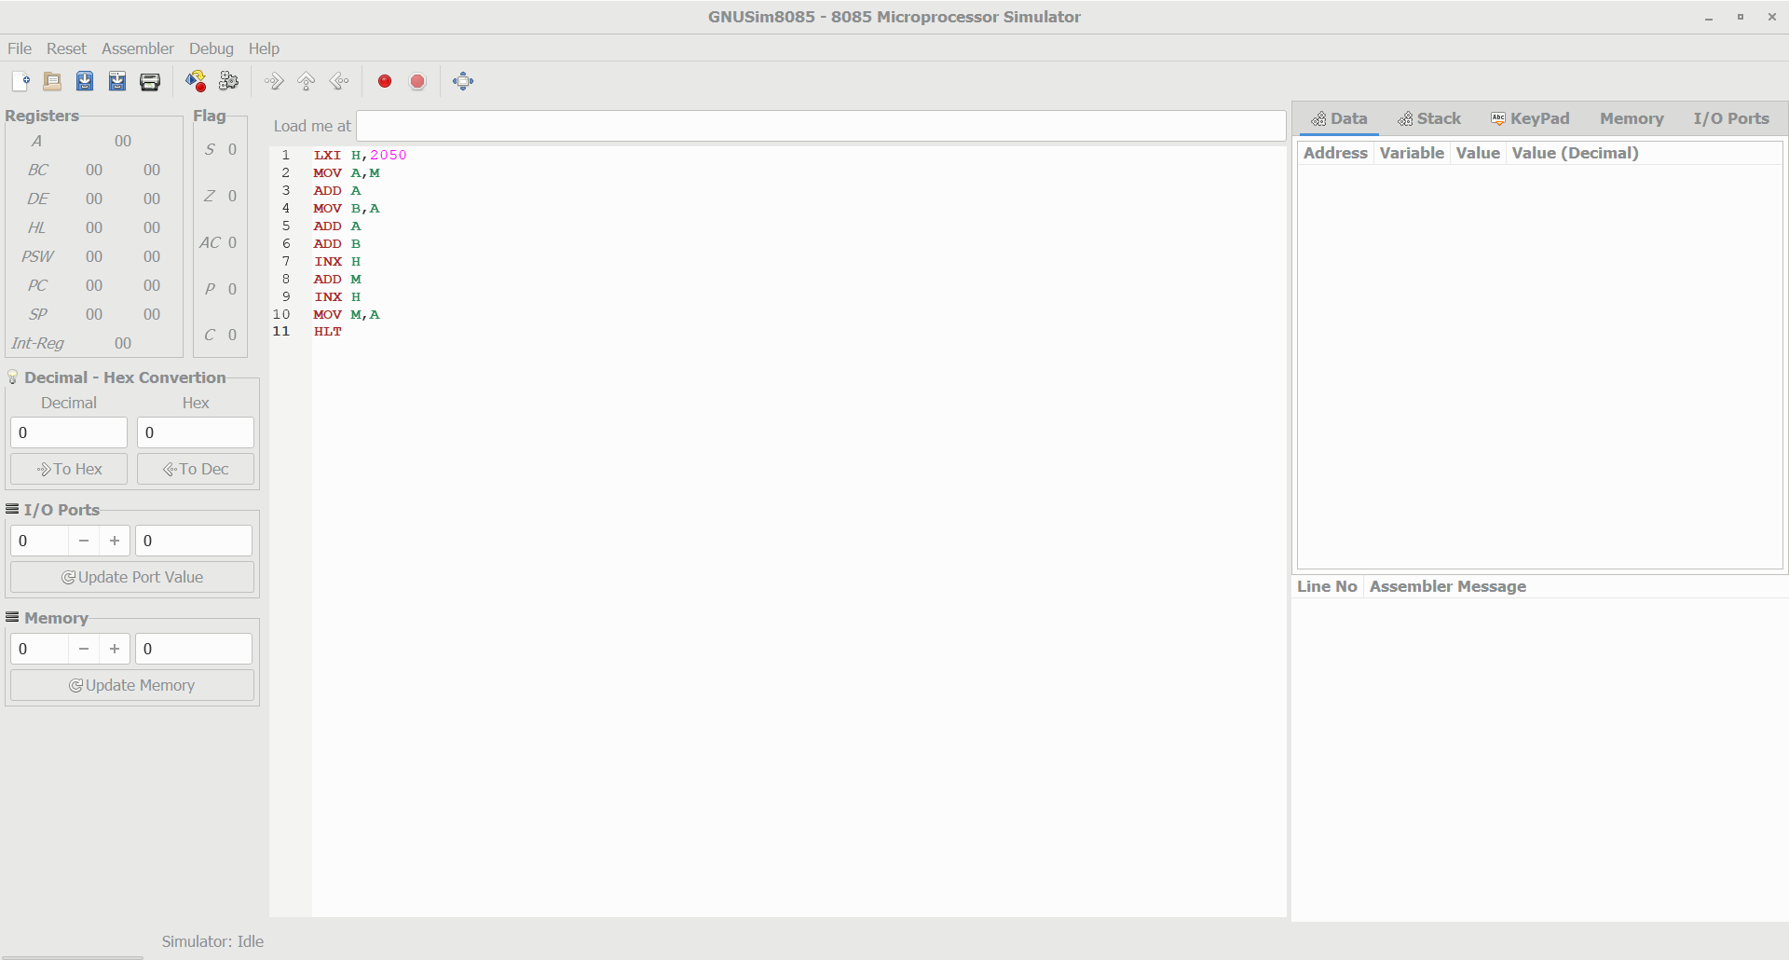

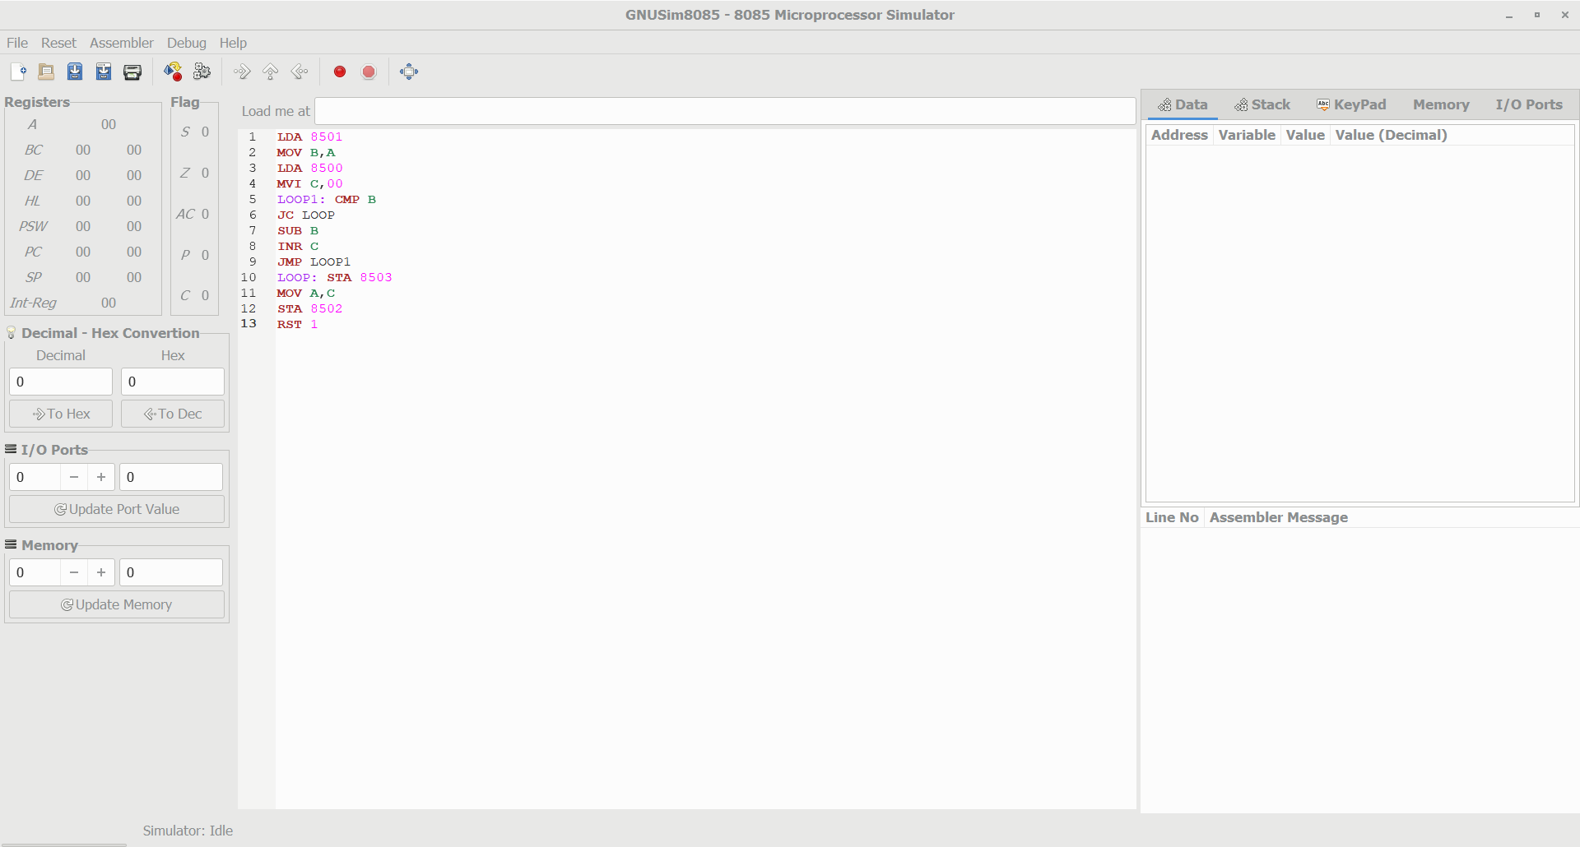

1. Write an assembly language program to find the given 8-bit number is Prime or not using 8085 processor.

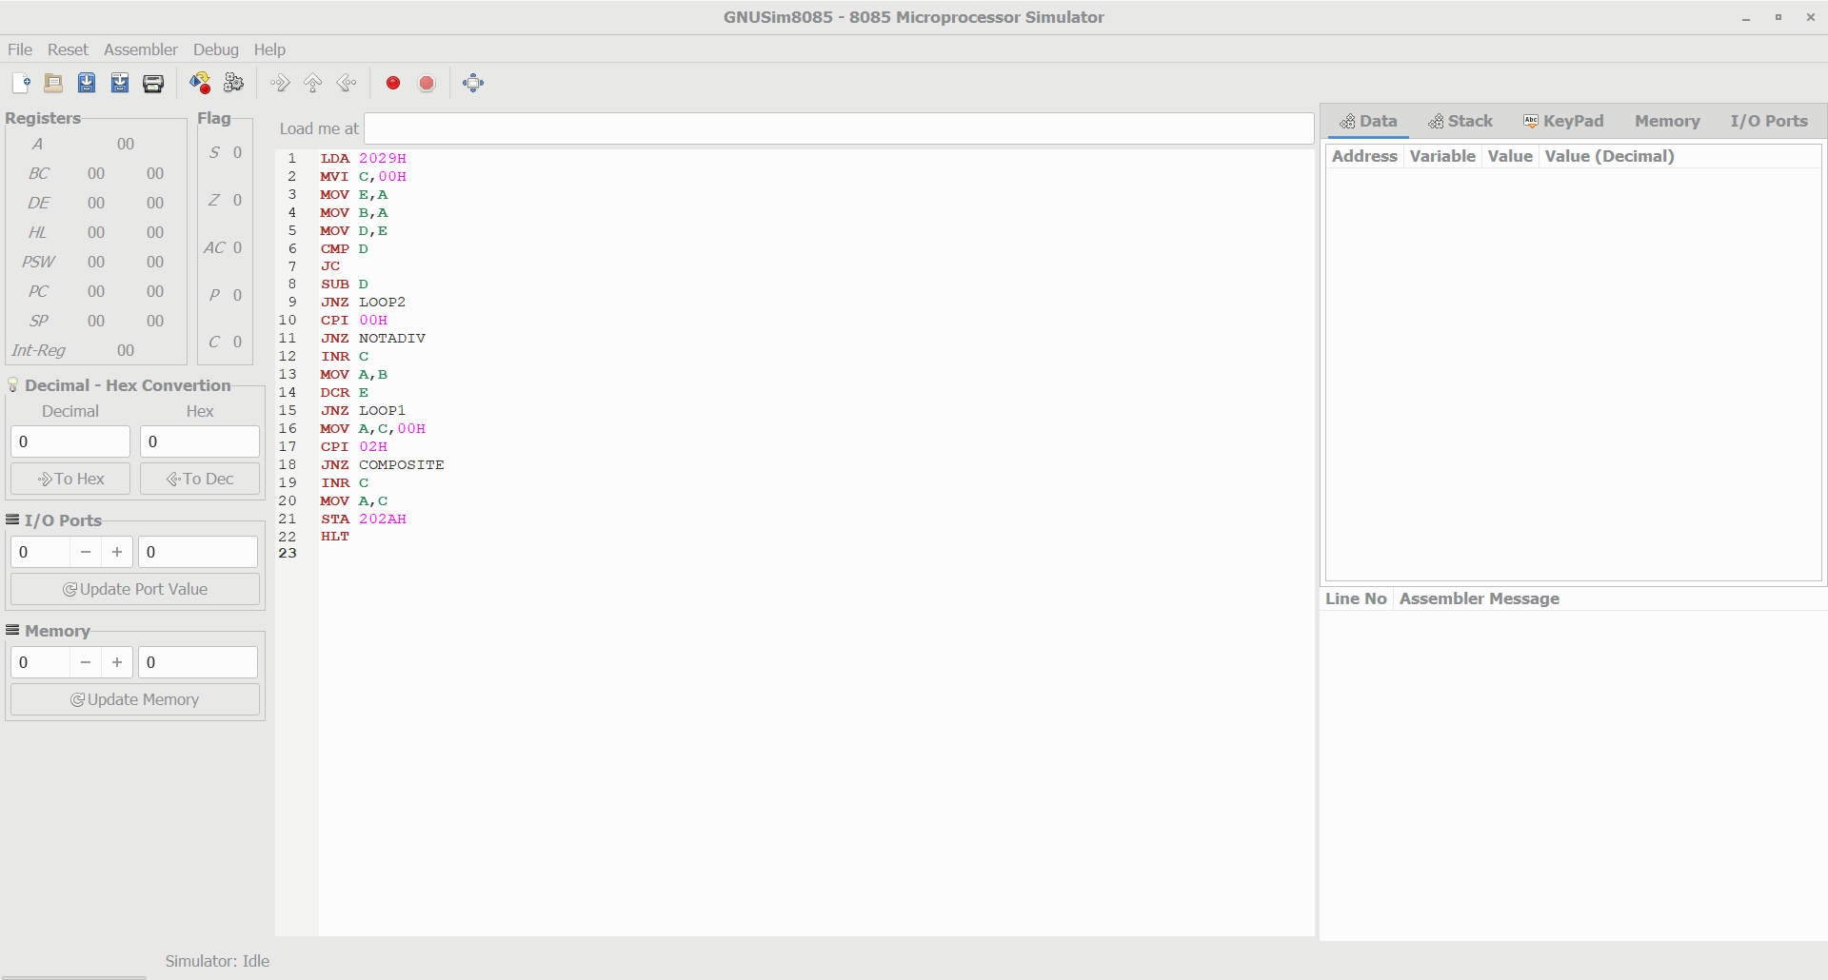

add

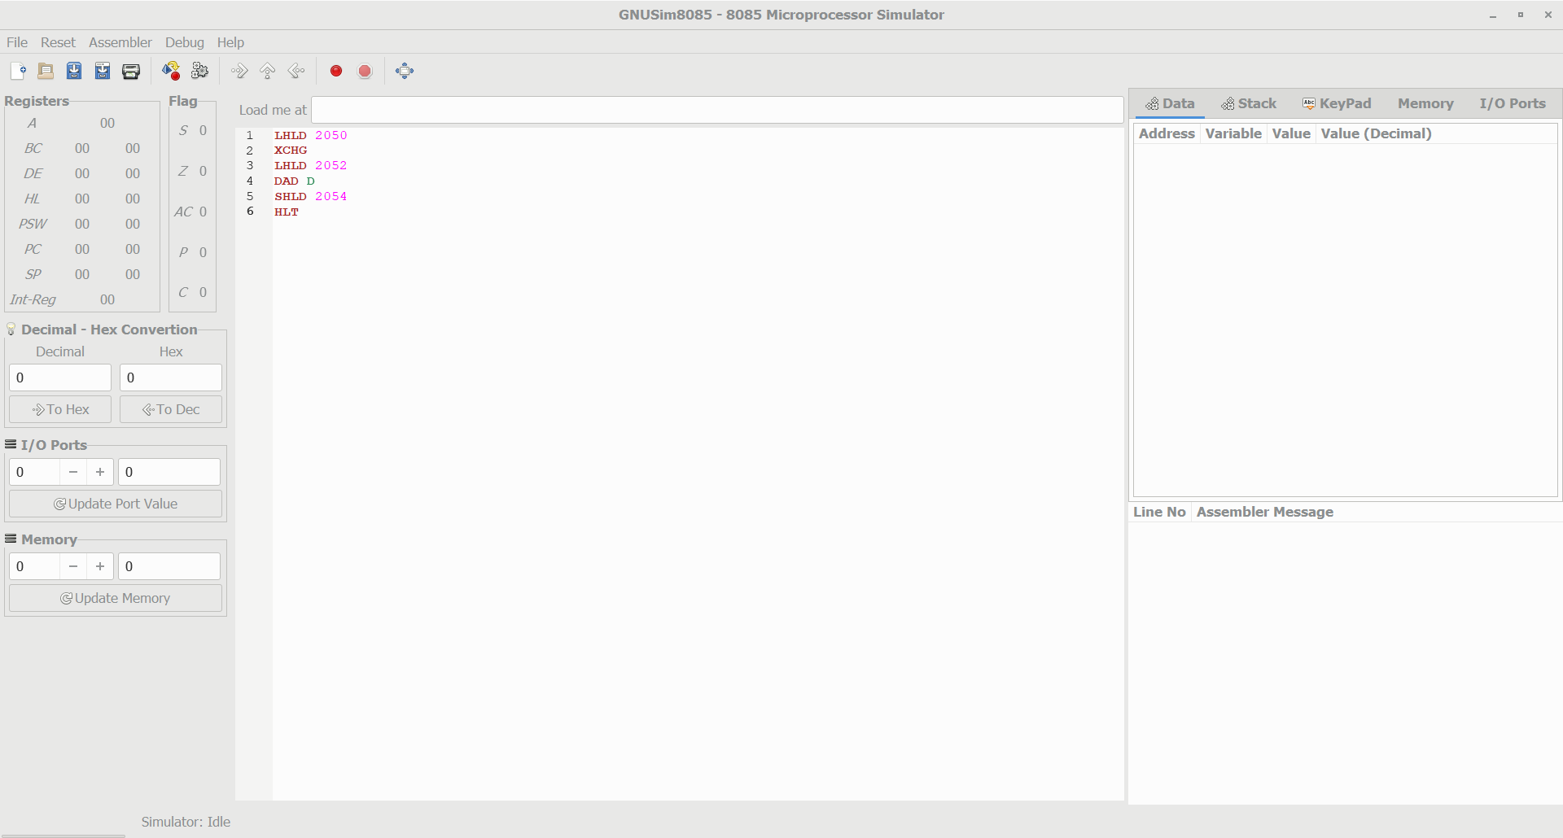

Sub

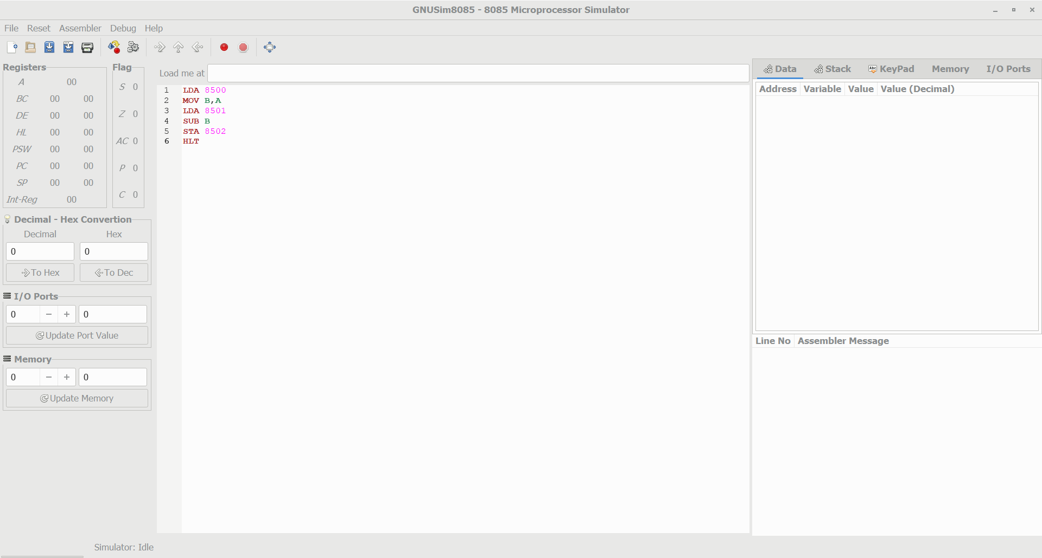

2 STAGE PIPELINE ADDITION AND SUBTRACTION

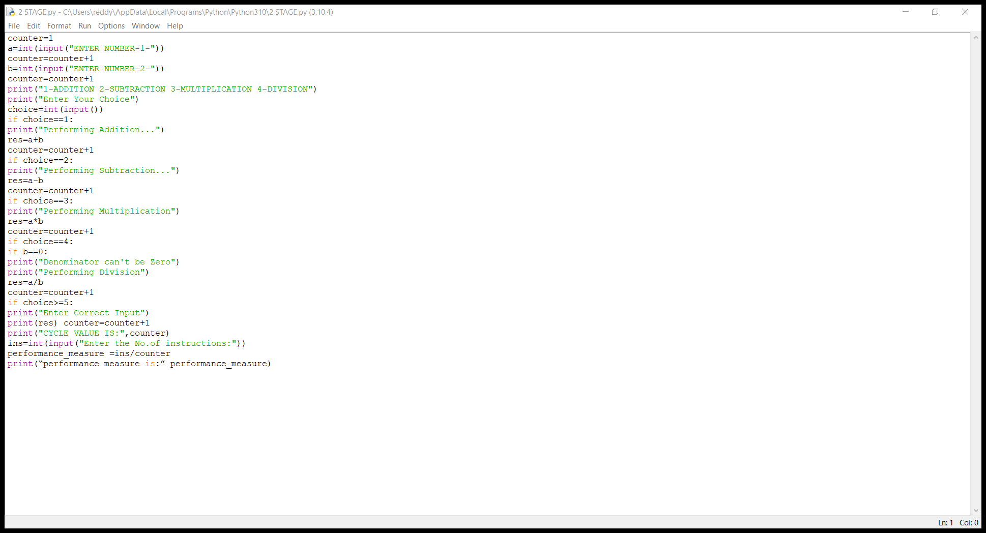

3 STAGE PIPELINE