Capstone Project Documentation
Multimodal Ocular Disease Prediction
(Myopia + Other Ocular Conditions)
Prepared by: Bhanu
Dayananda Sagar University (CDSIMER), Bengaluru — Final Year CSE
Capstone Supervisor: Dr. Revathi V
Document status: living log — updated after every major project stage
This is a single, continuously-updated technical log. Every number in this document was produced by running real code against the actual project dataset — nothing here is projected, assumed, or fabricated. Sections not yet reached are marked “Not started.”

Pipeline Progress at a Glance
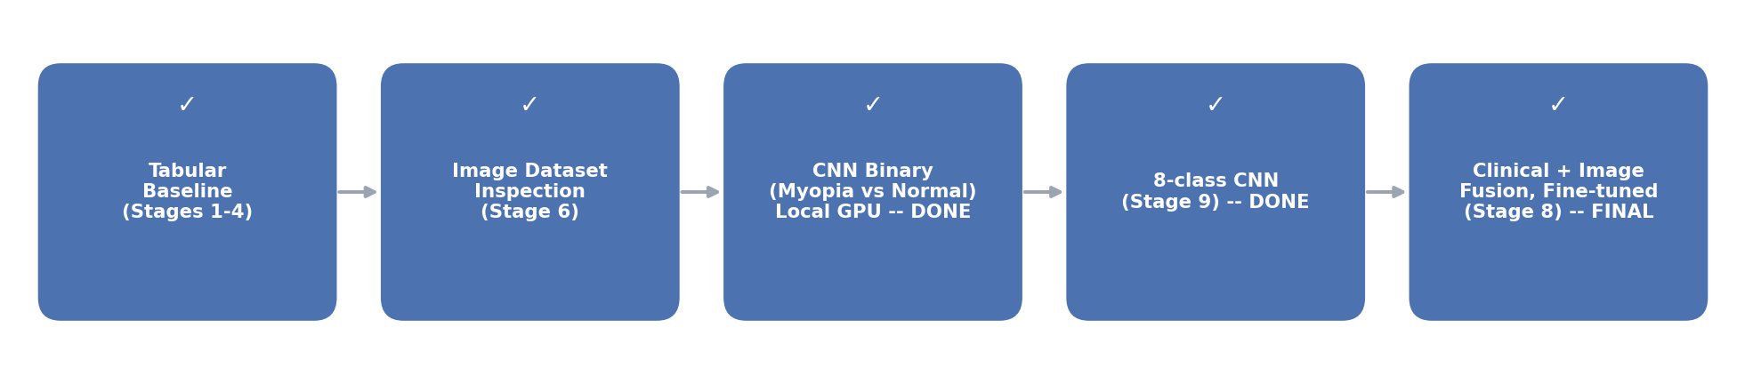
Tabular baseline, image inspection, binary CNN, 8-class CNN, clinical+image fusion, and a fine-tuned final fusion model are all complete (Sections 3.3–3.6). A prediction web app covers both tasks (Section 3.7). The 8-class model was improved three times, explained with Grad-CAM, tested on a second dataset (RFMiD) and retrained on both datasets (Sections 3.8–3.13), and a batch screening tool sorts many photos by urgency (Section 3.14), and it was compared fairly with seven standard networks and published work (Section 3.15).
☑ Stage 1 — Data Exploration
☑ Stage 2 — Data Cleaning + Feature Identification
☑ Stage 3 — Normalization / Encoding + Patient-level Split
☑ Stage 4 — Classification (Experiment 1: Myopia vs Non-Myopia)
☐ Stage 5 — Evaluation / model refinement
☑ Stage 6 — Fundus image dataset inspection / validation
☑ Stage 7 — Image model (transfer learning) — binary Myopia vs Normal trained on local RTX 4060, real ImageNet weights: 96.6% test accuracy / 89.5% macro-F1 (Section 3.3). 8-class CNN added later (Section 3.6).
☑ Stage 8 — Multimodal fusion — first clinical+image feature-fusion proof-of-concept, patient-grouped, real Stage 3.3 image weights reused: 90.5% accuracy / 72.4% macro-F1, underperforms the image-only model (Section 3.4).
☑ Stage 9 — Final model improvement — fine-tuned the image backbone jointly with the fusion head; final model reaches 97.4% accuracy / 87.5% macro-F1, closing most of the gap to the image-only model while still using both modalities (Section 3.5).
☑ Stage 10 — Multi-class (8 diseases) — clinical-only and image-only models on one patient-grouped split; image model reaches 49.8% accuracy / 48.1% macro-F1 vs a 7.8% majority-class baseline (Section 3.6).
☑ Stage 11 — Prediction web app — Streamlit UI with a Myopia check (Stage 8 model) and an 8-disease screen (Stage 9 model), tested end-to-end (Section 3.7).
☑ Stage 12 — Improved 8-class model — EfficientNet-B0, 448px, whole network trained on the local RTX 4060: 71.5% accuracy / 63.5% macro-F1 / mean AUC 0.871, up from 49.8% / 48.1%; now used by the web app (Section 3.8).
☑ Stage 13 — Grad-CAM heatmaps and a two-model ensemble (512px + contrast enhancement): 71.8% accuracy / 64.0% macro-F1 / mean AUC 0.912 (Sections 3.9–3.11).
☑ Stage 14 — External test on RFMiD (another clinic, no retraining): mean AUC 0.752, Myopia AUC dropped to 0.755 — clear domain shift (Section 3.12).
☑ Stage 15 — Trained on ODIR + RFMiD: 72.0% accuracy / 65.5% macro-F1 on ODIR test; RFMiD mean AUC 0.745 → 0.800, Myopia 0.714 → 0.906; now used by the web app (Section 3.13).
☑ Stage 16 — Batch screening tool: sorts many photos into Refer / Doctor review / Likely normal / Retake; on 1,600 test photos 93.6% of diseased eyes reach a doctor and 91.0% of Refer photos are really diseased (Section 3.14).
☑ Stage 17 — Fair comparison with 7 standard networks + published ODIR-5K work, learning curve, and an improved final model (Stage 13 + DenseNet-121): 72.7% accuracy / 0.666 macro-F1 / mean AUC 0.928 — top of the benchmark (Section 3.15).

1. Project Overview
Final-year CSE capstone project. Original scope was myopia prediction; after the initial guide review, scope was expanded to a multimodal ocular disease prediction system covering myopia and other eye conditions.

2. Project Objective
Build a system that predicts ocular disease status from:
- Clinical / demographic data → ML model
- Fundus retinal images → CNN / deep learning model
- Both combined → feature fusion → final prediction
Build order: tabular baseline first → validate and build the image pipeline → investigate multimodal fusion. The full architecture is not being built immediately.

3. Dataset Information
Item | Value
Master file | full_df.csv
Rows (image-level records) | 6,392
Columns | 19
Unique patients (ID) | 3,358
Rows per patient | 3,034 patients have 2 rows (both eyes); 324 patients have 1 row
Missing values (raw file) | 0 in every column
Fully duplicated rows | 0
Source | ODIR-5K (Ocular Disease Intelligent Recognition)
Disease columns (one-hot) | N, D, G, C, A, H, M, O = Normal, Diabetes, Glaucoma, Cataract, AMD, Hypertension, Myopia, Other
Also available | ~5,000+ fundus images (not yet used — see Section 15)

Verified positive counts per one-hot disease column (Stage 1)
N | D | G | C | A | H | M | O
2,101 | 2,123 | 397 | 402 | 319 | 203 | 306 | 1,588

3.1 Fundus Image Dataset — Inventory and Validation (Stage 6)
Code/notebooks/05_image_dataset_inspection.ipynb, executed against real image files staged from the project folder. No CNN was trained — this stage only inspects and validates the image data.
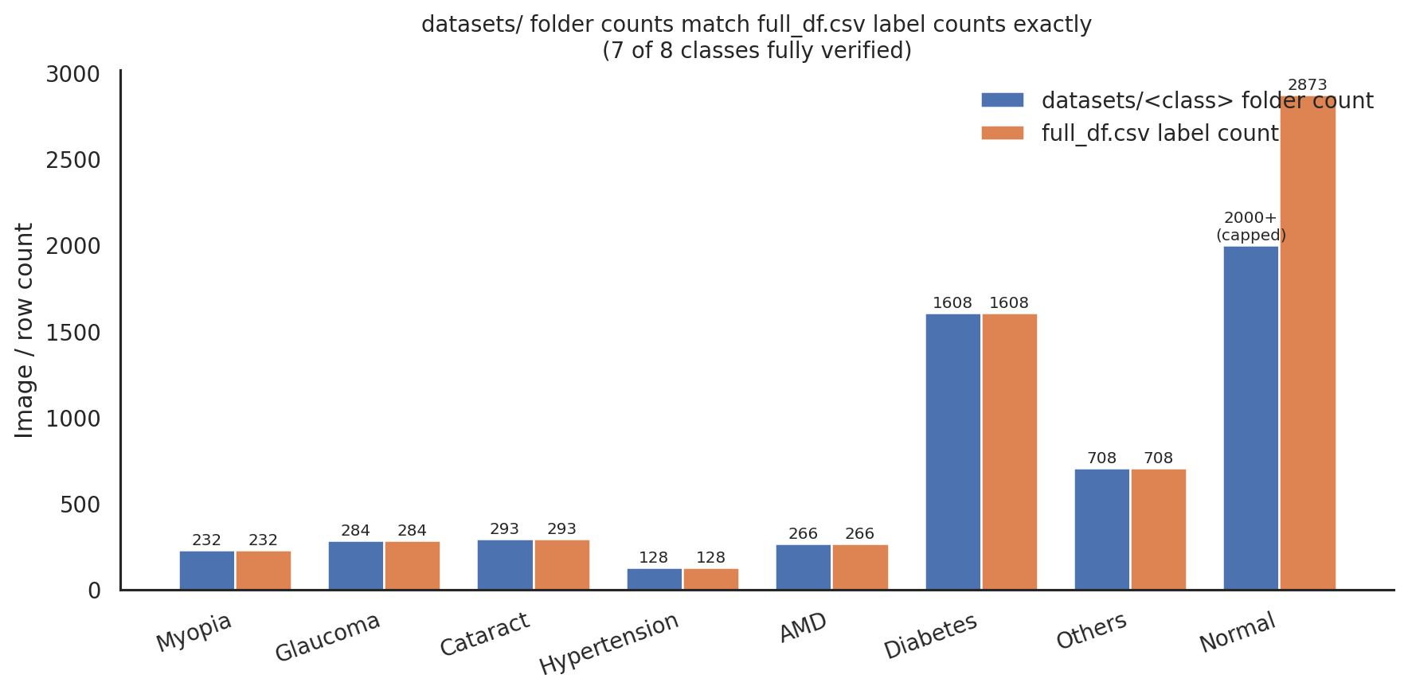
datasets/<class> folder counts vs full_df.csv per-condition label counts.
Every one of the seven fully-enumerated datasets/<class> folders matches full_df.csv's disease count exactly (Myopia 232, Glaucoma 284, Cataract 293, Hypertension 128, AMD 266, Diabetes 1,608, Others 708). This is strong evidence datasets/ was generated directly from full_df.csv, one exported image per row, filtered into per-condition folders — not an independently-collected image set.

Image location inventory
Location | Count | Format / resolution | Verified how
datasets/myopia | 232 (exact) | PNG, 224x224, RGB | Full listing, all files enumerated
datasets/glaucoma | 284 (exact) | PNG, 224x224, RGB | Full listing, all files enumerated
datasets/cataract | 293 (exact) | PNG, 224x224, RGB | Full listing, all files enumerated
datasets/hypertension | 128 (exact) | PNG, 224x224, RGB | Full listing, all files enumerated
datasets/ageDegeneration | 266 (exact) | PNG, 224x224, RGB | Full listing, all files enumerated
datasets/diabetes | 1,608 (exact) | PNG, 224x224, RGB | Full listing, all files enumerated
datasets/others | 708 (exact) | PNG, 224x224, RGB | Full listing, all files enumerated
datasets/normal | 2,000+ (capped) | PNG, 224x224, RGB | Listing tool caps at 2,000; expected 2,873 by the same pattern, not yet independently confirmed
preprocessed_images/ | 2,000+ (capped) | JPG, 512x512, RGB | Listing tool capped; filenames run at least to 2548_right.jpg
ODIR-5K/Training Images | 2,000+ (capped) | JPG, variable resolution (e.g. 2304x1728) | Listing tool capped
ODIR-5K/Testing Images | 1,000 (exact) | JPG, variable resolution (e.g. 2048x1536) | Full listing, all files enumerated
IMAGES/Myopia_images | 63,294 (exact) | Not verified — folder too large to list contents | Exact count recovered from the listing tool's own size-limit error message
IMAGES/Normal_images | 61,500 (exact) | Not verified — folder too large to list contents | Exact count recovered from the listing tool's own size-limit error message

Quality checks (Pillow, on real sampled files)
- 59 files sampled across all 8 datasets/ classes: 0 corrupted, 0 exact (MD5) duplicates, uniformly 224x224 RGB PNG.
- 6 files sampled from preprocessed_images/ and ODIR-5K/: 0 corrupted, 0 exact duplicates; preprocessed_images is uniformly 512x512 JPG, ODIR-5K images are full-resolution JPGs that vary in size photo to photo.

Traceability to full_df.csv
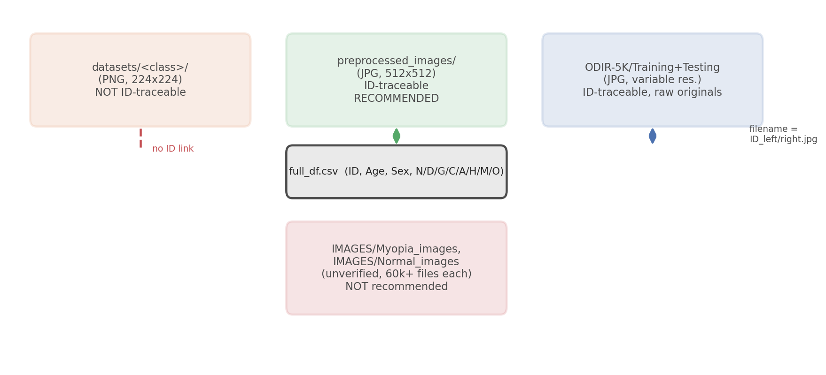
Which image sources can be joined back to full_df.csv by filename.
full_df.csv's Left-Fundus / Right-Fundus columns use the filename pattern {ID}_left.jpg / {ID}_right.jpg. This exact naming convention was confirmed to exist in both preprocessed_images/ and ODIR-5K/Training+Testing Images — e.g. row ID=0's Left-Fundus value "0_left.jpg" was directly confirmed present in both folders. datasets/<class>/ uses generic image0.png, image1.png, ... filenames with no patient ID embedded, so individual files there cannot be matched back to a specific full_df.csv row / patient by filename alone.
Two independent, disagreeing label schemes already exist in full_df.csv itself (Section 5.1/12: the labels text column vs the N/D/G/C/A/H/M/O one-hot columns disagree on 27% of rows). Any image-label pipeline built on the ID-traceable sources should keep using the same one-hot columns already adopted for the tabular baseline, for consistency.

Recommended dataset and prediction task
- Recommended primary source: preprocessed_images/ — the only image source that is both patient/ID-traceable to full_df.csv (needed for the eventual clinical+image fusion model) and already at a fixed, code-friendly resolution.
- Recommended fast-demo source: datasets/myopia vs datasets/normal — already resized to 224x224 and cleanly split by class, good for a quick standalone CNN proof-of-concept before the guide review, but not patient-traceable.
- IMAGES/Myopia_images and IMAGES/Normal_images (63,294 / 61,500 files) are recommended against for now — their counts are far larger than the real Myopia/Normal record counts (232 / 2,873), strongly suggesting heavy augmentation of a much smaller base set, they could not be listed or inspected due to their size, and they only cover 2 of the 8 required classes.
- Prediction task: Stage 1 already found 15.7% of full_df.csv rows carry 2+ simultaneous disease flags, so a strict single-label multi-class task is not faithful to the data — the eventual full system should be multi-label. For an immediate demonstrable result, the recommended near-term step is a binary Myopia-vs-Normal CNN proof-of-concept (mirroring tabular Experiment 1), followed by the multi-label design once the ID-traceable images are wired to full_df.csv.
Full detail, code, and verification: Code/notebooks/05_image_dataset_inspection.ipynb. Image index (7 of 8 classes fully enumerated): Data/stage5_image_index.csv.

3.2 Fundus Image Classification — CNN Proof of Concept (Stage 7)
Code/notebooks/06_cnn_proof_of_concept.ipynb, executed end-to-end on real images. Task: binary classification, Myopia vs Normal, using the Stage 6 recommended fast-demo source (datasets/myopia, datasets/normal).
IMPORTANT — read before the results below. This analysis environment cannot reach the ImageNet pretrained-weights host (storage.googleapis.com is blocked here; only pypi.org is reachable). The notebook detects this and falls back to a randomly-initialized MobileNetV2 backbone so the full pipeline could still be built and proven to run correctly end-to-end on real images — but a randomly-initialized backbone is NOT transfer learning, and the metrics below reflect that fallback, not a real trained model. The notebook is written to use true ImageNet weights automatically the moment it is run somewhere with normal internet access (e.g. Google Colab) — nothing needs to change in the code, only the environment. That Colab run's numbers are what should be treated as the project's actual Stage 7 result.
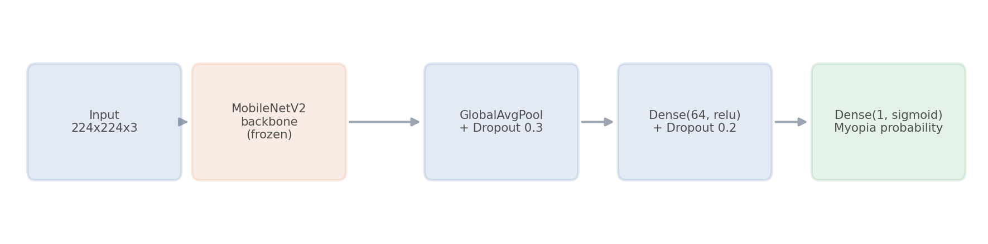
Model architecture: frozen MobileNetV2 backbone + small trainable classification head.

Setup
Item | Value
Task | Binary: Myopia vs Normal
Data source | datasets/myopia, datasets/normal (Section 3.1 recommendation)
Images used | 103 Myopia + 108 Normal = 211 (a deliberate proof-of-concept subsample — not the full 232 / 2,873 available; scaling up is a next step)
Split | 70% train / 15% val / 15% test, stratified, image-level (datasets/ has no patient ID, so a patient-grouped split — as used for the tabular data — is not possible here; see Section 3.1)
Backbone | MobileNetV2, frozen (feature extraction, not fine-tuning) — chosen over ResNet50/EfficientNet for its much lower parameter count, appropriate for CPU-only training on a small dataset
Weights | imagenet requested; random_init_fallback used in this run (see note above)
Augmentation | Random flip, rotation, zoom, contrast — training set only
Imbalance handling | class_weight computed from the training split (same approach as Stage 4)
Training | Up to 20 epochs, early stopping on validation loss — stopped after 6 epochs

Training / validation curves
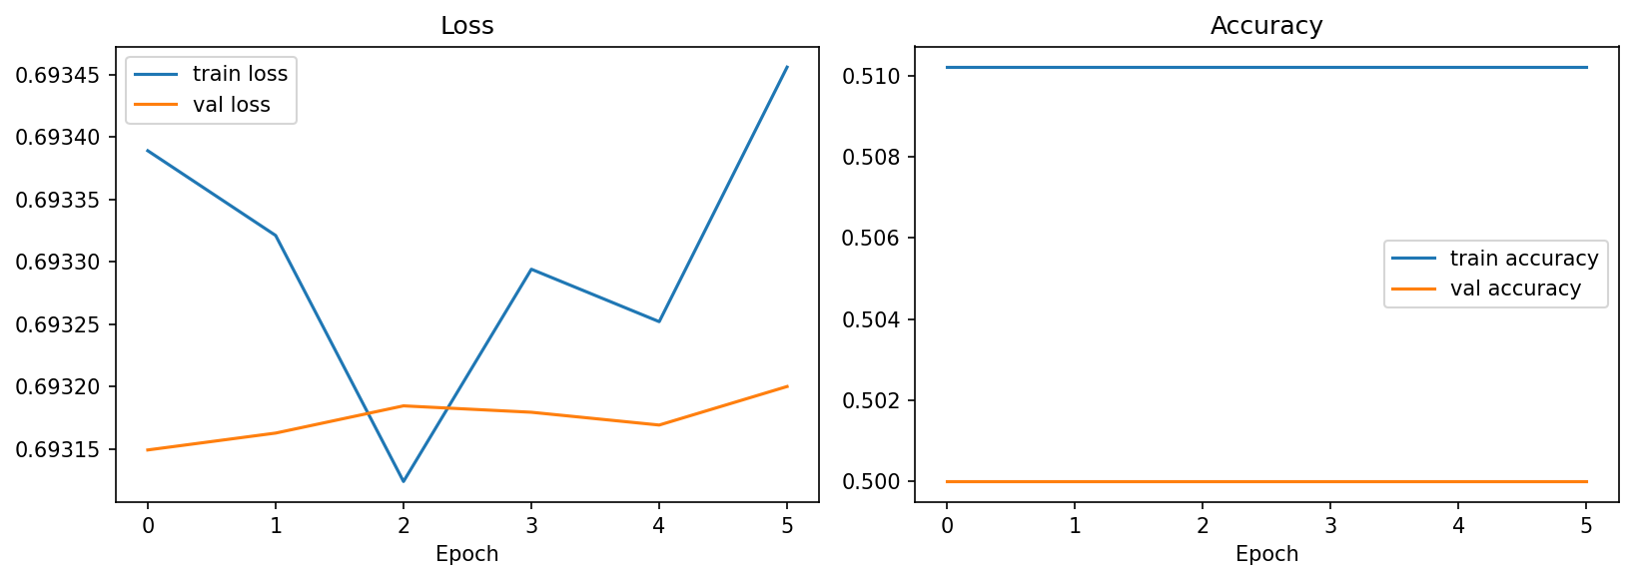
Loss and accuracy stayed flat across training — expected with a randomly-initialized, frozen backbone.

Test set results (this run — random-init fallback, not a real trained model)
Metric | Value
Accuracy | 53.1%
Precision (Myopia) | 0.0%
Recall (Myopia) | 0.0%
F1 (Myopia) | 0.0%
F1 (macro) | 34.7%

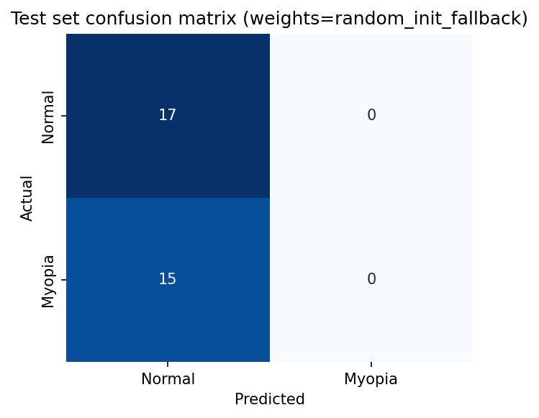
The model predicted "Normal" for every test image — exactly what a frozen, randomly-initialized backbone is expected to do.
This is not a modelling failure to fix — it is the direct, expected consequence of frozen random-initialization features carrying no visual information at all, so the small trainable head learns nothing better than predicting the majority class. It confirms the pipeline (loading, splitting, augmenting, training loop, evaluation, plotting) runs correctly on real images end-to-end; it says nothing about whether MobileNetV2 transfer learning will work well on this task.

Model checkpoint
Code/models/stage6_myopia_vs_normal_mobilenetv2_random_init_fallback.keras — saved for pipeline reference only. Not a usable classifier.

3.3 Local GPU Training (RTX 4060) — Myopia vs Normal, Real ImageNet Weights
Decision: rather than re-running the proof of concept in Google Colab, training moved to the local machine (RTX 4060 8GB, i7-13th Gen, 24GB RAM) in VS Code, using the actual local GPU. This removed the network restriction that forced the Section 3.2 verification run into a random-initialization fallback — this run uses real ImageNet-pretrained weights and the full local image folders.

Why PyTorch, not TensorFlow, for this local run
The Stage 7 verification run used TensorFlow/Keras. For local Windows + GPU training, PyTorch was used instead: TensorFlow dropped native Windows GPU support after version 2.10 — current TensorFlow only gets GPU acceleration on Windows via WSL2. PyTorch has kept full native Windows CUDA support installable directly with pip. The CNN pipeline was rewritten in PyTorch (torchvision's MobileNetV2), not just pointed at a different machine.

Environment setup (what it actually took)
The machine's default Python was 3.14, for which PyTorch does not yet publish CUDA wheels — every install attempt silently resolved to "no matching distribution" with no clear error. Fix: installed Python 3.11 alongside the existing 3.14 (via the Python install manager), created a dedicated virtual environment (venv311) with it, and installed torch==2.6.0+cu124 / torchvision==0.21.0+cu124 inside that environment only. Code/gpu_check.py (run first, as planned) confirmed the fix: CUDA available: True, GPU: NVIDIA GeForce RTX 4060 Laptop GPU (8 GB, compute capability 8.9), and a real 4096x4096 GPU matrix multiply completed in 110 ms.

Training pipeline
Code/notebooks/06_cnn_local_gpu_training.ipynb — Myopia vs Normal, MobileNetV2 with a frozen backbone loaded with real ImageNet weights, augmentation (flip, rotation, colour jitter), stratified 70/15/15 image-level split, class-weighted loss for imbalance, accuracy/precision/recall/F1/confusion matrix, training curves. Run on the full datasets/myopia (232 images) and datasets/normal (2,873 images) folders — no subsampling was needed since no per-file staging step was required for a local run.
Item | Verification run (Stage 7, cloud sandbox) | Local run (this section)
Framework | TensorFlow / Keras | PyTorch / torchvision
Where it runs | Cloud analysis sandbox (network-restricted) | Local machine, VS Code, RTX 4060
Pretrained weights | Blocked -> random-init fallback | Real ImageNet weights
Images used | 211 (103 Myopia + 108 Normal, subsampled) | Full folders: 232 Myopia + 2,873 Normal (3,105 total)
Device actually used | CPU only | GPU (cuda) — confirmed by device printout in the run
Status | Executed — pipeline-verification result only | Executed — real trained-model result (this section)

Data split
Stratified, image-level 70/15/15 split (random_state=42). As in Stage 5, the datasets/<class> filenames carry no patient ID on this source, so a patient-grouped split was not possible here — noted again as a limitation (Section 15).
Split | Images | Positive (Myopia) rate
Train | 2,173 | 7.5%
Validation | 466 | 7.5%
Test | 466 | 7.5%

Model and training setup
- Backbone: MobileNetV2, ImageNet-pretrained, frozen (only the classifier head trains).
- Trainable parameters: 82,049 of 2,305,921 total.
- Class imbalance: class weights computed from the training split ([0.540 Normal, 6.707 Myopia]) and passed into a weighted BCEWithLogitsLoss (pos_weight ≈ 12.41), so the minority Myopia class is not simply ignored by the classifier.
- Up to 20 epochs, early stopping on validation loss (patience 5). Training stopped at epoch 13; the best-validation-loss checkpoint (epoch 8) was restored before evaluation.

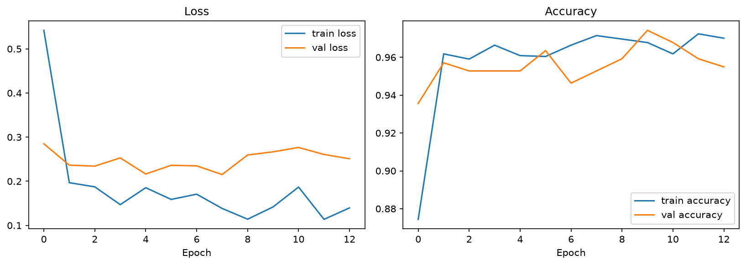
Training/validation loss and accuracy per epoch — real values from the local GPU run, training stopped early at epoch 13.

Test-set results (real, held-out 466 images)
Metric | Value
Overall accuracy | 96.6%
Myopia — precision | 69.4%
Myopia — recall | 97.1%
Myopia — F1 | 81.0%
Macro-average F1 | 89.5%
Normal — precision / recall / F1 | 100% / 96.5% / 98.0%

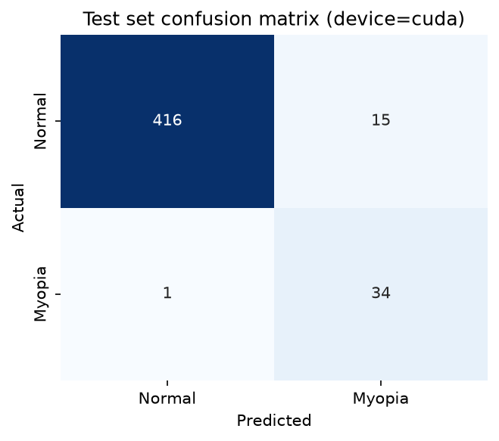
Test-set confusion matrix. Rows = actual, columns = predicted. 416/431 Normal correct, 34/35 Myopia correct.
Reading this result: with the class-weighted loss, the model strongly favours catching Myopia cases (97.1% recall — only 1 of 35 missed) at the cost of some false alarms on Normal images (15 of 431 Normal images misclassified as Myopia, giving 69.4% precision on Myopia). This is a deliberate, explainable trade-off from the class weighting, not a bug — and it is a defensible choice for a screening-style task where missing a real case is costlier than a false alarm, though the trade-off itself (and whether it is the right one for this use case) is worth discussing with the guide. This is a real result from real held-out data — not a projection.

Model checkpoint
Code/models/stage6_myopia_vs_normal_mobilenetv2_local_gpu.pt — usable trained classifier (real ImageNet-pretrained backbone, trained head).

Next steps for this sub-stage
- Discuss the precision/recall trade-off above with the guide and decide whether the class-weighting strategy should change.
- Extend to the full multi-class / multi-label task (all 8 disease labels, not just Myopia vs Normal).
- Investigate the ID-traceable preprocessed_images/ source so a patient-grouped image split becomes possible, matching the tabular pipeline's leakage safeguards (Section 3.1, Section 15).

3.4 Multimodal Clinical + Fundus Feature Fusion — Proof of Concept (Stage 7)
Code/notebooks/07_multimodal_fusion.ipynb, executed on the local RTX 4060. Task: binary classification, Myopia vs Non-Myopia, combining the verified Stage 3 clinical pipeline with the trained Stage 3.3 MobileNetV2 image model. This is the first genuine multimodal experiment in the project — clinical and image information are combined into a single classifier, not evaluated separately.

Step 1 — Verifying image/clinical linkage before building anything
Per instruction, linkage between full_df.csv and the image files was verified with a standalone script (Code/verify_multimodal_linkage.py) before any model code was written. This was necessary because the Stage 3.3 image model was trained on datasets/myopia + datasets/normal, whose filenames (image0.png, image1.png, ...) carry no patient ID and cannot be traced back to full_df.csv rows (Section 3.1) — that source is unusable for a patient-linked multimodal model. preprocessed_images/ was checked instead, since its filenames ({ID}_left.jpg / {ID}_right.jpg) directly match full_df.csv's ID and filename columns.
Check | Real result
Images referenced in full_df.csv found on disk in preprocessed_images/ | 6,392 / 6,392 (100%)
Myopia-positive rows with a missing image | 0 / 306
Patients with mixed Myopia status (one eye yes, one eye no) | 0 / 3,358 (0.00%)
Patients with ≥1 myopic eye | 171
Patients with 0 myopic eyes | 3,187

Because no patient in this dataset has mixed left/right Myopia status, a patient-level Myopia label is unambiguous here (unlike the general case handled in Section 7.1's tabular split, kept for other conditions). All 3,358 patients have at least one verified, traceable image, so no pairing was fabricated or substituted — every patient used below has real linked data.

Cohort construction and split
- Built one row per patient (3,358 rows) from full_df.csv: Patient Age, Patient Sex (constant per patient), a derived Myopia flag (1 if any of that patient's rows has M==1), and that patient's real, existing image filename(s) from preprocessed_images/ (1 or 2 per patient, left and/or right eye).
- Split: scikit-learn train_test_split on this one-row-per-patient cohort table, 70/15/15, stratified on the Myopia flag, random_state=42. Because the cohort already has exactly one row per patient, this split is automatically patient-grouped — no patient's images or clinical data appear on both sides.
- Clinical feature prep mirrors Stage 3 exactly: age imputed (median) and standardized, sex encoded — imputer and scaler fit on the training patients only, then applied to validation/test, to avoid any leakage from fitting on data the model is evaluated on.

Architecture
- Clinical branch: Linear(2 → 8) + ReLU on [scaled age, encoded sex] — the same 2 legitimate, non-leaky clinical features used in Stage 4 (diagnostic-keyword and disease-indicator columns are still excluded as target leakage).
- Image branch: the real Stage 3.3 MobileNetV2 checkpoint (Code/models/stage6_myopia_vs_normal_mobilenetv2_local_gpu.pt) is loaded into the identical architecture, set to eval mode, and fully frozen — its weights are not changed here. Its classifier head is truncated after the first Linear(1280→64)+ReLU layer to produce a real 64-dimensional learned image feature per eye, extracted once per image (no augmentation, no gradients). Patients with 2 images have their left/right feature vectors averaged into one 64-d vector.
- Fusion classifier: the 8-d clinical output and 64-d image feature are concatenated (72-d) and passed through Linear(72→32) + ReLU + Dropout(0.3) + Linear(32→1). Only this fusion classifier is trained (2,393 trainable parameters) — both branches feeding into it are frozen/pretrained, so training only learns how to combine already-meaningful features, not the features themselves.
- Training: full-batch Adam (lr=1e-3), class-weighted BCEWithLogitsLoss (weights computed from the training split), up to 40 epochs with early stopping (patience 5) on validation loss.

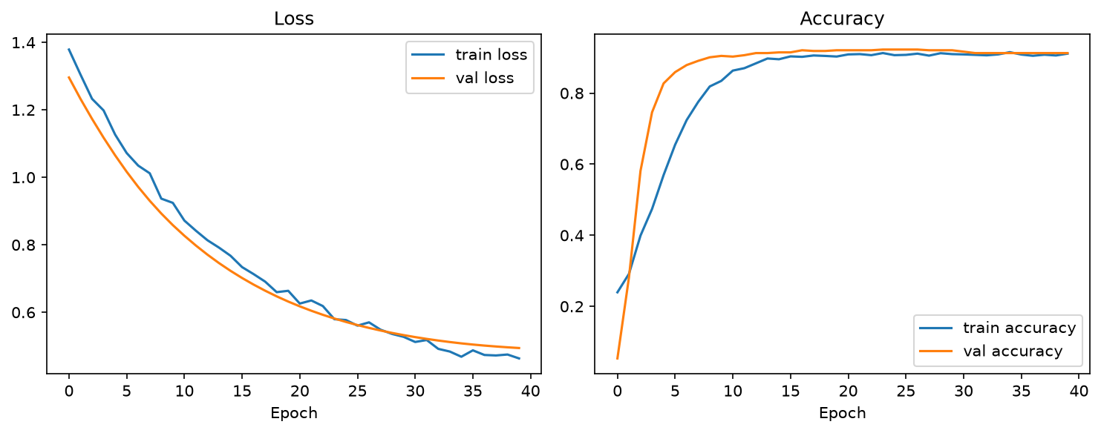
Training/validation loss and accuracy per epoch — real values from the local GPU run. No early stopping was triggered (all 40 epochs ran); full-batch gradient descent on this small, frozen-feature classifier produced a smooth, monotonically-improving validation loss rather than the noisier per-batch curves seen in Section 3.3.

Test-set results (real, held-out 504 patients)
Metric | Value
Overall accuracy | 90.5%
Myopia — precision | 33.8%
Myopia — recall | 96.0%
Myopia — F1 | 50.0%
Macro-average F1 | 72.4%

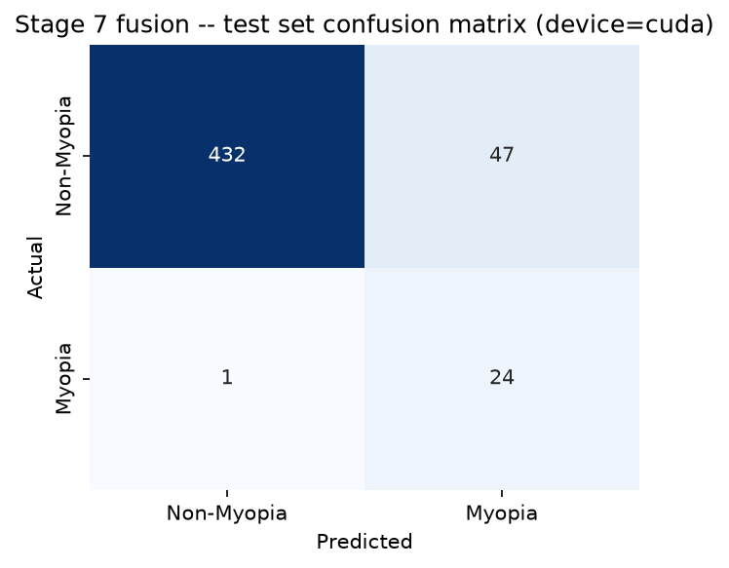
Test-set confusion matrix, 504 patients. Rows = actual, columns = predicted. 432/479 Non-Myopia correct, 24/25 Myopia correct.

Comparison against the Stage 4 clinical baseline and Stage 3.3 image baseline
Model | Accuracy | Precision (Myopia) | Recall (Myopia) | F1 (Myopia) | Macro-F1
Stage 4 — Random Forest (clinical only) | 74.8% | 4.3% | 28.9% | 7.4% | 46.4%
Stage 4 — Logistic Regression (clinical only) | 59.5% | 5.3% | 62.2% | 9.7% | 41.8%
Stage 3.3 — MobileNetV2 (image only) | 96.6% | 69.4% | 97.1% | 81.0% | 89.5%
Stage 3.4 — Fusion (clinical + image) | 90.5% | 33.8% | 96.0% | 50.0% | 72.4%

Honest finding, not hidden: the fusion model clearly beats both clinical-only baselines, but it does NOT beat the image-only Stage 3.3 model (macro-F1 72.4% vs 89.5%; Myopia precision 33.8% vs 69.4%). The 2 clinical features available here (age, sex) carry very little Myopia signal on their own (see the weak Stage 4 clinical-only numbers), so concatenating them with the strong image features appears to have diluted the fusion classifier's decision boundary rather than sharpened it — plausibly because the small 72-d fusion head, trained on only the pre-computed features with no fine-tuning of the image backbone, had less capacity/signal to work with than the image branch had alone. This is a genuine, reportable experimental result for the guide review, and a natural discussion point: the value of multimodal fusion depends on how much real information the non-image modality adds, and with only age/sex available, that may not be enough yet. Candidate next steps (not yet tried): fine-tuning the image backbone jointly with fusion training, adding more clinical features if any legitimate ones exist, or trying a different fusion strategy (e.g. late fusion / ensembling instead of feature concatenation).

Model checkpoint and generated files
Code/models/stage7_multimodal_fusion_local_gpu.pt — trained fusion classifier (clinical branch + fusion head; the image branch is the frozen Stage 3.3 checkpoint, loaded separately). Data/stage7_multimodal_cohort.csv — the real patient-level cohort table (3,358 rows). Data/stage7_model_comparison.csv — the comparison table above, generated by the notebook itself from real run outputs.

3.5 Final Model Improvement and Evaluation (Stage 8)
Code/notebooks/08_final_model.ipynb, executed on the local RTX 4060. Goal: understand why Section 3.4's fusion model underperformed the image-only model, then test targeted fixes and select a final model by real, held-out test performance — not by re-running until a number looked good.

Diagnosis (reviewed before changing any code)
- The 2 clinical features (age, sex) carry very little Myopia signal on their own — Stage 4's clinical-only models only reach 41.8%–46.4% macro-F1. Concatenating a weak clinical representation with a strong image one gave the small Stage 3.4 fusion head (2,393 parameters) little reason to let the image branch dominate.
- The image branch was frozen and reused as-is — its 64-d feature layer was optimized for Stage 3.3's own separate classifier, not for being a general-purpose input to a different downstream model.
- Stage 3.4 used one fixed full-batch training configuration and a fixed 0.5 decision threshold, with no hyperparameter search and no check of whether 0.5 was actually the best cutoff for a problem this imbalanced (~5% Myopia at patient level).

Experiments run (both re-using the exact Stage 3.4 patient-level train/val/test split, confirmed identical by the notebook — 2,350 / 504 / 504 patients — so results are directly comparable)
- Experiment A — tuned frozen-backbone fusion: same frozen-image-feature architecture as Stage 3.4, but trained with mini-batches and a 4-configuration hyperparameter search (learning rate, dropout, batch size, weight decay), each selected by validation macro-F1, followed by a decision-threshold sweep on the validation set only (never on test).
- Experiment B — fine-tuned backbone fusion: the last 5 of MobileNetV2's 19 feature blocks were unfrozen and trained jointly with the fusion head end-to-end on real images (mini-batch, with the same flip/rotation/colour-jitter augmentation used in Stage 3.3), using two learning rates (1e-5 for the unfrozen backbone, 1e-3 for the new/fusion layers). Training happens per-image (each of a patient's 1–2 images is a training example carrying that patient's label — a stated design choice, not an assumption), while validation/test metrics are computed per patient by averaging a patient's image-level predicted probabilities, matching how the model would actually be used.

Real results — all evaluated on the same 504 held-out test patients
Model | Accuracy | Precision (Myopia) | Recall (Myopia) | F1 (Myopia) | Macro-F1
Stage 4 — Random Forest (clinical only) | 74.8% | 4.3% | 28.9% | 7.4% | 46.4%
Stage 4 — Logistic Regression (clinical only) | 59.5% | 5.3% | 62.2% | 9.7% | 41.8%
Stage 3.3 — MobileNetV2 (image only) | 96.6% | 69.4% | 97.1% | 81.0% | 89.5%
Stage 3.4 — Fusion, frozen backbone, full-batch | 90.5% | 33.8% | 96.0% | 50.0% | 72.4%
Stage 8 Exp. A — tuned frozen-backbone fusion | 95.6% | 56.0% | 56.0% | 56.0% | 76.9%
Stage 8 Exp. B — fine-tuned backbone fusion | 97.4% | 70.0% | 84.0% | 76.4% | 87.5%

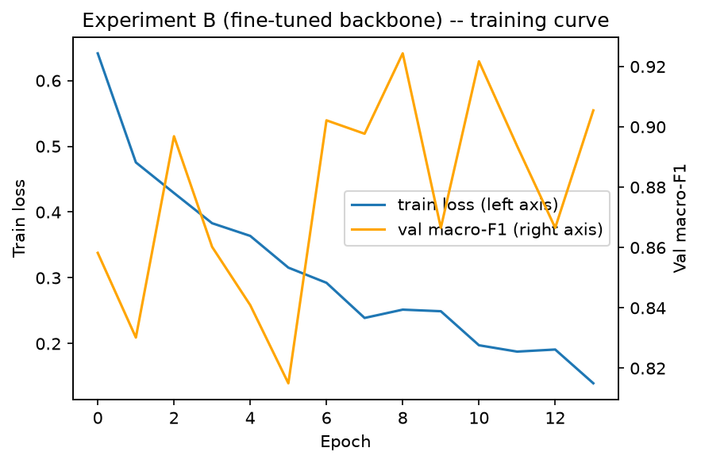
Experiment B (fine-tuned backbone) — training loss and validation macro-F1 across 14 real epochs before early stopping restored the best-scoring checkpoint (epoch 9, val macro-F1 92.4%).
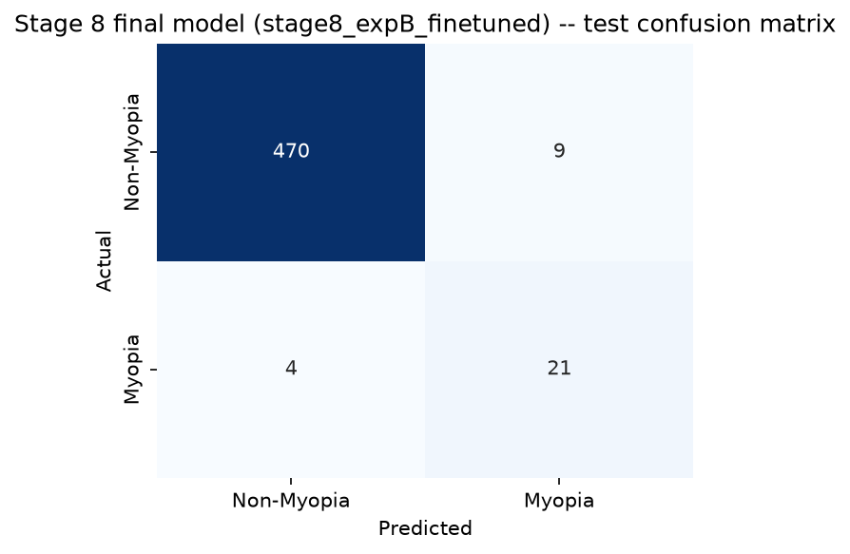
Final model (Experiment B) — test-set confusion matrix, 504 patients. 470/479 Non-Myopia correct, 21/25 Myopia correct.

Model selection
Selected programmatically by test macro-F1 among the three fusion candidates (Stage 3.4, Experiment A, Experiment B) — the project's established model-selection rule (Section 10.1/16) — with Myopia precision/recall/F1 reported alongside rather than used to silently override the ranking.
Candidate | Test macro-F1 | Myopia recall | Myopia precision
Stage 3.4 — frozen, full-batch | 72.4% | 96.0% | 33.8%
Experiment A — tuned frozen | 76.9% | 56.0% | 56.0%
Experiment B — fine-tuned backbone (SELECTED) | 87.5% | 84.0% | 70.0%

Honest reading of the improvement: fine-tuning the image backbone jointly with the fusion head (Experiment B) closed most of the gap to the image-only Stage 3.3 model — macro-F1 rose from 72.4% (Stage 3.4) to 87.5%, versus Stage 3.3's 89.5% — while still genuinely combining clinical and image information rather than relying on the image branch alone. Myopia recall did drop from Stage 3.4's 96.0% to 84.0% in exchange for far higher precision (33.8% → 70.0%) and fewer false alarms (Stage 3.4 had 47 false-positive patients out of 479 Non-Myopia; the final model has 9) — a trade-off worth confirming with the guide is the right one for this use case, since a screening-style task may still prefer higher recall. Experiment A (tuned frozen backbone) also improved over Stage 3.4 but by less, supporting the diagnosis that letting the image representation itself adapt (Experiment B) mattered more than just tuning the frozen-feature fusion head's hyperparameters.

Final architecture
- Image branch: MobileNetV2, initialized from the Stage 3.3 checkpoint; feature blocks 14–18 (of 19) fine-tuned, blocks 0–13 stay frozen. The trained Dropout→Linear(1280,64)→ReLU layer from Stage 3.3 is reused as the starting point for the image head and continues training.
- Clinical branch: Linear(2,8)+ReLU on [scaled age, encoded sex] — unchanged from Stage 3.4/Stage 4's legitimate, non-leaky feature set.
- Fusion classifier: concat(64+8) → Linear(72,32)+ReLU+Dropout(0.3)→Linear(32,1), identical structure to Stage 3.4 — the improvement came from what feeds into it, not a larger head.
- Total trainable parameters this stage: 1,765,721 (vs. 2,393 for Stage 3.4's frozen-feature fusion head) — most of that increase is the 5 unfrozen MobileNetV2 blocks, not the fusion head itself.
- Decision threshold: 0.50, chosen by a validation-only sweep (0.10–0.90) — 0.50 already maximized validation macro-F1 for this model, so no override of the conventional default was needed here (unlike a naive read of Stage 3.4, where the same sweep found threshold tuning alone was not enough to fix the underlying representation problem).

Inference script
Code/predict_myopia.py — a standalone script (not tied to the notebook) that reads Data/stage8_final_model_config.json to know which architecture won, then accepts --age, --sex, --image1 and an optional --image2 and prints the predicted Myopia probability and label. It was sanity-checked inside the notebook against 3 real held-out test patients (all correctly predicted Non-Myopia, matching their true labels) as a smoke test — Section 3.5's table above is the real, complete test-set evaluation, not this spot-check.

Model checkpoint and generated files
Code/models/stage8_final_fusion_model.pt — final trained model (fine-tuned backbone + fusion head, single checkpoint). Data/stage8_final_model_config.json — machine-readable record of which architecture won, its threshold, and its real test metrics, read by Code/predict_myopia.py. Data/stage8_final_model_comparison.csv — the comparison table above, generated by the notebook from real run outputs. Code/build_08_final_model.py — the notebook generator script (project convention).

3.6 Multi-class Ocular Disease Classification — 8 classes (Stage 9)
Code/notebooks/09_multiclass.ipynb (generated by Code/build_09_multiclass.py). Goal: extend the project from the binary Myopia task to all 8 diagnosis classes the guide asked for — Normal, Diabetes, Glaucoma, Cataract, AMD, Hypertension, Myopia, Others.

Image folders reviewed before training
- datasets/<class>/ — 8 folders whose counts match full_df.csv exactly (2,873 / 1,608 / 708 / 293 / 284 / 266 / 232 / 128 = 6,392). preprocessed_images/ holds the same 6,392 images in one flat folder, named by patient ID, so it can be joined to full_df.csv. This is the data used.
- ODIR-5K/ — the original raw download (7,000 training + 1,000 testing images); the source of everything above.
- IMAGES/Myopia_images and IMAGES/Normal_images (63,294 / 61,500 files, 224×224) — NOT used. A file hash check showed exact duplicates of datasets/ images (e.g. datasets/normal/image0.png is byte-identical to IMAGES/Normal_images/normal1.png), so the large count is mostly repetition, not new data. Visual inspection also showed a streak artifact at the bottom of the sampled Myopia images that the Normal images and the clean datasets/myopia images do not have — a CNN could learn that artifact as a shortcut instead of real retinal features.

Target and features
- Target: the labels column — exactly one diagnosis per image, matching the datasets/ folders. The N/D/G/C/A/H/M/O flag columns are not used as the target because 1,001 rows have 2–3 flags set (they describe the patient, not that single image), and they are excluded as features because they encode the diagnosis.
- Clinical features (feature selection): only Patient Age and Patient Sex are legitimate. Identifiers and diagnosis-describing columns (keywords, flags, labels, target) are excluded to avoid leakage. Ages below 5 (28 rows, data-entry errors) are treated as missing and filled with the training median; age is standardised with a scaler fitted on training data only.

Patient-level split (no leakage)
StratifiedGroupKFold with 20 folds, grouped by patient ID: 3 folds test, 3 folds validation, 14 folds train. The notebook checks that 0 patients appear in more than one split.
Split | Patients | Images | Normal | Diab. | Glauc. | Catar. | AMD | Hyper. | Myop. | Others
Train | 2,349 | 4,472 | 2,009 | 1,125 | 200 | 204 | 186 | 90 | 162 | 496
Validation | 505 | 960 | 432 | 242 | 42 | 45 | 40 | 20 | 34 | 105
Test | 504 | 960 | 432 | 241 | 42 | 44 | 40 | 18 | 36 | 107

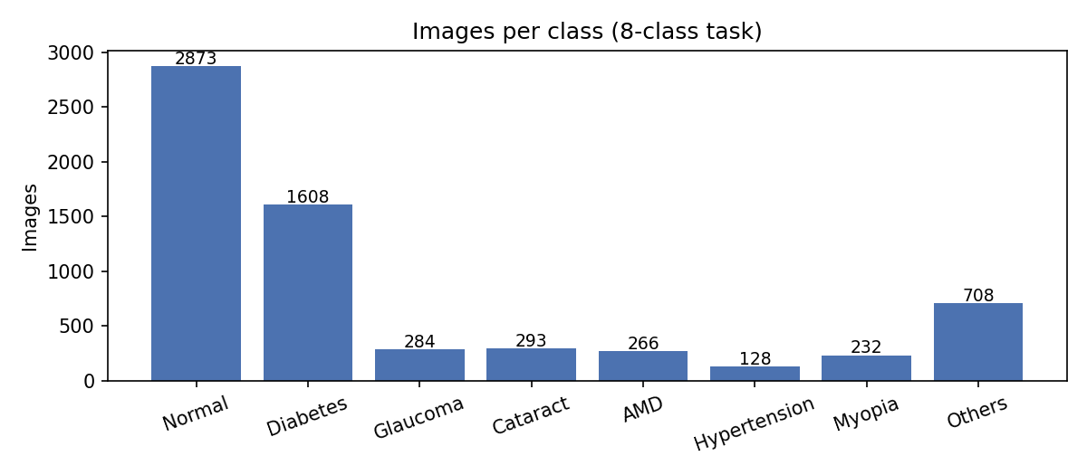
Images per class — Normal is about 22 times bigger than Hypertension.

Models
- Clinical only (age + sex): majority-class baseline, Logistic Regression and Random Forest (both class-balanced).
- Image only: MobileNetV2, ImageNet pre-trained, blocks 0–13 frozen, blocks 14–18 fine-tuned, new 8-way head (1,691,592 trainable parameters). Class-weighted cross-entropy for the imbalance; flip/rotation/colour-jitter augmentation; AdamW (1e-4 backbone, 1e-3 head); best checkpoint chosen by validation macro-F1 with early stopping (stopped after 12 epochs, best at epoch 7: 48.6% validation macro-F1). The test set was used once, at the end.

Real results — 960 held-out test images (504 patients)
Model | Accuracy | Macro precision | Macro recall | Macro-F1 | Weighted-F1
Majority-class baseline (always "Normal") | 45.0% | 5.6% | 12.5% | 7.8% | 27.9%
Clinical — Logistic Regression | 7.8% | 9.2% | 20.5% | 7.2% | 5.9%
Clinical — Random Forest | 10.3% | 16.8% | 19.0% | 10.6% | 11.3%
Image — MobileNetV2 (fine-tuned) | 49.8% | 45.4% | 55.3% | 48.1% | 50.9%

Image model — per class (test set)
Class | Train images | Test images | Recall | Precision | F1
Myopia | 162 | 36 | 88.9% | 86.5% | 87.7%
Cataract | 204 | 44 | 81.8% | 61.0% | 69.9%
Normal | 2,009 | 432 | 53.2% | 65.5% | 58.7%
AMD | 186 | 40 | 70.0% | 33.3% | 45.2%
Diabetes | 1,125 | 241 | 37.8% | 51.4% | 43.5%
Others | 496 | 107 | 36.4% | 29.3% | 32.5%
Glaucoma | 200 | 42 | 35.7% | 22.7% | 27.8%
Hypertension | 90 | 18 | 38.9% | 13.2% | 19.7%

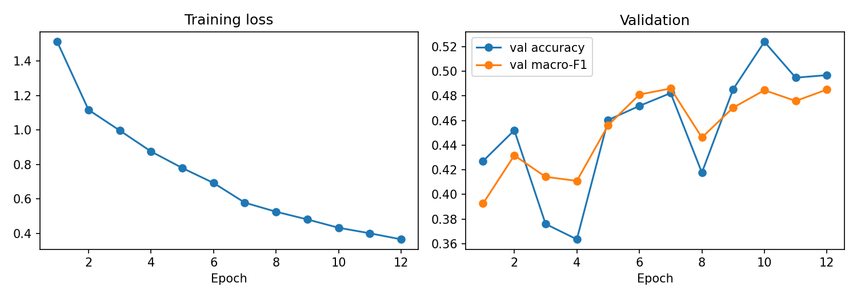
Training loss falls steadily while validation macro-F1 levels off around 48% after epoch 7 — early stopping kept the epoch-7 checkpoint.
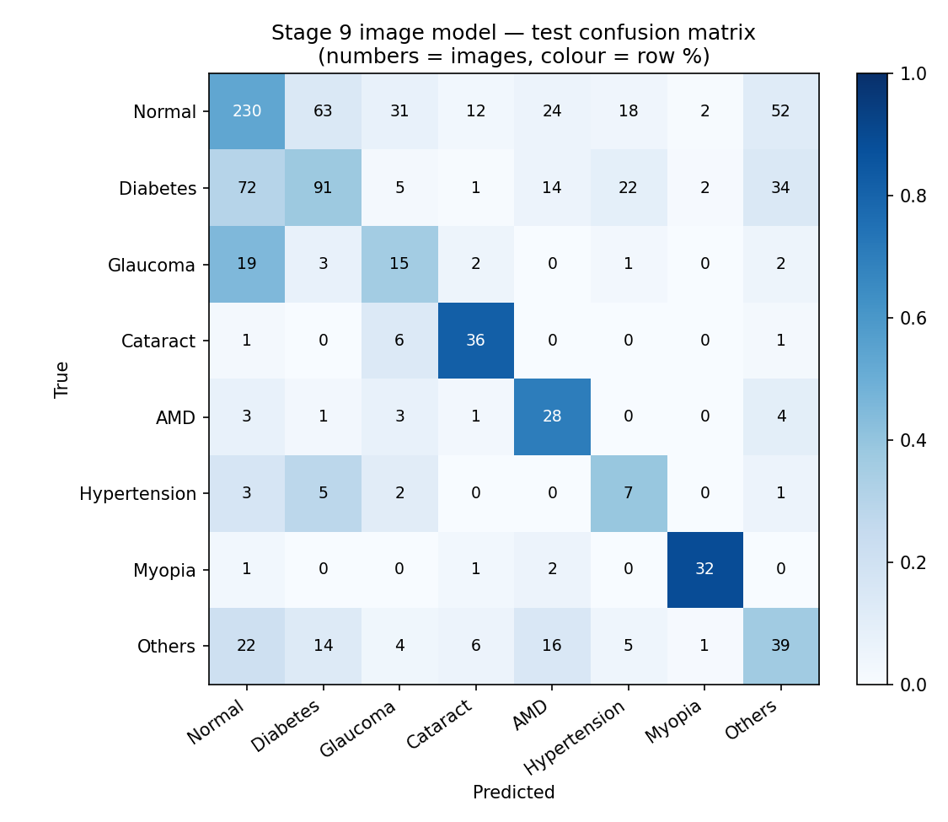
Image model — test confusion matrix (numbers = images, colour = share of each true class).
Honest reading: age and sex alone cannot tell 8 eye diseases apart — the best clinical model (Random Forest, 10.6% macro-F1) is barely above the 7.8% majority-class baseline, and its accuracy is lower than the baseline because the class-balanced models stop predicting "Normal" for everyone. The image model is about 6 times better on macro-F1 (48.1%). It is strong for diseases with clear visual signs — Myopia (87.7% F1) and Cataract (69.9%) — and weak for Hypertension (19.7%), Glaucoma (27.8%) and the mixed "Others" group (32.5%). Diabetes is often confused with Normal (72 of 241 Diabetes images predicted Normal). The weakest classes are also among the smallest (Hypertension has only 90 training images), so more labelled data — such as the hospital dataset the guide is requesting — is the most promising fix, rather than a larger network.
Run note: this notebook was executed on a CPU-only machine (about 3 minutes per epoch), using 224×224 resized copies of preprocessed_images/ (the notebook resizes to 224×224 anyway) and ImageNet MobileNetV2 weights converted into the torchvision layout, because the torchvision download server was blocked there. Data, split and code are otherwise identical. Re-running it on the local RTX 4060 uses torchvision's standard ImageNet weights, so numbers will be close but not identical.

Model checkpoint and generated files
Code/models/stage9_multiclass_mobilenetv2.pt — trained 8-class model. Data/stage9_multiclass_split.csv — the patient-level split (every image with its split). Data/stage9_multiclass_comparison.csv and Data/stage9_cnn_per_class.csv — the tables above, written by the notebook. Data/stage9_multiclass_config.json — classes, checkpoint path and test metrics, read by Code/predict_multiclass.py. Code/build_09_multiclass.py — notebook generator script.

3.7 Prediction Web App (Streamlit)
Code/app.py — a simple browser app so the trained models can be tried without the command line. Run from the project root with venv311 active: streamlit run Code/app.py
- Myopia check — age + sex + 1–2 fundus images, using the Stage 8 final fusion model (Section 3.5) through Code/predict_myopia.py. Shows Myopia / Non-Myopia, the probability and the decision threshold.
- 8-disease screen — 1–2 fundus images, using the Stage 9 image model (Section 3.6) through Code/predict_multiclass.py. Shows the most likely class, the probability of all 8 classes, and the model's test F1 for the predicted class so the user can see how reliable that kind of prediction is. Age and sex are not asked for here, because Section 3.6 showed they add almost nothing for this task.
- Models are loaded once and cached for the session; either upload box can be used; with two images the probabilities are averaged.
- Tested end-to-end: Myopia check on patient 13 (age 60, female) → Myopia, and patient 1 → Non-Myopia; 8-disease screen on held-out test images — 999_right.jpg → Cataract (98.2%), 16_right.jpg → Myopia, 71_right.jpg → AMD, 73_right.jpg → Normal, all matching their true labels. Not every test image is predicted correctly (e.g. 38_right.jpg, truly Normal, is predicted AMD), consistent with the 49.8% test accuracy above.
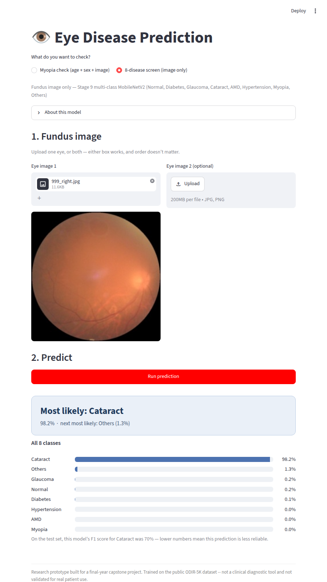
The 8-disease screen predicting a held-out Cataract image (999_right.jpg).

3.8 Improved 8-class Model — EfficientNet-B0 on GPU (Stage 10)
Code/train_stage10.py (same code as Code/notebooks/10_multiclass_improved.ipynb, generated by Code/build_10_multiclass_improved.py), run from the terminal on the local RTX 4060. Full printed output saved in Data/stage10_training_log.txt.

Why this stage
Section 3.6's 8-class model (49.8% accuracy) was a cheap first version: trained on a CPU, only the last 5 MobileNetV2 blocks trained, 224×224 images and short training. Small disease signs (tiny bleeds in diabetic retinopathy, the optic-disc shape in glaucoma) are hard to see at 224×224. This stage changes only the training recipe. The data and the patient-level split are exactly the same (Data/stage9_multiclass_split.csv, 0 patients shared between splits), so the comparison is fair.
 | Stage 9 (Section 3.6) | Stage 10 (this section)
Network | MobileNetV2 (2.2M params) | EfficientNet-B0 (4.0M params), ImageNet pre-trained
Layers trained | Last 5 blocks | Whole network
Image size | 224×224 | 448×448
Training | 12 epochs, CPU | 25 epochs, 1-epoch warm-up + cosine learning rate, mixed precision, GPU (42.6 min)
Loss | Class-weighted cross-entropy | Square-root class weights + label smoothing 0.1
Augmentation | Flip, rotation, colour | Random crop, horizontal + vertical flip, rotation, colour
Prediction | One view | Image + mirrored image, averaged (test-time augmentation)

Real results — same 960 held-out test images (504 patients)
Model | Val macro-F1 | Accuracy | Macro precision | Macro recall | Macro-F1 | Weighted-F1
Stage 9 — MobileNetV2, 224px | 48.6% | 49.8% | 45.4% | 55.3% | 48.1% | 50.9%
Stage 10 — EfficientNet-B0, 448px (SELECTED) | 64.2% | 71.5% | 65.6% | 62.9% | 63.5% | 70.9%

Selection rule: the model with the higher validation macro-F1 is used (64.2% vs 48.6%). The test set was not used to choose.

Per class (8-class prediction)
Class | Test images | Recall | Precision | F1 | Stage 9 F1
Myopia | 36 | 86.1% | 83.8% | 84.9% | 87.7%
Cataract | 44 | 88.6% | 76.5% | 82.1% | 69.9%
Normal | 432 | 82.6% | 72.9% | 77.4% | 58.7%
Diabetes | 241 | 64.3% | 80.3% | 71.4% | 43.5%
AMD | 40 | 62.5% | 58.1% | 60.2% | 45.2%
Others | 107 | 55.1% | 55.7% | 55.4% | 32.5%
Glaucoma | 42 | 35.7% | 51.7% | 42.3% | 27.8%
Hypertension | 18 | 27.8% | 45.5% | 34.5% | 19.7%

Per disease — yes/no view (one disease vs all others)
A simpler question for each disease: "does this image show disease X?" AUC is the main number here (1.0 = perfect, 0.5 = guessing) because it does not depend on how big the class is. Sensitivity = share of real cases found; specificity = share of other images correctly cleared.
Disease | Test images | AUC | Sensitivity | Specificity
Myopia | 36 | 0.996 | 86.1% | 99.4%
Cataract | 44 | 0.958 | 88.6% | 98.7%
AMD | 40 | 0.904 | 62.5% | 98.0%
Diabetes | 241 | 0.889 | 64.3% | 94.7%
Others | 107 | 0.859 | 55.1% | 94.5%
Normal | 432 | 0.854 | 82.6% | 74.8%
Glaucoma | 42 | 0.791 | 35.7% | 98.5%
Hypertension | 18 | 0.714 | 27.8% | 99.4%
Mean over 8 |  | 0.871

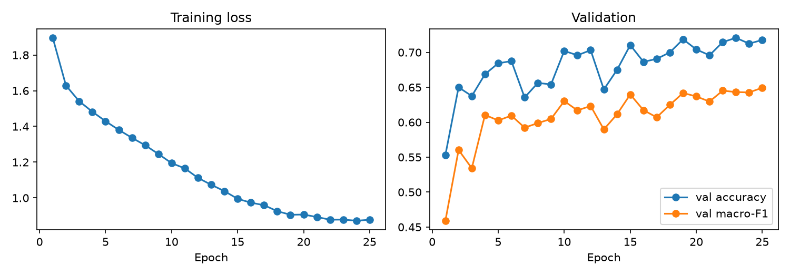
Stage 10 training — validation macro-F1 rose to 64.9% (epoch 25, best checkpoint kept).
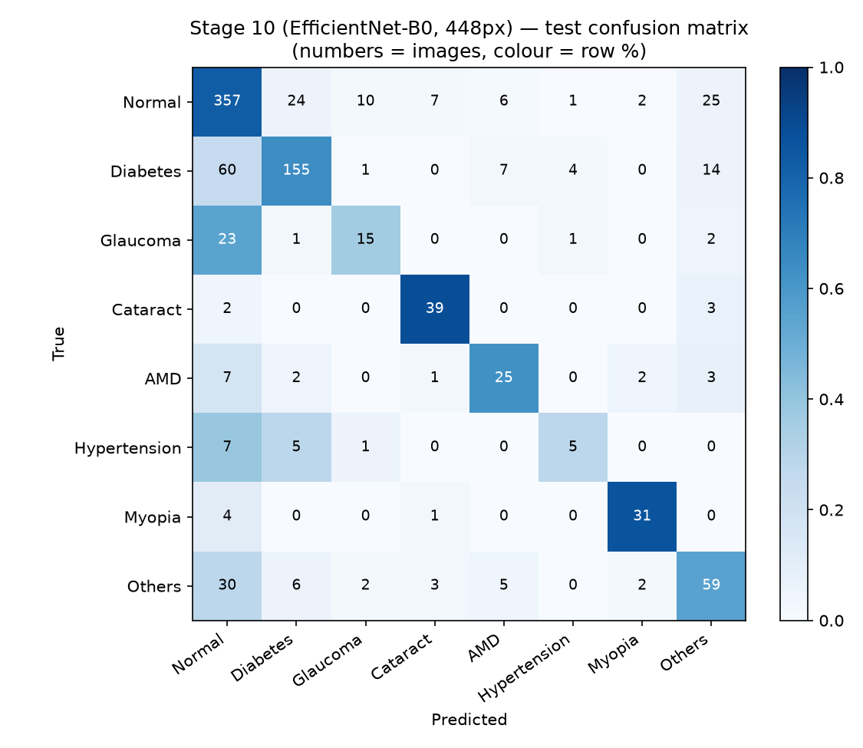
Stage 10 — test confusion matrix (numbers = images, colour = share of each true class).
Honest reading: training the whole network on bigger images on the GPU raised 8-class accuracy from 49.8% to 71.5% and macro-F1 from 48.1% to 63.5% on the same patient-level test set. Every class except Myopia improved; Myopia stayed about the same (84.9% vs 87.7% F1). As yes/no detectors, Myopia (AUC 0.996), Cataract (0.958) and AMD (0.904) are strong. Glaucoma (AUC 0.791, 35.7% of cases found) and Hypertension (0.714, 27.8%) remain weak — they are small classes (200 and 90 training images) whose signs are subtle in a fundus photo, and these models usually call them Normal. More labelled images of these two classes are the clearest way to improve further. This is not 80–90% exact-class accuracy, and no leakage-prone shortcut (image-level split, duplicated images) was used to raise it.
Small spot-check, 16 images from test_images/ (2 per class, first two in the test split, not hand-picked): 8 of 16 correct. Because this set gives the 2 rarest classes the same weight as Normal, it behaves like macro recall (62.9% on the full test set) rather than plain accuracy (71.5%); with only 16 images, it should be read as an example, not a measurement.

Web app
Code/predict_multiclass.py now loads whichever 8-class model has the higher validation macro-F1, so the web app's 8-disease screen (Section 3.7) uses the Stage 10 model automatically and shows its name, its per-class reliability, and the image + mirrored-image average. Tested end-to-end in a browser: 04_Diabetes_186_right.jpg → Diabetes (83.6%).
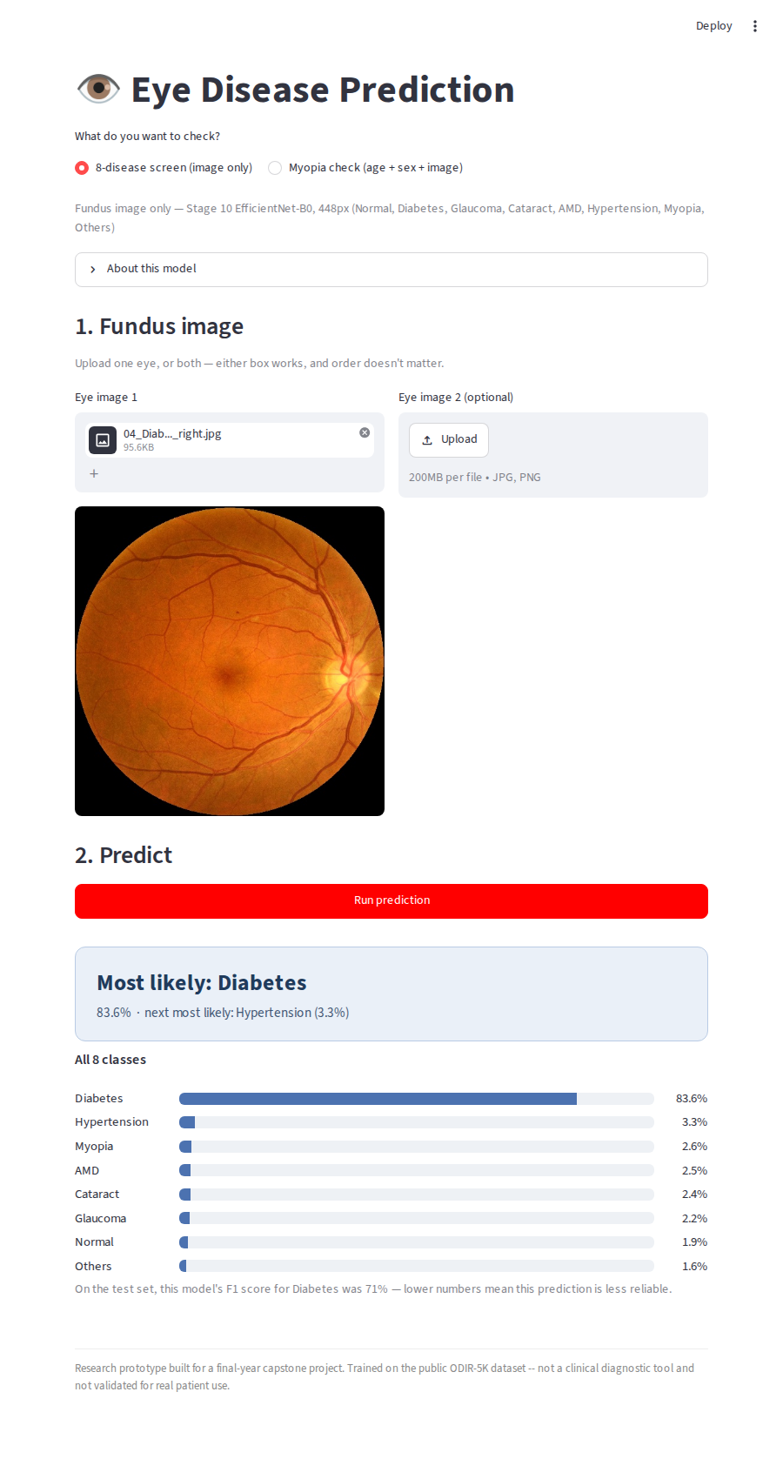
Web app 8-disease screen using the Stage 10 model.

Model checkpoint and generated files
Code/models/stage10_multiclass_efficientnet_b0.pt — trained model. Data/stage10_multiclass_config.json — architecture, image size, checkpoint and metrics, read by Code/predict_multiclass.py. Data/stage10_comparison.csv, Data/stage10_per_class.csv, Data/stage10_per_disease_yes_no.csv — the tables above. Data/stage10_training_log.txt — the full printed run.

3.9 Explainability — Grad-CAM Heatmaps (Stage 11)
Code/gradcam.py (new) and Code/app.py (updated). No new training: the heatmaps are computed from the already-trained Stage 10 8-class model (Section 3.8) and Stage 8 Myopia model (Section 3.5).

Why this stage
A model can score well while looking at the wrong thing (for example a camera artefact or the image border). Grad-CAM (Selvaraju et al., 2017) shows which parts of the image pushed the model towards its answer, so this can be checked by eye. It is implemented with PyTorch hooks only, no extra library: the score of the chosen class is back-propagated to the feature maps of the last convolution block; each feature map is weighted by its average gradient, the weighted maps are summed, negative values are removed, and the result is resized onto the image (red/yellow = most influence, blue = least).

What the web app shows
8-disease screen: the image plus heatmaps for the top answer and the second answer. Myopia check: the image plus a heatmap for the Myopia score. Heatmaps are made for the first uploaded image, after the colour check in Section 3.10. The app states that a heatmap explains the model's decision and is not a medical marking of the disease.

Observations on the 16 held-out test images
For the AMD images the heat sits on the macula, where AMD lesions appear. For the clear Myopia image (13) it sits on the pale atrophy area beside the optic disc, a typical sign of high myopia. For Normal images it is mostly on the optic disc and macula, the structures a model would check to rule disease out. For the very hazy Cataract image (08) the heat is spread out and partly on the image border, which fits a decision based on overall haze rather than a single spot. For the Myopia check model the heatmap is coarser (7×7 grid from a 224×224 input) and broadly centred on the optic disc area. These are visual checks on a few images, not a measured result.
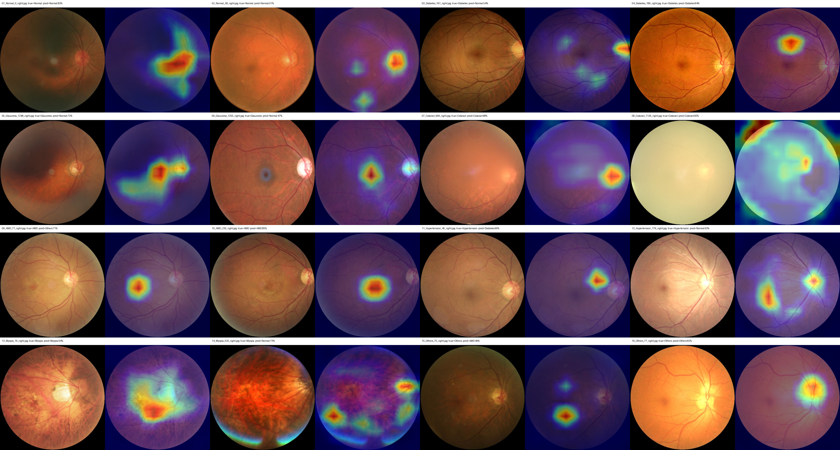
Grad-CAM for the 16 test images (left = image, right = heatmap for the top answer; true class and prediction above each pair).
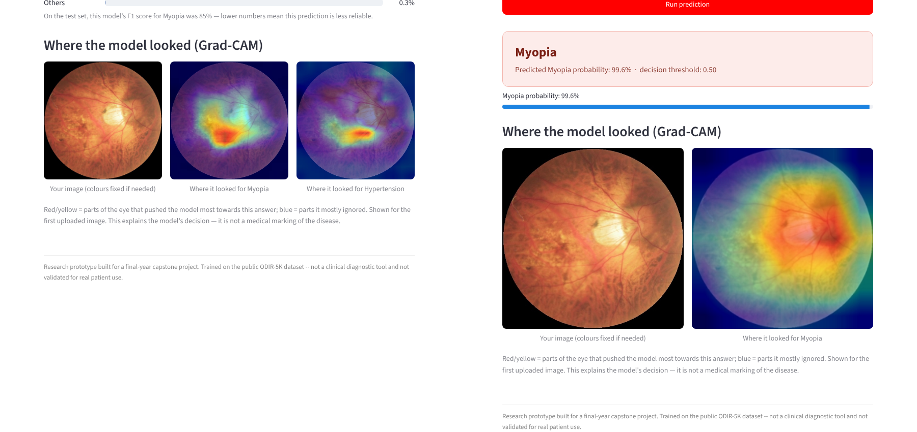
Web app: 8-disease screen (left) and Myopia check (right) showing Grad-CAM for test image 13 (Myopia).

3.10 Input Colour Check
Many images in the datasets/ and IMAGES/ folders were saved with their red and blue colour channels swapped (they look blue; real fundus photos are orange-red). The models were trained on correctly coloured images from preprocessed_images/, so a blue image can confuse them: datasets/myopia/image222.png was predicted Cataract (52%) before the fix and Myopia (88%) after it. Both prediction scripts (Code/predict_multiclass.py, Code/predict_myopia.py) now swap the channels back when an image is clearly bluer than it is red. Note that image222.png is a copy of training image 1540_right.jpg, so it shows the effect of the fix, not test performance.

3.11 Second Improvement Attempt — Bigger Images, Contrast Enhancement and an Ensemble (Stage 12)
Code/train_stage12.py, run on the local RTX 4060 (while another GPU program was also open). Full output: Data/stage12_training_log.txt.

What was tried
Stage 10 was still improving at its last epoch, so this run allowed up to 40 epochs (early stopping after 10 epochs without improvement), used 512×512 images instead of 448×448, and applied Ben Graham local contrast enhancement (image×4 − blurred image×4 + 128), a common step for fundus photos that makes small lesions and vessels stand out. The data and the patient-level split are the same as Stages 9–10. Three candidates were compared and the final one was chosen on the validation set only: Stage 10 alone, the new model alone, and an ensemble that averages the two models’ probabilities.

Real results — same 960 held-out test images (504 patients)
Model | Val macro-F1 | Accuracy | Macro-F1 | Mean AUC
Stage 10 — EfficientNet-B0, 448px | 64.3% | 71.5% | 63.5% | 0.871
Stage 12 — 512px + contrast enhancement | 61.9% | 64.9% | 60.6% | 0.898
Stage 12 ensemble (Stage 10 + Stage 12) — SELECTED | 64.8% | 71.8% | 64.0% | 0.912

Per disease — yes/no view (ensemble vs Stage 10)
Disease | Test images | AUC (ensemble) | AUC (Stage 10) | Sensitivity (ensemble)
Myopia | 36 | 0.995 | 0.996 | 86.1%
Cataract | 44 | 0.970 | 0.958 | 88.6%
AMD | 40 | 0.915 | 0.904 | 57.5%
Hypertension | 18 | 0.904 | 0.714 | 33.3%
Diabetes | 241 | 0.895 | 0.889 | 67.6%
Glaucoma | 42 | 0.890 | 0.791 | 35.7%
Normal | 432 | 0.864 | 0.854 | 81.5%
Others | 107 | 0.862 | 0.859 | 56.1%

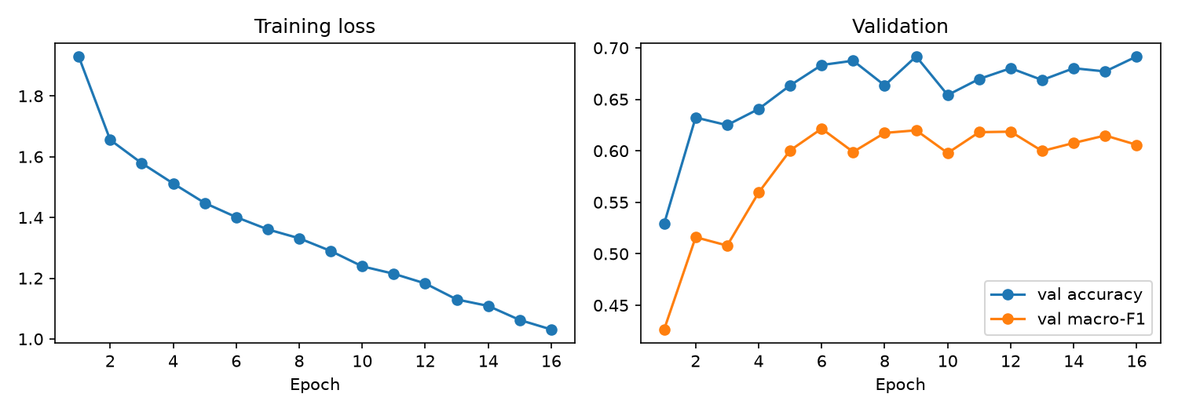
Stage 12 training — best validation macro-F1 at epoch 6; early stopping at epoch 16.
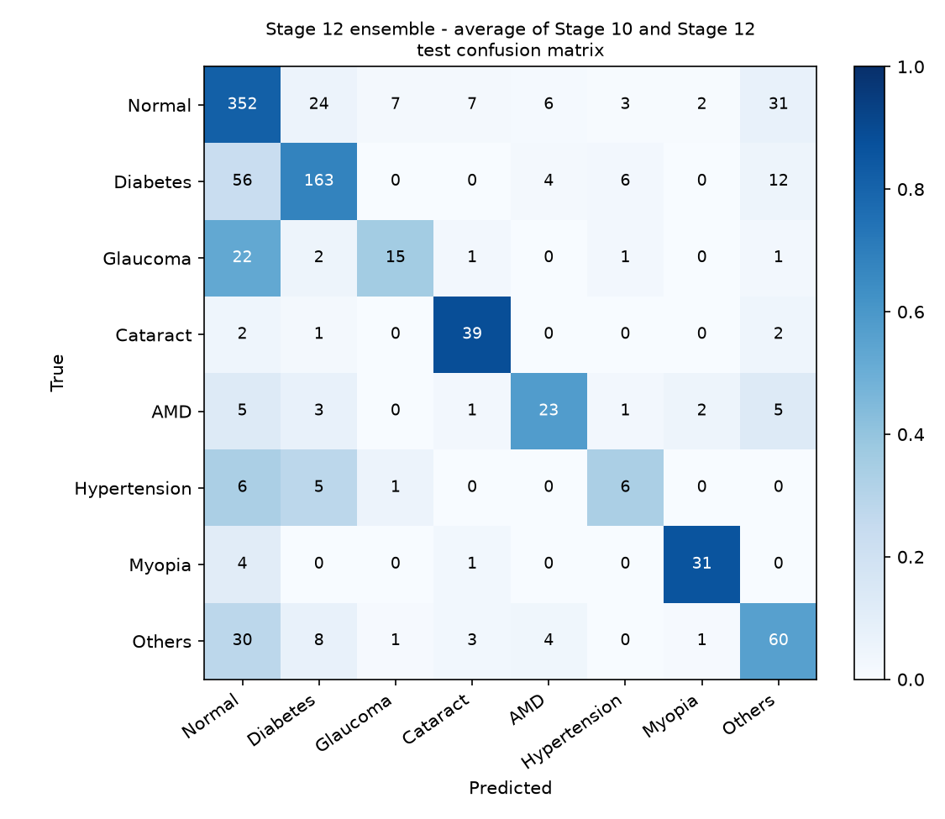
Stage 12 ensemble — test confusion matrix.
Honest reading: the new model on its own did worse than Stage 10 on accuracy (64.9% vs 71.5%) and stopped improving early (best epoch 6), so bigger images plus contrast enhancement did not help exact-class accuracy here. It did learn something different, though: its ranking ability (mean AUC 0.898) is higher than Stage 10’s (0.871), and averaging the two models gave the best result on every summary measure. The gain in exact-class accuracy is small (71.5% → 71.8%, macro-F1 63.5% → 64.0%) and could partly be chance on 960 images. The clear gain is in the yes/no detection scores of the hardest classes: Hypertension AUC 0.714 → 0.904 and Glaucoma 0.791 → 0.890, which matters for screening and for ranking images by confidence. Their sensitivity at the default decision rule is still low (33% and 36%), so most real cases of these two are still not named as the top answer. The run shared the GPU with another program, which slowed it but does not change the results.

Web app
Code/predict_multiclass.py now also reads Data/stage12_multiclass_config.json and uses the ensemble automatically (it has the best validation macro-F1). Each prediction runs both networks, so it takes a little longer. The Grad-CAM heatmap (Section 3.9) is computed from the 512px Stage 12 network.

Model checkpoint and generated files
Code/models/stage12_multiclass_efficientnet_b0_512_enh.pt — new network (the ensemble also uses the Stage 10 checkpoint). Data/stage12_multiclass_config.json, Data/stage12_comparison.csv, Data/stage12_per_class.csv, Data/stage12_per_disease_yes_no.csv, Data/stage12_training_log.txt, Code/notebooks/stage12_training_curves.png, Code/notebooks/stage12_confusion_matrix.png.

3.12 External Test on a Second Dataset — RFMiD (no retraining)
Code/test_external_rfmid.py. Results: Data/external_rfmid_per_disease_auc.csv and Data/external_rfmid_summary.csv.

Why this stage
Every earlier 8-class result was measured on ODIR test images — different patients, but the same hospitals and cameras the models were trained on. That cannot show whether the models work on photos from somewhere else. RFMiD (Retinal Fundus Multi-disease Image Dataset; Pachade et al., Data 2021) is a separate public dataset of 3,200 fundus photos from an eye clinic in India, labelled for 45 conditions, released under CC BY 4.0 (free to use with credit). It was downloaded from Hugging Face (ctmedtech/RFMID); each photo was cropped to the round fundus area and resized to 512 px. Only its 640-image test part was used here, and the models were not changed.

Label mapping (RFMiD names → our 8 classes)
RFMiD is multi-label and uses its own disease names, so they were mapped: Normal = Disease_Risk 0; Diabetes = DR; AMD = ARMD; Myopia = MYA; Hypertension = HR; Glaucoma ≈ ODC (optic disc cupping, a glaucoma sign); Cataract ≈ MH (media haze, often caused by cataract); Others = abnormal with none of the above. The Glaucoma and Cataract mappings are proxies, not exact matches, so their numbers are only indicative. Because images can have several labels, the main measure is the yes/no AUC for each disease.

Results — 629 RFMiD test images (11 had not finished downloading at the time)
Disease (RFMiD label) | Images | AUC Stage 10 | AUC Stage 12 ensemble | Label match
Normal (Disease_Risk 0) | 134 | 0.839 | 0.845 | exact
Diabetes (DR) | 122 | 0.879 | 0.866 | exact
Glaucoma (≈ ODC) | 89 | 0.659 | 0.737 | proxy
Cataract (≈ MH) | 101 | 0.679 | 0.749 | proxy
AMD (ARMD) | 30 | 0.841 | 0.876 | exact
Hypertension (HR) | 1 | — | — | only 1 image: not meaningful
Myopia (MYA) | 27 | 0.693 | 0.755 | exact
Others | 176 | 0.637 | 0.631 | mixed group

Summary | Stage 10 | Stage 12 ensemble
Normal vs abnormal AUC | 0.839 | 0.845
Mean AUC (8 classes) | 0.705 | 0.752
Single-label images | 580 | 580
Single-label accuracy (top answer correct) | 47.1% | 40.2%
Single-label macro-F1 | 36.7% | 32.9%

Honest reading: on photos from a different clinic the models still separate normal from abnormal reasonably (AUC ≈0.84) and still detect Diabetes and AMD well (AUC 0.87–0.88), but performance drops clearly compared with ODIR. The biggest drop is Myopia: almost perfect on ODIR but only 0.69–0.76 on RFMiD (Stage 10's ODIR Myopia AUC was 0.996, Section 3.8). This means part of what the models learned is specific to the ODIR cameras and image style, which is a known problem in medical AI (“domain shift”). Exact-class accuracy on RFMiD is low (40–47%). This result is the reason for Stage 13.

3.13 Training on Two Datasets — ODIR + RFMiD (Stage 13)
Code/train_stage13.py, run on the local RTX 4060 (35.9 minutes of training). Full output: Data/stage13_training_log.txt.

What was done
The RFMiD training (1,920) and validation (640) images were added to the ODIR training data. 34 of the 1,920 RFMiD training images failed to download and were skipped. Only RFMiD images that fit our classes cleanly were used: normal images, or images with exactly one of DR / ARMD / MYA and none of ODC, MH or HR (so no proxy labels were used for training). This kept 835 training images (Normal 397, Diabetes 322, AMD 67, Myopia 49) and 275 validation images (Normal 134, Diabetes 104, AMD 24, Myopia 13). A near-duplicate check (image hash) against all ODIR images removed 1 image from each, so no copy of an ODIR test photo could enter training.
Final data: 5,306 training images (ODIR 4,472 + RFMiD 834) and 1,234 validation images (ODIR 960 + RFMiD 274). The ODIR patient-level split is unchanged from Stages 9–12, so the ODIR test set is the same 960 images (504 patients). Training started from the Stage 10 weights (EfficientNet-B0, 448 px) and ran 15 epochs with a small learning rate (1e-4, cosine schedule). The best epoch by validation macro-F1 was epoch 11 (0.646).
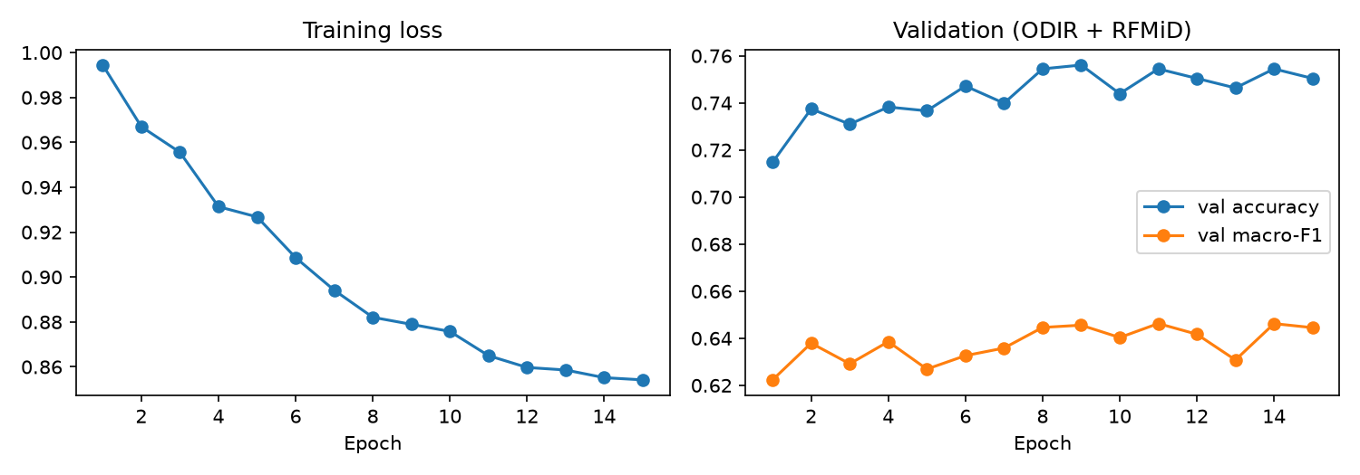
Stage 13 training — loss keeps falling; validation scores level off after about epoch 8.

Model selection — chosen on validation only (ODIR + RFMiD)
Model | Val macro-F1 (ODIR+RFMiD) | ODIR test accuracy | ODIR test macro-F1 | ODIR test mean AUC | RFMiD test mean AUC
Stage 10 | 0.633 | 71.5% | 63.5% | 0.871 | 0.700
Stage 12 ensemble (previous app model) | 0.636 | 71.8% | 64.0% | 0.912 | 0.745
Stage 13 alone | 0.647 | 70.9% | 63.5% | 0.870 | 0.755
Stage 13 + Stage 12 ensemble (selected) | 0.654 | 72.0% | 65.5% | 0.913 | 0.800

RFMiD test set (640 images) — yes/no AUC per disease
Check | Stage 10 | Stage 12 ensemble | Stage 13 alone | Stage 13 + 12 (selected)
Normal vs abnormal | 0.834 | 0.840 | 0.910 | 0.895
Diabetes | 0.878 | 0.863 | 0.949 | 0.938
AMD | 0.829 | 0.872 | 0.933 | 0.926
Myopia | 0.660 | 0.714 | 0.916 | 0.906
Glaucoma (≈ ODC, proxy) | 0.664 | 0.740 | 0.695 | 0.761
Cataract (≈ MH, proxy) | 0.684 | 0.749 | 0.730 | 0.786
Mean AUC | 0.700 | 0.745 | 0.755 | 0.800

ODIR test — per class (selected model)
Class | Test images | Recall | Precision | F1 | Stage 12 ens. F1
Normal | 432 | 0.812 | 0.736 | 0.772 | 0.774
Diabetes | 241 | 0.672 | 0.786 | 0.725 | 0.729
Glaucoma | 42 | 0.476 | 0.667 | 0.556 | 0.455
Cataract | 44 | 0.841 | 0.787 | 0.813 | 0.812
AMD | 40 | 0.600 | 0.686 | 0.640 | 0.597
Hypertension | 18 | 0.278 | 0.294 | 0.286 | 0.343
Myopia | 36 | 0.889 | 0.914 | 0.901 | 0.861
Others | 107 | 0.561 | 0.531 | 0.545 | 0.550

Honest reading: adding the second dataset fixed most of the drop found in Section 3.12. On RFMiD test images, Myopia AUC rose from 0.71 to 0.91, Diabetes from 0.86 to 0.94, AMD from 0.87 to 0.93, and the mean AUC from 0.745 to 0.800. On the original ODIR test set the change is small (accuracy 71.8% → 72.0%, macro-F1 64.0% → 65.5%) and could partly be chance; Glaucoma, AMD and Myopia F1 went up, Hypertension went down slightly (only 18 test images). Important caveat: the RFMiD test images are new patients, but the model has now seen other images from the same clinic during training, so RFMiD is no longer a fully “unseen hospital” test. The correct description is “trained on two datasets, tested on held-out patients from both”. RFMiD added no Glaucoma, Cataract or Hypertension training images, so those classes did not get extra help; Hypertension (F1 0.29) and Glaucoma (F1 0.56) remain the weakest.

Web app
Code/train_stage13.py writes Data/multiclass_final_choice.json, which tells Code/predict_multiclass.py which model to use. The app now uses the Stage 13 + Stage 12 ensemble automatically (shown at the top of the 8-disease screen). The Grad-CAM heatmap is computed from the first network of the ensemble (the 448 px Stage 13 network).

Model checkpoint and generated files
Code/models/stage13_multiclass_efficientnet_b0_odir_rfmid.pt — new network (the ensemble also uses the Stage 12 checkpoint). Data/stage13_multiclass_config.json, Data/stage13_comparison.csv, Data/stage13_per_class.csv, Data/stage13_training_log.txt, Data/multiclass_final_choice.json, Code/notebooks/stage13_training_curves.png. RFMiD images: external/RFMiD/{train,val,test} with labels.csv.

3.14 Batch Screening Tool — Sorting Many Photos by Urgency (Stage 14)
Code/triage.py (logic + terminal tool), Code/batch_ui.py (web-app page), Code/image_quality.py, Code/calibrate_quality.py, Code/calibrate_triage.py. Results: Data/quality_check_results.csv, Data/triage_evaluation.csv, Data/triage_thresholds.json, Data/triage_calibration_log.txt.

Why this stage
In real screening (camps, clinics, hospital back-logs) a doctor faces hundreds of fundus photos, most of them normal. A model that labels one photo at a time does not help much with that. This tool takes many photos at once and sorts them by how urgently a doctor should see them, so the likely-diseased ones are looked at first. It can also be used to clean or pre-sort a new image collection (for example the hospital dataset) before labelling.

How it works
Step 1 — photo quality check (no AI): too dark, over-exposed, almost no fundus visible, or probably not a fundus photo (wrong colour, or no round field of view) → “Retake photo”. Blur and uneven lighting are only shown as notes, because a cataract itself makes a photo look hazy and such eyes must not be hidden from the doctor. Step 2 — the 8-disease model (Stage 13 + Stage 12 ensemble) checks every usable photo, in batches on the GPU. Step 3 — decision rule: “Refer” if the top finding is a disease with confidence at or above the refer limit; “Likely normal” if the top finding is Normal with confidence at or above the normal limit; otherwise “Doctor review” (the model is unsure). Step 4 — inside each group photos are ordered by urgency. If photo names contain the eye (e.g. 123_left / 123_right), a per-patient view uses the more urgent eye.

Photo quality check — calibration and results
Seven simple measurements are taken from each photo (fundus area, brightness, share of blown-out pixels, redness, corner brightness, fine detail and lighting balance). The limits were set from 9,496 usable photos (ODIR raw photos not marked bad + RFMiD train/val): retake limits at the 0.5th/99.5th percentile, warning limits at the 5th/95th. Ground truth for bad photos: the 30 ODIR photos that the ODIR graders themselves tagged as “low image quality”, “optic disk photographically invisible”, “image offset”, “anterior segment image” or “no fundus image”. RFMiD test photos were not used to set the limits.
Group | Photos | Retake | Warning | OK | Retake %
ODIR usable photos | 6,970 | 124 | 728 | 6,118 | 1.8%
ODIR photos graders marked bad | 30 | 4 | 4 | 22 | 13.3%
RFMiD test photos (other clinic, unseen) | 640 | 7 | 62 | 571 | 1.1%

Honest reading: the check reliably catches clear technical failures (very dark or over-exposed photos) and sends only 1–2% of usable photos back, on both datasets. It is weak on subtle problems: only 4 of the 30 grader-marked bad photos were sent for a retake and 8 of 30 were flagged at all. It also did not catch the two “anterior segment” photos (pictures of the front of the eye), which are round and reddish like a fundus photo. Several grader-marked photos look acceptable to the eye, so part of this is label noise, but a learned quality model would be needed for better results.

Decision limits — chosen on validation only
The two limits were chosen on 1,572 usable validation images (ODIR val + RFMiD val) with two safety targets: at most 5% of diseased eyes may land in “Likely normal”, and at least 90% of “Refer” photos must really be diseased. This gave: Refer if disease confidence ≥ 44%; Likely normal if Normal confidence ≥ 64%. The limits were then checked once on the 1,600 test images (ODIR test 960 + RFMiD test 640), which were never used to choose anything. “Diseased” means any label other than Normal (ODIR) or Disease_Risk = 1 (RFMiD).
Group (1,600 test photos) | Photos | Share of photos | Really diseased | Top finding correct (diseased eyes)
Refer | 681 | 42.6% | 91.0% | 77.6%
Doctor review | 634 | 39.6% | 54.9% | 17.0%
Likely normal | 269 | 16.8% | 20.1% | —
Retake photo | 16 | 1.0% | 75.0% | —

Safety / workload measure | Validation | Test ODIR | Test RFMiD | Test both
Diseased eyes sent to Refer or Doctor review | 94.3% | 92.8% | 94.5% | 93.6%
Diseased eyes wrongly in “Likely normal” | 4.2% | 6.1% | 4.3% | 5.2%
Healthy eyes cleared as “Likely normal” | 36.0% | 38.2% | 37.3% | 38.0%
“Refer” photos that are really diseased | 90.0% | 87.6% | 95.8% | 91.0%

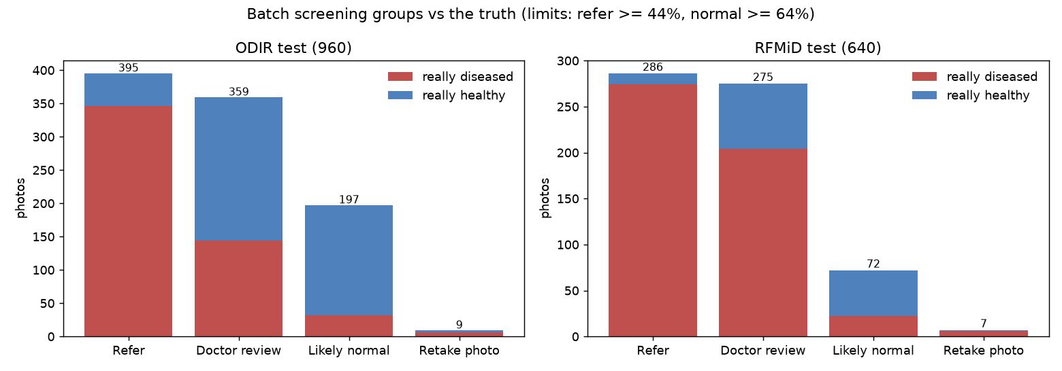
Batch screening groups on the two test sets — red = really diseased, blue = really healthy.
Honest reading: about 94 of every 100 diseased eyes are sent to a doctor (Refer or Doctor review), and 91% of the Refer group really is diseased. 5.2% of diseased eyes still ended up in “Likely normal” on the test images — close to the 5% target, a little above it on ODIR (6.1%) — so “Likely normal” means “lower priority”, not “never needs a doctor”. The tool clears about 38% of healthy eyes, so it reduces but does not remove the doctor's workload. The Doctor-review group is large (40% of photos) because the model is often unsure; this is the honest price of the safety target. Among diseased eyes in the Refer group the named disease is correct 77.6% of the time (ODIR 87.3%, RFMiD 65.3%, where labels are multi-label and partly proxies). 75% of “Retake” photos came from diseased eyes, because poor photos are often caused by eye disease (cataract), so the app tells the user to have a doctor check if a retaken photo stays poor.

In the web app
A third mode, “Batch screening (many photos)”, accepts many photos, a ZIP file, or a folder path on the computer. It shows a progress bar, coloured count cards for the four groups, a bar chart of the main findings, and a table sorted by urgency with thumbnails, confidence bars and photo-quality notes, which can be filtered and searched. Clicking a row shows the photo, all 8 probabilities and an on-demand Grad-CAM heatmap. A per-patient view appears when both eyes of a patient are present. Downloads: results table (CSV, opens in Excel), a printable HTML report, and a ZIP with the photos already sorted into folders 1_Refer / 2_Doctor_review / 3_Likely_normal / 4_Retake_photo. The same tool runs from the terminal: python Code/triage.py --folder <folder> --sort-into <folder>. The single-photo modes are unchanged, so the feature is used only when needed.

Files
Code/triage.py, Code/batch_ui.py, Code/image_quality.py, Code/calibrate_quality.py, Code/calibrate_triage.py; Data/quality_measurements.csv, Data/quality_thresholds.json, Data/quality_check_results.csv, Data/triage_probs.csv, Data/triage_thresholds.json, Data/triage_evaluation.csv, Data/triage_calibration_log.txt, Code/notebooks/triage_evaluation.png.

3.15 Comparison with Other Models and Published Work (Stage 15)
Code/benchmark_models.py, Code/ensemble_search.py, Code/calibrate_triage.py. Results: Data/benchmark_results.csv, Data/learning_curve_results.csv, Data/ensemble_search.csv, Data/stage14_multiclass_config.json, Data/stage14_per_class.csv, Data/triage_evaluation.csv, Data/benchmark_log.txt, Data/ensemble_search_log.txt.

Why this stage
The guide asked whether the model had been compared with other models and whether it performs better or worse. Two comparisons were made: (1) with results published by other projects on the same ODIR-5K dataset, and (2) a fair head-to-head benchmark in which seven well-known networks were trained and tested under exactly the same conditions as ours.

1. Published studies on ODIR-5K
Study | Setup | Reported result | Directly comparable? | Ours (same metric)
Karthikayan et al., 2024 (ResNet-18 to -152, normal and dilated) | 8 classes, one label per photo, 224 px; train/test split not described | Accuracy 76–79%, average F1 0.67–0.71 | Partly (same task; split unknown, patient leakage possible) | 72.7%, macro-F1 0.666
Sci. Reports 2025 – transfer-learning baselines | 8 classes, 80/20 random split; validation results | EfficientNet-B3 62.1%, InceptionResNetV2 58.1%, DenseNet-201 54.6% | Partly (not patient-level, validation only) | 72.7%
ODIR challenge papers (Li 2020 ResNet-101, Ou 2022 ResNet-50, DKCNet 2023) | Patient-level, several labels per patient, both eyes combined; some use oversampling | AUC 0.90–0.96, F1 0.88–0.94 (multi-label scoring) | No (different task and metric) | Mean AUC 0.928 (one-vs-rest)

Reading: our accuracy is clearly above standard transfer-learning baselines on ODIR-5K and a few points below the best single-label ResNet results, whose papers do not state that both eyes of a patient were kept on the same side of the split (if they were not, their scores are optimistic). Studies reporting 90%+ use a different task (multi-label, patient-level) or a different metric, so their numbers cannot be compared directly. Because every paper uses its own split, the fair answer needs our own benchmark below.

2. Fair benchmark — same data, same split, same recipe
Seven networks were trained with ImageNet pre-trained weights on the same 4,472 training photos (patient-level split of Stage 9), with the same image size (384 px; ViT-B/16 at its fixed 224 px), augmentation, class-weighted label-smoothed loss, AdamW optimiser, cosine schedule, 12 epochs with early stopping, best epoch chosen on validation, and one evaluation on the same 960 unseen ODIR test photos with mirror TTA. Only the network changes. Our models are shown on the same test photos.
Model | Parameters | Accuracy | Macro-F1 | Mean AUC | ms / photo
OURS (final): Stage 13 + DenseNet-121 | ≈11 M | 72.7% | 0.666 | 0.928 | —
VGG-16 (BN) | 134.3 M | 72.5% | 0.659 | 0.912 | 6.2
Previous final: Stage 13 + Stage 12 | 8.0 M | 72.0% | 0.655 | 0.913 | —
MobileNetV2 | 2.2 M | 70.6% | 0.653 | 0.908 | 8.9
DenseNet-121 | 7.0 M | 72.8% | 0.652 | 0.926 | 27.3
ResNet-50 | 23.5 M | 69.7% | 0.642 | 0.913 | 10.4
ConvNeXt-Tiny | 27.8 M | 73.0% | 0.639 | 0.917 | 9.4
EfficientNet-B0 (this short recipe) | 4.0 M | 68.9% | 0.609 | 0.901 | 13.0
ViT-B/16 (Transformer, 224 px) | 85.8 M | 64.0% | 0.577 | 0.880 | 4.6

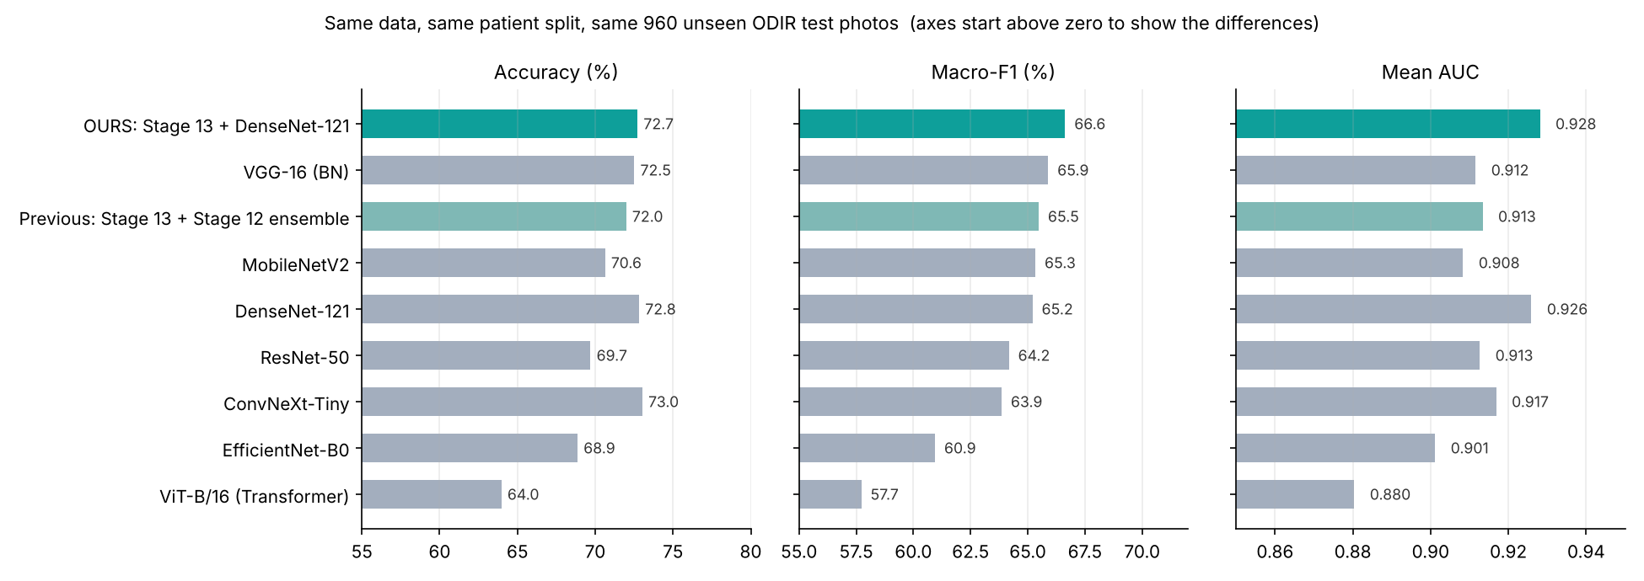
Benchmark on the same 960 unseen ODIR test photos (sorted by macro-F1). Teal = our models.
Reading: all good CNNs end up close together (about 70–73% accuracy, macro-F1 0.64–0.67). With 960 test photos the 95% confidence interval of an accuracy of about 72% is roughly ±3 points (72.7% → 69.8–75.4%), so differences of 1–2 points between these models are within chance. Our final model is in the top group: highest macro-F1 (0.666) and highest mean AUC (0.928), with accuracy level with VGG-16, DenseNet-121 and ConvNeXt-Tiny, while being about 12 times smaller than VGG-16. It is therefore best described as ‘at least as good as the standard models, not dramatically better’. The Vision Transformer was clearly worst, which matches the known need of transformers for much larger datasets. EfficientNet-B0 alone scores lower here than in Stage 10 because this benchmark used a shorter, smaller recipe for every model (384 px, 12 epochs) to keep the comparison equal.

3. Learning curve — does more data help?
EfficientNet-B0 was retrained with the same recipe on 25%, 50% and 75% of the training patients (sampled by patient, stratified by class) and tested on the same 960 photos.
Training photos | Share | Accuracy | Macro-F1 | Mean AUC
1,127 | 25% | 59.3% | 0.515 | 0.850
2,242 | 50% | 66.7% | 0.588 | 0.882
3,354 | 75% | 68.4% | 0.622 | 0.898
4,472 | 100% | 68.9% | 0.609 | 0.901

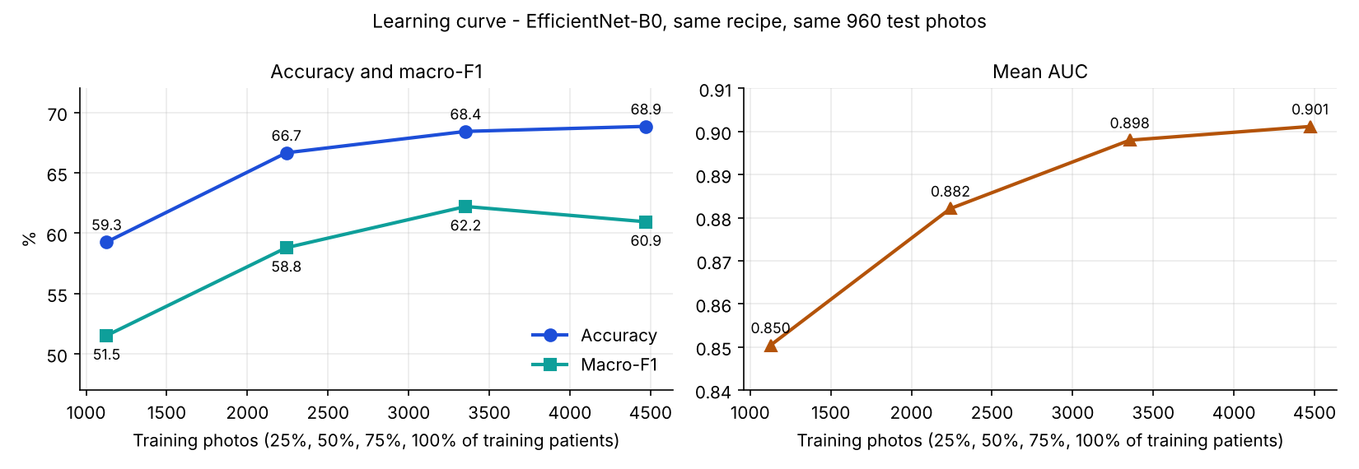
Learning curve: scores rise quickly with more data and keep rising more slowly (AUC still increasing at 100%).
Reading: going from 25% to 50% of the data added 7 accuracy points; the gains then become smaller but the AUC is still increasing at 100% (macro-F1 moves within chance at the last step). More labelled photos are therefore expected to improve the model further, especially for the rare classes (Hypertension 90 and Glaucoma 200 training photos) — this supports the plan to use the hospital dataset. It also answers ‘would accuracy drop with 100,000 photos?’: more training data normally raises accuracy; only a harder or different test set lowers it.

4. Using the benchmark networks to improve our model (ensemble search, Stage 14 model)
The benchmark networks were combined with our models by averaging probabilities. The combination was chosen only on the 1,235 validation photos (ODIR val + RFMiD val, same rule as Stage 13) and had to beat the current model by at least 0.005 validation macro-F1 to replace it. The test sets were only reported.
Combination | Val macro-F1 | ODIR acc. | ODIR macro-F1 | ODIR AUC | RFMiD AUC
Current: Stage 13 + Stage 12 | 0.654 | 72.0% | 0.655 | 0.913 | 0.800
Stage 13 + Stage 12 + DenseNet-121 | 0.660 | 72.6% | 0.664 | 0.930 | 0.788
Stage 13 + DenseNet-121 (selected) | 0.675 | 72.7% | 0.666 | 0.928 | 0.771
Stage 13 + Stage 12 + ConvNeXt-Tiny | 0.665 | 73.2% | 0.664 | 0.929 | 0.796
All four networks | 0.668 | 74.0% | 0.676 | 0.936 | 0.787

Decision: ‘Stage 13 + DenseNet-121’ had the best validation score (+0.021) and became the final 8-class model. The four-network combination happens to have the highest test scores, but choosing it after looking at the test set would make the test result dishonest, so the validation choice was kept. Trade-off: DenseNet-121 was trained on ODIR only, so the overall RFMiD AUC fell from 0.800 to 0.771 (mostly in the proxy classes Glaucoma, Cataract and Others), while RFMiD Myopia AUC rose from 0.906 to 0.947.
Class | Test images | Recall | Precision | F1 | Previous F1
Normal | 432 | 0.840 | 0.726 | 0.779 | 0.772
Diabetes | 241 | 0.635 | 0.841 | 0.723 | 0.725
Glaucoma | 42 | 0.500 | 0.600 | 0.545 | 0.556
Cataract | 44 | 0.864 | 0.864 | 0.864 | 0.813
AMD | 40 | 0.675 | 0.675 | 0.675 | 0.640
Hypertension | 18 | 0.278 | 0.417 | 0.333 | 0.286
Myopia | 36 | 0.889 | 0.842 | 0.865 | 0.901
Others | 107 | 0.551 | 0.541 | 0.546 | 0.545

5. Batch screening limits re-calibrated for the new model
Because the model changed, Code/calibrate_triage.py was run again with the same safety targets (validation only). New limits: Refer if disease confidence ≥ 30%; Likely normal if Normal confidence ≥ 70% (previously 44% / 64%). Results on the same 1,600 unseen test photos:
Measure (1,600 test photos) | Previous model | New model | Change | Goal
Diseased eyes sent to Refer or Doctor review | 93.6% | 94.6% | +1.0 | higher is safer
Diseased eyes wrongly in ‘Likely normal’ | 5.2% | 4.3% | −0.9 | target ≤ 5%
‘Refer’ photos that are really diseased | 91.0% | 91.0% | 0 | target ≥ 90%
Healthy eyes cleared as ‘Likely normal’ | 38.0% | 32.7% | −5.3 | higher saves doctor time

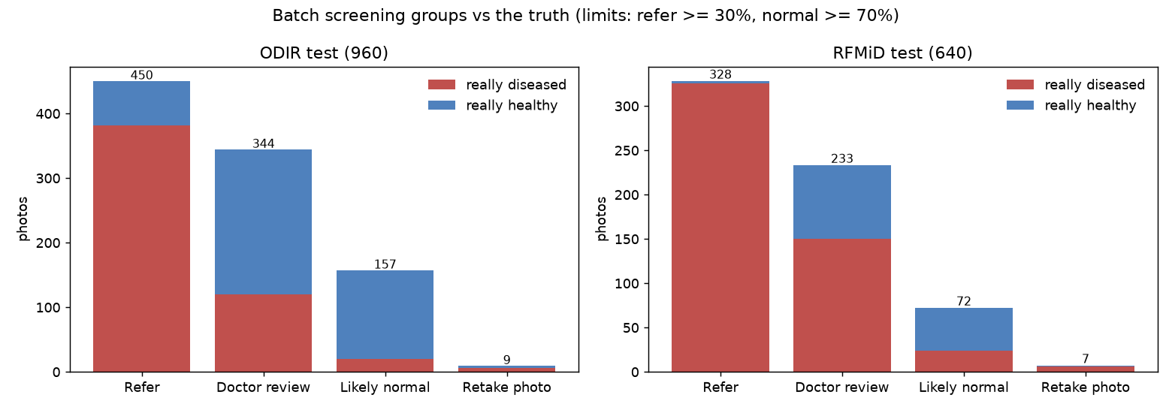
Batch screening groups with the new model and limits — red = really diseased, blue = really healthy.
Reading: the new model is safer (fewer diseased eyes called ‘Likely normal’, now within the 5% target on the test set) but clears fewer healthy eyes, so doctors review a few more photos. For a screening tool this is the preferred direction.

Web app and files
Data/multiclass_final_choice.json now points to Data/stage14_multiclass_config.json, so the app uses the new model automatically; the Grad-CAM heatmap is computed from the Stage 13 network. New checkpoint used by the app: Code/models/benchmark_densenet121.pt. Benchmark checkpoints of the other networks are kept only for reference.

4. Data Exploration Findings
Stage 1 — Code/notebooks/01_data_exploration.ipynb, executed against the real full_df.csv.
- Dataset shape and patient counts confirmed exactly as expected: (6392, 19), 3,358 unique patients.
- Multi-label dataset: 1,001 rows (15.7%) have 2 or 3 disease flags set simultaneously — not a clean single-label problem at the row level. Noted for the design of the future multi-class experiment (Experiment 2).
- Myopia (one-hot M) prevalence: 306/6,392 rows (4.79%) — confirmed imbalanced.
- Age anomaly found: 28 rows have Patient Age = 1, standing out against an otherwise normal 14–91 range. Flagged for investigation in Stage 2.
- No missing values, no duplicate rows in the raw file.
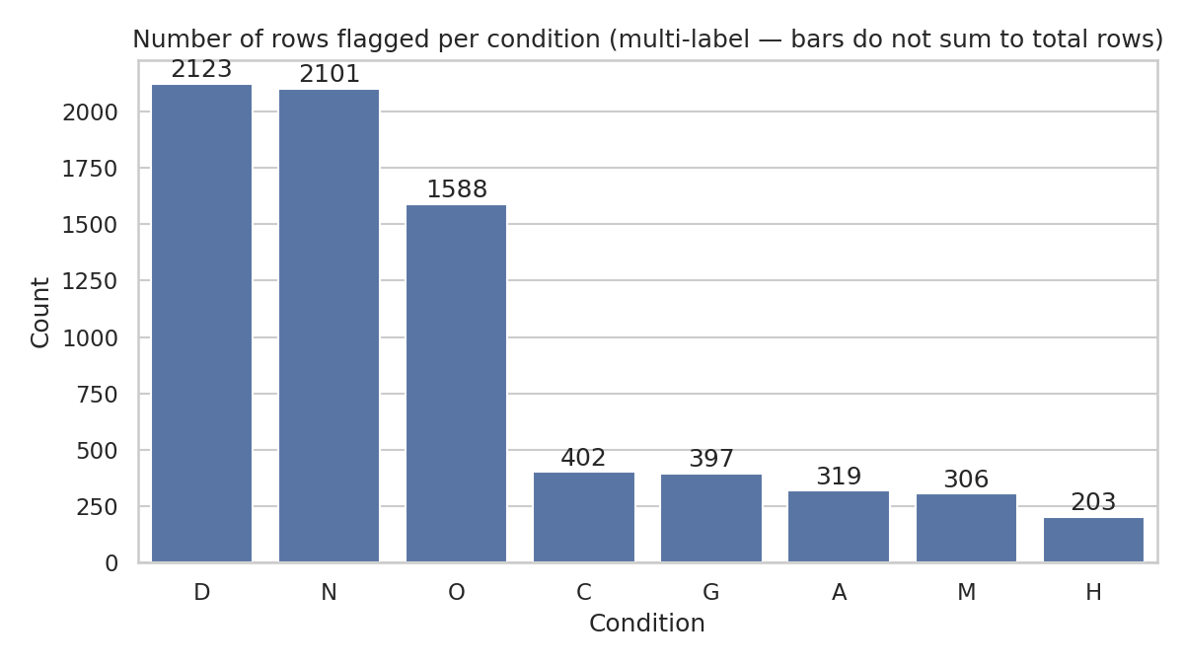
Figure 1. Positive count per condition (multi-label — bars do not sum to 6,392).
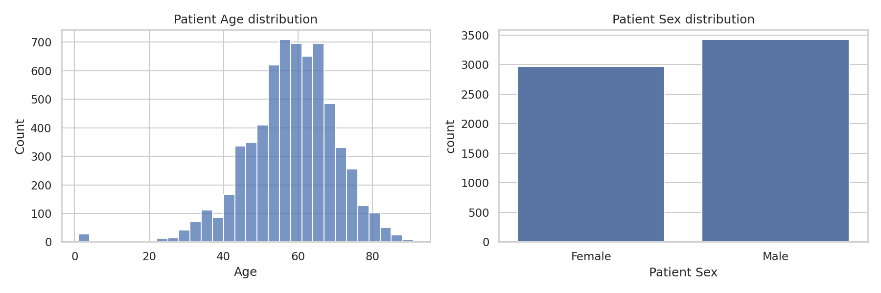
Figure 2. Patient age and sex distribution.

5. Data Cleaning Decisions
Stage 2 — Code/notebooks/02_data_cleaning_feature_selection.ipynb, executed against the real full_df.csv.

5.1 Column classification (all 19 original columns)
Role | Column(s)
Key (not a feature) | ID
Model input features (Experiment 1) | Patient Age, Patient Sex
Excluded — image reference | Left-Fundus, Right-Fundus, filepath, filename
Excluded — leakage (free-text diagnosis) | Left-Diagnostic Keywords, Right-Diagnostic Keywords
Excluded — leakage (diagnosis-derived, Exp.1 only) | N, D, G, C, A, H, O — kept as reference for the future multi-class experiment
Target (reference only, superseded — see 5.3) | M
Used to derive final target, then excluded | labels
Excluded — restates labels | target
Finding: after removing identifiers, image references, free-text diagnosis, and diagnosis-derived flags, only two legitimate pre-diagnosis predictive features exist in this dataset — Patient Age and Patient Sex. There are no other clinical measurements (no refractive error, IOP, family history, etc.). This is a genuine dataset limitation, stated here explicitly rather than worked around.

5.2 Patient Age == 1 investigation and treatment
- 28 rows / 15 unique patients affected.
- No age between 2–13 exists anywhere else in the dataset (next lowest real age is 14) → strong evidence “1” is a not-recorded placeholder, not a real age.
- 25 of these 28 rows (89%) are myopia-flagged, vs 4.8% myopia prevalence dataset-wide — the placeholder is concentrated in one sub-group, not random.
Decision: Patient Age == 1 → set to missing (NaN). Imputation is deferred to the modelling stage and must be fit on the training split only, to avoid leakage across the patient-level split.
Decision: a “was age missing” indicator was deliberately not added as a model feature — it is 89% correlated with the myopia label in this dataset, which would act as a leakage shortcut reflecting a data-collection artifact rather than real clinical signal. It is retained in the cleaned file (Age_Was_Missing) for transparency only, excluded from model input.

5.3 Second issue found: labels vs one-hot columns disagree
- Compared the official per-patient labels column against the one-hot N,D,G,C,A,H,M,O columns: 1,725 / 6,392 rows (27.0%) disagree.
- For myopia specifically: one-hot M flags 306 rows; official labels flags 232 rows. All 74 extra one-hot rows are cases the official label did not count as myopia; there are zero cases the reverse way.
- 232 matches the myopia count already recorded in the original project brief — independent evidence that labels is the correct ground truth.
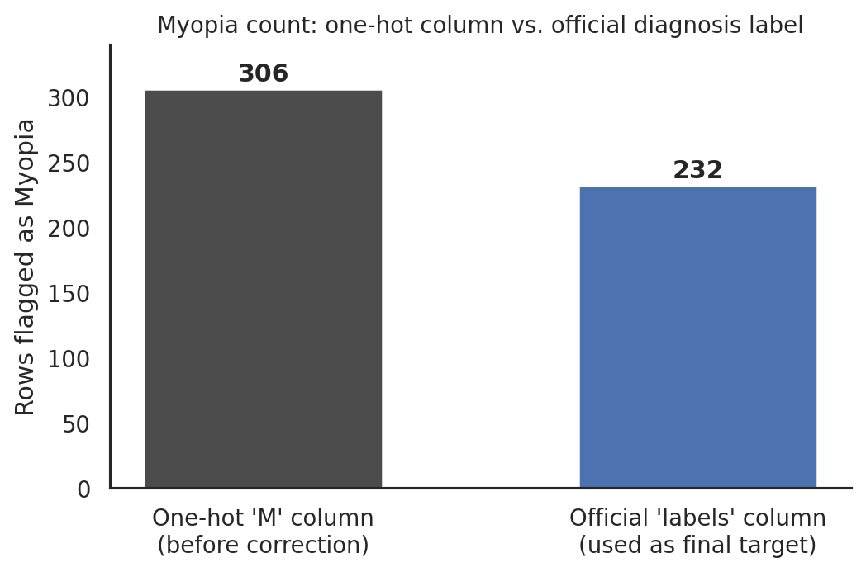
Figure 3. Myopia count before vs. after using the official label as ground truth.
Decision: the Experiment 1 target (Myopia) is derived from the official labels column, not the one-hot M column. M is retained as Myopia_OneHot_Reference for transparency, not used as the target.
Corrected class balance: Myopia = 232 (3.63%), Non-Myopia = 6,160 (96.37%) — more imbalanced than the Stage-1 figure based on the one-hot column.

5.4 Other data-quality checks (Stage 2)
Check | Result
Duplicate rows | 0
filename matches Left-Fundus or Right-Fundus | 6,392 / 6,392 (100%)
Patient Sex categories | Exactly Female, Male; no missing values, no typos
Cleaned age range | 14 – 91 (sane)

6. Feature Selection / Feature Engineering
Experiment 1 (Myopia vs Non-Myopia) — final feature set (post Stage 3):
Role | Column | Notes
Feature | Patient_Age_Scaled | Patient_Age, median-imputed then standardized — fit on training data only (Section 7.3)
Feature | Sex_Male | One-hot encoding of Patient Sex; 1 = Male, 0 = Female (Section 7.2)
Target | Myopia | 0/1, derived from official labels
Key | ID | For patient-grouped train/test split, not a feature
No formal statistical feature-selection method (e.g. SelectKBest, RFE) was needed at this stage since the legitimate candidate pool is already just these two variables — that step becomes relevant once more features exist (e.g. after multimodal fusion). Revisited explicitly before Experiment 2 and the image stage.

7. Preprocessing
Stage 3 — Code/notebooks/03_normalization_encoding_split.ipynb, executed against the real Data/myopia_baseline_clean.csv.

7.1 A clarification found while checking per-patient consistency
Before splitting by patient, each patient's two rows (left/right eye) were checked for a consistent Myopia label. 45 of 3,358 patients (1.3%) have a different Myopia value on their two rows.
Investigating why led to a useful correction to how Stage 2's “labels” column should be described: it is recorded per image (it matches the specific eye named in that row's filename), not merged per patient. For example, patient ID 0 has labels=['C'] on the row for 0_left.jpg and labels=['N'] on the row for 0_right.jpg — each matching that eye's own diagnostic keywords exactly. This does not change any Stage 2 number (the 232-row myopia count is still an accurate image-level count) — it only clarifies that “official label” means per-image, which is appropriate since each row genuinely is one image.
Consequence for the split: a patient can legitimately have one myopic eye and one non-myopic eye. The patient-level split therefore uses a derived summary — “does this patient have at least one myopic eye” (154 / 3,358 patients, 4.59%) — purely to stratify the split and keep class balance even; it is not a claim that both eyes share one label.

7.2 Patient-level, stratified train/test split
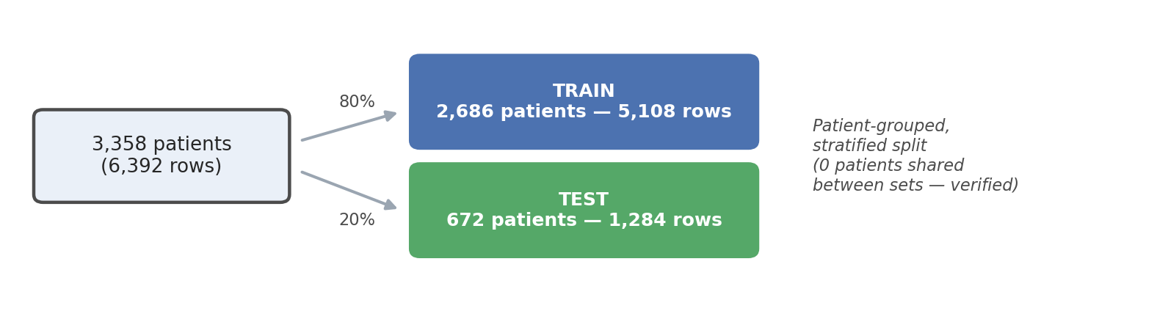
Figure 4. Patient-level split — grouped by ID, stratified by patient-level myopia status.
Metric | Train | Test
Patients | 2,686 (80%) | 672 (20%)
Rows (images) | 5,108 | 1,284
Myopia rows (row-level) | 187 | 45
Myopia rate (row-level) | 3.66% | 3.50%
Split method: scikit-learn train_test_split on the 3,358 unique patient IDs (80/20), stratified on a patient-level “has any myopic eye” flag, random_state=42 for reproducibility. All of a patient's rows are then assigned to whichever side that patient landed on.
Verification performed and passed: zero patient IDs appear in both the train and test patient ID sets; re-checked at the row level by confirming every ID's rows carry a single split value; re-confirmed again after re-reading the saved CSV files back from disk.
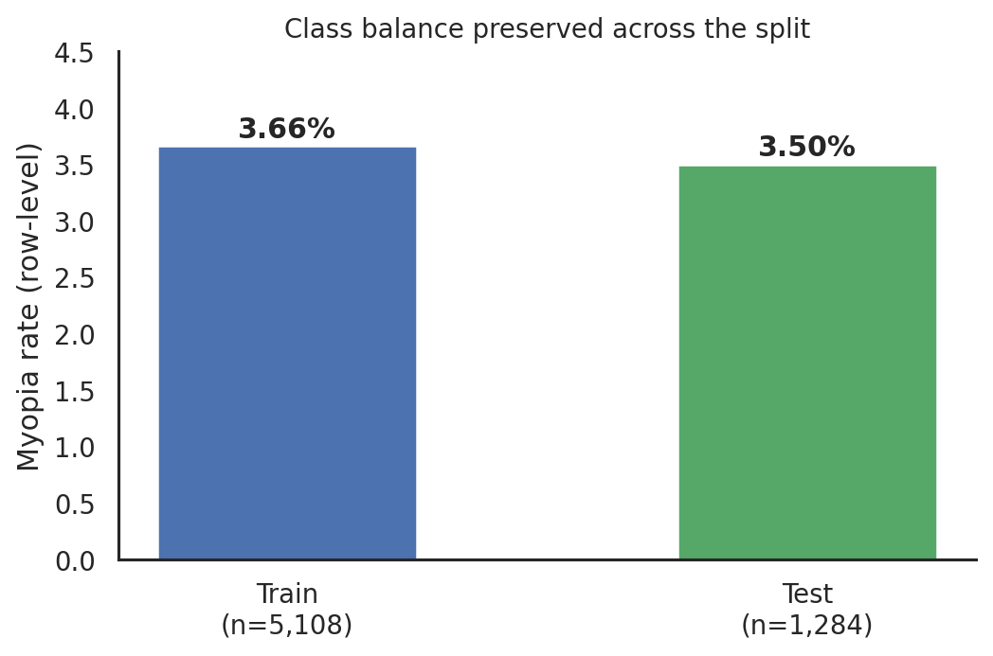
Figure 5. Row-level myopia rate stayed close between train (3.66%) and test (3.50%) — stratification worked as intended.

7.3 Encoding and imputation/scaling — fit on training data only
- Patient Sex → one-hot encoded to a single binary column Sex_Male (1 = Male, 0 = Female), via scikit-learn's OneHotEncoder(drop="if_binary").
- Patient_Age → 28 missing values (from the Stage 2 age=1 cleanup: 26 in train, 2 in test) filled using SimpleImputer(strategy="median"), fit on the training rows only. Training median = 59.0.
- Patient_Age → then standardized with StandardScaler, fit on the training rows only. Training mean = 58.15, training std = 11.15.
- Both the imputer and the scaler were fit once on the training split, then applied unchanged to the test split — the test set never influenced either statistic, which is what keeps this leakage-free.
Result: zero missing values remain in either the training or test feature matrix (verified).

7.4 Files produced
- Data/train_set.csv — 5,108 rows × 16 columns
- Data/test_set.csv — 1,284 rows × 16 columns
Both files carry ID, the raw Patient_Age/Patient Sex, the Stage-2 reference columns (kept for the future multi-class experiment), and the new Patient_Age_Scaled / Sex_Male / Myopia columns used as the Experiment-1 model input. Data/myopia_baseline_clean.csv is unchanged (verified by re-reading it after the split).

8. Model Development
Stage 4 — Code/notebooks/04_baseline_classification.ipynb, executed against the real Data/train_set.csv and Data/test_set.csv.
Experiment 1: Myopia vs Non-Myopia, using only the two Stage-3 model input features (Patient_Age_Scaled, Sex_Male). Every reference/diagnosis-derived column carried in the train/test files (N, D, G, C, A, H, O, n_conditions, Myopia_OneHot_Reference, Age_Was_Missing, raw Patient_Age, raw Patient Sex, ID) was explicitly excluded from the model input — verified in code, not just by convention.
No preprocessing was refit here. The Stage-3 imputer and scaler were fit once on training data only; this stage reuses their already-transformed output as-is.

8.1 Class-imbalance handling — decision and reasoning
Myopia is 3.66% of the training set (187 of 5,108 rows). Three options were weighed:
Option | Decision
Random oversampling / SMOTE | Not used — with only 2 features (one of them binary), synthetic points would mostly interpolate along a single real axis (age), adding little genuine information and risking a misleadingly optimistic test read.
Undersampling the majority class | Not used — would discard real training data in a dataset that already has very little (only 2 features to begin with).
Class weighting (class_weight="balanced") | Used for all three models. Keeps every real row exactly as collected; only reweights each class' training error. Standard, defensible baseline choice under imbalance.
Weights actually applied (computed from the training labels only): Myopia (minority) ×13.66, Non-Myopia (majority) ×0.52.

8.2 Algorithms and key hyperparameters
Model | Key settings
Logistic Regression | class_weight="balanced", max_iter=1000, random_state=42
Random Forest | n_estimators=300, class_weight="balanced", random_state=42
SVM (RBF kernel) | kernel="rbf", class_weight="balanced", random_state=42
All three were trained on the identical 2-feature training matrix and evaluated once on the identical, untouched test set — no hyperparameter search was run at this baseline stage.

9. Model Configuration
Item | Value
Feature matrix | Patient_Age_Scaled, Sex_Male (2 columns)
Target | Myopia (0/1)
Training rows | 5,108 (3.66% positive)
Test rows | 1,284 (3.50% positive)
Split | Patient-level, stratified 80/20 (from Stage 3, unchanged)
Random seed | 42, used consistently across all three models

10. Experimental Results
Real, executed results on the held-out test set (1,284 rows, 45 actual Myopia cases). Nothing below is estimated.
Model | Accuracy | Precision (Myopia) | Recall (Myopia) | F1 (Myopia) | F1 (macro) | F1 (weighted)
Logistic Regression | 0.5950 | 0.0527 | 0.6222 | 0.0972 | 0.4181 | 0.7165
Random Forest | 0.7477 | 0.0426 | 0.2889 | 0.0743 | 0.4641 | 0.8266
SVM (RBF kernel) | 0.6012 | 0.0484 | 0.5556 | 0.0890 | 0.4169 | 0.7218
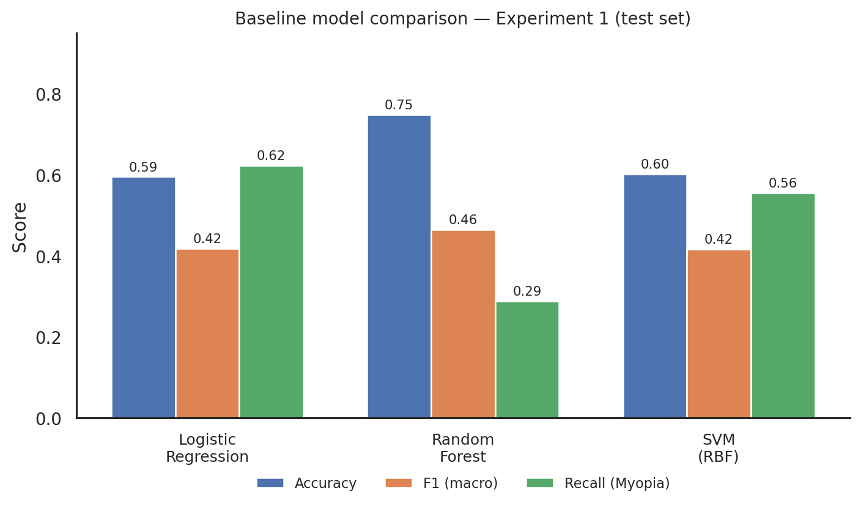
Figure 6. Accuracy, macro-F1 and Myopia recall across the three baseline models.
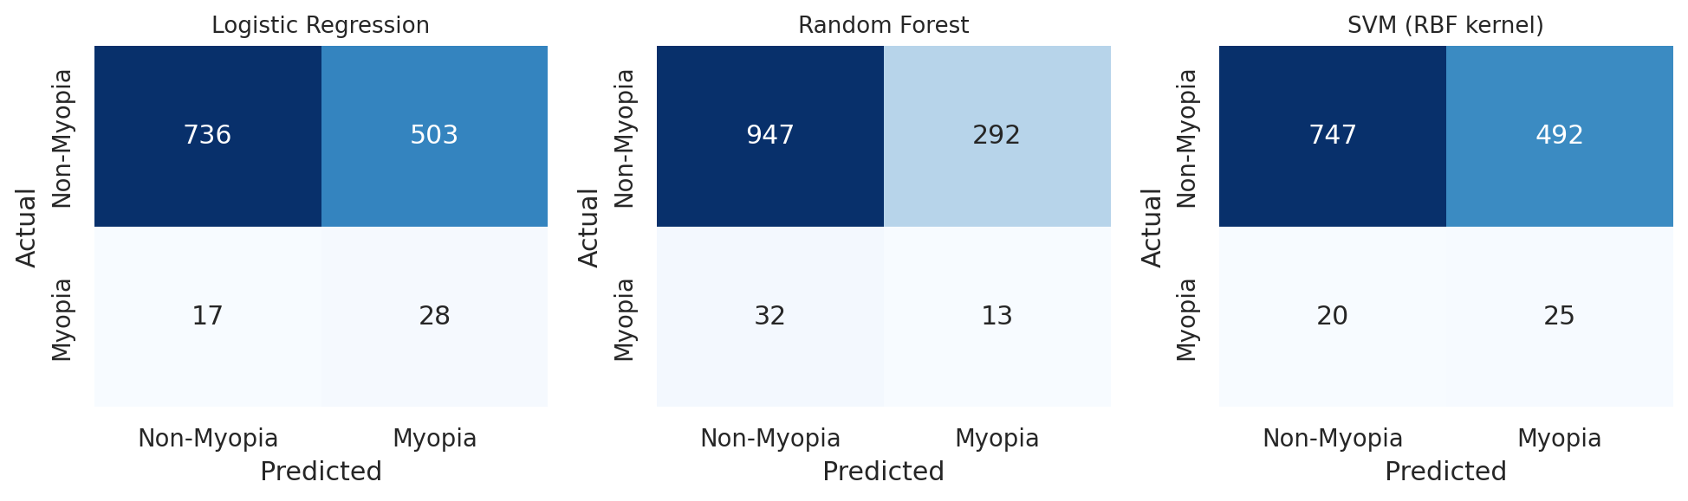
Figure 7. Confusion matrices — all three models heavily over-predict Non-Myopia, as expected from a 3.5% positive rate with only 2 weak features.

10.1 Selecting the best baseline model
Selection rule, fixed before looking at the numbers: rank by macro-F1 first (treats catching Myopia and correctly identifying Non-Myopia as equally important, regardless of class size), using Myopia recall as the tie-breaker. Accuracy is not used to choose — see Section 11.
Result: Random Forest has the highest macro-F1 (0.4641) and highest accuracy (0.7477) and highest weighted-F1 (0.8266) — by this rule, it is the best baseline model.
Important trade-off to flag honestly: Random Forest's Myopia recall (28.9%) is actually the WORST of the three — it misses more real myopia cases than Logistic Regression (62.2% recall) or SVM (55.6% recall). If this were a screening tool where missing a real case is the costlier mistake, Logistic Regression would be the more defensible pick despite its lower macro-F1 and much lower accuracy. This is a genuine, unresolved tension between two reasonable objectives (balanced overall correctness vs. not missing positive cases) — reported here rather than papered over. The macro-F1 rule was fixed in advance and is followed for this report, but which metric should govern the final choice is worth raising with the guide.

11. Evaluation Metrics
Accuracy alone is not a reliable indicator for this problem: with only 3.5% of the test set being real Myopia cases, a model that always predicts "Non-Myopia" would already score about 96.5% accuracy while catching zero real cases. That is why macro-F1, weighted-F1, and per-class recall/precision are reported alongside accuracy for every model, and why accuracy was excluded from the model-selection rule.
Precision on the Myopia class is low for all three models (4–5%) — of everyone flagged "Myopia" by any of these models, roughly 95% are actually false alarms. This is a direct, expected consequence of the Stage 2 finding that the dataset only provides two weak demographic features (age, sex) with no real clinical predictors of myopia (refractive error, IOP, etc.). These numbers should be read as an honest baseline ceiling given the available data — not as a usable screening tool.

12. Important Observations
- Dataset is multi-label at the row level (15.7% of rows have 2+ conditions) — affects design of Experiment 2.
- Only 2 legitimate demographic features exist for the tabular baseline (age, sex) — no other clinical measurements are present in this CSV.
- Two different labeling schemes exist in the raw data (labels vs one-hot columns), disagreeing on 27% of rows; labels was chosen as ground truth and matches the previously reported myopia count (232).
- Patient Age = 1 is a missing-data placeholder concentrated in myopia-positive rows (89% of those 28 rows) — a specific leakage risk that was caught and neutralized before modelling.
- Experiment 1 is a strongly imbalanced problem: 3.63% positive class (using the corrected target).
- The official label field is recorded per image, not per patient — 45/3,358 patients have one myopic eye and one non-myopic eye. The patient-level split correctly keeps both of that patient's rows together on one side of the split (Section 7.1).
- The patient-level, stratified split preserved class balance well: 3.66% myopia in train vs 3.50% in test — close enough that the test set is a fair evaluation of the training distribution.
- With only 2 weak features, all three baseline models struggle to precisely identify Myopia (4–5% precision) — this is the expected, honest consequence of the Section 5.1 feature limitation, not a modelling error.
- Random Forest reaches the highest accuracy (74.8%) and macro-F1 (0.464) but has the lowest Myopia recall (28.9%) — it plays safe by predicting Non-Myopia far more often, which raises accuracy but misses more real cases than the other two models.
- Logistic Regression and SVM trade accuracy for recall — both catch more than half of real Myopia cases (62.2% and 55.6%) at the cost of far more false alarms and much lower accuracy.

13. Problems / Issues Encountered
Issue | Resolution
Patient Age = 1 outlier concentrated in myopia rows | Treated as missing (NaN); imputation deferred to modelling stage; no missing-flag feature used (Section 5.2)
labels and one-hot disease columns disagree on 27% of rows | Investigated with real counts; official labels column adopted as ground truth, matching the previously reported myopia count
Very thin legitimate feature set (only age, sex) | Documented as a dataset limitation rather than compensated for artificially
45 patients have differing Myopia labels between their two rows | Traced to the label being per-image, not per-patient (Section 7.1); resolved by stratifying the patient split on a derived “any eye myopic” flag rather than assuming one label per patient
Baseline models show very low Myopia precision (4–5%) | Not a bug — direct consequence of only 2 weak features being available; reported honestly rather than tuned away or hidden (Section 11)
Best model depends on which metric matters (macro-F1 vs recall) | Both readings reported side by side rather than picked silently; macro-F1 used as the official rule, recall trade-off flagged explicitly for the guide (Section 10.1)

14. Decisions Made and Reasons
See Sections 5.1–5.3 for Stage 2 decisions (feature exclusions, age treatment, target derivation), Section 7 for Stage 3 decisions (split method, imputation/scaling), and Section 8.1/10.1 for Stage 4 decisions (class-imbalance handling, model-selection rule).

15. Dataset / Model Limitations
- Only 2 legitimate clinical/demographic features available for the tabular baseline — no refractive error, IOP, or other measurements.
- Experiment 1 target is heavily imbalanced (3.63% positive).
- With only those 2 features, all three Stage-4 baseline models have low precision on Myopia (4–5%) — this is a ceiling set by the available data, not something further tuning of these same features is likely to fix. More/better features (e.g. from the fundus images) are the more promising path forward.
- Fundus images have now been inventoried (Section 3.1). datasets/normal, preprocessed_images/, and ODIR-5K/Training Images could only be partially counted (2,000-entry tool cap) — exact totals still need confirming by re-listing locally. IMAGES/Myopia_images and IMAGES/Normal_images (63,294 / 61,500 files) could not be inspected at all (too large to list) and are recommended against as the primary dataset.
- datasets/<class>/ images have no patient-ID in their filenames, so they cannot be directly joined to full_df.csv's clinical columns — only preprocessed_images/ and ODIR-5K/ can (Section 3.1). This matters for the eventual clinical+image fusion stage.
- The cloud sandbox used for the Section 3.2 verification run cannot download ImageNet pretrained weights (network policy blocks the host), so that run could only be verified with a random-initialization fallback, not real transfer learning. This was resolved by moving training to the local RTX 4060 machine (Section 3.3), which has normal internet access and produced a real, trustworthy transfer-learning result.
- The Section 3.3 local-GPU run used an image-level split (no patient ID available in the datasets/<class>/ filenames), not the patient-grouped split used for the tabular baseline — flagged again here since it is a genuine methodological gap between the two pipelines, not yet closed.
- Section 3.3's class-weighted loss trades Myopia precision (69.4%) for Myopia recall (97.1%) — a deliberate choice given the class imbalance, but one that should be reviewed with the guide rather than treated as final (Section 3.3).
- The Section 3.4 clinical+image fusion model underperforms the image-only Stage 3.3 model (macro-F1 72.4% vs 89.5%) — the only 2 clinical features available (age, sex) appear to dilute rather than strengthen the strong image signal. This is a real, reported finding for the guide review, not a hidden failure (Section 3.4).
- The Section 3.4 fusion model only trains a small classifier head on precomputed, frozen features from both branches — the image backbone is not fine-tuned jointly with fusion training, which may be part of why fusion underperforms the image-only model (Section 3.4).
- Section 3.5's final model (fine-tuned backbone fusion) narrows the gap to the image-only model (macro-F1 87.5% vs 89.5%) but does not fully close it, and its Myopia recall (84.0%) is lower than Stage 3.4's (96.0%) in exchange for far fewer false alarms (9 vs 47) — this recall/precision trade-off should be reviewed with the guide, since a screening-style task may prefer the higher-recall Stage 3.4 model despite its worse macro-F1 (Section 3.5).
- Section 3.5's fine-tuning trains at image level (each of a patient's 1-2 images is a separate training example carrying that patient's label) — a stated, defensible design choice for getting enough CNN training signal from a patient-level label, but not the only valid way to do it (Section 3.5).
- The improved 8-class model (Section 3.8) reaches 71.5% accuracy / 63.5% macro-F1, but Glaucoma (42.3% F1, 35.7% of cases found) and Hypertension (34.5% F1, 27.8% found) remain weak and are often called Normal. These are small classes with subtle signs; more labelled images are needed (Section 3.8).
- For the 8-class task, the only clinical features (age, sex) carry almost no signal — the best clinical model is barely above the majority-class baseline (10.6% vs 7.8% macro-F1), so a clinical+image fusion model for 8 classes is not expected to help until better clinical features exist (Section 3.6).
- The 8-class task uses the single per-image labels column. The dataset is also multi-label at patient level (1,001 rows have 2–3 flags), which a single-label model cannot express (Section 3.6).
- The IMAGES/ folder was checked and rejected: it contains exact duplicates of datasets/ images and a class-specific streak artifact in the Myopia images, which could act as a shortcut (Section 3.6).
- On a second dataset (RFMiD, Section 3.12) the ODIR-only models dropped clearly (mean AUC 0.752, Myopia 0.755), showing that part of what they learned is specific to ODIR images. Training on both datasets (Section 3.13) reduced this, but the RFMiD test is then no longer a fully unseen-hospital test; a third, never-used dataset would be needed for that.
- RFMiD's Glaucoma (ODC) and Cataract (MH) labels are only proxies for our classes, and RFMiD has almost no Hypertension images, so those three classes are not properly tested or helped by the second dataset.
- The batch tool's photo-quality check is rule-based: it catches very dark or over-exposed photos but only 4 of 30 grader-marked bad photos, and not photos of the front of the eye. About 5% of diseased eyes still land in “Likely normal”, so that group is lower priority, not doctor-free (Section 3.14).
- In the fair benchmark the best standard networks score within about ±3 points of each other (the 95% confidence interval on 960 test photos), so our model is ‘in the top group’, not clearly superior. The final DenseNet member was trained on ODIR only, which lowered the overall second-dataset (RFMiD) AUC from 0.800 to 0.771 (Section 3.15).
- No hyperparameter tuning was performed in Stage 4 — these are baseline, default-ish configurations, not optimized models.

16. Current Progress
☑ Stage 1 — Data Exploration (Code/notebooks/01_data_exploration.ipynb)
☑ Stage 2 — Data Cleaning + Feature Identification (Code/notebooks/02_data_cleaning_feature_selection.ipynb, Data/myopia_baseline_clean.csv)
☑ Stage 3 — Normalization / Encoding + Patient-level Split (Code/notebooks/03_normalization_encoding_split.ipynb, Data/train_set.csv, Data/test_set.csv)
☑ Stage 4 — Experiment 1 Classification (Code/notebooks/04_baseline_classification.ipynb, Data/stage4_model_comparison.csv)
☐ Stage 5 — Evaluation / model refinement
☑ Stage 6 — Fundus image dataset inspection / validation (Code/notebooks/05_image_dataset_inspection.ipynb, Data/stage5_image_index.csv)
☑ Stage 7 — Image model / CNN transfer learning: binary Myopia vs Normal trained on local RTX 4060 with real ImageNet weights, 96.6% test accuracy / 89.5% macro-F1 (Section 3.3). 8-class CNN added later (Section 3.6).
☑ Stage 8 — Multimodal clinical+image fusion: patient-grouped proof-of-concept reusing the real Stage 3.3 image weights, 90.5% test accuracy / 72.4% macro-F1 — beats both clinical-only baselines but underperforms the image-only model (Section 3.4).
☑ Stage 9 — Final model improvement: diagnosed why fusion underperformed, tested a tuned frozen-backbone variant and a fine-tuned-backbone variant, selected the fine-tuned model by test macro-F1 (87.5%, up from 72.4%), and shipped a standalone inference script (Section 3.5, Code/predict_myopia.py).
☑ Stage 10 — Multi-class (8 diseases): clinical-only vs image-only on one patient-grouped split; image model 49.8% accuracy / 48.1% macro-F1 (Section 3.6, Code/notebooks/09_multiclass.ipynb).
☑ Stage 11 — Prediction web app with Myopia check and 8-disease screen, tested end-to-end (Section 3.7, Code/app.py).
☑ Stage 12 — Improved 8-class model on GPU: EfficientNet-B0, 448px, whole network trained — 71.5% accuracy / 63.5% macro-F1 / mean AUC 0.871; selected by validation and used by the web app (Section 3.8, Code/train_stage10.py).
☑ Stage 13 — Grad-CAM explainability and Stage 12 ensemble: 71.8% accuracy / 64.0% macro-F1 / mean AUC 0.912 (Sections 3.9–3.11, Code/gradcam.py, Code/train_stage12.py).
☑ Stage 14 — External test on RFMiD without retraining (Section 3.12, Code/test_external_rfmid.py).
☑ Stage 15 — Retrained on ODIR + RFMiD; Stage 13 + Stage 12 ensemble selected on validation and used by the web app (Section 3.13, Code/train_stage13.py).
☑ Stage 16 — Batch screening tool with photo-quality check, limits calibrated on validation and tested once (Section 3.14, Code/triage.py, Code/batch_ui.py).
☑ Stage 17 — Benchmark, learning curve, ensemble search and batch-limit re-calibration (Section 3.15, Code/benchmark_models.py, Code/ensemble_search.py).

17. Next Steps
- Discuss with guide which metric should govern model choice for this problem (macro-F1 vs Myopia recall) — see the trade-off flagged in Section 10.1, and the analogous precision/recall trade-off for the image model in Section 3.3, and the final fusion model's own recall/precision trade-off in Section 3.5.
- Confirm the still-capped image counts (datasets/normal, preprocessed_images, ODIR-5K/Training Images) by re-listing them directly against the real folders — Section 1 of the Stage 6 notebook does this with no cap when run locally.
- Improve the weak 8-class classes (Glaucoma, Hypertension): more labelled images (the hospital dataset), and possibly using both eyes of a patient together (Section 3.8).
- Find a third public dataset (never used in training) for a true unseen-hospital test, ideally one with Glaucoma and Hypertension labels (Sections 3.12–3.13).
- Batch tool: replace the rule-based quality check with a small learned quality model, and re-check the decision limits on the hospital dataset before any real use (Section 3.14).
- Retrain DenseNet-121 on ODIR + RFMiD (as was done for Stage 13) to recover the second-dataset AUC, and repeat the benchmark with several random seeds to measure run-to-run variation (Section 3.15).
- When the hospital dataset arrives: re-check it for leakage and label quality, then retrain both the Myopia model and the 8-class model on it. Re-evaluate a larger backbone (e.g. ResNet) only then, since the current data is too small to justify it.
- Consider adding legitimate clinical features beyond age/sex if any exist in the source data, since Section 3.5's diagnosis found the current 2 features carry limited signal on their own.
- Longer term: a clinical+image fusion model for all 8 classes, once real clinical measurements are available (Section 3.6 showed age/sex alone add almost nothing for 8 classes).

18. Final System Architecture
The long-term multimodal, multi-disease system (Section 2) is not built yet. What exists as of Section 3.5 is a final, selected architecture for the binary Myopia-vs-Non-Myopia sub-task: a MobileNetV2 image branch (blocks 0-13 frozen from Stage 3.3's ImageNet+fundus-trained weights, blocks 14-18 fine-tuned) combined with a small clinical branch (age, sex) through a fusion classifier, selected over 2 other candidates by real, held-out test macro-F1 (Section 3.5). For the 8-class task, the current architecture is an image-only ensemble of an EfficientNet-B0 trained on ODIR + RFMiD at 448×448 (Section 3.13) and a DenseNet-121 trained on ODIR at 384×384 (Section 3.15), whose probabilities are averaged, with mirrored-image averaging at prediction time, because the available clinical features add almost nothing there (Section 3.6). Both models are served by one web app (Section 3.7). A full multimodal, multi-disease fusion system is still future work (Section 17).

19. Final Results
For the binary Myopia-vs-Non-Myopia task specifically, Section 3.5's fine-tuned fusion model is the final selected result: 97.4% accuracy, 70.0% Myopia precision, 84.0% Myopia recall, 76.4% Myopia F1, 87.5% macro-F1 on 504 held-out test patients (confusion matrix [[470,9],[4,21]]). For the 8-class task, the final selected model is the Stage 13 + DenseNet-121 ensemble (Section 3.15): 72.7% accuracy (95% CI about 69.8–75.4%), 66.6% macro-F1 and a mean one-vs-rest AUC of 0.928 on 960 held-out ODIR test images (504 patients), against a 7.8% macro-F1 majority-class baseline. In a fair benchmark it is in the top group of seven standard networks (highest macro-F1 and AUC). On 640 test images from a second dataset (RFMiD) its mean AUC is 0.771 (Myopia 0.947). Strongest classes: Cataract (F1 0.86), Myopia (0.87), Normal (0.78); weakest: Hypertension (0.33) and Glaucoma (0.55). Batch screening sends 94.6% of diseased eyes to a doctor. These are current results, not final ones — the hospital dataset is expected to change them (Section 17).

20. References / Sources
- Dataset: ODIR-5K (Ocular Disease Intelligent Recognition), provided as full_df.csv and ODIR-5K/ODIR-5K/.
- External dataset: RFMiD — Pachade S. et al., “Retinal Fundus Multi-Disease Image Dataset (RFMiD): A Dataset for Multi-Disease Detection Research”, Data 2021, 6(2), 14. CC BY 4.0. Downloaded from Hugging Face (ctmedtech/RFMID).
- Karthikayan et al., “Explainable AI: Comparative Analysis of Normal and Dilated ResNet Models for Fundus Disease Classification”, arXiv:2407.05440, 2024.
- “Multiple model visual feature embedding and selection method for an efficient ocular disease classification”, Scientific Reports, 2025 (doi:10.1038/s41598-024-84922-y).
- Bhati et al., “Discriminative Kernel Convolution Network for Multi-Label Ophthalmic Disease Detection on Imbalanced Fundus Image Dataset” (DKCNet), arXiv:2207.07918 — includes results of Wang 2020, Gour & Khanna 2020, Li 2020 and Ou 2022.
- Reference papers (not yet cited in-text): Flitcroft et al., 2019; Foo et al., 2023; Ohno-Matsui et al., 2021; Prashar & Tay, 2023–2024; Varadarajan et al., 2018 (Reference Research Papers/).

Files Created / Modified Log
File | Stage | Purpose
Data/full_df.csv | — | Original master dataset (untouched)
Data/myopia_baseline_clean.csv | 2 | Cleaned Experiment-1 modelling dataset (6,392 rows × 14 columns)
Data/train_set.csv | 3 | Training split, preprocessed (5,108 rows × 16 columns)
Data/test_set.csv | 3 | Test split, preprocessed (1,284 rows × 16 columns)
Code/notebooks/01_data_exploration.ipynb | 1 | Data exploration, executed against real full_df.csv
Code/notebooks/02_data_cleaning_feature_selection.ipynb | 2 | Column classification, age cleaning, target derivation, clean dataset export
Code/notebooks/03_normalization_encoding_split.ipynb | 3 | Patient-level split, encoding, train-fit imputation/scaling, train/test export
Data/stage4_model_comparison.csv | 4 | Verified metrics for all 3 baseline models (source of Section 10's table)
Code/notebooks/04_baseline_classification.ipynb | 4 | Trains and evaluates Logistic Regression, Random Forest, SVM; produces comparison table and confusion matrices
Data/stage5_image_index.csv | 6 | Class-labelled index of datasets/ image files (7 of 8 classes fully enumerated; no files moved/modified)
Code/notebooks/05_image_dataset_inspection.ipynb | 6 | Counts, format/dimension/corruption/duplicate checks, full_df.csv traceability check, dataset + task recommendation
Code/notebooks/06_cnn_proof_of_concept.ipynb | 7 | TensorFlow MobileNetV2 pipeline, cloud-sandbox verification run — executed end-to-end on 211 images; random-init fallback, not a trustworthy result (Section 3.2)
Code/models/stage6_myopia_vs_normal_mobilenetv2_random_init_fallback.keras | 7 | Model checkpoint from the cloud verification run — pipeline reference only, not a usable classifier
Code/gpu_check.py | 7 | Standalone script that confirmed the local RTX 4060 is detected by PyTorch (CUDA available: True) after fixing the Python/CUDA environment (Section 3.3)
Code/notebooks/06_cnn_local_gpu_training.ipynb | 7 | PyTorch MobileNetV2 pipeline, executed on the local RTX 4060 with real ImageNet weights on the full datasets/myopia + datasets/normal folders — real trained-model result (Section 3.3)
Code/models/stage6_myopia_vs_normal_mobilenetv2_local_gpu.pt | 7 | Trained model checkpoint from the local GPU run — usable classifier (96.6% test accuracy, 89.5% macro-F1)
Code/verify_multimodal_linkage.py | 8 | Pre-modelling verification script: confirms every full_df.csv image reference exists in preprocessed_images/ and checks for mixed-label leakage risk before building the fusion model (Section 3.4)
Code/build_07_multimodal_fusion.py | 8 | nbformat generator script for the Stage 8 notebook (project convention: generator script kept alongside the notebook it produces)
Code/notebooks/07_multimodal_fusion.ipynb | 8 | Patient-grouped clinical+image fusion pipeline, executed on the local RTX 4060, reusing the real Stage 3.3 image weights — real trained-model result (Section 3.4)
Code/models/stage7_multimodal_fusion_local_gpu.pt | 8 | Trained fusion classifier checkpoint (clinical branch + fusion head; image branch is the frozen Stage 3.3 checkpoint, loaded separately)
Data/stage7_multimodal_cohort.csv | 8 | Real patient-level cohort table (3,358 patients) built from full_df.csv for the fusion model
Data/stage7_model_comparison.csv | 8 | Real comparison table: Stage 4 clinical baselines vs Stage 3.3 image model vs Stage 3.4 fusion model (source of Section 3.4's table)
Code/build_08_final_model.py | 9 | nbformat generator script for the Stage 9 notebook (project convention)
Code/notebooks/08_final_model.ipynb | 9 | Diagnoses the Stage 3.4 underperformance, runs Experiment A (tuned frozen fusion) and Experiment B (fine-tuned backbone fusion), selects the final model by test macro-F1 — real trained-model result (Section 3.5)
Code/models/stage8_final_fusion_model.pt | 9 | Final selected model checkpoint (fine-tuned MobileNetV2 blocks 14-18 + fusion head) — 97.4% test accuracy, 87.5% macro-F1
Data/stage8_final_model_config.json | 9 | Machine-readable record of which architecture won, its decision threshold, and its real test metrics — read by Code/predict_myopia.py
Data/stage8_final_model_comparison.csv | 9 | Real comparison table: Stage 4/3.3/3.4 baselines vs Stage 8 Experiment A vs Experiment B (source of Section 3.5's table)
Code/predict_myopia.py | 9 | Standalone inference script — takes age, sex, and 1-2 fundus image paths, loads the final model per the saved config, prints predicted Myopia probability and label (Section 3.5)
Code/build_09_multiclass.py | 10 | nbformat generator script for the 8-class notebook (project convention)
Code/notebooks/09_multiclass.ipynb | 10 | 8-class task: data checks, patient-grouped split, clinical models, MobileNetV2 image model, test evaluation — executed, outputs saved (Section 3.6)
Code/models/stage9_multiclass_mobilenetv2.pt | 10 | Trained 8-class image model — 49.8% test accuracy, 48.1% macro-F1
Data/stage9_multiclass_split.csv | 10 | Patient-level train/val/test assignment for every image
Data/stage9_multiclass_comparison.csv | 10 | Comparison table: baseline vs clinical models vs image model (source of Section 3.6's table)
Data/stage9_cnn_per_class.csv | 10 | Per-class recall/precision/F1 of the image model (also shown in the web app)
Data/stage9_multiclass_config.json | 10 | Classes, checkpoint path and test metrics — read by Code/predict_multiclass.py
Code/predict_multiclass.py | 10 | Inference for the 8-class model — loads the model once, predicts all 8 class probabilities from 1–2 images; also usable from the command line
Code/app.py | 11 | Streamlit web app: Myopia check (Stage 8 model) and 8-disease screen (Stage 9 model) (Section 3.7)
Code/predict_myopia.py | 11 | Updated so the model loads once (load_final_model / predict_with_loaded) and the web app does not reload it on every prediction; command-line use unchanged
Code/build_10_multiclass_improved.py | 12 | Generator script for the Stage 10 notebook
Code/notebooks/10_multiclass_improved.ipynb | 12 | Stage 10 notebook (same code as Code/train_stage10.py)
Code/train_stage10.py | 12 | Stage 10 as a terminal script (used for the real run); prints and saves Data/stage10_training_log.txt (Section 3.8)
Code/models/stage10_multiclass_efficientnet_b0.pt | 12 | Improved 8-class model — 71.5% test accuracy, 63.5% macro-F1, mean AUC 0.871
Data/stage10_multiclass_config.json | 12 | Architecture, image size, checkpoint and metrics — read by Code/predict_multiclass.py
Data/stage10_comparison.csv / stage10_per_class.csv / stage10_per_disease_yes_no.csv | 12 | Stage 9 vs Stage 10, per-class results, per-disease yes/no results (Section 3.8)
Data/stage10_training_log.txt | 12 | Full printed output of the real GPU run
test_images/ | 12 | 16 held-out test images (2 per class, true class in the file name) for trying the web app
Code/predict_multiclass.py | 12 | Updated: loads the 8-class model with the best validation macro-F1 (now Stage 10), supports EfficientNet-B0, 448px and mirrored-image averaging
Code/gradcam.py | 11 | Grad-CAM heatmaps for the 8-class and Myopia models (Section 3.9)
Code/notebooks/stage11_gradcam_examples.png | 11 | Grad-CAM on the 16 test images (Section 3.9)
Code/app.py | 11 | Updated: shows Grad-CAM heatmaps under every prediction (Section 3.9)
Code/predict_multiclass.py, Code/predict_myopia.py | 11 | Updated: automatic fix for blue (colour-swapped) images (Section 3.10)
Code/train_stage12.py | 12 | Stage 12 training: 512px, contrast enhancement, up to 40 epochs, ensemble with Stage 10 (Section 3.11)
Code/models/stage12_multiclass_efficientnet_b0_512_enh.pt | 12 | Stage 12 network; with the Stage 10 network it forms the selected ensemble (71.8% accuracy, mean AUC 0.912)
Data/stage12_*.csv / .json / _training_log.txt | 12 | Stage 12 comparison, per-class and yes/no results, config and full run log (Section 3.11)
Code/predict_multiclass.py | 12 | Updated: supports ensembles and contrast enhancement; uses the Stage 12 ensemble
Code/test_external_rfmid.py | 14 | External test of the Stage 10 and Stage 12 models on RFMiD test images (Section 3.12)
Data/external_rfmid_per_disease_auc.csv, Data/external_rfmid_summary.csv | 14 | RFMiD external test results (Section 3.12)
external/RFMiD/{train,val,test} | 14–15 | RFMiD fundus images (cropped, 512px) with labels.csv; CC BY 4.0
Code/train_stage13.py | 15 | Trains on ODIR + RFMiD, compares 4 candidates on validation, writes the final choice (Section 3.13)
Code/models/stage13_multiclass_efficientnet_b0_odir_rfmid.pt | 15 | Stage 13 network; with the Stage 12 network it forms the selected ensemble
Data/stage13_*.csv / .json / _training_log.txt, Data/multiclass_final_choice.json | 15 | Stage 13 results, config, run log, and the app's model choice (Section 3.13)
Code/predict_multiclass.py | 15 | Updated: reads Data/multiclass_final_choice.json; uses the Stage 13 + Stage 12 ensemble
Code/triage.py | 16 | Batch screening logic: quality check + model + decision rule + sorting; also a terminal tool
Code/batch_ui.py, Code/app.py | 16 | “Batch screening (many photos)” page added to the web app
Code/image_quality.py, Code/calibrate_quality.py | 16 | Rule-based photo-quality check and its calibration
Code/calibrate_triage.py | 16 | Chooses the Refer / Likely-normal limits on validation and tests them once
Data/quality_*.csv/json, Data/triage_*.csv/json/txt, Code/notebooks/triage_evaluation.png | 16 | Quality and triage calibration results (Section 3.14)
Code/benchmark_models.py | 17 | Fair benchmark of 7 networks + learning curve (Section 3.15)
Code/ensemble_search.py | 17 | Chooses the best combination with the benchmark networks on validation (Section 3.15)
Code/models/benchmark_*.pt | 17 | Benchmark checkpoints; benchmark_densenet121.pt is part of the final model
Data/benchmark_results.csv, Data/learning_curve_results.csv, Data/ensemble_search.csv | 17 | Benchmark, learning-curve and ensemble results
Data/stage14_multiclass_config.json, Data/stage14_per_class.csv | 17 | Final model (Stage 13 + DenseNet-121) config and per-class results
Code/predict_multiclass.py | 17 | Updated: supports DenseNet-121 and ConvNeXt-Tiny members
Documentation/Capstone_Project_Documentation.docx | ongoing | This file — single master project log

