Generate Response For Array of Complex

This document contains the information on generating response for Array of Complex using generate response trigger in a process. In order to generate the response for Array of Complex, a template need to be defined in a prescribed manner. This template is attached with a genrate response trigger, which inturn is attached to an Action.
On clicking the action in an workitem of process, it activates the trigger, which upon firing generate the document.

Prerequisites:
- Open office must be installed on server.
- Template should be *.odt for complex array support.

Limitations:
- This feature is supported only on open office.
- This is not supported on MS Office or wdgc.dll.
- Template can only be *.odt type in order to support this feature.
- Output can only be exported to *.doc or *.pdf format.
- First level complex variable is supported only. Nth level complex is not supported.
- One table can be represented by only one complex variable. One table with multiple complex variable is not allowed.

Designing odt template for Array of complex support:

- Open an open office instance.
- Click File --> New --> Text document.
- Give it any name you like and save as .odt document.
- Write the template as per your requirement.
- Insert the table in template to use the array of complex array support .
- Table must have two rows. One having the Header of the table.
- Second row contains the information about complex variable and its attributes columnwise. This denotes that which attribute's value will go to which column.
Attribute names in columns must be in complexVariable.attribute format.

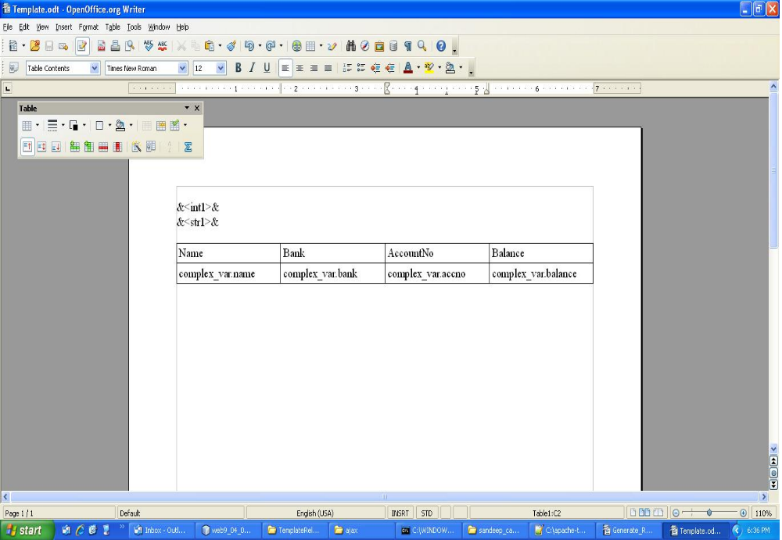
These rows are mandatory.
- Define the table name using open office as shown in the diagrams. Table name should exactly match the complex attribute name in process. Right click on the table and define table name and apply.
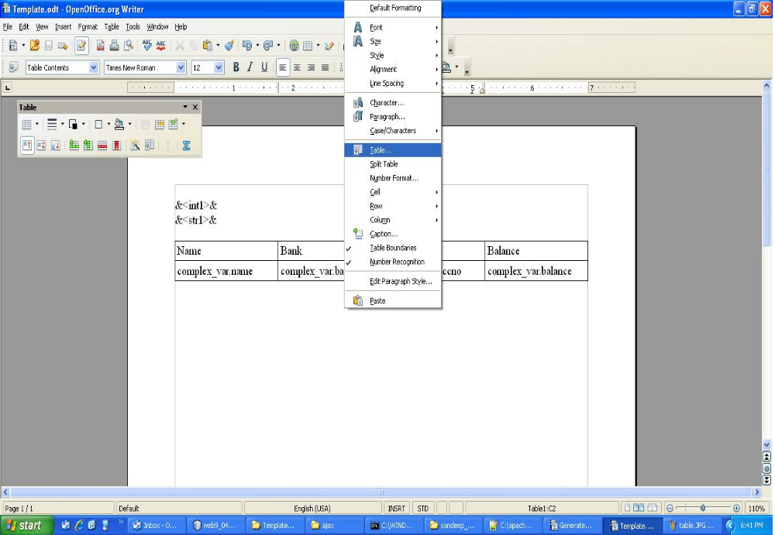

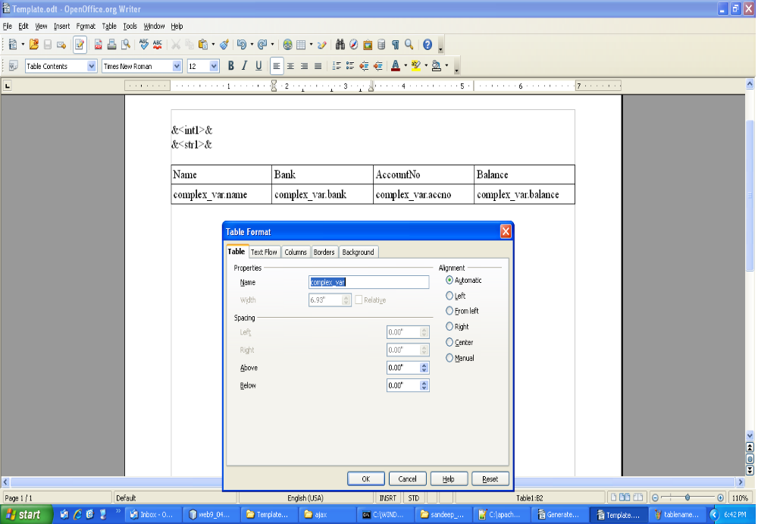

- Other non- complex attributes can simply be in &<simpleAttribute>& form.
- Apply and save the template.
- Reconfirm that the table name and row data is as per the above instructions.
- Define template in process modeler and attach this doc as template.

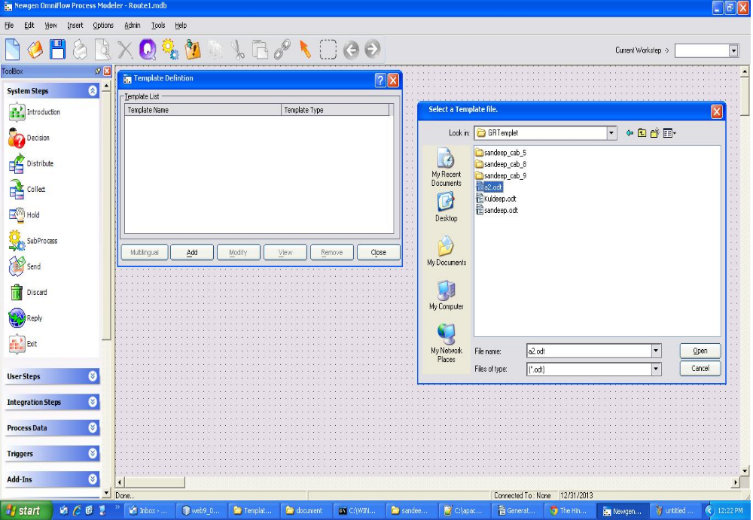

- Attach this template to Generate response trigger and use in the process.

