For compiling the CustomClass.java refer below screen shot.

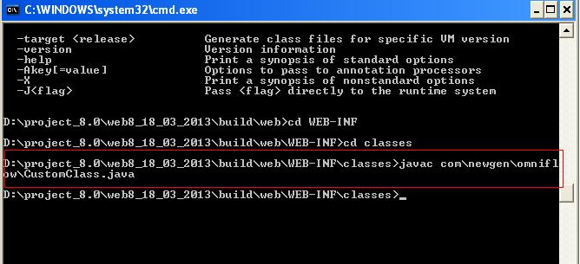

1.Put the java file inside the webdesktop.war\WEB-INF\classes\com\newgen\omniflow\ folder
2.Make the classes folder of webdesktop.war as a working directory
3.Compile the java file using command javac com\newgen\omniflow\CustomClass.java
4.Remove the java file from that location

