# PROPOSAL DETAILS

|  |  |  |  |
| --- | --- | --- | --- |
| **Name:** | ---- | **Date:** | ----- |
| **Company:** | ---- | **Submitted By:** | ---- |
| **Address:** | --- | **Contact Details:** | ---- |
| **Country & Currency:** | ---- | **Email** | ------- |

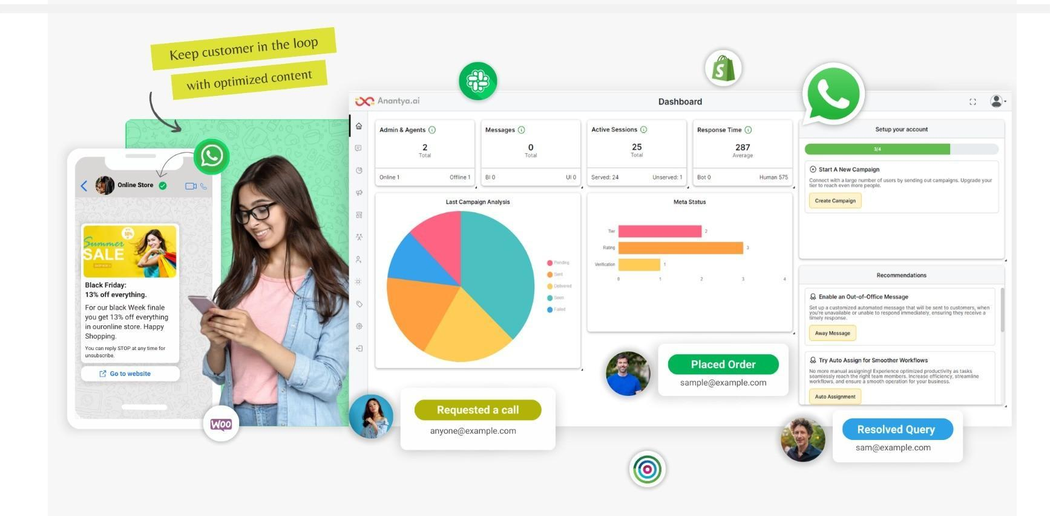

|  |  |  |
| --- | --- | --- |
| **WhatsApp Business API**  **Setup and Verification:**  WABA Setup and Number Configuration  FBM Meta Verification  Green Tick Verification  Account Setup and Verification | **Admin Dashboard and Omni-Channel Inbox:**  Admin Dashboard  Team Inbox  Channels and Filters  Communication Filters | **Cart & Catalog**  **Management:**  Product Setup  Catalog Profile  E-Commerce Integration  CRM & Location Integration |
| **Bot Setup and**  **Automation:**  Bot Setup and Keyword Configuration  Multi Language Support  Welcome Message  Away Message  Feedback Message  Quick Replies  Conversation Flows  AI Bot Integration  List and Button Integration | **Campaign Management and Reporting & Analytics:**  Campaign Scheduling  Template Management and Synchronization  Detailed Usage Reports  Multilingual Campaigns  Dynamic and Static Campaigns  Multi-Category Campaigns  Rich Media Campaigns  Scheduling Logs & Campaign Reports  Live Label, User & Agent Reports | **Multi-Agent Management & SMS Fallback:**  Manual Transfer  Reports  Pickup and Round Robin Allocation  Unique Login Credentials  Fallback Mechanism  Social Media Integration  SMS Integration  CRM/ERP Integrations  Open APIs |

**Pricing Details**

|  |  |  |
| --- | --- | --- |
| **Particulars** | **Billing Type** | **Cost(USD)** |
| Meta Business Verification & Number Configuration | One-time |  |
| Monthly Platform Chargers   * 1000 Free Service Conversations/month * 5 User Access + 1 Admin Access * Chatbot Automation * Unlimited Templates * Comprehensive Customer Support (Email, Chat & Call) | Monthly Recurring |  |

|  |  |  |  |
| --- | --- | --- | --- |
| **WhatsApp Conversation Charges (USD)** | | | |
| **Conversation Type** | **Per Conv. Cost (Country1)** | **Per Conv. Cost (Country2)** | **Per Conv. Cost (Country3)** |
| **Marketing (BI)** |  |  |  |
| **Utility (BI)** |  |  |  |
| **Authentication (BI)** |  |  |  |
| **Service (UI)** |  |  |  |

|  |  |  |  |
| --- | --- | --- | --- |
| **ADDITIONAL UPGRADE** | **Unit** | **One Time** | **Recurrent**  **(Per Year)** |
| **Green Tick\*** | **1** | - | - |
| **Additional Agent/ Sub-login** | **1** | - | - |
| **Addon Channel FB Messenger, Instagram**  **(Unlimited Conversation)** | **1** | - | - |
| **API Integration (Per API)** | **1** | - | - |
| **On-Premises Database Hosting** | **1** | - | - |
| **Advance analytics (Bot ,Click, Opt out reports)** |  |  | - |
| **Custom Domain Charges** |  |  | - |

#### Terms of Service

1. **Meta Disclosure:** The green tick, subject to Meta approval, epitomises your business's goodwill and branding. We pledge our best efforts to obtain it, as brand establishment is vital for securing the green tick according to Meta's standards. Trust us to enhance your brand's presence, guiding you towards this symbol of credibility and recognition.
2. The attainment of Facebook (FB) verification, the display of the Green verified tick on WhatsApp numbers, as well as template pausing and account restrictions, are solely under the control of Meta Platforms, Inc. ("Meta"). While we, as suppliers, provide assistance in submitting necessary details and documents, we are not liable if Meta does not approve FB verification, the Green tick, or imposes template pausing or account restrictions, regardless of the information provided. Meta's decisions are final, and we accept no responsibility for any consequences resulting from failed verification, template pausing, or account restrictions. This disclaimer remains valid even after termination of this Agreement.
3. Above all prices are exclusive of any applicable taxes or VAT. Taxes will be charged separately and are the responsibility of the customer.
4. If campaigns are sent outside the countries specified in the agreement,[**Global Conversational Pricing**](https://anantya.ai/pdf/Global%20Conversational%20Pricing.pdf) will be applicable to any additional countries where the campaigns are sent.
5. The prices outlined in this agreement are subject to Meta's policies. Any changes in Meta's pricing structure will directly impact our pricing accordingly.
6. The currency used for any operations governed by this Agreement is USD. In accordance with Section 4 of this Agreement, the price per each Chargeable Event shall be communicated to the Customer via e-mail in a coverage list.
7. Supplier is in every instance entitled to pass on price increase by email to the Customer, arising from an obligation pursuant to legislation and regulations, from an increase in the purchase price of messages or from rates changes effected by META, Network Operators, market dynamics, Statutory charges or any rate increase. Supplier shall make reasonable efforts to notify the Customer in advance of such price change. In the event that the Customer does not agree with the proposed changes, this Agreement can be terminated in accordance with this Agreement.
8. The initial configuration and onboarding cost for utilizing Anantya.ai Panel must be paid before onboarding, including if white labeling and on-premise features are used, regardless of the agreed payment terms."
9. All amounts are payable within thirty (30) days of the respective invoice date. In addition, Supplier has the right to suspend performance under this Agreement, including as to any and all Messaging Platform and/or Services, without notice at any time that Customer is in payment default.  Supplier’s acceptance of Customer’s partial payment of an invoice will not waive Supplier’s right to claim any further payment for that portion of the invoice not paid by Customer.  Costs of collection (including without limitation attorneys’ fees) and related bank charges shall be paid by Customer.