PYTHON PROGRAMMING
ACTIVITY-BASED LEARNING • CASE STUDY
Case Study 1: University Scholarship Allocation
Name: B. Bhanushri Roll Number: 26000865
Branch: Computer Science & Engineering (AI & ML) Section: CSM1
1. Problem Statement
AIM: Evaluate a scholarship applicant using three subject marks, attendance, and family annual income.
2. Rules and Assumptions
• Each subject mark must be from 0 to 100.
• Each subject must have at least 50 marks.
• Attendance must be at least 75%.
• Family annual income must not exceed Rs. 300,000.
3. Python Source Code
Copy the following code into a .py file and run it in Python.
name = input("Applicant name: ")
m1 = float(input("Subject 1 marks: "))
m2 = float(input("Subject 2 marks: "))
m3 = float(input("Subject 3 marks: "))
attendance = float(input("Attendance percentage: "))
income = float(input("Family annual income (Rs.): "))
if (m1 < 0 or m1 > 100 or m2 < 0 or m2 > 100 or
m3 < 0 or m3 > 100 or attendance < 0 or
attendance > 100 or income < 0):
print("Invalid input.")
else:
percentage = (m1 + m2 + m3) / 3
print("Applicant:", name)
print("Aggregate percentage:", round(percentage, 2))
if (m1 >= 50 and m2 >= 50 and m3 >= 50 and
attendance >= 75 and income <= 300000):
print("Result: Eligible for scholarship")
else:
print("Result: Not eligible for scholarship")
4. Sample Input
Applicant name: Anu
Subject 1 marks: 80
Subject 2 marks: 75
Subject 3 marks: 90
Attendance percentage: 85
Family annual income (Rs.): 200000
5. Expected Program Output
Applicant: Anu
Aggregate percentage: 81.67
Result: Eligible for scholarship
6. Explanation
A student with any subject mark below 50, attendance below 75%, or income above Rs. 300,000 is not eligible.
Python Programming | Activity-Based Learning Page 2
7. Conclusion
This case study applies Python input, variables, arithmetic operations, conditional statements, and validation to
solve a practical problem.
FLOW CHART:
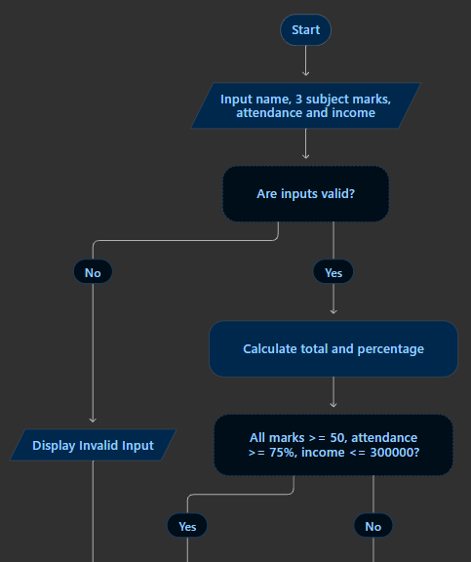

OUTPUT:
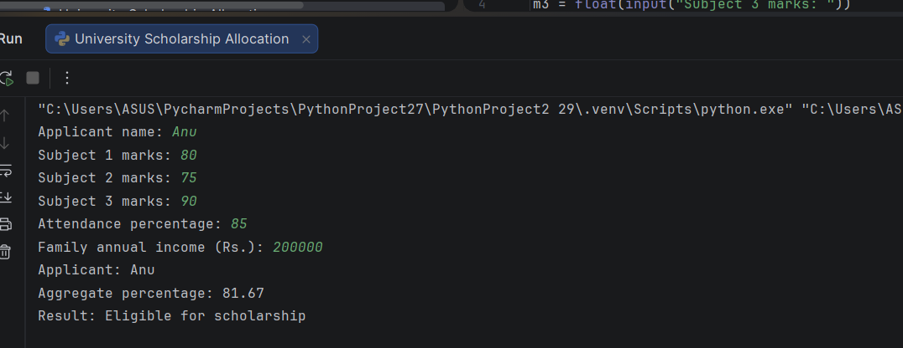

Python Programming | Activity-Based Learning Page 1
PYTHON PROGRAMMING
ACTIVITY-BASED LEARNING • CASE STUDY
Case Study 2: Progressive Electricity Billing
Name: B. Bhanushri Roll Number: 26000865
Branch: Computer Science & Engineering (AI & ML) Section: CSM1
1. Problem Statement
AIM: Calculate an electricity bill using progressive unit slabs, a fixed charge, and a high-consumption surcharge.
2. Rules and Assumptions
• First 100 units: Rs. 2 per unit.
• Next 100 units: Rs. 3 per unit.
• Units above 200: Rs. 5 per unit.
• Fixed charge: Rs. 50.
• Consumption above 200 units: 5% surcharge on energy charge.
3. Python Source Code
Copy the following code into a .py file and run it in Python.
units = int(input("Enter electricity units: "))
if units < 0:
print("Invalid units.")
else:
if units <= 100:
energy = units * 2
elif units <= 200:
energy = 100 * 2 + (units - 100) * 3
else:
energy = 100 * 2 + 100 * 3 + (units - 200) * 5
fixed = 50
surcharge = energy * 0.05 if units > 200 else 0
total = energy + fixed + surcharge
print("\n--- Electricity Bill ---")
print("Energy charge: Rs.", round(energy, 2))
print("Fixed charge: Rs.", fixed)
print("Surcharge: Rs.", round(surcharge, 2))
print("Total bill: Rs.", round(total, 2))
4. Sample Input
Enter electricity units: 250
5. Expected Program Output
--- Electricity Bill ---
Energy charge: Rs. 750
Fixed charge: Rs. 50
Surcharge: Rs. 37.5
Total bill: Rs. 837.5
6. Explanation
For 250 units, the energy charge is 100×2 + 100×3 + 50×5 = Rs. 750.
Python Programming | Activity-Based Learning Page 2
7. Conclusion
This case study applies Python input, variables, arithmetic operations, conditional statements, and validation to solve a practical problem

FLOW CHART:
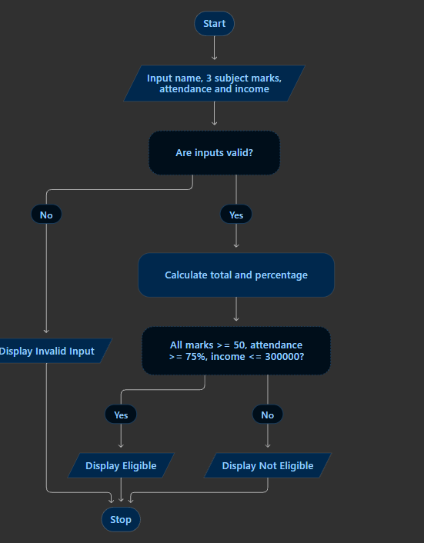
Output:
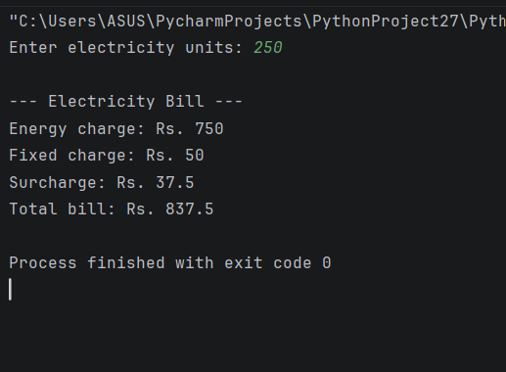

Case Study 3: Hospital Billing and Patient Classification
Name: B. Bhanushri Roll Number: 26000865
Branch: Computer Science & Engineering (AI & ML) Section: CSM1
1. Problem Statement
AIM: Calculate consultation, diagnostic, and treatment charges, apply a senior-patient concession, and classify the final
bill.
2. Rules and Assumptions
• Patients aged 60 or above receive a 10% concession.
• Basic: final bill below Rs. 1,000.
• Standard: Rs. 1,000 to below Rs. 5,000.
• High: Rs. 5,000 or above.
• Charges and age cannot be negative.
3. Python Source Code
Copy the following code into a .py file and run it in Python.
age = int(input("Patient age: "))
consult = float(input("Consultation charge: Rs. "))
diagnostic = float(input("Diagnostic charge: Rs. "))
treatment = float(input("Treatment charge: Rs. "))
if age < 0 or consult < 0 or diagnostic < 0 or treatment < 0:
print("Invalid input.")
else:
subtotal = consult + diagnostic + treatment
discount = subtotal * 0.10 if age >= 60 else 0
final_bill = subtotal - discount
if final_bill < 1000:
category = "Basic"
elif final_bill < 5000:
category = "Standard"
else:
category = "High"
print("\n--- Hospital Bill ---")
print("Subtotal: Rs.", round(subtotal, 2))
print("Concession: Rs.", round(discount, 2))
print("Final bill: Rs.", round(final_bill, 2))
print("Bill category:", category)
4. Sample Input
Patient age: 65
Consultation charge (Rs.): 500
Diagnostic charge (Rs.): 800
Treatment charge (Rs.): 2000
5. Expected Program Output
--- Hospital Bill ---
Subtotal: Rs. 3300
Concession: Rs. 330

Python Programming | Activity-Based Learning Page 2
Final bill: Rs. 2970
Bill category: Standard
6. Explanation
The senior-patient concession is calculated from the subtotal before it is subtracted from the bill.
7. Conclusion
This case study applies Python input, variables, arithmetic operations, conditional statements, and validation to
solve a practical problem.

FLOW CHART:

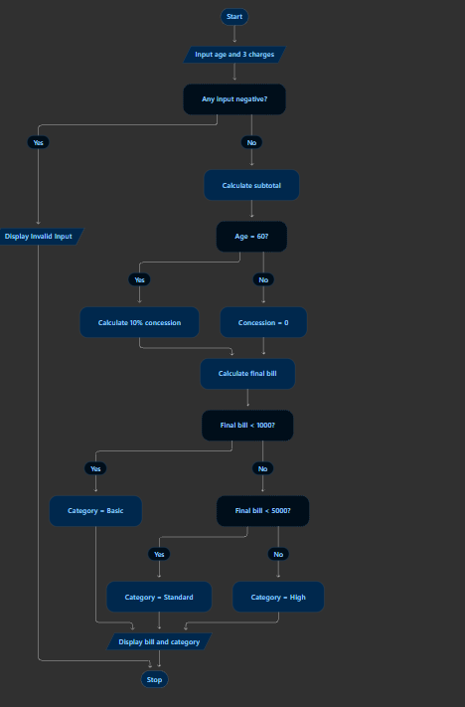

OUTPUT:
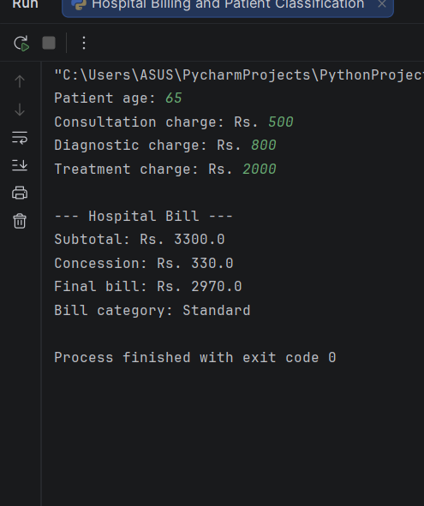

Python Programming | Activity-Based Learning Page1
PYTHON PROGRAMMING
ACTIVITY-BASED LEARNING • CASE STUDY
Case Study 4: Employee Payroll and Deduction
Analysis
Name: B. Bhanushri Roll Number: 26000865
Branch: Computer Science & Engineering (AI & ML) Section: CSM1
1. Problem Statement
AIM: Calculate gross salary from basic pay, allowances, overtime, and incentive, then subtract a deduction to find net
salary.
2. Rules and Assumptions
• HRA = 20% of basic pay.
• Other allowance = 10% of basic pay.
• Overtime = Rs. 150 per hour.
• Incentive is added to gross salary.

3. Python Source Code
Copy the following code into a .py file and run it in Python.
basic = float(input("Basic pay (Rs.): "))
hours = float(input("Overtime hours: "))
incentive = float(input("Incentive (Rs.): "))
if basic < 0 or hours < 0 or incentive < 0:
print("Invalid input.")
else:
hra = basic * 0.20
other = basic * 0.10
overtime = hours * 150
gross = basic + hra + other + overtime + incentive
deduction = gross * 0.08
net = gross - deduction
print("\n--- Salary Statement ---")
print("Basic pay: Rs.", round(basic, 2))
print("HRA: Rs.", round(hra, 2))
print("Other allowance: Rs.", round(other, 2))
print("Overtime pay: Rs.", round(overtime, 2))
print("Incentive: Rs.", round(incentive, 2))
print("Gross salary: Rs.", round(gross, 2))
print("Deduction: Rs.", round(deduction, 2))
print("Net salary: Rs.", round(net, 2))
4. Sample Input
Basic pay (Rs.): 20000
Overtime hours: 2
Incentive (Rs.): 500
5. Expected Program Output
--- Salary Statement ---
Python Programming | Activity-Based Learning Page 2
Basic pay: Rs. 20000.0
HRA: Rs. 4000.0
Other allowance: Rs. 2000.0
Overtime pay: Rs. 300
Incentive: Rs. 500
Gross salary: Rs. 26800.0
Deduction: Rs. 2144.0
Net salary: Rs. 24656.0
6. Explanation
Net salary = gross salary − deduction.
7. Conclusion
This case study applies Python input, variables, arithmetic operations, conditional statements, and validation to
solve a practical problem.

FLOW CHART:

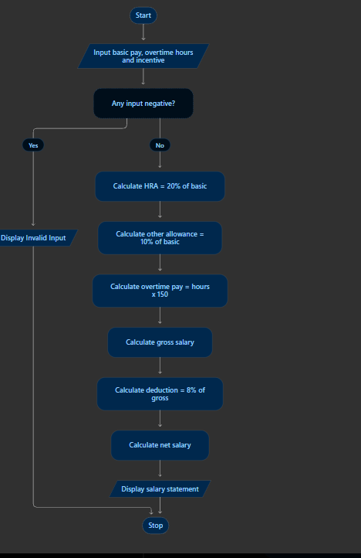

OUTPUT:
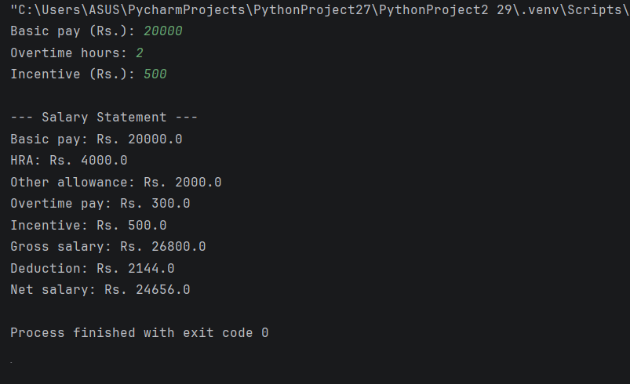

Python Programming | Activity-Based Learning Page 1
PYTHON PROGRAMMING
ACTIVITY-BASED LEARNING • CASE STUDY
Case Study 5: Multi-Plan Telecommunications Cost
Optimization
Name: B. Bhanushri Roll Number: 26000865
Branch: Computer Science & Engineering (AI & ML) Section: CSM1
1. Problem Statement
AIM: Compare three mobile plans for a given monthly data usage and budget, then recommend the cheapest plan within
budget.
2. Rules and Assumptions
• Plan A: Rs. 199 includes 2 GB; extra data costs Rs. 50 per GB.
• Plan B: Rs. 299 includes 5 GB; extra data costs Rs. 30 per GB.
• Plan C: Rs. 399 includes 10 GB; extra data costs Rs. 20 per GB.
• Usage and budget must be non-negative.
3. Python Source Code
Copy the following code into a .py file and run it in Python.
usage = float(input("Monthly data usage (GB): "))
budget = float(input("Monthly budget (Rs.): "))
if usage < 0 or budget < 0:
print("Invalid input.")
else:
cost_a = 199 + max(0, usage - 2) * 50
cost_b = 299 + max(0, usage - 5) * 30
cost_c = 399 + max(0, usage - 10) * 20
plans = [("Plan A", cost_a), ("Plan B", cost_b), ("Plan C", cost_c)]
print("Plan A cost: Rs.", round(cost_a, 2))
print("Plan B cost: Rs.", round(cost_b, 2))
print("Plan C cost: Rs.", round(cost_c, 2))
eligible = [(name, cost) for name, cost in plans if cost <= budget]
if not eligible:
print("No plan is within your budget.")
else:
best_name, best_cost = min(eligible, key=lambda item: item[1])
print("Recommended plan:", best_name)
print("Monthly cost: Rs.", round(best_cost, 2))
4. Sample Input
Monthly data usage (GB): 12
Monthly budget (Rs.): 600
5. Expected Program Output
Plan A cost: Rs. 699
Plan B cost: Rs. 509
Plan C cost: Rs. 439
Recommended plan: Plan C
Monthly cost: Rs. 439
Python Programming | Activity-Based Learning Page 2
6. Explanation
The program calculates excess-data charges separately for each plan before comparing prices with the budget.
7. Conclusion
This case study applies Python input, variables, arithmetic operations, conditional statements, and validation to
solve a practical problem.

FLOW CHART:
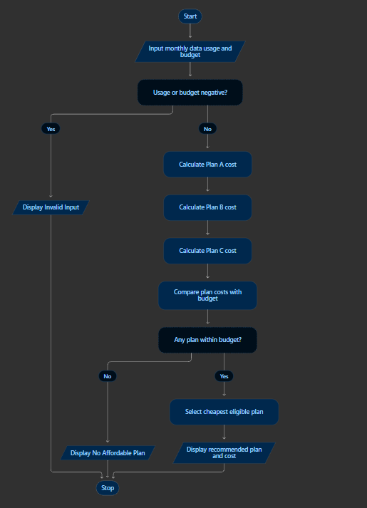
OUTPUT:
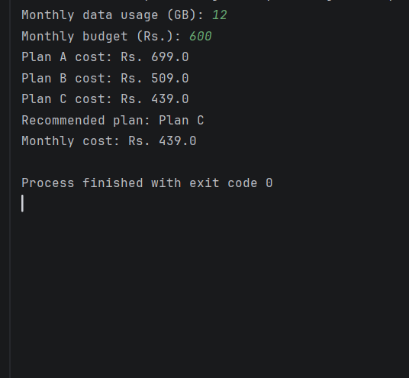

Python Programming | Activity-Based Learning Page 1
PYTHON PROGRAMMING
ACTIVITY-BASED LEARNING • CASE STUDY
Case Study 6: Railway Fare and Reservation Calculator
Name: B. Bhanushri Roll Number: 26000865
Branch: Computer Science & Engineering (AI & ML) Section: CSM1
1. Problem Statement
AIM: Calculate ticket fare from travel distance, class of travel, and passenger age, including child and senior-citizen
concessions.
2. Rules and Assumptions
• Sleeper: Rs. 1.50/km.
• AC Three Tier: Rs. 2.50/km.
• AC First Class: Rs. 4.00/km.
• Children under 5 travel free.
• Passengers aged 60 or above receive a 25% concession.
• Distance and age must be non-negative; class must be 1–3.
3. Python Source Code
Copy the following code into a .py file and run it in Python.
distance = float(input("Distance (km): "))
print("Classes: 1. Sleeper, 2. AC 3-Tier, 3. AC First Class")
travel_class = int(input("Enter class choice (1-3): "))
age = int(input("Passenger age: "))
if distance < 0 or age < 0 or travel_class < 1 or travel_class > 3:
print("Invalid input.")
else:
if travel_class == 1:
rate = 1.50
elif travel_class == 2:
rate = 2.50
else:
rate = 4.00
base_fare = distance * rate
if age < 5:
final_fare = 0
elif age >= 60:
final_fare = base_fare * 0.75
else:
final_fare = base_fare
print("\n--- Railway Ticket Summary ---")
print("Base fare: Rs.", round(base_fare, 2))
print("Final ticket fare: Rs.", round(final_fare, 2))
4. Sample Input
Distance (km): 800
Class choice (1-3): 2
Passenger age: 65
5. Expected Program Output
--- Railway Ticket Summary ---
Python Programming | Activity-Based Learning Page 2
Base fare: Rs. 2000
Final ticket fare: Rs. 1500
6. Explanation
An 800 km AC Three Tier trip has a base fare of Rs. 2,000; a 25% senior concession reduces it to Rs. 1,500.
7. Conclusion
This case study applies Python input, variables, arithmetic operations, conditional statements, and validation to
FLOW CHART:
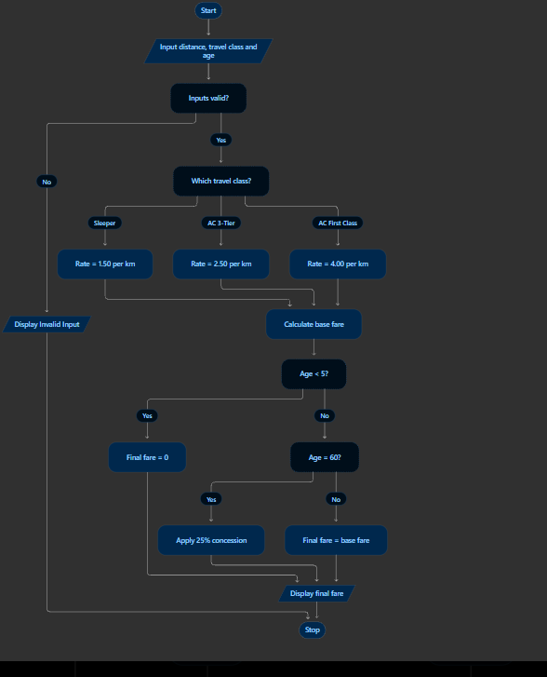

OUTOUT:
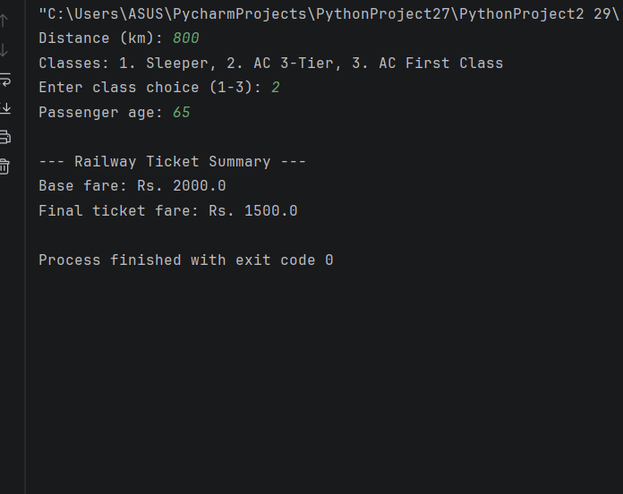

PYTHON PROGRAMMING
ACTIVITY-BASED LEARNING • CASE STUDY
Case Study 7: Retail Billing with Multiple Discount Rules
Name: B. Bhanushri Roll Number: 26000865
Branch: Computer Science & Engineering (AI & ML) Section: CSM1
1. Problem Statement
AIM: Calculate the total purchase amount and apply a high-value purchase discount and a premium membership
discount.
2. Rules and Assumptions
• Prices and quantities must be non-negative.
• Subtotal of Rs. 5,000 or more receives 5% discount.
• Premium members receive an additional 10% discount.
3. Python Source Code
Copy the following code into a .py file and run it in Python.
p1 = float(input("Item 1 price: "))
q1 = int(input("Item 1 quantity: "))
p2 = float(input("Item 2 price: "))
q2 = int(input("Item 2 quantity: "))
p3 = float(input("Item 3 price: "))
q3 = int(input("Item 3 quantity: "))
is_member = input("Premium member? (yes/no): ").lower()
if p1 < 0 or q1 < 0 or p2 < 0 or q2 < 0 or p3 < 0 or q3 < 0:
print("Invalid input.")
else:
subtotal = (p1 * q1) + (p2 * q2) + (p3 * q3)
discount = 0
if subtotal >= 5000:
discount += subtotal * 0.05
if is_member == "yes":
discount += subtotal * 0.10
net_amount = subtotal - discount
print("\n--- Retail Bill Summary ---")
print("Subtotal: Rs.", round(subtotal, 2))
print("Total discount: Rs.", round(discount, 2))
print("Net payable: Rs.", round(net_amount, 2))
4. Sample Input
Item 1 price: 3000
Item 1 quantity: 1
Item 2 price: 2000
Item 2 quantity: 1
Item 3 price: 1000
Item 3 quantity: 1
Premium member? (yes/no): yes
5. Expected Program Output
--- Retail Bill Summary ---
Subtotal: Rs. 6000
Total discount: Rs. 900
Net payable: Rs. 5100
Python Programming | Activity-Based Learning Page 2
6. Explanation
In this example, the total discount is 5% + 10% of the subtotal = 15% of Rs. 6,000.
7. Conclusion
This case study applies Python input, variables, arithmetic operations, conditional statements, and validation to
solve a practical problem.
FLOW CHART:
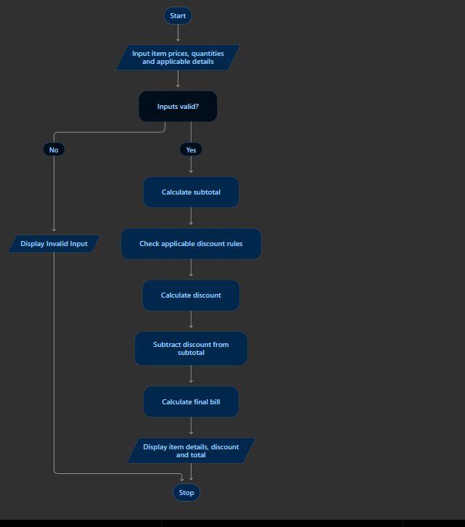
OUTOUT:
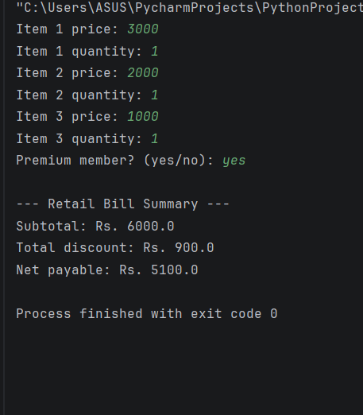

Python Programming | Activity-Based Learning Page 1
PYTHON PROGRAMMING
ACTIVITY-BASED LEARNING • CASE STUDY
Case Study 8: Manufacturing Cost and Profitability
Analysis
Name: B. Bhanushri Roll Number: 26000865
Branch: Computer Science & Engineering (AI & ML) Section: CSM1
1. Problem Statement
AIM: Calculate total manufacturing cost, cost per unit, target profit, and selling price per unit.
2. Rules and Assumptions
• Material, labor, and overhead costs must be non-negative.
• Units produced must be greater than zero.
• Target profit is 20% of total manufacturing cost.
3. Python Source Code
Copy the following code into a .py file and run it in Python.
material = float(input("Material cost: Rs. "))
labor = float(input("Labor cost: Rs. "))
overhead = float(input("Overhead cost: Rs. "))
units = int(input("Units produced: "))
if material < 0 or labor < 0 or overhead < 0 or units <= 0:
print("Invalid input.")
else:
total_cost = material + labor + overhead
cost_per_unit = total_cost / units
profit = total_cost * 0.20
total_revenue = total_cost + profit
selling_price = total_revenue / units
print("\n--- Manufacturing Summary ---")
print("Total manufacturing cost: Rs.", round(total_cost, 2))
print("Cost per unit: Rs.", round(cost_per_unit, 2))
print("Target profit (20%): Rs.", round(profit, 2))
print("Selling price per unit: Rs.", round(selling_price, 2))
4. Sample Input
Material cost (Rs.): 50000
Labor cost (Rs.): 30000
Overhead cost (Rs.): 20000
Units produced: 1000
5. Expected Program Output
--- Manufacturing Summary ---
Total manufacturing cost: Rs. 100000
Cost per unit: Rs. 100
Target profit (20%): Rs. 20000
Selling price per unit: Rs. 120
6. Explanation
Selling price per unit = (total cost + 20% profit) ÷ units produced.
Python Programming | Activity-Based Learning Page 2
7. Conclusion
This case study applies Python input, variables, arithmetic operations, conditional statements, and validation to

Python Programming | Activity-Based Learning Page 2
7. Conclusion
This case study applies Python input, variables, arithmetic operations, conditional statements, and validation to
solve a practical problem.

FLOW CHART:
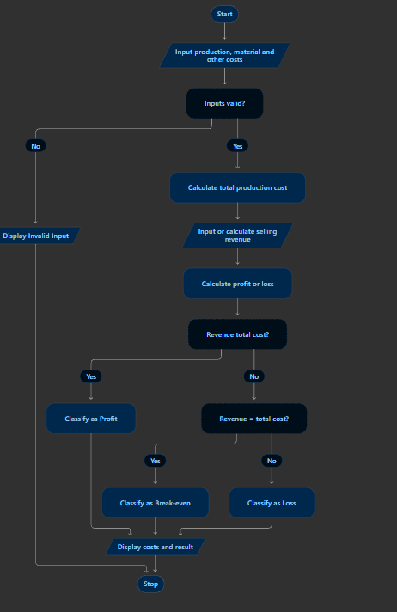
Output:
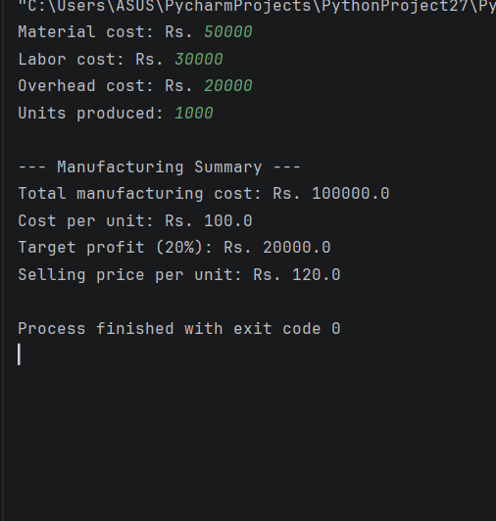

PYTHON PROGRAMMING
ACTIVITY-BASED LEARNING • CASE STUDY
Case Study 9: Multi-Currency Travel Budget Analysis
Name: B. Bhanushri Roll Number: 26000865
Branch: Computer Science & Engineering (AI & ML) Section: CSM1
1. Problem Statement
AIM: Convert an Indian Rupee budget into USD, EUR, or GBP and compare it with estimated expenses.
2. Rules and Assumptions
• 1 USD = Rs. 83.
• 1 EUR = Rs. 90.
• 1 GBP = Rs. 105.
• Budget and estimated expenses must be non-negative.
3. Python Source Code
Copy the following code into a .py file and run it in Python.
inr_budget = float(input("Enter budget in INR: "))
print("Choose currency: 1. USD, 2. EUR, 3. GBP")
choice = int(input("Enter choice (1-3): "))
expense = float(input("Estimated trip expense in foreign currency: "))
if inr_budget < 0 or expense < 0 or choice < 1 or choice > 3:
print("Invalid input.")
else:
if choice == 1:
converted = inr_budget / 83
c_name = "USD"
elif choice == 2:
converted = inr_budget / 90
c_name = "EUR"
else:
converted = inr_budget / 105
c_name = "GBP"
print("\n--- Travel Budget Summary ---")
print("Converted Budget:", round(converted, 2), c_name)
if expense <= converted:
print("Status: Within budget")
else:
print("Status: Budget exceeded")
4. Sample Input
Budget in INR: 83000
Currency choice (1 USD, 2 EUR, 3 GBP): 1
Estimated trip expense: 900
5. Expected Program Output
--- Travel Budget Summary ---
Converted Budget: 1000.0 USD
Status: Within budget
6. Explanation
This case study uses the fixed exchange rates specified in the source document, not live exchange rates.
Python Programming | Activity-Based Learning Page 2
7. Conclusion
This case study applies Python input, variables, arithmetic operations, conditional statements, and validation to
FLOW CHART:
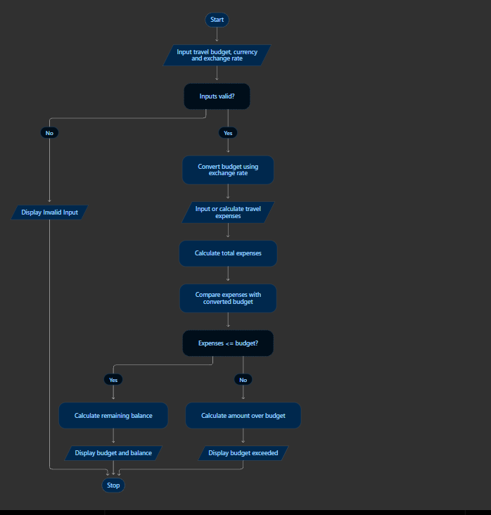

OUTPUT:
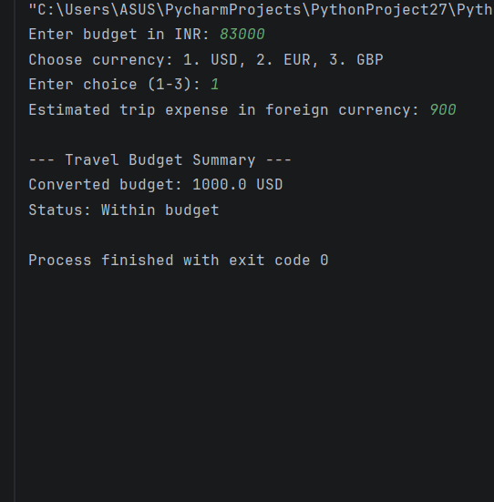

Python Programming | Activity-Based Learning Page 1
PYTHON PROGRAMMING
ACTIVITY-BASED LEARNING • CASE STUDY
Case Study 10: Campus Event Financial Planning
Name: B. Bhanushri Roll Number: 26000865
Branch: Computer Science & Engineering (AI & ML) Section: CSM1
1. Problem Statement
AIM: Calculate ticket and sponsorship revenue, subtract event expenses, and report profit, loss, or break-even.
2. Rules and Assumptions
• Ticket revenue = tickets sold × price per ticket.
• Total revenue = ticket revenue + sponsorship.
• Net result = total revenue − expenses.
• All inputs must be non-negative.
3. Python Source Code
Copy the following code into a .py file and run it in Python.
tickets = int(input("Tickets sold: "))
price = float(input("Price per ticket: Rs. "))
sponsorship = float(input("Total sponsorship amount: Rs. "))
expenses = float(input("Total event expenses: Rs. "))
if tickets < 0 or price < 0 or sponsorship < 0 or expenses < 0:
print("Invalid input.")
else:
revenue = (tickets * price) + sponsorship
net = revenue - expenses
print("\n--- Event Financial Statement ---")
print("Total Revenue: Rs.", round(revenue, 2))
print("Total Expenses: Rs.", round(expenses, 2))
if net > 0:
print("Net Profit: Rs.", round(net, 2))
elif net < 0:
print("Net Loss: Rs.", round(abs(net), 2))
else:
print("Break-even (No profit, no loss)")
4. Sample Input
Tickets sold: 200
Price per ticket (Rs.): 100
Sponsorship amount (Rs.): 15000
Total event expenses (Rs.): 25000
5. Expected Program Output
--- Event Financial Statement ---
Total Revenue: Rs. 35000
Total Expenses: Rs. 25000
Net Profit: Rs. 10000
6. Explanation
The example has Rs. 35,000 total revenue and Rs. 25,000 expenses, resulting in Rs. 10,000 profit.
Python Programming | Activity-Based Learning Page 2
7. Conclusion
This case study applies Python input, variables, arithmetic operations, conditional statements, and validation
FLOW CHART:
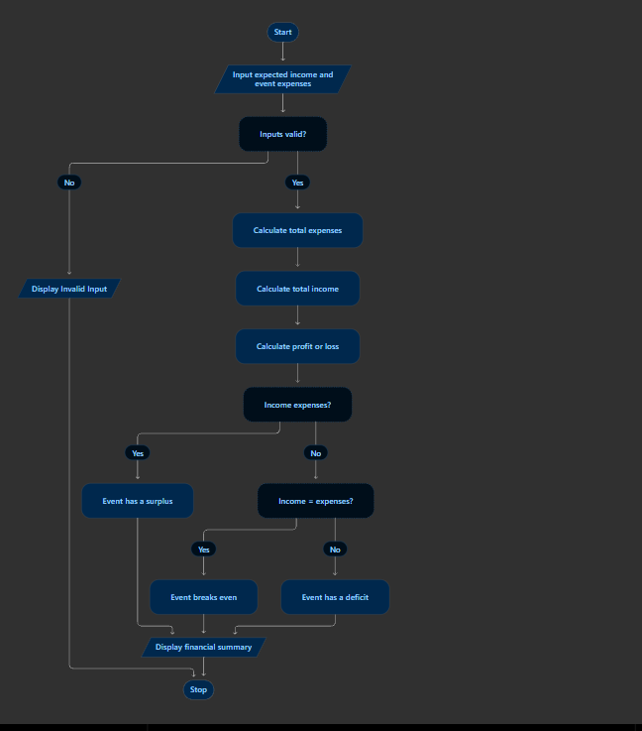
Output:
