1.Restaurant and Cafe Website

Create a restaurant website with menu sections, chef profiles, restaurant ambience, customer testimonials, opening hours, location details, and table reservation forms. Use a responsive menu and elegant typography.
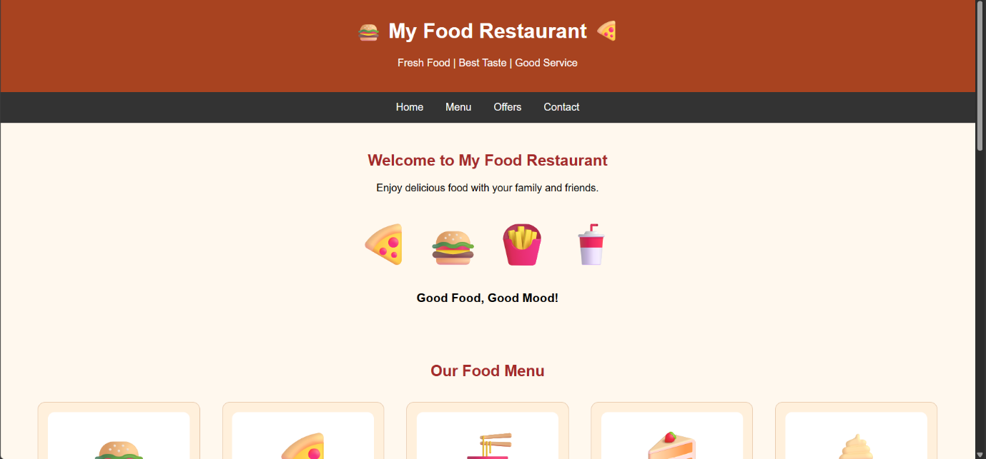

2.Bakery and Cake Shop Website
Create a website for a bakery displaying cakes, pastries, cookies, custom cake designs, product prices, seasonal offers, and store contact details. Use a visually appealing color scheme and image
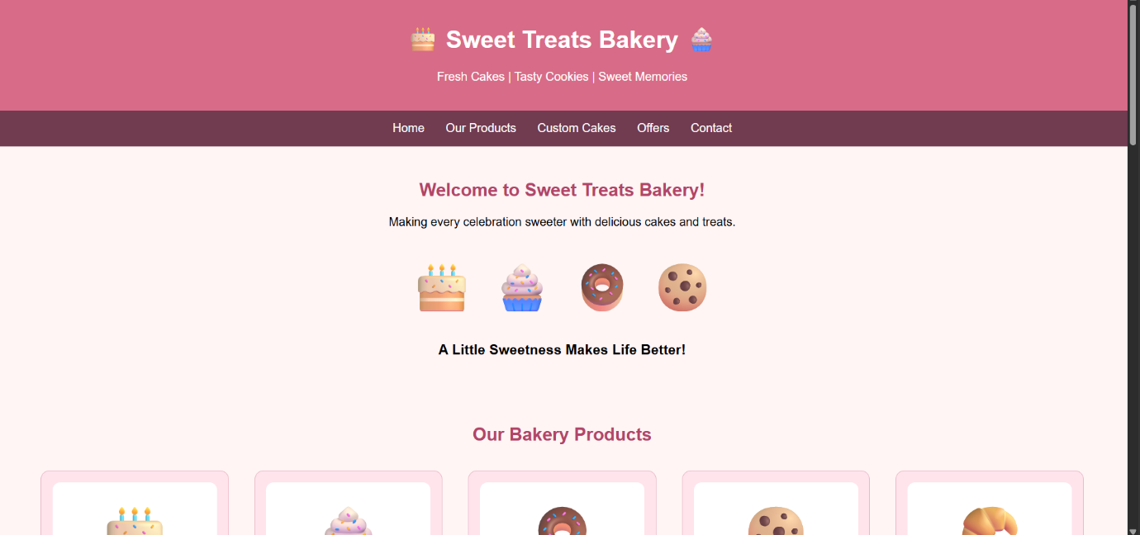

3. Adventure and Trekking Website

Build a website showcasing trekking routes, camping trips, difficulty levels, trip schedules, equipment checklists, safety guidelines, and package prices. Use image overlays and visually distinct information panels.



