**Fashion Retail Analytics**

**Dataset Description:** I obtained the dataset from 365 DataScience, this dataset is a excel file contains two sheets

Consumers info – 3188 rows & 13 columns

Purchases info – 3679 rows & 13 columns

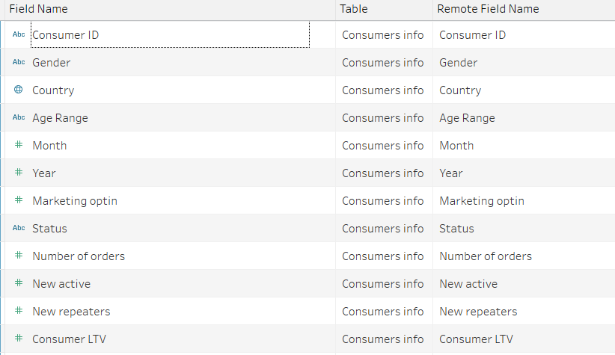

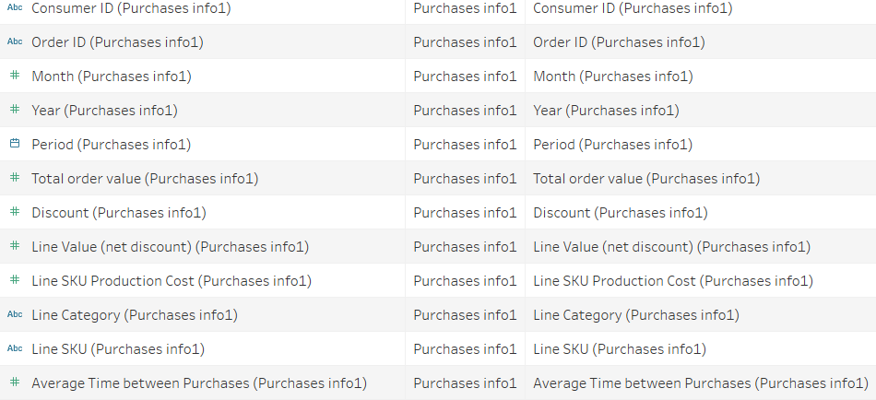

These two sheets are inner joined on customer id,

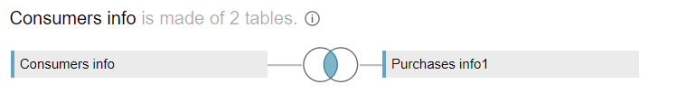

**Problem Statement**

The Fashion retail is the most popular industry in present world. Using Data Visualization, I am addressing three issues as follows.

**Dashboard 1:** *Company KPIs* – company metrics compared year to year basis, also a map of consumer base with country filter. This will allow zero in our opportunities or potential problem areas in different parts of the world.

**Dashboard 2:** *Customer Engagement* – Customer driven metrics across three different customer segments or tiers.

**Dashboard 3:** *Customer Lifecycle* - It features two charts: Number of orders consumers have made in the website and how long it usually takes for consumer to make a repeat purchase. Both are integral to understanding the behavior of clients and more importantly are the key metrics that need to be optimized to improve margins.

I am planning to design the following sheets –

*Company KPIs – Sales by Country – Customer KPIs – Consumer Bar Charts*

*Frequency Curve – Repurchase Curve*