**Fashion Retail Analytics**

**Dataset Description:** I obtained the dataset from 365 DataScience, this dataset is a excel file contains two sheets

Consumers info – 3188 rows & 13 columns

Purchases info – 3679 rows & 13 columns

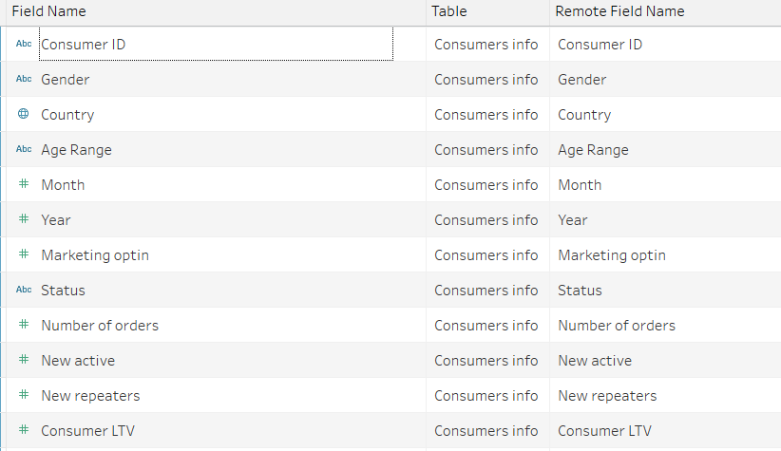

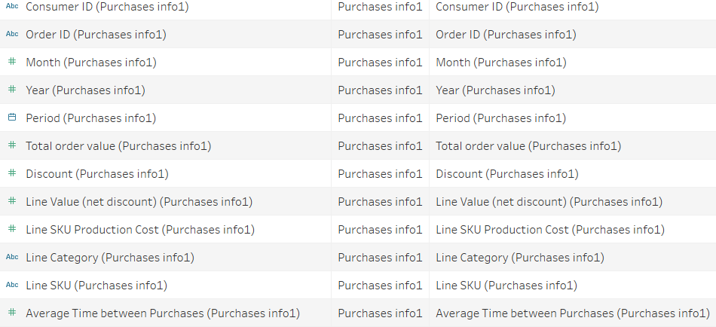

These two sheets are inner joined on customer id,

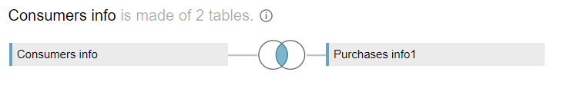

**Problem Statement**

The Fashion retail is the most popular industry in present world. Using Data Visualization, I am addressing three issues as follows.

1.Company metrics compared year to year basis, also a map of consumer base with country filter. This will allow zero in our opportunities or potential problem areas in different parts of the world.

2.Customer driven metrics across three different customer segments or tiers.

3.Number of orders consumers have made in the website and how long it usually takes for consumer to make a repeat purchase. Both are integral to understanding the behavior of clients and more importantly are the key metrics that need to be optimized to improve margins.

**Following sheets are designed:**

* *Company KPIs*
* *Sales by Country*
* *Customer KPIs*
* *Consumer Bar Charts*
* *Frequency Curve*
* *Repurchase Curve*

**Following Dashboards are designed:**

* **Dashboard 1:** *Company KPIs*
* **Dashboard 2:** *Customer Engagement*
* **Dashboard 3:** *Customer Lifecycle*