Lab 14 – Web Frontend Development
Course Title: AI Assisted Coding
Assignment Number: 14.4
2303A51407

Task 1: Responsive Homepage Layout for a Startup Website

Question
Design a responsive homepage for a startup company.
The page must include:
- Header with navigation links
- Main content section
- Footer with company information
Use AI assistance to generate responsive CSS using media queries so that the layout works properly on desktop, tablet, and mobile screens.

AI Prompt Used
Write HTML and responsive CSS using media queries for a startup homepage with header navigation, main content section, and footer. Ensure the layout adapts for desktop, tablet, and mobile devices.

Code
<!DOCTYPE html>
<html>
<head>
<title>Startup Homepage</title>

<style>

/* Basic page styling */
body{
font-family: Arial;
margin:0;
}

/* Header styling */
header{
background:#333;
color:white;
padding:15px;
text-align:center;
}

/* Navigation links */
nav a{
color:white;
margin:10px;
text-decoration:none;
}

/* Main content */
main{
padding:20px;
}

/* Footer */
footer{
background:#222;
color:white;
text-align:center;
padding:10px;
}

/* Tablet view */
@media(max-width:768px){
nav{
display:block;
text-align:center;
}
}

/* Mobile view */
@media(max-width:480px){
header,footer{
font-size:14px;
}
}

</style>
</head>

<body>

<header>
<h1>Startup Company</h1>
<nav>
<a href="#">Home</a>
<a href="#">Services</a>
<a href="#">Contact</a>
</nav>
</header>

<main>
<h2>Welcome</h2>
<p>This is a responsive startup homepage.</p>
</main>

<footer>
<p>© 2025 Startup Company</p>
</footer>

</body>
</html>

Output
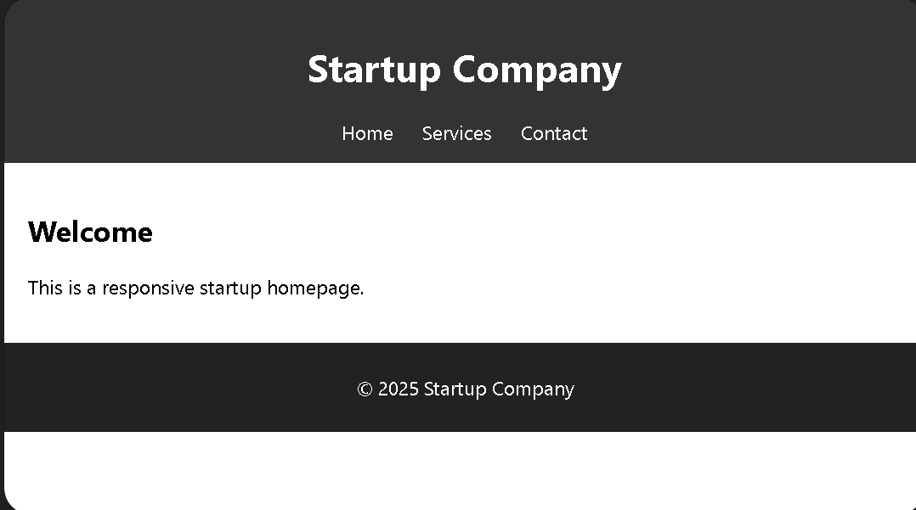
A responsive web page where:
- Header displays navigation links
- Main content appears in the center
- Footer shows company information
- Layout adjusts for mobile, tablet, and desktop screens

Code Explanation
The HTML structure defines three main sections: header, main content, and footer.
CSS styling controls layout and visual appearance.
Media queries adjust the layout for different screen sizes.
This ensures that the page remains readable and usable across multiple devices.

Task 2: Interactive Call-to-Action Button

Question
Create a call-to-action button that responds when users click it.
Use JavaScript to display a message without refreshing the page.

AI Prompt Used
Generate JavaScript code that triggers an alert when a button is clicked and include comments explaining the logic.

Code
<!DOCTYPE html>
<html>
<head>
<title>CTA Button</title>

<script>

// Function triggered when button is clicked
function showMessage(){

// Display alert message
alert("Thank you for your interest in our startup!");

}

</script>
</head>

<body>

<h2>Join Our Platform</h2>

<button onclick="showMessage()">Click Here</button>

</body>
</html>

Output
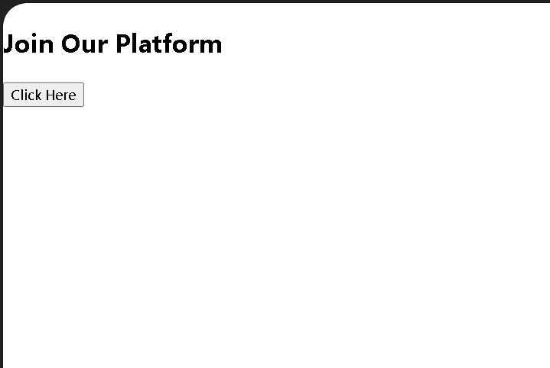
When the user clicks the button, an alert message appears saying:
“Thank you for your interest in our startup!”

Code Explanation
The HTML button triggers the JavaScript function showMessage() using the onclick event.
The function executes immediately and displays an alert message.
Since the script runs on the client side, the page does not reload.

Task 3: Contact Form with Client-Side Validation

Question
Create a contact form with the following fields:
- Name
- Email
- Message
Use JavaScript to validate input before submission.

AI Prompt Used
Generate JavaScript validation for a contact form that prevents empty inputs and checks valid email format.

Code
<!DOCTYPE html>
<html>
<head>
<title>Contact Form</title>

<script>

function validateForm(){

var name=document.getElementById("name").value;
var email=document.getElementById("email").value;
var message=document.getElementById("message").value;

if(name=="" || email=="" || message==""){
alert("All fields are required");
return false;
}

/* Email format validation */
var emailPattern=/^\S+@\S+\.\S+$/;

if(!emailPattern.test(email)){
alert("Enter a valid email");
return false;
}

alert("Form submitted successfully");
return true;

}

</script>

</head>

<body>

<form onsubmit="return validateForm()">

Name:<br>
<input type="text" id="name"><br><br>

Email:<br>
<input type="text" id="email"><br><br>

Message:<br>
<textarea id="message"></textarea><br><br>

<input type="submit" value="Submit">

</form>

</body>
</html>

Output
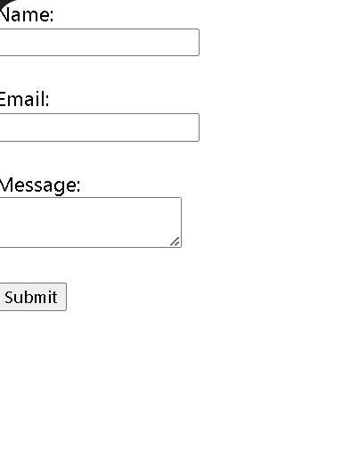
- Empty fields trigger an error message
- Invalid email format triggers validation warning
- Valid input displays success alert

Code Explanation
The form uses JavaScript validation before submission.
The script checks if any field is empty.
A regular expression verifies the email format.
If validation fails, the form submission is prevented.

Task 4: Dynamic List Management

Question
Create a product list where items can be dynamically added or removed without refreshing the page.

AI Prompt Used
Generate JavaScript code to dynamically add and remove items from an HTML list using DOM manipulation.

Code
<!DOCTYPE html>
<html>
<head>
<title>Dynamic List</title>

<script>

function addItem(){

var list=document.getElementById("list");
var newItem=document.createElement("li");

newItem.textContent="New Product";

list.appendChild(newItem);

}

function removeItem(){

var list=document.getElementById("list");

if(list.lastChild){
list.removeChild(list.lastChild);
}

}

</script>

</head>

<body>

<h2>Product List</h2>

<ul id="list">
<li>Product 1</li>
<li>Product 2</li>
</ul>

<button onclick="addItem()">Add Item</button>
<button onclick="removeItem()">Remove Item</button>

</body>
</html>

Output
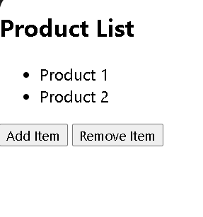
- Clicking Add Item inserts a new list element
- Clicking Remove Item deletes the last element
- Changes appear immediately without page refresh

Code Explanation
JavaScript manipulates the DOM using createElement() and appendChild() to add items.
The removeChild() method removes elements dynamically.
This allows real-time updates without refreshing the page.

Task 5: Modal Popup for User Notifications

Question
Create a modal popup with:
- Overlay background
- Open and close functionality
- Multiple closing options

AI Prompt Used
Generate HTML, CSS, and JavaScript code for a modal popup with overlay and close functionality.

Code
<!DOCTYPE html>
<html>
<head>
<title>Modal Popup</title>

<style>

.modal{
display:none;
position:fixed;
top:0;
left:0;
width:100%;
height:100%;
background:rgba(0,0,0,0.5);
}

.modal-content{
background:white;
padding:20px;
margin:15% auto;
width:300px;
text-align:center;
}

</style>

<script>

function openModal(){
document.getElementById("modal").style.display="block";
}

function closeModal(){
document.getElementById("modal").style.display="none";
}

</script>

</head>

<body>

<button onclick="openModal()">Open Modal</button>

<div id="modal" class="modal" onclick="closeModal()">

<div class="modal-content">

<p>This is a notification popup</p>

<button onclick="closeModal()">Close</button>

</div>

</div>

</body>
</html>

Output
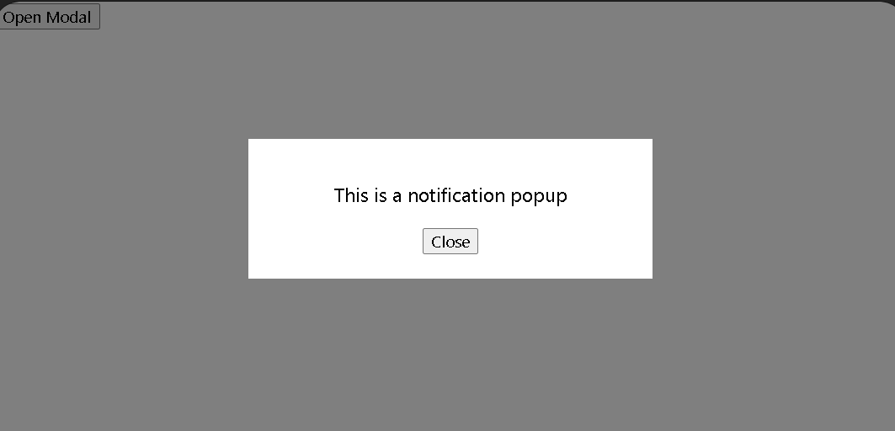
- Clicking Open Modal displays the popup
- Popup appears above page content with dark overlay
- Clicking Close or the overlay hides the modal

Code Explanation
The modal popup is hidden by default using display:none.
JavaScript functions control visibility by changing the display property.
CSS overlay provides visual focus on the popup content.

