AI Assisted Coding Ch.Bhanu Prkash 2303A51407

BATCH - 06

Lab 1: Environment Setup – GitHub Copilot and VS Code Integration + Understanding AI-assisted Coding Workflow
Lab Objectives:
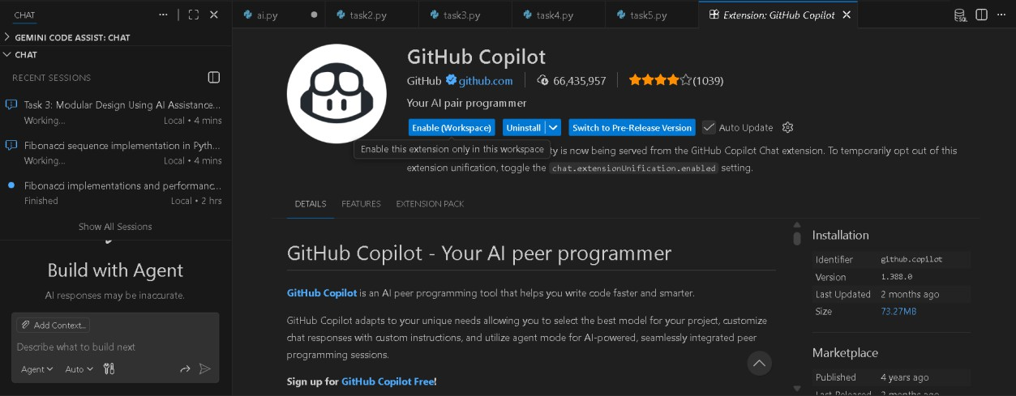
Week1 -

Task 1: AI-Generated Logic Without Modularization (Fibonacci Sequence Without Functions)

PROMPT:
Task 1: AI-Generated Logic Without Modularization (Fibonacci Sequence Without Functions)
- Scenario
You are asked to write a quick numerical sequence generator for a learning platform prototype.
- Task Description

Use GitHub Copilot to generate a Python program that:
- Prints the Fibonacci sequence up to n terms
- Accepts user input for n
- Implements the logic directly in the main code
- Does not use any user-defined functions
- Expected Output
- Correct Fibonacci sequence for given n
- Screenshot(s) showing Copilot-generated suggestions
- Sample inputs and outputs
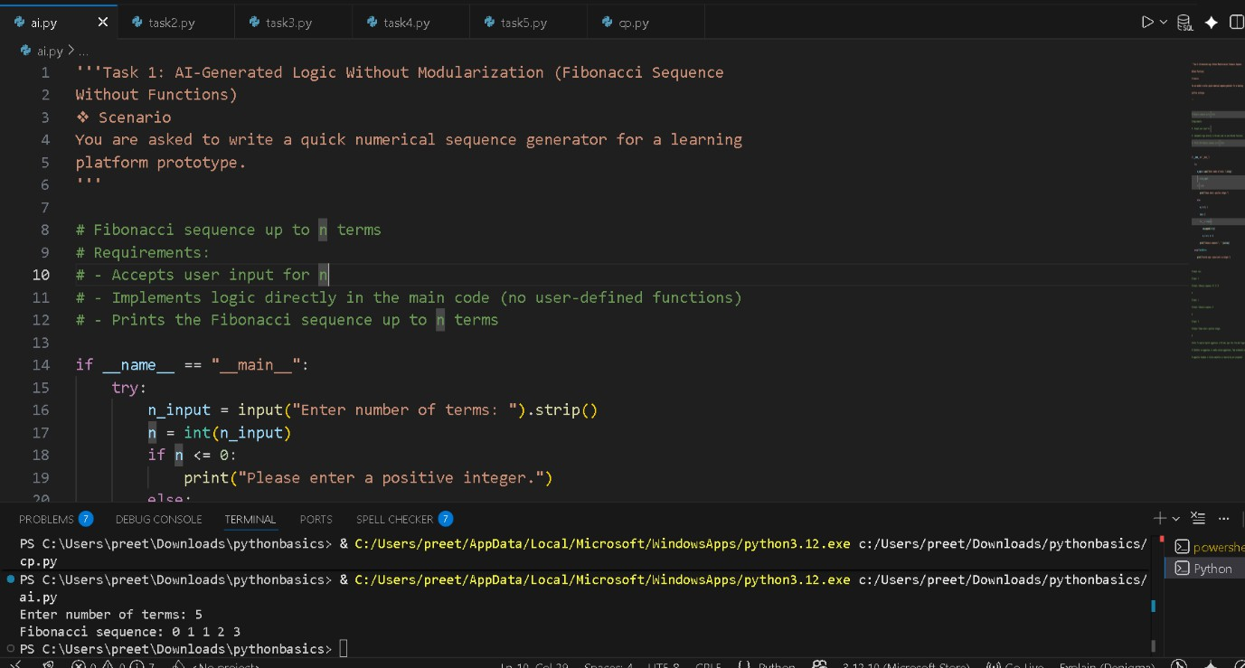

OUTPUT: Enter number of terms: 5 Fibonacci sequence: 0 1 1 2 3

Code Explanation (Fibonacci without functions)
  - input() → takes number of terms from user
  - int() → converts input to integer
  - if n <= 0 → checks for invalid (non-positive) input

  - a, b = 0, 1 → starting Fibonacci numbers
  - for _ in range(n) → runs loop n times
  - seq.append(str(a)) → stores current Fibonacci number
  - a, b = b, a + b → updates values for next term
  - " ".join(seq) → prints numbers in one line
  - try / except → handles invalid (non-integer) input safely
Output: Prints Fibonacci sequence up to n terms.

Task 2: AI Code Optimization & Cleanup (Improving Efficiency)
PROMPT: Task 2: AI Code Optimization & Cleanup (Improving Efficiency)
- Scenario
The prototype will be shared with other developers and needs optimization.
- Task Description
- Examine the Copilot-generated code from Task 1 and improve it by:
- Removing redundant variables
- Simplifying loop logic
- Avoiding unnecessary computations
- Use Copilot prompts such as:
- “Optimize this Fibonacci code”
- “Simplify variable usage” Hint:
Prompt Copilot with phrases like
“optimize this code”, “simplify logic”, or “make it more readable”
- Expected Output
- Original vs improved code
- Written explanation of:
- What was inefficient

- How the optimized version improves performance and readability
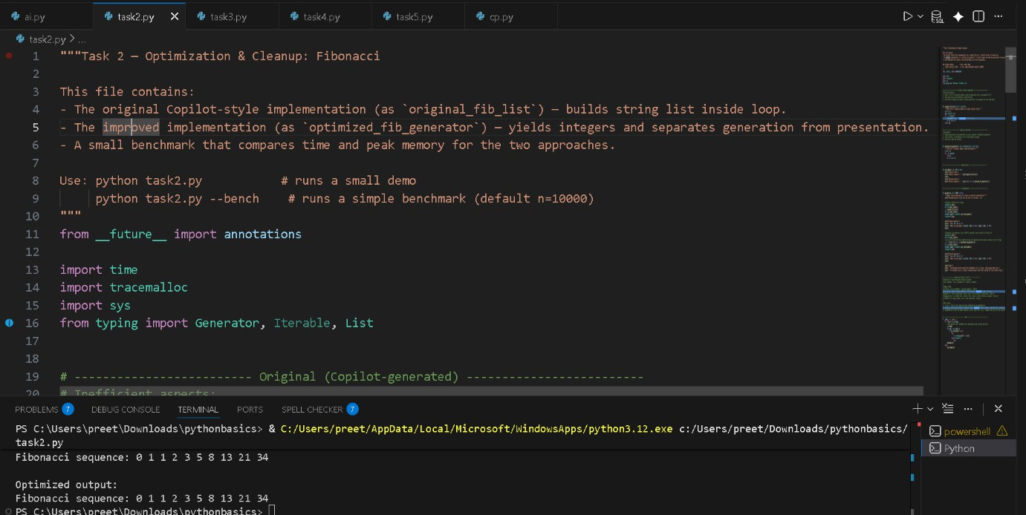

OUTPUT:

Fibonacci sequence: 0 1 1 2 3 5 8 13 21 34

Optimized output:
Fibonacci sequence: 0 1 1 2 3 5 8 13 21 34

CODE EXPLANATION
Optimization & Cleanup (Fibonacci) Original version (original_fib_list)
  - Generates Fibonacci numbers
  - Converts each number to string inside the loop
  - Stores all values in a list
⬛➜ More memory usage, mixed logic (generation + formatting)
Optimized version (optimized_fib_generator)
  - Uses a generator (yield)
  - Produces numbers one-by-one
  - Conversion to string happens only when printing
⬛➜ Less memory, cleaner design, reusable

Demo
  - Prints Fibonacci using both methods
  - Output is the same
Benchmark
  - Measures time and memory
  - Optimized version:
    - Uses less peak memory
    - Scales better for large n
Key takeaway
  - Generator = better performance + cleaner code
  - Separate logic (generation) from presentation (printing)

Task 3: Modular Design Using AI Assistance (Fibonacci Using Functions) PROMPT:
Task 3: Modular Design Using AI Assistance (Fibonacci Using Functions)
- Scenario
The Fibonacci logic is now required in multiple modules of an application.
- Task Description
Use GitHub Copilot to generate a function-based Python program that:
- Uses a user-defined function to generate Fibonacci numbers
- Returns or prints the sequence up to n
- Includes meaningful comments (AI-assisted)
- Expected Output
- Correct function-based Fibonacci implementation
- Screenshots documenting Copilot’s function generation
- Sample test cases with outputs

Code Explanation:
Optimization & Cleanup (Fibonacci)

Original version (original_fib_list)
  - Generates Fibonacci numbers
  - Converts each number to string inside the loop
  - Stores all values in a list
⬛➜ More memory usage, mixed logic (generation + formatting)
Optimized version (optimized_fib_generator)
  - Uses a generator (yield)
  - Produces numbers one-by-one
  - Conversion to string happens only when printing
⬛➜ Less memory, cleaner design, reusable
Demo
  - Prints Fibonacci using both methods
  - Output is the same
Benchmark
  - Measures time and memory
  - Optimized version:
    - Uses less peak memory
    - Scales better for large n
Key takeaway
  - Generator = better performance + cleaner code
  - Separate logic (generation) from presentation (printing)

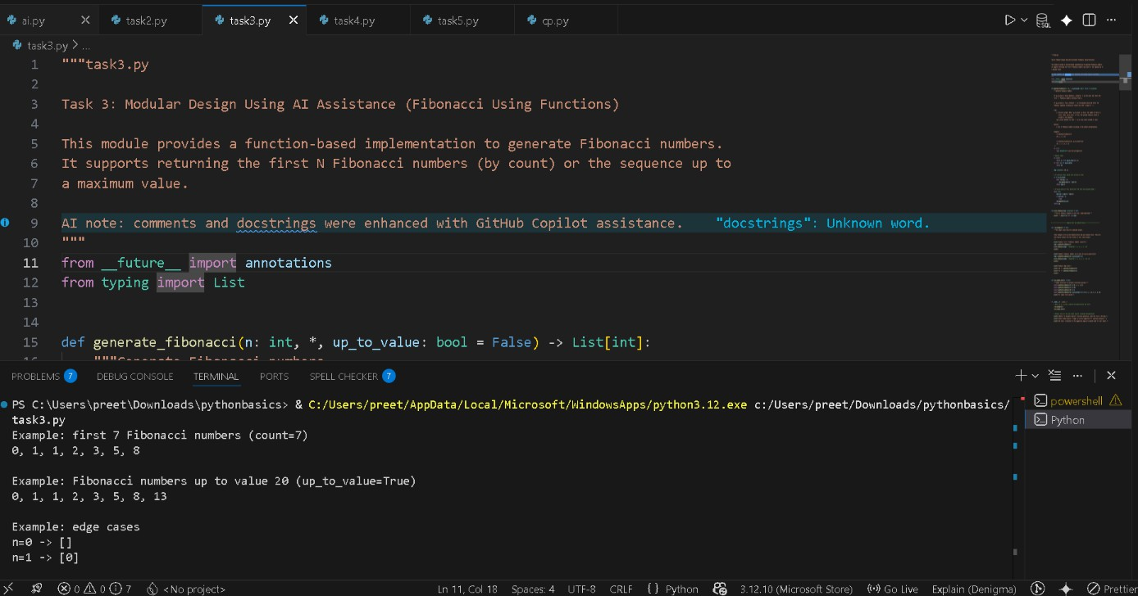

OUTPUT:
Example: first 7 Fibonacci numbers (count=7) 0, 1, 1, 2, 3, 5, 8

Example: Fibonacci numbers up to value 20 (up_to_value=True) 0, 1, 1, 2, 3, 5, 8, 13

Example: edge cases n=0 -> []
n=1 -> [0]

All simple tests passed.

Notes: To document Copilot's function generation, open this file in VS Code, enable GitHub Copilot, trigger an inline suggestion for `generate_fibonacci`,
and take a screenshot of the suggestion popup or accepted code for your report.

Task 4: Comparative Analysis – Procedural vs Modular Fibonacci Code

PROMPT:
Task 4: Comparative Analysis – Procedural vs Modular Fibonacci Code
- Scenario
You are participating in a code review session.
- Task Description
Compare the Copilot-generated Fibonacci programs:
- Without functions (Task 1)
- With functions (Task 3)
- Analyze them in terms of:
- Code clarity
- Reusability
- Debugging ease
- Suitability for larger systems
- Expected Output
Comparison table or short analytical report
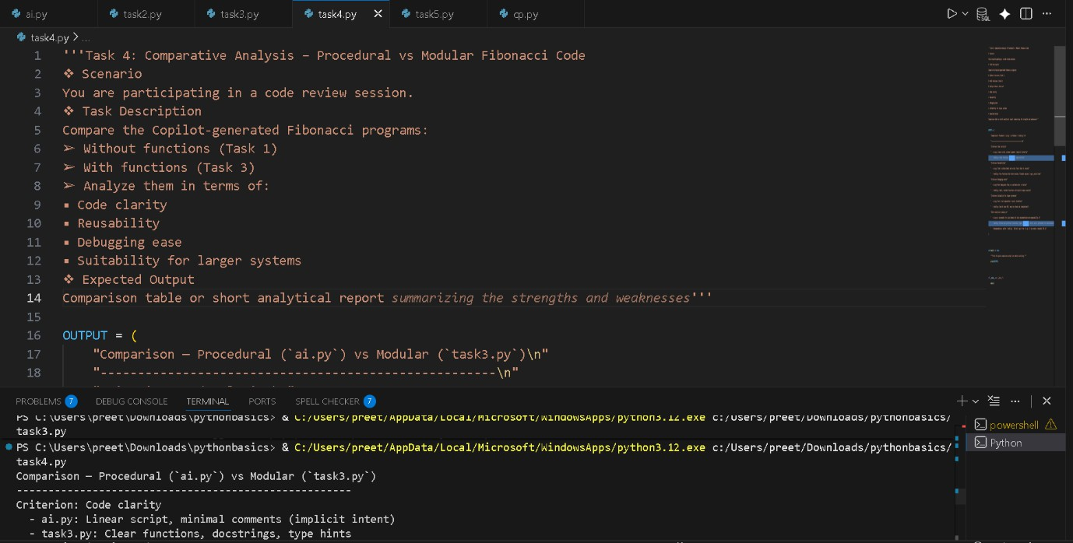
OUTPUT:
Comparison — Procedural (`ai.py`) vs Modular (`task3.py`)

Criterion: Code clarity
- ai.py: Linear script, minimal comments (implicit intent)

- task3.py: Clear functions, docstrings, type hints

Criterion: Reusability
- ai.py: Tied to stdin/stdout and script flow — hard to reuse
- task3.py: Pure functions that return values, flexible options (`up_to_value`)

Criterion: Debugging ease
- ai.py: Must debug main flow; no isolated units or tests
- task3.py: Small, testable functions with explicit edge cases

Criterion: Suitability for larger systems
- ai.py: Poor — not composable or easily testable
- task3.py: Good — clear API, easy to extend and integrate

Short analytical summary:
- ai.py is acceptable for quick demos but lacks documentation and composability.
- task3.py follows best practices (functions, types, docstrings, tests) and is preferable for maintainability and production.
- Recommendation: prefer `task3.py`. Extract logic from `ai.py` if you need a reusable API.

Task 5: AI-Generated Iterative vs Recursive Fibonacci Approaches (Different Algorithmic Approaches for Fibonacci Series)

PROMPT :
Task 5: AI-Generated Iterative vs Recursive Fibonacci Approaches (Different Algorithmic Approaches for Fibonacci Series)
- Scenario
Your mentor wants to assess AI’s understanding of different algorithmic

paradigms.
- Task Description
Prompt GitHub Copilot to generate: An iterative Fibonacci implementation A recursive Fibonacci implementation
- Expected Output
- Two correct implementations
- Explanation of execution flow for both
- Comparison covering:
- Time and space complexity
- Performance for large n
- When recursion should be avoided

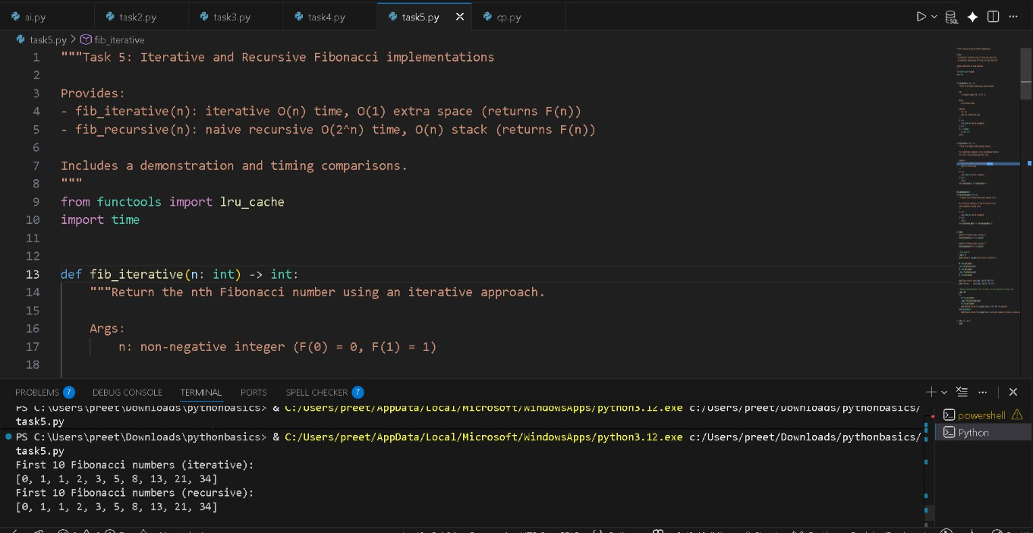

OUTPUT:

First 10 Fibonacci numbers (iterative): [0, 1, 1, 2, 3, 5, 8, 13, 21, 34]
First 10 Fibonacci numbers (recursive):

[0, 1, 1, 2, 3, 5, 8, 13, 21, 34]

Timing for n=30 (naive recursive vs iterative):
naive recursive: value=832040, time=0.185535s iterative: value=832040, time=0.000009s
memoized recursive for n=500 computed in 0.001015s (memoized)

CODE EXPLANATION
Task 5: Iterative vs Recursive Fibonacci fib_iterative(n)
  - Uses a loop to calculate Fibonacci
  - Updates values using a, b = b, a + b
  - Time: O(n)
  - Space: O(1)
Fast and memory-efficient fib_recursive(n)
  - Follows the formula F(n) = F(n-1) + F(n-2)
  - Repeats many calculations
  - Time: O(2ⁿ)
  - Space: O(n) (call stack)
+ Very slow for large n fib_recursive_memo(n)
  - Uses @lru_cache to store previous results
  - Avoids repeated work
  - Time: O(n)
  - Space: O(n)
Fast but still uses recursion Demo & Timing
  - Prints first 10 Fibonacci numbers
  - Compares execution time of iterative vs recursive
  - Shows memoized recursion is much faster than naive recursion Conclusion
  - Iterative → best for performance

  - Naive recursive → only for learning
  - Memoized recursive → good balance, but iterative is safest for large n

