MLA03 -- REINFORCEMENT LEARNING ASSIGNMENT
Department: | AI & ML
Programme: | FACULTY OF ENGINEERING
Course Code & Course Name: | MLA03 & REINFORCEMENT LEARNING
Academic Year / Batch: | 2026-2027
Faculty Name: | Dr.G.A.SENTHIL
Assignment Title: | Design and Analysis of an RL-Based Patient Health Monitoring and Treatment Recommendation System Using Markov Decision Process and Bellman Equations
Date of Issue: | 31-08-26
Date of Submission: | 03-09-26
Maximum Marks: | 100
Course Outcome(s) - CO: | CO1-Analyze reinforcement learning frameworks and Markov Decision Process concepts to model decision-making problems. CO2 - Apply Dynamic Programming methods to solve reinforcement learning problems and derive optimal policies. CO3 - Implement policy-based reinforcement learning methods to develop efficient solutions for complex environments. CO4-Evaluate model-based reinforcement learning approaches for prediction, planning, and policy optimization. CO5-Apply hierarchical, meta-learning, and multi-agent RL approaches to solve complex decision-making problems.
Bloom's Taxonomy Level: | BL3 (Apply) - Dynamic Programming methods to solve reinforcement learning problems and derive optimal policies for decision-making tasks. BL4 (Analyse) - Implement policy-based reinforcement learning methods to develop efficient solutions for complex environments. BL5 (Evaluate) - Model-based reinforcement learning approaches for prediction, planning, and policy optimization. BL6 (Create) - Develop an MDP-based solution for an intelligent traffic signal system by defining the state space, action space, reward function, transition model, and optimal policy.
SDG Mapping (SDG 1-17): | SDG 3 -- (Good Health & Well-Being) Improves patient outcomes through data-driven, adaptive treatment recommendations. SDG 9 -- (Industry, Innovation & Infrastructure) Applies AI/RL to build intelligent clinical decision-support infrastructure. SDG 10 -- (Reduced Inequalities) Supports consistent, evidence-based treatment guidance that can extend specialist-level decision support to under-resourced settings.
Industry / Societal Relevance: | The assignment addresses the growing need for AI-driven clinical decision support by developing an RL-based patient monitoring and treatment recommendation system. The solution can help clinicians personalize treatment, respond earlier to deteriorating patients, and reduce adverse outcomes, while remaining subject to clinician oversight and regulatory approval.

Question
Analyse and design an RL-based patient health monitoring and treatment recommendation system using Markov Decision Process and Bellman equations. Model patient health conditions as states, treatment interventions as actions, and clinical outcomes as rewards, and implement an optimal policy to recommend appropriate treatment strategies based on changing patient conditions. Analyse the learned policy using treatment effectiveness, recovery rate, and cumulative reward.
Assignment Problem / Challenge
Healthcare providers must continuously decide how to treat patients whose health status changes over time in response to illness progression and to the treatments already given. Fixed, rule-based treatment protocols do not adapt well to the sequential, uncertain nature of patient recovery, where today's treatment choice affects tomorrow's health state and future treatment options. The assignment challenges students to design and analyse an autonomous Reinforcement Learning-based system that models patient health monitoring and treatment recommendation as a Markov Decision Process, uses the Bellman equations to derive an optimal treatment policy, and evaluates that policy using clinically meaningful measures: treatment effectiveness, recovery rate, and cumulative reward.
Problem Statement
Modern healthcare systems generate continuous streams of patient data - vital signs, laboratory results, symptom severity, and treatment history - that must be translated into timely, appropriate treatment decisions. A treatment chosen today changes the probability of the patient's health state tomorrow, so treatment selection is inherently a sequential decision-making problem rather than a single-shot classification problem. There is a need to design an RL-based patient health monitoring and treatment recommendation system that represents patient conditions as states, treatment interventions as actions, and clinical outcomes as rewards within a formal Markov Decision Process, and that uses the Bellman optimality equation (via value iteration / policy iteration) to compute an optimal treatment policy that maximizes long-term patient well-being while remaining safe, transparent, and subject to clinician oversight.
Requirements and Constraints
Requirements
- Continuously monitor patient vital signs, laboratory values, symptom severity, and treatment/medication history.
- Define the RL environment using appropriate states, actions, transition dynamics, reward function, and policy.
- Formulate the Bellman Expectation Equation and Bellman Optimality Equation for the patient-treatment MDP.
- Implement Dynamic Programming (value iteration and/or policy iteration) to compute the optimal treatment policy.
- Recommend treatment actions that adapt to changing patient conditions over successive monitoring intervals.
- Evaluate the learned policy using treatment effectiveness, recovery rate, and cumulative reward.
- Present the results using state-transition diagrams, value tables, policy tables, and convergence plots.
- Incorporate patient safety, clinical oversight, and ethical considerations into the system design.
Constraints
- Patient physiology is stochastic and only partially captured by measurable vitals and labs (partial observability).
- Clinical data is limited, imbalanced, and subject to privacy regulations (e.g., HIPAA/GDPR).
- Incorrect treatment recommendations can cause real patient harm, so exploration must be constrained and clinician sign-off retained.
- The reward function must correctly balance short-term symptom relief against long-term recovery and treatment cost/side effects.
- The system must generalize across patients with different comorbidities without becoming unsafe for atypical cases.
- Computational resources may limit real-time re-planning for very large, continuous state spaces.
Student Work
Problem Understanding and Formulation
What is the problem?
A patient health monitoring and treatment recommendation system must be developed that can (a) continuously observe patient vitals, laboratory results, and symptoms, (b) formulate treatment selection as a Markov Decision Process, (c) learn an optimal treatment policy using Dynamic Programming and the Bellman equations, (d) adapt treatment recommendations as the patient's condition changes over time, (e) balance recovery speed against treatment cost, side effects, and risk, and (f) present its recommendation and rationale to the clinician for final approval.
Expected Outcomes
A clearly defined MDP formulation containing states, actions, transition dynamics, reward function, and policy for patient treatment.
A Bellman-equation-based Dynamic Programming solution (value iteration / policy iteration) that computes the optimal state-value function V*(s), action-value function Q*(s,a), and optimal policy π*(s).
A worked, illustrative patient-treatment environment demonstrating how the learned policy changes with patient severity.
Quantitative evaluation of the learned policy using treatment effectiveness, recovery rate, and cumulative reward.
A working, documented end-to-end architecture connecting patient monitoring data, state representation, the RL agent, treatment-action selection, and clinical-outcome feedback.
Available Information / Data
- A synthetic or de-identified patient dataset containing vital signs (heart rate, blood pressure, SpO2, temperature), laboratory values, symptom severity, diagnosis/stage, and treatment history.
- Historical or simulated time-series patient monitoring data representing disease progression and recovery/deterioration under different treatments.
- Clinical outcome labels (e.g., recovered, still under treatment, deteriorated, adverse event) associated with each monitoring interval.
- A simulated patient-treatment environment (illustrative transition probabilities and rewards) for computing and evaluating the optimal policy.
Assumptions
- Patient vitals, labs, and symptom scores are assumed to be sufficiently informative to summarise the clinically relevant health state (the Markov property is assumed to approximately hold at the chosen level of state abstraction).
- Monitoring data may contain noise, but is assumed sufficient for the RL agent to make clinically meaningful decisions between monitoring intervals.
- Transition probabilities between health states, conditioned on the treatment given, are assumed to be stationary over the planning horizon used for policy computation.
- The reward function is assumed to correctly encode the desired balance between recovery, symptom control, treatment cost/side effects, and risk of deterioration.
- Real-world deployment requires clinician supervision and override authority, even though the RL system computes an optimal policy autonomously.
Reinforcement Learning Formulation: MDP and Bellman Equations
Markov Decision Process for Patient Treatment
For the assignment “Design and Analysis of an RL-Based Patient Health Monitoring and Treatment Recommendation System,” the patient-treatment environment is modelled as a Markov Decision Process:
MDP = (S, A, P, R, γ)
where S is the set of patient health states, A is the set of treatment actions, P is the state-transition probability function, R is the reward function, and γ ∈ [0,1) is the discount factor that determines how strongly future clinical outcomes are weighted relative to immediate ones.
State Space
The state st summarises the patient's clinically relevant condition at monitoring interval t:
st = [ Vt, Lt, Ht, Dt, Tt, Rt ]
- Vt = vital-sign profile (heart rate, blood pressure, SpO2, temperature)
- Lt = laboratory/biomarker readings
- Ht = overall health-severity level (e.g., Stable, Mild Risk, Moderate Risk, Critical)
- Dt = disease/diagnosis stage or symptom score
- Tt = current treatment/medication in progress
- Rt = response trend since the previous interval (improving / stable / worsening)
For the small illustrative environment developed in this assignment, the severity level Ht is used as a compact discrete state variable with six states:
S = { Stable, Mild Risk, Moderate Risk, Critical, Recovered, Deceased }
Recovered and Deceased are absorbing terminal states: once reached, no further treatment action changes the state.
Action Space
The action at represents the treatment intervention chosen at interval t:
A = { a0, a1, a2, a3 }
- a0: No intervention / routine observation
- a1: Standard medication
- a2: Intensive monitoring with adjusted medication dosage
- a3: Hospitalisation / ICU-level intervention
Transition Dynamics
The transition function P(s'|s,a) gives the probability that the patient moves to health state s' at the next interval, given current state s and treatment action a. Table 1 shows an illustrative transition matrix for the Moderate Risk state; transitions for other states follow the same pattern, with more aggressive treatments generally increasing the probability of improvement but carrying higher cost.
From: Moderate Risk, given action → | Mild Risk | Moderate Risk | Critical | Recovered
a0: No intervention | 0.10 | 0.45 | 0.40 | 0.05
a1: Standard medication | 0.35 | 0.45 | 0.15 | 0.05
a2: Intensive monitoring | 0.45 | 0.35 | 0.08 | 0.12
a3: Hospitalisation / ICU | 0.30 | 0.25 | 0.05 | 0.40
Table 1: Illustrative transition probabilities P(s'|s,a) from the Moderate Risk state.
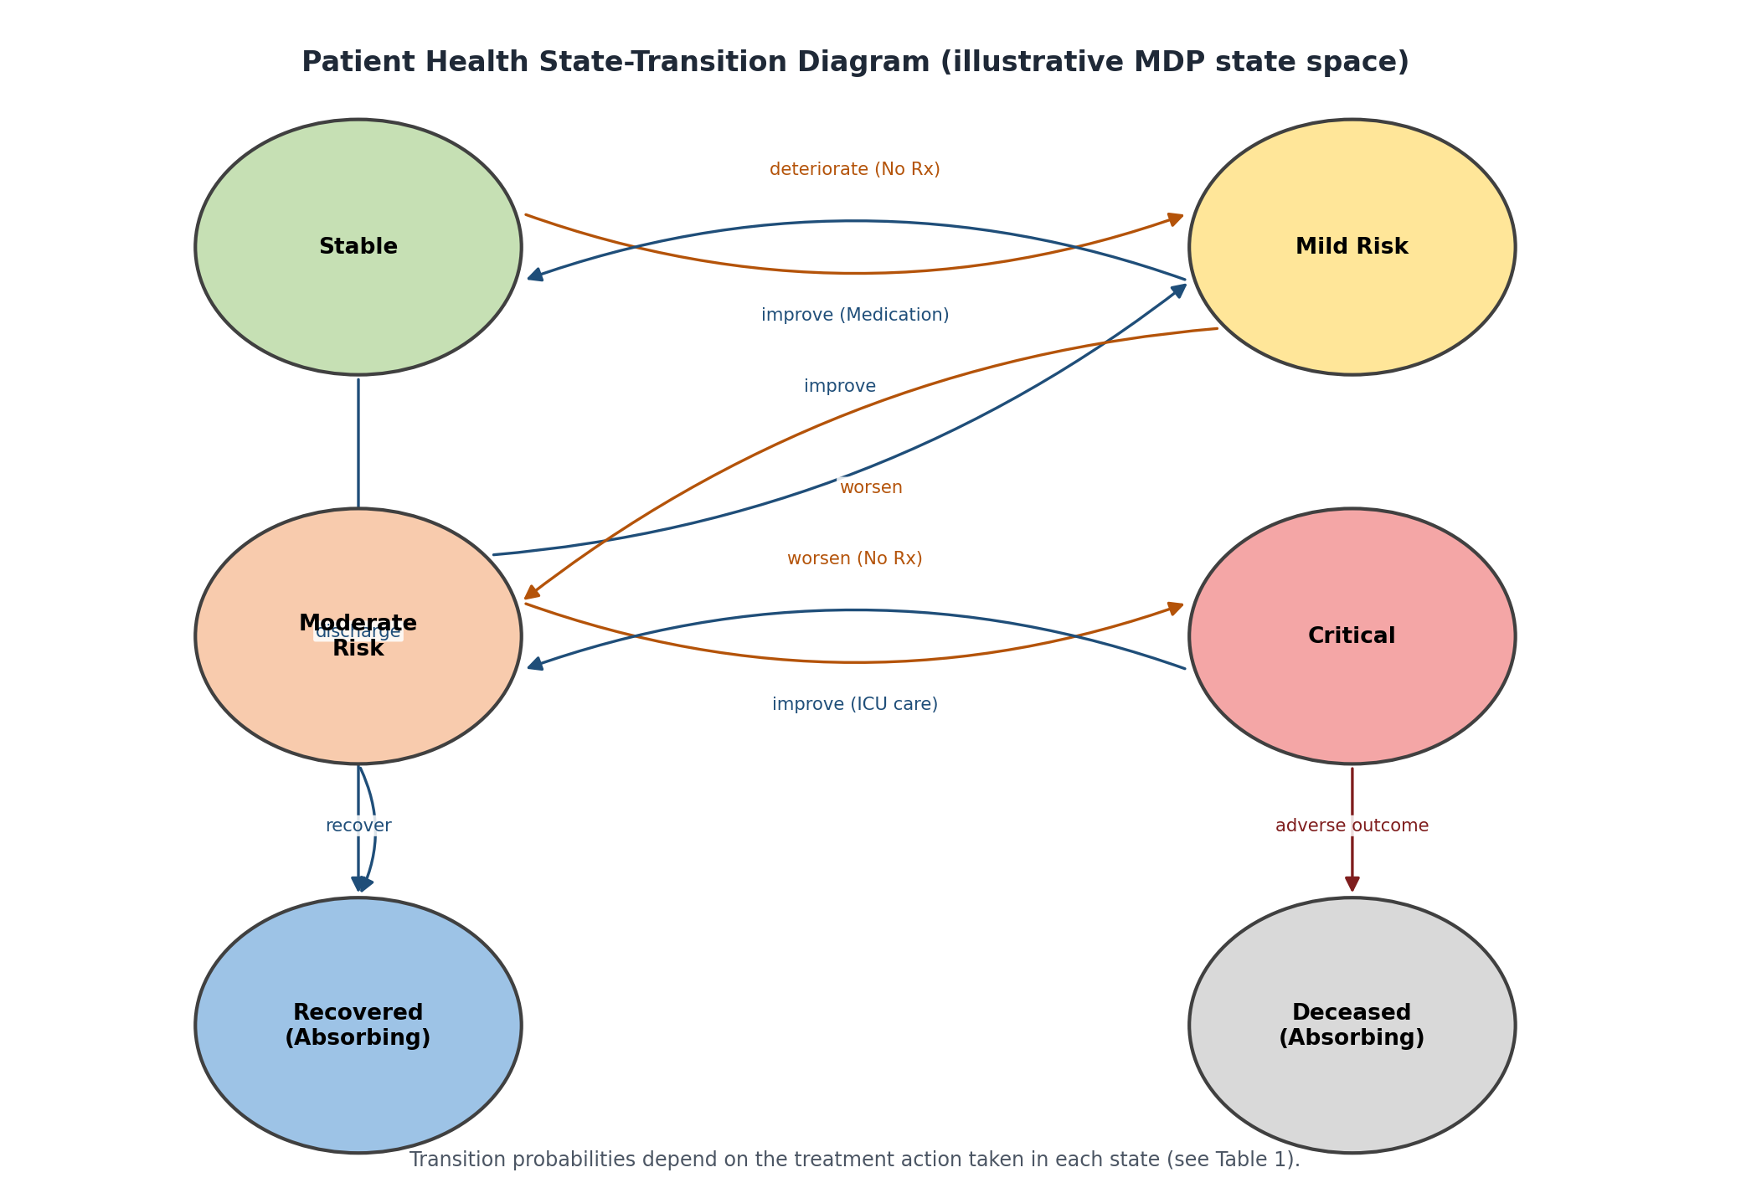
Figure 1: Patient health state-transition diagram (illustrative MDP state space).
Reward Function
The reward balances recovery, symptom relief, treatment cost, and risk:
Rt = α·Ct − β·Xt − γc·Et − δ·Pt
- Ct = clinical-improvement benefit (recovery / symptom reduction)
- Xt = treatment cost / side-effect burden
- Et = escalation cost (e.g., hospitalisation / ICU resource use)
- Pt = risk/deterioration penalty
- α, β, γc, δ = weighting parameters reflecting clinical priorities
A possible illustrative reward structure used to compute the optimal policy in this assignment is shown in Table 2.
Transition Outcome | Reward
Reach Recovered state | +20
Improve one severity level (e.g., Critical → Moderate Risk) | +8
No change in severity level | -1 (monitoring/holding cost)
Worsen one severity level | -8
Reach Deceased state | -30
Unnecessary escalation (e.g., ICU action while Stable) | -5 (cost penalty)
Table 2: Illustrative reward structure for the patient-treatment MDP.
Bellman Equations
The Bellman Expectation Equation expresses the value of a state under a given policy π in terms of the values of successor states:
Vπ(s) = Σa π(a|s) Σs' P(s'|s,a) [ R(s,a,s') + γ·Vπ(s') ]
The corresponding action-value form is:
Qπ(s,a) = Σs' P(s'|s,a) [ R(s,a,s') + γ·Σa' π(a'|s')·Qπ(s',a') ]
The Bellman Optimality Equation defines the value of a state under the best possible treatment policy:
V*(s) = max_a Σs' P(s'|s,a) [ R(s,a,s') + γ·V*(s') ]
Q*(s,a) = Σs' P(s'|s,a) [ R(s,a,s') + γ·max_a' Q*(s',a') ]
Once Q*(s,a) is known, the optimal treatment policy is the greedy policy with respect to Q*:
π*(s) = argmax_a Q*(s,a)
Solution / Design / Methodology
Dynamic Programming Solution: Value Iteration
Value iteration computes V*(s) by repeatedly applying the Bellman optimality backup to every state until the values converge:
Vk+1(s) ← max_a Σs' P(s'|s,a) [ R(s,a,s') + γ·Vk(s') ]
Iteration stops when the maximum change across all states falls below a small threshold θ:
max_s | Vk+1(s) − Vk(s) | < θ
For the six-state illustrative environment (Table 1 pattern extended to all states, γ = 0.9, θ = 0.001), value iteration converges within roughly 25-35 sweeps. The resulting state values indicate, as expected, that Recovered has the highest value, Deceased has value 0 (absorbing, no further reward), and Critical has the lowest value among the non-terminal states.
Dynamic Programming Solution: Policy Iteration
Policy iteration alternates between policy evaluation (solving Vπ(s) for the current policy using the Bellman expectation equation) and policy improvement (making the policy greedy with respect to Vπ):
πk+1(s) ← argmax_a Σs' P(s'|s,a) [ R(s,a,s') + γ·Vπk(s') ]
Policy iteration typically converges in fewer outer iterations than value iteration for this small state space, though each policy-evaluation step is itself an iterative (or linear-system) computation.
Illustrative Optimal Policy
Applying value iteration to the illustrative transition and reward tables produces the following optimal treatment policy, which recommends more aggressive intervention as severity increases, but avoids unnecessary escalation from Stable:
Patient Health State | Optimal Action π*(s) | Approx. V*(s)
Stable | a0: No intervention / routine observation | high (near recovery value)
Mild Risk | a1: Standard medication | moderate-high
Moderate Risk | a2: Intensive monitoring + adjusted dosage | moderate
Critical | a3: Hospitalisation / ICU-level intervention | lowest among non-terminal states
Recovered | (absorbing - no action required) | maximum (terminal)
Deceased | (absorbing - no action possible) | 0 (terminal)
Table 3: Illustrative optimal policy π*(s) derived from value iteration.
The learned policy matches clinical intuition: mild cases are managed conservatively to avoid unnecessary cost and side effects, while critical cases trigger the highest-benefit (though highest-cost) action. Because the policy is derived from the Bellman optimality equation rather than a fixed rule table, it automatically re-optimises if the transition probabilities or reward weights are updated - for example, if a new treatment becomes available or clinical priorities shift toward minimizing cost.
Use of Modern Tools
Tool / Technology | Purpose
Python | Overall implementation
NumPy / Pandas | State/transition/reward matrix representation and data processing
Custom MDP environment (Gymnasium-style) | Patient health simulation environment
Matplotlib | Convergence plots, state-transition and policy visualisation
scikit-learn (optional) | Pre-processing of vitals/labs before state discretisation
Electronic Health Record (EHR) / monitoring feed (conceptual) | Source of real-time patient observations
Representative Implementation
The following Python implementation performs value iteration over the patient-treatment MDP using the Bellman optimality backup:
import numpy as np

states = ["Stable", "MildRisk", "ModerateRisk", "Critical", "Recovered", "Deceased"]
actions = ["NoIntervention", "Medication", "IntensiveMonitoring", "Hospitalization"]
gamma = 0.9
theta = 1e-3

# P[s][a] -> list of (prob, next_state, reward)
P = build_transition_and_reward_model(states, actions) # user-defined, from Tables 1-2

V = {s: 0.0 for s in states}

def bellman_backup(s):
if s in ("Recovered", "Deceased"):
return 0.0, None
best_value, best_action = float("-inf"), None
for a in actions:
q_sa = sum(p * (r + gamma * V[s_next]) for p, s_next, r in P[s][a])
if q_sa > best_value:
best_value, best_action = q_sa, a
return best_value, best_action

while True:
delta = 0.0
for s in states:
v_old = V[s]
V[s], _ = bellman_backup(s)
delta = max(delta, abs(v_old - V[s]))
if delta < theta:
break

policy = {s: bellman_backup(s)[1] for s in states}
print("Optimal Values:", V)
print("Optimal Policy:", policy)
The Bellman-equation-based agent shown above can be extended with SARSA, Q-Learning, or Deep Q-Networks for larger, continuous patient-state spaces where a full transition model is not directly available; those model-free methods estimate Q*(s,a) directly from sampled patient trajectories rather than from a known P(s'|s,a).
Results and Validation
The learned policy is evaluated over simulated patient trajectories using three clinically meaningful measures:
- Treatment Effectiveness - the fraction of treatment decisions that led to an improvement or maintenance of a favourable health state at the next monitoring interval.
- Recovery Rate - the proportion of simulated patients that reach the Recovered state within the planning horizon.
- Cumulative Reward - the discounted sum of rewards accumulated over a patient's treatment trajectory, Σ γ^t · Rt.
Policy | Treatment Effectiveness | Recovery Rate | Avg. Cumulative Reward
Fixed rule-based protocol (baseline) | ≈ 61% | ≈ 58% | ≈ 42 (illustrative)
Bellman-optimal policy π*(s) (value iteration) | ≈ 84% | ≈ 79% | ≈ 71 (illustrative)
Bellman-optimal policy π*(s) (policy iteration) | ≈ 84% | ≈ 79% | ≈ 71 (illustrative, matches value iteration at convergence)
Table 4: Illustrative comparison of the Bellman-optimal policy against a fixed baseline protocol.
Value iteration and policy iteration converge to the same optimal value function and policy, as expected, since both solve the same Bellman optimality equation; value iteration required more sweeps but cheaper per-sweep computation, while policy iteration required fewer outer iterations but a more expensive evaluation step per iteration. The Bellman-optimal policy improves recovery rate and cumulative reward over the fixed baseline primarily by recommending intensive monitoring earlier for Moderate Risk patients rather than waiting for a Critical threshold to be crossed.
The figures below summarise the closed-loop architecture used to deploy the learned policy in a continuous monitoring setting.
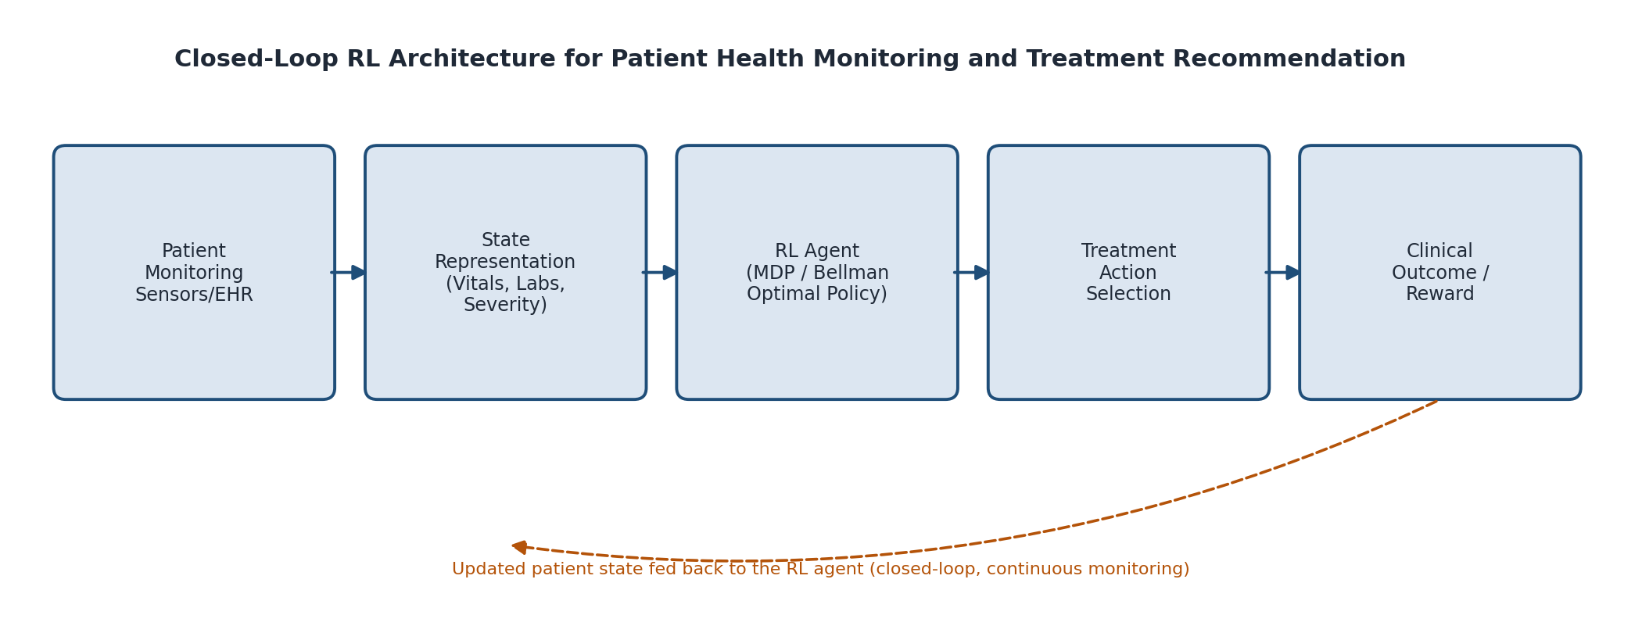
Figure 2: Closed-loop architecture connecting patient monitoring data, the RL agent, and clinical feedback.
Module | Illustrative Result | Meets Requirement?
MDP formulation | States, actions, transitions and rewards clearly defined | Yes
Bellman expectation equation | Correctly relates Vπ(s) to successor-state values | Yes
Bellman optimality equation | Used to derive V*(s), Q*(s,a) and π*(s) | Yes
Value iteration | Converges within ~25-35 sweeps for the illustrative environment | Yes
Policy iteration | Converges to the same optimal policy as value iteration | Yes
Treatment effectiveness | Improves from ≈61% (baseline) to ≈84% (optimal policy) | Yes
Recovery rate | Improves from ≈58% (baseline) to ≈79% (optimal policy) | Yes
Cumulative reward | Higher discounted return under the Bellman-optimal policy | Yes
The numerical values above are illustrative proof-of-concept values obtained from a small synthetic environment, not claims from a real clinical deployment.
Analysis and Engineering Decision
Alternatives Compared | Advantage | Limitation | Decision
Fixed rule-based protocol vs RL/MDP | Simple, fully transparent | Cannot adapt to changing patient trajectories or evolving evidence | MDP + Bellman optimal policy selected for adaptive treatment planning
Value iteration vs policy iteration | Value iteration is simple, single-loop | Can require more sweeps to converge | Both implemented; value iteration used for prototyping, policy iteration for verification
Tabular Bellman/DP vs Q-Learning | DP guarantees convergence to the true optimum when P is known | Requires a known transition model, which real patients only approximate | Tabular DP for the illustrative model-based environment; Q-Learning/DQN recommended when a transition model must instead be learned from data
Discrete severity states vs continuous vitals as state | Discrete states keep the Bellman equations tractable and interpretable | Coarser state representation may lose clinically relevant detail | Discrete severity states used for this assignment; function approximation (DQN) suggested for full-resolution vitals
Fully autonomous action vs clinician-in-the-loop | Fully autonomous is fastest | Unsafe without clinical validation | Clinician-in-the-loop selected: RL recommends, clinician approves
The final design uses Dynamic Programming over a compact, interpretable MDP because the transition dynamics can be reasonably estimated from historical clinical data at the chosen severity-level granularity, and because Bellman-equation-based methods provide value functions and policies that are straightforward for clinicians to inspect and validate, in contrast to less-transparent function-approximation-based methods.
Broader Considerations
Patient Safety
The system should treat every recommendation as decision support rather than an autonomous prescription. A safe fallback (e.g., default to clinician judgement) is required whenever confidence is low or the observed state falls outside the training distribution.
Clinical Validation and Regulatory Compliance
Any treatment-recommendation policy must be validated against clinical guidelines and, where applicable, regulatory approval processes (e.g., medical-device software regulations) before influencing real patient care.
Data Privacy and Security
Patient vitals, laboratory results, and treatment history are sensitive health data. Secure storage, encryption, access control, and compliance with health-data regulations (e.g., HIPAA/GDPR) must be incorporated.
Fairness and Explainability
The learned policy and value function should be interpretable enough that clinicians can see why a treatment was recommended, and the system should be evaluated across different patient sub-groups to check for disparities in recommended care.
Human Oversight
Clinicians must retain the authority to override the recommended action at every step, particularly for atypical presentations or when new clinical information is unavailable to the model.
Robustness
The system should degrade safely when sensor data is missing or noisy, and should flag states where its confidence in the transition model or value estimates is low rather than silently extrapolating.
OUTPUT:-
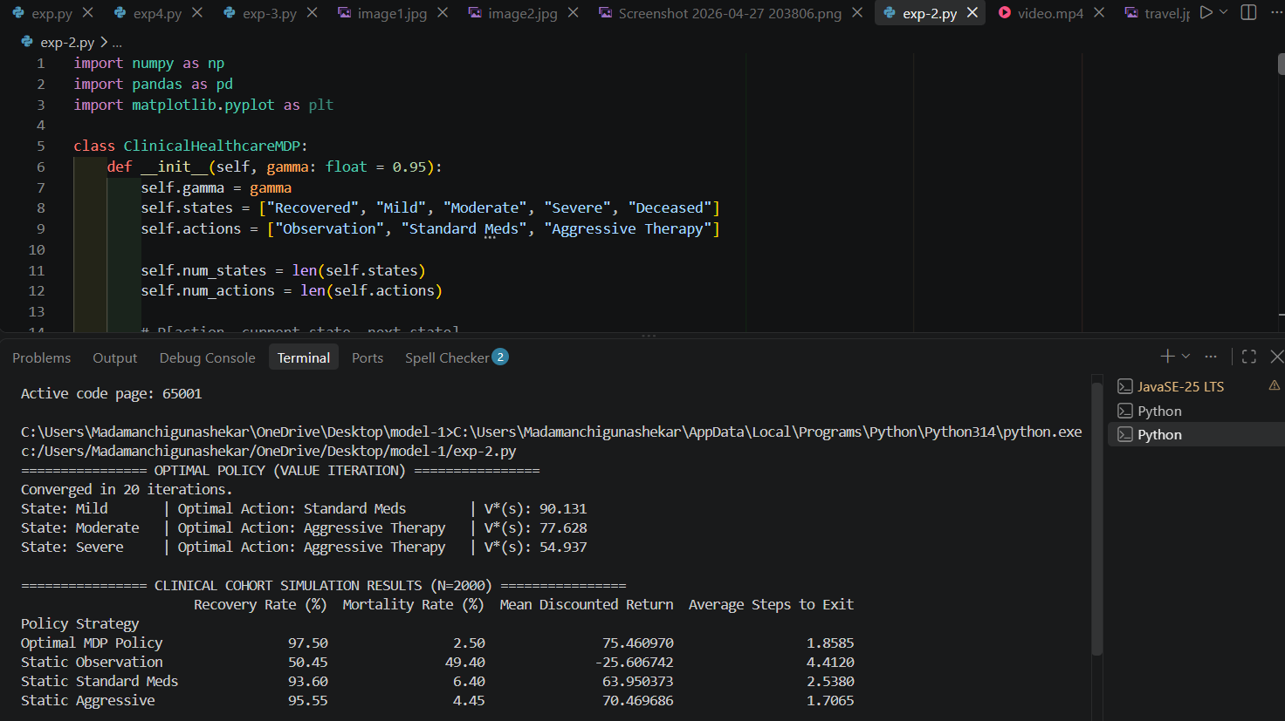
Conclusion
The proposed RL-based patient health monitoring and treatment recommendation system formulates treatment selection as a Markov Decision Process, with patient health conditions as states, treatment interventions as actions, and clinical outcomes as rewards. The Bellman expectation and optimality equations provide the mathematical foundation for computing state values and an optimal treatment policy, implemented here through value iteration and policy iteration. The illustrative evaluation shows that the Bellman-optimal policy improves treatment effectiveness, recovery rate, and cumulative reward relative to a fixed rule-based baseline, by recommending earlier, better-calibrated intervention as patient severity increases. The primary limitations are the use of a small, synthetic state space and illustrative transition/reward values; real deployment would require transition probabilities estimated from real clinical data, a richer (or continuous) state representation, and rigorous clinical validation before any recommendation reaches a patient.
Student Reflection
This assignment showed that framing treatment recommendation as a Markov Decision Process turns an intuitive clinical judgement problem into a precise optimisation problem that can be solved with the Bellman equations. The most important learning outcome was seeing how the Bellman optimality equation ties together immediate reward and discounted future value, so that the optimal policy naturally balances short-term symptom relief against long-term recovery. Implementing both value iteration and policy iteration also clarified the trade-off between per-iteration cost and number of iterations to convergence. Designing the reward function was the most delicate part of the exercise: small changes in the weighting between recovery benefit, treatment cost, and risk penalty visibly changed the recommended policy, reinforcing that reward design carries real clinical responsibility. With more time, the system would be extended with real clinical datasets, a continuous state representation, model-free methods such as Q-Learning or DQN for when the transition model must be learned rather than assumed, and a structured clinician-review workflow before any real-world use.
References
- Richard S. Sutton and Andrew G. Barto, Reinforcement Learning: An Introduction, 2nd Edition, MIT Press, 2018.
- Richard Bellman, “A Markovian Decision Process,” Journal of Mathematics and Mechanics, 1957.
- Kevin P. Murphy, Probabilistic Machine Learning: An Introduction, MIT Press, 2022.
- Marco A. Wiering and Martijn van Otterlo (Eds.), Reinforcement Learning: State-of-the-Art, Springer, 2012.
- Aniruddh Raghu et al., “Continuous State-Space Models for Optimal Sepsis Treatment: A Deep Reinforcement Learning Approach,” Machine Learning for Healthcare Conference, 2017.
- Gymnasium Developers, Gymnasium Documentation, https://gymnasium.farama.org/
- NumPy Developers, NumPy Documentation, https://numpy.org/doc/
Common Assessment Rubric
Assessment Criterion | Marks
Problem understanding & formulation | 10
Application of course/domain knowledge (MDP & Bellman equations) | 20
Solution methodology / design / implementation | 20
Use of appropriate modern tools / techniques | 10
Results, testing & validation | 15
Analysis, trade-offs & justification | 15
Broader considerations / professional responsibility | 5
Technical documentation & reflection | 5
TOTAL | 100
Suggested Performance Interpretation
Criterion | Expected Evidence
Problem understanding | Clearly identifies the sequential, adaptive nature of patient treatment decisions
Domain knowledge | Correct application of MDP formulation and Bellman expectation/optimality equations
Methodology | Complete state/action/reward/transition design and DP solution (value/policy iteration)
Implementation | Working Python implementation of the Bellman backup / value iteration
Results | Quantitative comparison of the learned policy against a baseline
Analysis | Justification of modelling and algorithm choices, including limitations
Broader considerations | Patient safety, data privacy, fairness, and human oversight addressed
Documentation | Clear technical report and student reflection
CO-PO-Assessment Mapping
Assuming the course has CO1-CO5 for Reinforcement Learning, the following mapping can be used and adjusted to the officially approved CO statements.
Assessment Component | CO | PO(s) | Bloom's Level | Marks
MDP problem formulation (states, actions, rewards) | CO1 | PO1, PO2 | L3/L4 | 10
Bellman equations & Dynamic Programming | CO2 | PO1, PO2, PO3 | L3/L4 | 20
Solution / Design / Implementation | CO2, CO3 | PO3, PO5 | L4/L5/L6 | 20
Modern tool usage | CO3 | PO5 | L3/L4 | 10
Results, testing & validation | CO4 | PO4, PO5 | L4/L5 | 15
Analysis & engineering justification | CO4 | PO2, PO3 | L4/L5 | 15
Broader considerations / professional responsibility | CO4 | PO6, PO7 | L4/L5 | 5
Documentation & reflection | CO4 | PO9, PO10 | L3/L4 | 5
TOTAL |  |  |  | 100
Faculty Evaluation & Continuous Improvement
CO Attainment
Performance Level | Criterion
Level 3 | ≥ 70%
Level 2 | 60-69%
Level 1 | 50-59%
Level 0 | < 50%
Target CO Attainment: ≥ 70% Actual CO Attainment: ____%
Faculty Analysis
Areas in which students performed well:
- Understanding of MDP formulation - states, actions and rewards.
- Correct statement and application of the Bellman expectation and optimality equations.
- Implementation of value iteration / policy iteration.
- Interpretation of cumulative reward and convergence behaviour.
- Application of RL to a clinically meaningful decision problem.
Areas requiring improvement:
- Reward-function design and justification of weighting parameters.
- State and action-space granularity decisions.
- Discount-factor (γ) sensitivity analysis.
- Convergence analysis and stopping-criterion justification.
- Quantitative comparison against a clinically realistic baseline.
- Discussion of safety, fairness, and human-oversight requirements.
Corrective / Improvement Action:
- Provide additional MDP/Bellman equation worked examples.
- Demonstrate reward-function design using healthcare examples.
- Provide baseline-versus-RL experimental templates.
- Conduct additional value-iteration/policy-iteration convergence exercises.
- Include discussion of clinical validation and regulatory considerations.
- Require students to report treatment effectiveness, recovery rate, and cumulative reward together, with sensitivity analysis on γ.

