**MACHINE LEARNING**

**Assignment 2(Logistic Regression &Naive Bayes)**

By

Parameswar K 2016A7PS0021H

Anish Reddy E 2016A7PS0104H

Sandeep Chowdary 2016A7PS0070H

**LOGISTIC REGRESSION:**

**Case I:**

**Learning rate**=0.0001

**Regularization constant**=0.1

**Number of iterations**=100

**Accuracy**=97.5432211%

**Precision**=0.75 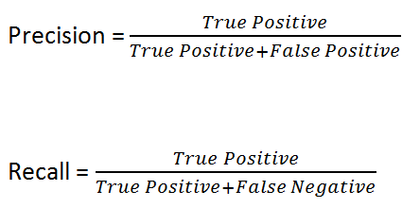

**Recall**=0.803

**F1**=0.7741

**CONFUSION MATRIX:**

|  |  |  |
| --- | --- | --- |
|  | **Predicted No** | **Predicted Yes** |
| **Actual No** | **True negative=735** | **False positive=27** |
| **Actual Yes** | **False negative=0** | **True Positive=337** |

**CASE ll:**

**Learning rate**=0.0001

**Regularization constant**0.0001

**Number of iterations**=10

**Accuracy**=77%

**Precision**=0.7430

**Recall**=0.81

**F1**=0.7734

**CONFUSION MATRIX:**

|  |  |  |
| --- | --- | --- |
|  | Predicted No | Predicted Yes |
| Actual No | True negative=108 | False positive=37 |
| Actual Yes | False negative=24 | True Positive=107 |

**NAIVE BAYES:**

**Case I: Smoothing factor (∝) =** 0.0001

**Accuracy =**65.63%

**Precision =**0.5963

**Recall =** 0.89

**F1=**0.7142

**CONFUSION MATRIX:**

|  |  |  |
| --- | --- | --- |
|  | **Predicted No** | **Predicted Yes** |
| **Actual No** | True negative=530 | False positive=700 |
| **Actual Yes** | False negative=119 | True Positive=1034 |

**Case II:**

**Smoothing factor (∝) =** 0.001

**Accuracy =**69.28%

**Precision =**0.628

**Recall =** 0.895

**F1=**0.738

**CONFUSION MATRIX:**

|  |  |  |
| --- | --- | --- |
|  | **Predicted No** | **Predicted Yes** |
| **Actual No** | True negative=619 | False positive=611 |
| **Actual Yes** | False negative=121 | True Positive=1032 |