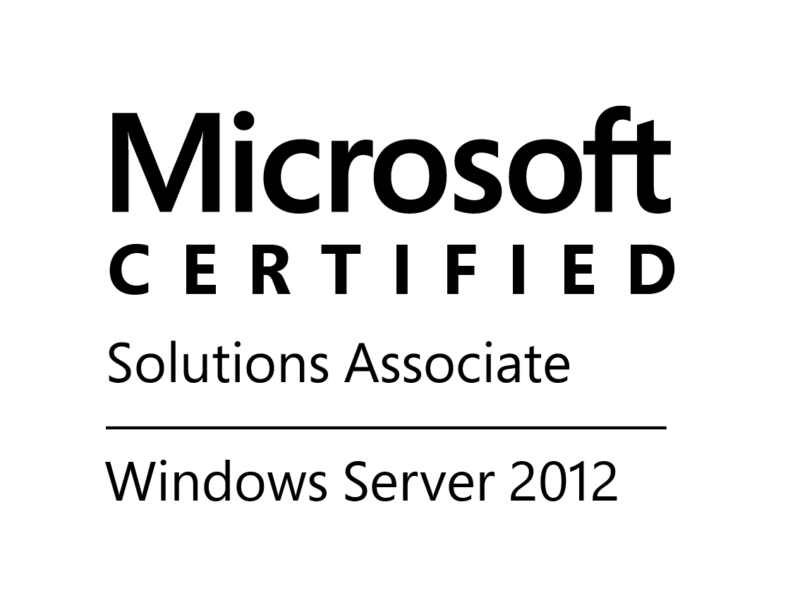
VENKATESH GADA
Ph: +91 9533202963
venkatesh863@gmail.com

CAREER OBJECTIVE:

To associate myself with an organization, where there is an opportunity to contribute and update my knowledge and making myself a better person fitting into an organization and strive hard for organization growth.

KEY SKILLS:

Operating Systems: Windows XP; Windows 7; Windows 8.1.
Microsoft Servers: Windows Server 2008; Windows Server 2012; AD DS 2008; DHCP Server.
Services: Security and share level permissions; FSRM; Group Policy Management; FTP.
Software: IBM Lotus Notes 8.5;IBM Verse; MS Office 2007; MS Office 2003; WinZip; Adobe Reader

PROFESSIONAL EXPERIENCE:
SYSTEM ADMINISTRATOR
Goodhope Asia Holdings Ltd.(www.goodhopeholdings.com), Hyderabad
Nov 2013 to Till Date
Duties and Responsibilities:
Network/Systems Administration:
- Administrating and troubleshooting 2008 server.
- Managing user accounts and giving share & security level permissions.
- Responsible for troubleshoot Microsoft windows issues.
- Responsible for the installation of operating system windows Xp, windows 7 and windows 8.1.
- Configuration and troubleshooting of IBM Lotus client Application.
- Resolving Desktop Issues based on service desk Request Tickets.
- Responsible for the installation of software’s like antivirus (Trend Micro), MS-office, adobe & acrobat reader etc.
- Responsible for maintaining the network & troubleshooting the network related issues.
- Responsible for maintaining & troubleshooting network printers.
- Responsible for troubleshooting Internet issues.
- Responsible for sharing the network printers.
- Maintenance and management of Active Directory.
- Group Policy Management for the Domain Users
  - Monitor the status/event logs of all the MS-Windows servers and escalate issues.
  - Monitor and Maintain network related applications (Officescan Anti-virus).
  - Provide periodic weekly and monthly reports on systems performance.
  - Ensure network security is implemented and maintained as per information security policy.
  - PABX/VOIP system, UPS Power, Physical access control, Desktop hardware, peripheral equipment and software etc.
  - Monitor and maintain Biometric Device and provide periodic reports.

Research and Development:
  - Establish strategic relationships with key IT suppliers and consultants.
  - Identify and understand new technologies and industry direction

CERTIFICATIONS:

Microsoft Certified Solutions Associate (MCSA) # F482-5080

Cisco Certified Networking Associate (CCNA) # CSCO12241474

N+ certified by compTIA

EDUCATION QUALIFICATIONS:
CLASS | BOARD/UNIVERSITY | SCHOOL/COLLEGE | YEAR OF PASS | PERCENTAGE
B-Tech(E.C.E) | Jawaharlal Nehru Technological University,Kakinada | Aditya Engineering College,  Surampalem | 2012 | 66.11
Intermediate(M.P.C) | Board of intermediate education | Sri Ravi junior college, Kapulapalem | 2008 | 87.7
S.S.C | Board of secondary education | Yanam public school, Yanam | 2006 | 68.66

PERSONAL PROFILE:

Father’s Name : Mr. TIRUMALA RAO GADA

Date Of Birth : 17th March1991

Languages known : Telugu, English

Nationality : Indian.

Address : H.NO:4, Sai Abhilash nagar,
Samalkot, Andhra Pradesh – 533440

DECLARATION:

I do hereby affirm that the particulars furnished above are true to the best of my knowledge and belief.

Date:
Place: Venkatesh Gada

