CURRICULUM VITAE

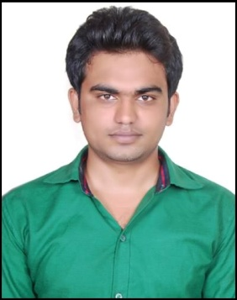

Daravath Venkatesh,
S/o Deepla Nayak
Contact: 3-48,
Shivalal thanda(vil), Aler(M),Nalgonda, +919885303500,
PIN-508108.
venkateshsoftcse@live.com

CAREER OBJECTIVE
To succeed in an environment of growth and excellence and earn a job which provides me job Satisfaction and self development and help me achieve personal as well as organization goals.

ACADEMIC PROFILE

2013 Completed B.Tech(C.S.E) from AURORA’s College of Engineering , Bhongir. Affiliated to JNTUH ,Telangana, with 59% .
2009 Completed Intermediate from Sri Aurobindo Junior college, Board ofIntermediate, Telangana with 60%.
2007 Completed 10th From Vishwa Bharathi Vidyalayam, aler, Nalgonda, SSC State Board, Telangana with 65%.

TECHNICAL SKILLS

- Programming Languages : C, C++, java

Inter Personal Skills

- Having Good Analytical and problem solving skills.
- Willingness to accept challenges and facing difficulties.
- Quick learner.

PROJECT DETAILS

- Project Title : Record Matching Over Query Results From Multiple Web Databases
- Software Tools Used : JAVA ,HTML .
- Operating System : Windows XP Professional.
- Duration : 4 Months.
- Description : Record matching, which identifies the records that represent the same real-world entity, is an important step for data integration. By using UDD(Unsupervised Duplicate Detection) algorithm show the query result records from multiple Web databases. An unsupervised, online record matching method, UDD, which, for a given query, can effectively identify duplicates from the query information.

PERSONALINFORMATION

- Father name : Deepla Nayak
- Date of Birth : 12-05-1990
- Gender : Male.
- Hobbies : Watching TV, playing Cricket,
Web Surfing, Keep Learning Something New.
- Languages known : English, Telugu, Hindi.
- Experience : Fresher

DECLARATION

I do hereby declare that the particulars of information and facts stated here in above are true, correct and complete to the best of my knowledge and belief.

Place : HYDERABAD

[Daravath Venkatesh]

