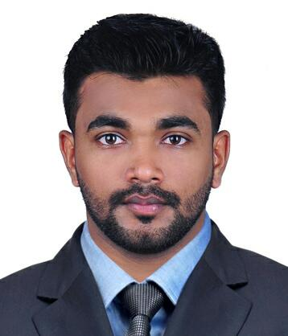
Hasif.M

Villa No 40

100 Villas
Email:hasifm2010@gmail.com Al quoz
Phone: +971-529371370 Dubai - 283699

SUMMARY

To take up any challenging position where my expertise of Server and Virtualization Administration, which would be utilized for the maximum benefit of the organization and to Leverage my ability to be as a part of the Technology team and to fulfill Organizational Goals and Objective. Has 2.6 years of experience in System Administration which includes Linux / UNIX, Windows Server Administration, Virtualization, and the good skills.

EDUCATIONAL BACKGROUND

- BE/B.Tech Computer Science and Engineering from Shree Devi Institute of Technology, Mangalore in 2012

CERTIFICATION AND TRAINING

- RHCE and RHCSA (certificate no: 120-201-124).
- CCNA (Course completed).
- VMware Certified Professional (VCP)

TECHNOLOGY SUMMARY

- Red Hat Enterprise Linux, Unix, CentOS, Ubuntu, Windows Server/Desktop.
- MySQL,TCP/IP,DNS,DHCP,WINS,SMTP,NFS,CIFS,LDAP,TFTP,FTP
- Remote server management : SSH, Telnet
- Monitoring tool : Nagios
- VMware vSphere, WebSphere, VMware Vcenter, basic configuration of Cisco routers, hubs and switches, Active Directory.
- Avira Antivirus, Symantec Antivirus, Bitdefender, Microsoft Security Essentials, Avast, AVG, PC Tools Firewall.
- MS Outlook Configuration, Driver installation, MS Office.
- MS SharePoint 2007 & 2010, EMC Documentum, IBM OnDemand.

PROFESSIONAL EXPERIENCE

NTT Data Global Delivery Services Ltd.

Location:- Bangalore, India
Designation: - System Administrator [Nov’3 2014 to Nov’27 2015]
Client: - Morgan Stanley

ROLES AND RESPONSABILITIES:-

- Providing Linux and Windows system administrator for our application environment.
- Administrating SharePoint 2007 and 2010.
- Responsible for troubleshooting and maintenance of Linux application servers.
- Responsible for execution of TCM (Technology Change Management).
- Responsible for resolving any issues related SharePoint Environment.
- Adding/Changing/Removing users and user group permissions for various sites, updating content & changing navigation.
- Performing daily host checkup for Linux application servers like Documentum, Ondemand, etc.
- Performing weekend scheduled Server maintenance.
- Resolving end users queries according to Service Now ticketing tool.
- Working in production environment with through knowledge in SLA’s.
- Performing host checkup for Linux and Windows Cluster nodes based on Netcool Alerts.
- Performing ready for business checkouts for various applications and services.
- Performing patch upgradation of various application such as Documentum, Ondemand, SharePoint, etc.

Flipkart India Private Ltd.

Location: - Bangalore, India
Designation: - System Engineer [May’2 2013 to Oct 5th 2014]
Payroll: - Axon Network Solution [May’2 2013 to Jan 2014], Acropetal Technologies [Feb’1st 2014 to Oct 5th].

ROLES AND RESPONSABILITIES:-

- Managing Linux/windows networking maintenance and troubleshooting.
- Driver Installation for Hardware.
- User and Group Administration.
- Monitoring servers and printers in Nagios.
- Taking care of all Linux and windows based desktop calls.
- Resolving issues according to Ticketing tool (OTRS).
- Installing Linux (Red Hat, Centos, Fedora, and Ubuntu).
- Yum configuration & RPM package Management.
- Managing and assign the permissions for users and groups
- Involved in several projects such as: FOG server, PXE Server, SAMBA, NAGIOS.
- Remote server management using SSH, Putty, TELNET.
- VPN Installing and Configuring.
- Avaya and Ameyo ID Creation and Deletion, resolving Avaya issues.
- Configuring outlook as per user needs.
- User and group creation in Active Directory.

PERSONAL DETAILS

Father’s name : Abdu Rahman
Date of Birth : 18-06-1990
Gender : Male
Nationality : Indian
Marital Status : Single
Hobbies : Playing Cricket and Football, Browsing Internet.
Languages Known : English, Malayalam, and Hindi.
Passport No : M4669685
Visa status : Visit

DECLARATION

I here by declare that the details furnished above are true to the best of my
Knowledge.

Place: Dubai
Date: 15/01/2016 (Hasif M)

