Email id: arshadpasha53@gmail.com
SYED. ARSHAD PASHA. MobileNo: +91 9951067081

Objective:
To work in an environment, where my skills are efficiently utilized towards the development of the organization as well as personal development in the organization and where I can acquire good amount of skills and knowledge for further growth in my profession.

Academic Qualification:

Qualification | University/Board | Name of the Institution | Year of Passing | Aggregate  (%)
Polytechnic CSE Technology | SBTET, Hyderabad. | Indur  engineering College | 2014 | 63.10
SSC. | Board of Secondary Education. | Navajyothi  High School | 2011 | 70%

Technical Skills:

- Programming Languages : C,C++,JAVA
- WEB Technologies : ASP.NET
- Databases : MS-SQL Server
- Operating system : Windows 7,win xp,win8

Courses:

Hardware and Networking.
CCNA Course in Zoom Technology.
Trained as a Hardware Engineer in MOTIF Institute.

Strengths:

▪ Adaptable to new environment.
▪ Committed to my work and Determined.
▪ Mingle with anyone.
▪ Keep learner with constant zest to acquire new skills.

Project Work:

ACADEMIC PROJECT:

Description: PROJECT NAME : THE EFFECT OF PAIRSI IN PROGRAME DESIGN TASK

TEAM SIZE : 5

TECNOLOGIES : Java, .NET

DATABASE : MS Access

DETAILS: in this projet effciency of pairs in programing desining tasks a defined violation

probability, the task of bandwidth estimation is formulated as inferring an unknown bounding

function from measurements of probing traffic. I derive an estimation methodology that is based on

iterative constant rate probes. Our solution provides evidence for the utility of packet trains for

bandwidth estimation in the presence of variable cross traffic. Taking advantage of statistical

Personal Profile:

Father’s name : SYED. SALEEM PASHA.
Date of Birth : 28-02-1996
Languages known : English, Telugu. Hindi.
Marital status : Single

Declaration:

I declare that all the above furnished information is true up to my knowledge.

Place: Hyderabad.

SYED. ARSHAD PASHA

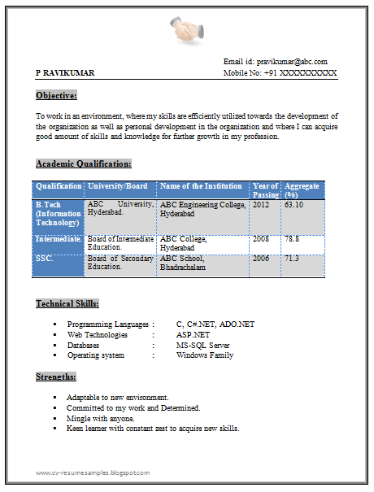

- See more at: http://cv-resumesamples.blogspot.in/2014/02/5-b-tech-resume-sample.html#sthash.wLPNqKkh.dpuf

