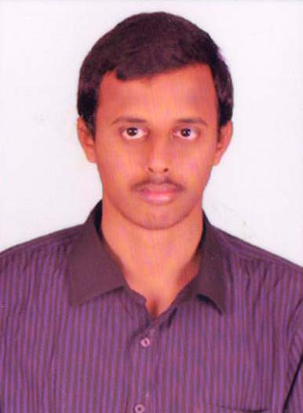
Permanent Address:
S/O: K.S.Venkateswara Rao,
D.NO.12-5-5,Raipeta,
Nidadavole,
West Godavari -534301
ANDHRA PRADESH

K.SRIKANTH
B.Tech, Electronics and Communication Engineering
E-mail:- kankipatisrikanth@gmail.com

Career Objective:

To work in a firm with a professional work driven environment where I can utilize and apply my knowledge, skills which would enable me as a fresh graduate to grow while fulfilling organizational goals.

Basic Academic Credentials:

Qualification | Board/University | College | Passing year | Percentage
B.tech(E.C.E) | Jntu Kakinada | Sri venkateswara institute of science and information technology (VISIT). | 2015 | 62%
Intermediate | Intermediate board of education A P | Aditya junior college. | 2011 | 56%
High School | SSC board of secondary education A.P | Vidyadeep EM School. | 2009 | 58%

IT Proficiency:

- Microsoft Office
- CCNA (R&S)
- MCSE 2012
- LINUX V7.0

Project details:

Domain name : Digital Image Processing
Title : Structure extraction from texture via relative total variation
Work details :
The aim of the project is to remove texture from structure by applying algorithm. We can recover old ancient images, graffiti on walls in this we are using relative total variation in this window technique is used for pixel operation.

Co–Curricular Activities:

- Servicing and Assembling laptops & desktops
- Participating in Seminar Presentations
- Circuit Modulation(Making mini projects)
- Playing volleyball

Achievements:

- Worked as CLASS REPRESENTATIVE in my B.tech
- Worked as Event Organizer for VOICE 2K15 held in our College
- Gave a Technical Seminar in Andhra University Visakhapatnam.
- Participated in a National level Robotics Workshop Conducted by A.R.K TECHNOLOGYES in Andhra University Visakhapatnam
- Secured 19th Place in TIMES Exam Conducted by T.I.M.E INSTITUTE & THE HINDU EDUCATION PLUS in Rajahmundry Circle.
- Secured a 2ND Place In Technical Seminar in VOICE 2K15 Held In Our College

Personal Details:

- Father’s Name :- K.S.Venkateswara Rao
- Mother’s Name: :- K.V.L.M.Sobha
- Date of Birth :- 02thNovember 1993
- Contact No :- 9550075220,9948778311
- Language Known :- Telugu, English
- Marital Status :- Unmarried
- Nationality/Religion : - Indian / Hindu
- Gender : - Male .
Declaration:

I do hereby declare that the above information is true to the best of my knowledge.

Place: K SRIKANTH
Date : (Signature)

