Cover Letter

Ramu Gurudu
Suchitra,
Hyderabad.
(P): +91 808-041-2252
Email: rammygurudu@gmail.com

Dear Sir/Madam
SUB: Application for the position of “Network Engineer “

Certified from CICSO- Cisco Certified Network Associate

My Combination of creative talent and Technical expertise in both Designing and Implementation of Networks makes me the right person to make your editorial team grow.

I have a good exposure to build strong relationships with all departments at an Organization. I have the ability to work within a team as well as cross team.

If I can provide you with any further information on my Background and Qualifications, Please let me know.

My resume which is enclosed, contains additional information on my trainings and skills. I can be reached at any time via email at rammygurudu@gmail.com or phone at +91 808-041-2252

Thank you for your time and consideration. I look forward to speaking with you about this employment opportunity.

Sincerely,
Ramu Gurudu

RESUME

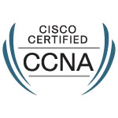
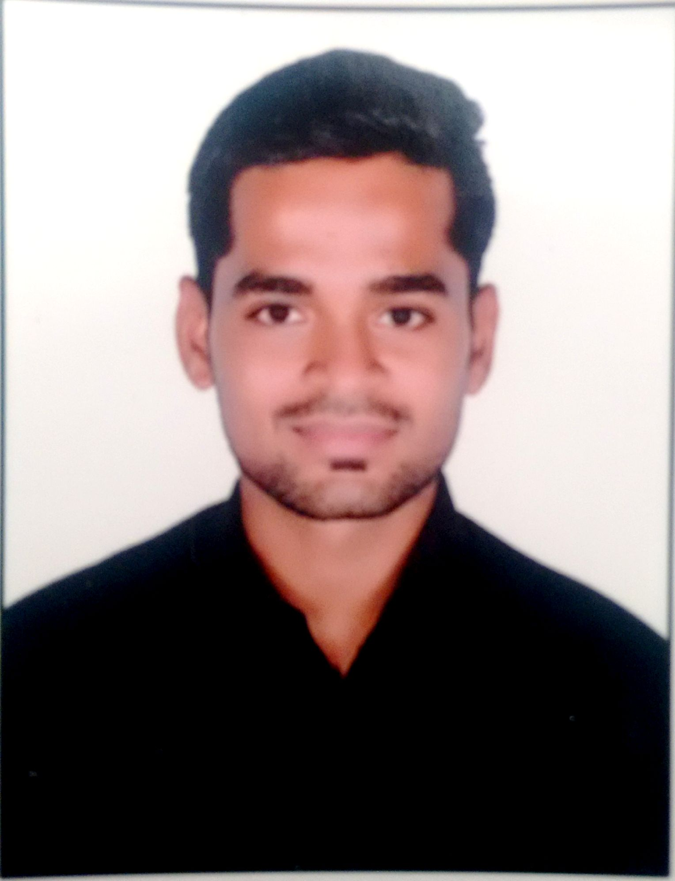

RAMU GURUDU
E-mail:- rammygurudu@gmail.com
Mobile:-+91 808-041-2252

OBJECTIVE:

Joining a large organization where I can apply, improve and sharpen my skills. Develop my career life through an impressive work environment and achieve any target with challenge, then use all those skills & knowledge and experience to develop and modernize workplace.
PROFESSIONAL PROFILE:

- Over above 1+years of experience focused around developing applications.
- Network Engineer, Customer Support Engineer, Maintenance of Systems and Internet Issues resolving.
- A flexible Network Engineer with professionalism in work, approach, committed and sets high standards for self, with strong verbal and written communication skills.
- Done course of CCNA Modules-1&2 in Networking from Zoom Academy, India.

E MOBILE SECURITY SYSTEMS GLOBAL PVT.LTD

Designation : Network Engineer.
Base Location : Hyderabad.
Period : From July 2014 to Present

JOB RESPONSIBILTIES:

- Responsible for Analyzing, Designing, Installing, Configuring, Maintaining and Repairing of Network Infrastructure and Application Components.
- Performa a wide variety of Evaluation, Maintenance and training tasks to ensure the computer network performance meets company and user satisfaction.
- Provides Direction, Information and Recommendations regarding network configurations and installations.
- Maintain a thorough understanding of the basics behind the internet and its workings (DNS, Security, IP Routing, HTTP, etc.)
- Design, Setup and Configure Complex Switching and Routing Components.
- Maintain a thorough understanding of LAN and WAN.
- Configuring and Installing client and server network software for upgrading and maintaining network.
- Maintaining multi-site network operations and software applications, operating systems and regular maintenance with both private and public facilities.
- Responding to inquiries from staff, administrators, service providers, site personnel and outside vendors, to provide technical assistance and support.
- Troubleshooting Malfunctions of Network Hardware and Software Applications, and Security systems to resolve operational issues and restore services.

CERTIFICATIONS:

CCNA (Cisco Certified Network Associate) CCNA ID: CSCO12196216

EDUCATIONAL QUALIFICATION:

- B.Com from Mumbai University, Mumbai, Maharashtra State, INDIA.
- Intermediate from Akbar Pheerboy College Of Commerce & Eco., Mumbai, INDIA.
- SSC from Hume High School, Mumbai, INDIA.

TECHNICAL SKILLS:

- Operating Systems – Windows Vista, Windows 7.
- Hardware assembling/Installation/Maintenance and Software issues.
- Ability to effectively implement and troubleshoot multiple Protocols and Standard TCP/IP, RIP, OSPF, EIGRP, BGP, VLAN, and NAT.
- Good Knowledge of Cisco Unified Communication Manager.
- Good Knowledge on Windows server 2008 and SQL Server 2008.

SOFT SKILLS:

- Ability to adjust in any situation.
- Fluency in English and public speaking skills.
- Keen to learn and quick to adapt to changes.
- Honesty, dedication to work and Truthfulness.
- Enthusiastic and committed to maintain quality and efficiency.
- Team Working.

PERSONAL INFORMATION:

Father name : Ashok Gurudu
Date of Birth : 9th May 1993
Marital Status : Single.
Nationality : Indian.
Languages : English, Hindi, & Telugu.

DECLARATION:

I hereby declare that the above information is true and correct to the best of my knowledge and belief.

(RAMU GURUDU)

