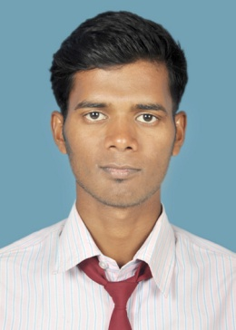

**RESUME**

**Padmakanta parida**

+919556536123, 7873644123

[Padmakanta94@gmail.com](mailto:Padmakanta94@gmail.com)

B.Tech in ELECTRONICS & COMMUNICATION Engineering,

Raajdhani Engineering College, Bhubaneswar (Orissa)

**CAREER OBJECTIVE**

To produce outstanding results for my organization by applying my skills and aptitude which I have acquired throughout my career, and thereby ensure growth of my organization and further enhance my professional growth.

**SKILLS:**

-Innovative & Creative.  
 -Positive Attitude.  
 -Effective communication skills

-Sincere & hardworking.

**EDUCATIONAL QUALIFICATIONS**

1. **B.tech in Electronics and communication engg securing C.G.P.A of 7.00**
2. **C.H.S.E (12th) from Abhimanyu samanta singhar College, Balia securing 60%**
3. **B.S.E (10th) from Samareswar bidyapitha , Saudia securing 67.3%**

**Summer internship**

* Institution: RSP
* Duration of course: 1month

**PERSONAL DETAILS:**

* Name: Padmakanta parida
* Date of birth: 14.06.1994
* Gender: Male
* Language known: Odia Hindi English
* Nationality: Indian
* Fathers name: Pramod kumar parida
* Mothers name: Sebati parida
* Permanent address: At-Narayan pur Po-Saudia

Ps-balichandra pur Pin-754292

Dist- Jajpur Odisha

**TECHNICAL SKILLS**

* Continuing CCNA,MCSE and LINUX at ZOOM technology,hydrabad
* Programming Language: Elementary knowledge of C and C++
* Operating system: Windows, Android OS
* Ms office: Excel, Word and Power point

**ACHIEVEMENTS**

* Project**:** I have completed the project of soldier tracking using GPS and GSM modem
* I have got a certificate from RSP for summer course
* Participated in various Sports activities in School

**HOBBIES & INTRESTS**

* Net surfing
* Playing cricket
* Listening to music ,Reading books

**DECLARATION**

I hereby declare that the above mentioned information is correct up to my knowledge and I bear the responsibility for the correctness of the above mentioned particulars.

Place: Bhubaneswar

Date: