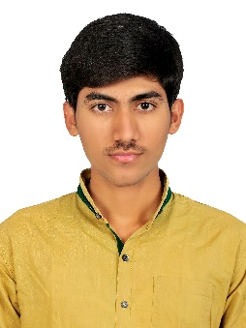**Shaik Mohammed Suhail**

*Phone:* **7799439363**

*Address:* **3/1305-3,**

**Co-operative colony,**

**Kadapa District,**

**Andhra Pradesh,**

**INDIA.**

*Email:* **networkingclouds@gmail.com**

___________________________________________________________________________________________

**Career Objective:**

I want to exploit my talent and want to grow with the Organization and want to become a responsible person by doing hard work and want to deliver my best to the organization.

**Education:**

|  |  |  |  |  |
| --- | --- | --- | --- | --- |
| **Education** | **Name of Institute** | **Specialization** | **Year of passing** | **Percentage** |
| B.Tech | Annamacharya Institute of technology & Sciences, Kadapa. | Electronics & Communication Engineering | 2015 | 65% |
| Intermediate | Board of Intermediate, A.P | MPC | 2011 | 64% |
| 10th Class | Board of SSC, A.P | __ | 2009 | 73% |

**Academic Project:** *in the year* **2015**

**Project Title:**“Detection and Warning System for Fireworks Warehouse Based On Wireless

Sensor Networks”

**Description:**

This project is designed around an ARM7 microcontroller. Whenever the fire is detected by the sensor the information will be sent to the microcontroller to switch on the water supply automatically and then send a text message to owner that fire is detected in particular location.

**Industrial Training:** *in the year* **2014**

**Organization:** Bharat Sanchar Nigam Limited (BSNL), INDIA

* Telecom operations
* Equipment installations
* Server Handling

***Technical Skills:***

* Windows server 2012,2008
* Red hat Linux operating system
* Hardware and Networking
* PC Troubleshooting
* Multimedia tools

***Certifications:***

* Technical seminar certificate on 4G communications from KSRM engineering college.
* MS-Office Trainee certificate from CSEC computer academy Chennai.

***Strength’s:***

* I am a man of my word
* Self-confidence & Great patience
* Analyzing every angle of a project before working on it.

***Personal profile:***

**Name** : Shaik Mohammed Suhail

**Father’s name** : Shaik Abdul Rahiman

**Mother’s name** : Shaik Nazma

**Date of Birth** : 02-10-1993

**Nationality** : INDIA

**Languages Known :** English, Hindi, Urdu and Telugu

**Passport Number** : **N 1121122**

**Declaration:**

I hereby declare that the above given statements are true and correct to the best of my knowledge and belief.

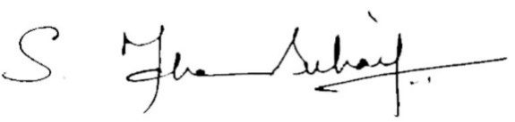

**Place: Shaik. Mohammed Suhail**

**Date:**