|  |  |
| --- | --- |
| Sagar S SontakkeB.E (Electronics and Communication) |  |
| Contact: +917757009676Email: sontakke.ccie@gmail.com |  |

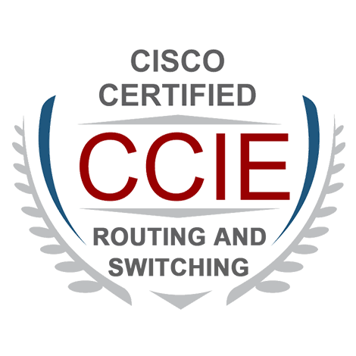

Career Objective

*Seeking a challenging environment that encourages continuous learning and creativity, that also provides exposure to new ideas and stimulates personal and professional growth.*

Academics

|  |  |  |  |
| --- | --- | --- | --- |
| YEAR | COURSE | INSTITUTE | UNIVERSITY/ BOARD |
| 2012 | Bachelor of Engineering (ECE) | Appa Institute Of Engineering And Technology, Gulbarga | Visvesvaraya Technological University, Belgaum |
| 2008 | Senior Secondary Examination | Dayanand Science College, Latur | Maharashtra state board of higher secondary education , Latur |
| 2006 | Secondary Examination | Lal Bahadur Shastri Vidyalaya, Udgir | Maharashtra state board of secondary education , Latur |

Experience

* Worked with Relianace Industries Limited as Technical Executive (AUG-2013 to FEB-2014)
* Worked with Cybex Technology as IT-ASSOCIATE (AUG-2012 to AUG-2013)

Industrial Training

* Technical training with Network Bulls in Integrated CCIE Routing and Switching. (NOV-2014 to JAN 2015 )

Technical Skills

**Networking Skills** : MPLS, LDP, MPLS VPN, Multicasting, DMVPN, VLAN, VTP, STP, RSTP, MSTP, HSRP/VRRP/GLBP,

LACP,PAGP, DNS, DHCP,IP Management , Subnetting, NAT, ACL, PPP, Frame Relay.

**Routing Protocols** : OSPF, EIGRP, RIP, BGP.

**Equipments**: **Routers** : Cisco 1800, 2500, 2600, 3600, 7200

**Switches** : Cisco 1900, 2900, 2950, 3550, 3650

Certifications

* CCIE (ROUTING AND SWITCHING) in DEC.2015
* CCNP (ROUTING AND SWITCHING) in JUL.2014
* CCNA (ROUTING AND SWITCHING) in JUN.2013

Extra-Curricular Activities

* Participated in workshop on Network implementation and security by IIT Delhi and Network bulls.
* Participated Certification in Statewide Engineering IT Quiz Organized by the PDA College.
* District Level Table Tennis Champion.

Personal Details

Name : Sagar S Sontakke

Father’s Name : Shivlingrao

Mother’s Name : Mrs. Mahananda

Date of Birth : March 8, 1991

Gender : Male

Marital Status : Single

Languages known : English, Hindi, Marathi, Kannada

Nationality : Indian

Permanent Address : #134/65-C Sontakke Niwas, Shivaji Chowk, Degloor Road, Udgir (Mah.)

India.

Declaration

I hereby declare that the above information is correct according to the best of my knowledge and belief.

Sagar S. Sontakke.