* Tested in this environment

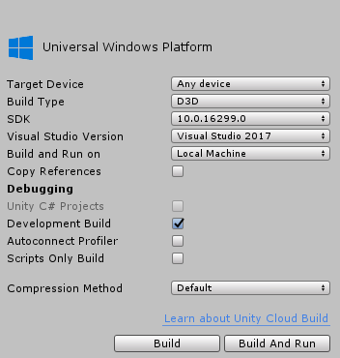

* After build please check capability of appxmanifest (internet client) of the project

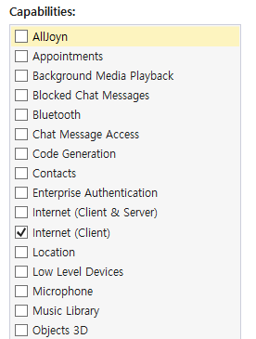

* Please check “Run In Background” option on the build option
  + <https://forums.hololens.com/discussion/6520/run-unity-3d-app-in-background>

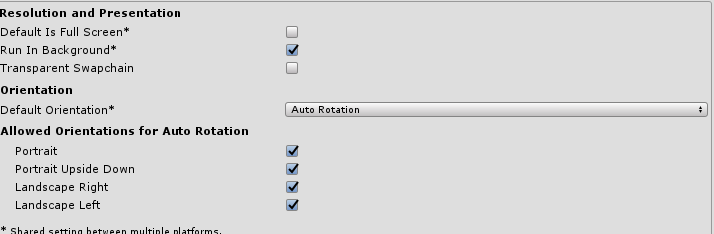

* Check the dll option

