1. Creating Docker Image of springboot App.

**Docker Hub Repository : subhajit1996/springboot-app:1.0.0**

* Dockerfile:

FROM openjdk:8-jdk-alpine

EXPOSE 8888

ARG JAR_FILE=/target/*.jar

COPY ${JAR_FILE} app.jar

ENTRYPOINT ["java", "-jar", "app.jar"]

MAINTAINER [subhoanindian@gmail.com](mailto:subhoanindian@gmail.com)

* docker pull $dockerHubId/$imageId:$tagName

*(pulled the docker image on a different machine )*

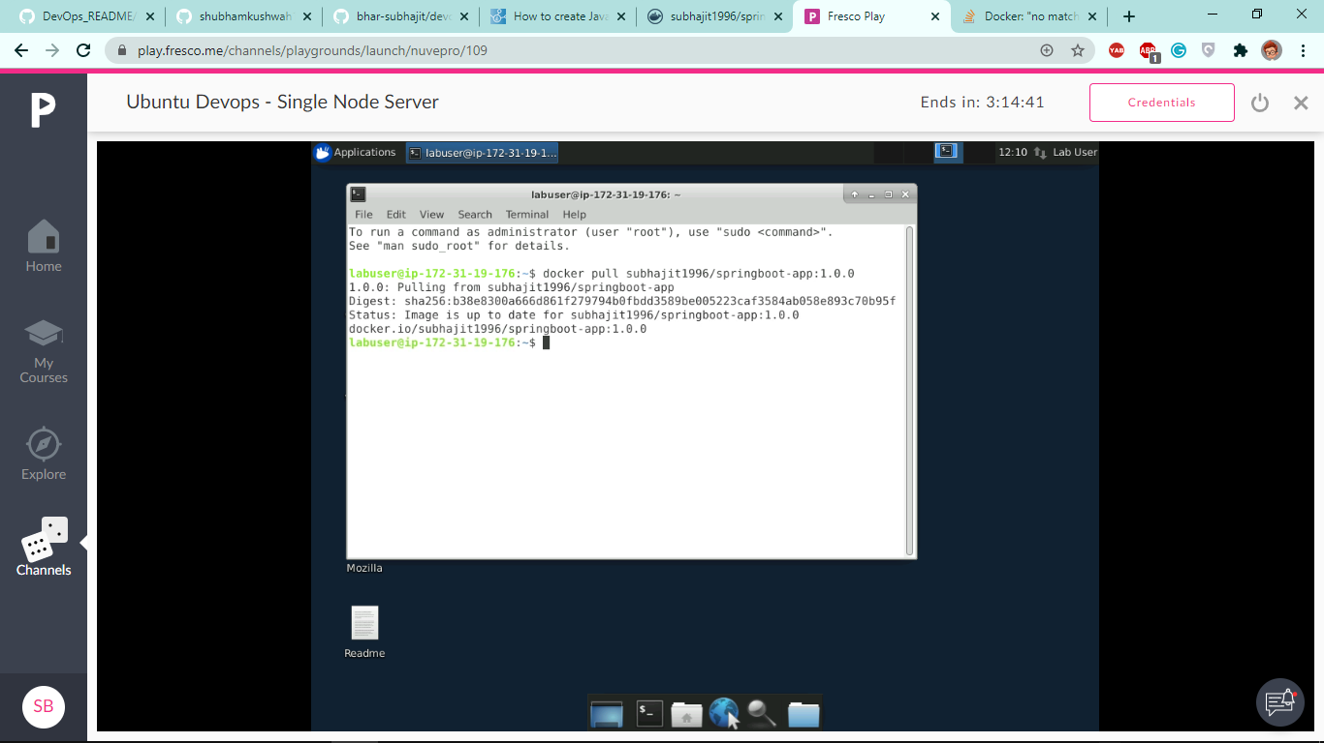

* docker run -p $entryPort:$PortToBeMapped -d $dockerId/$imageId:$tagName

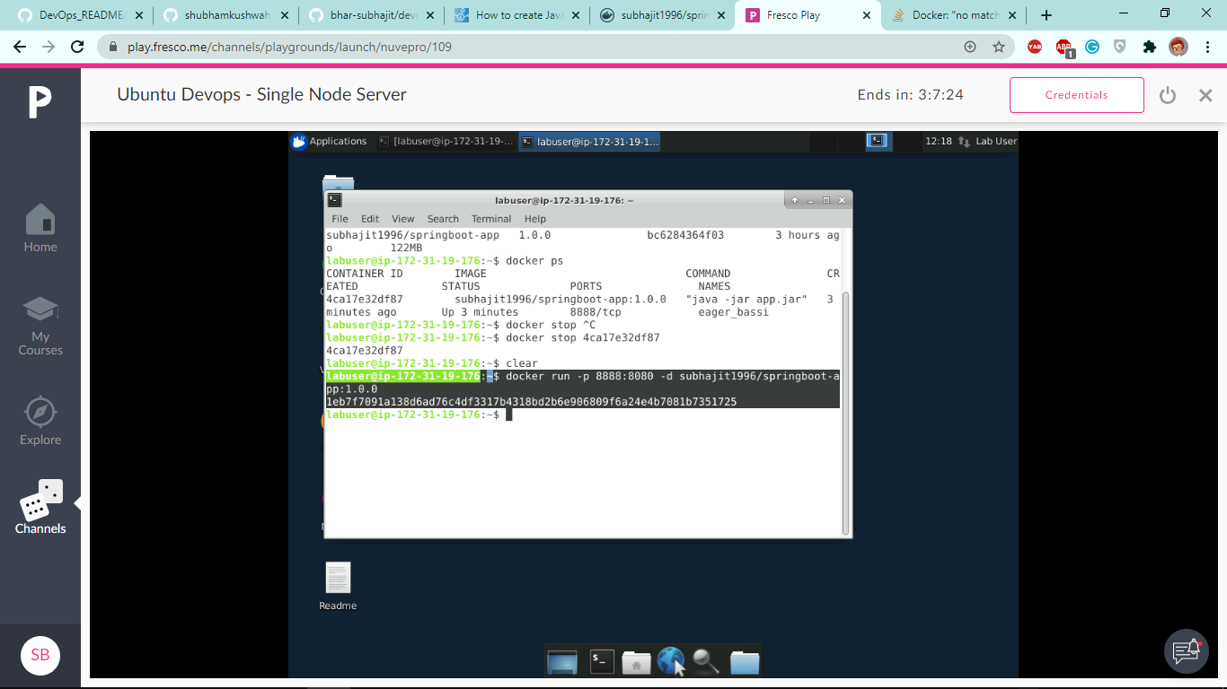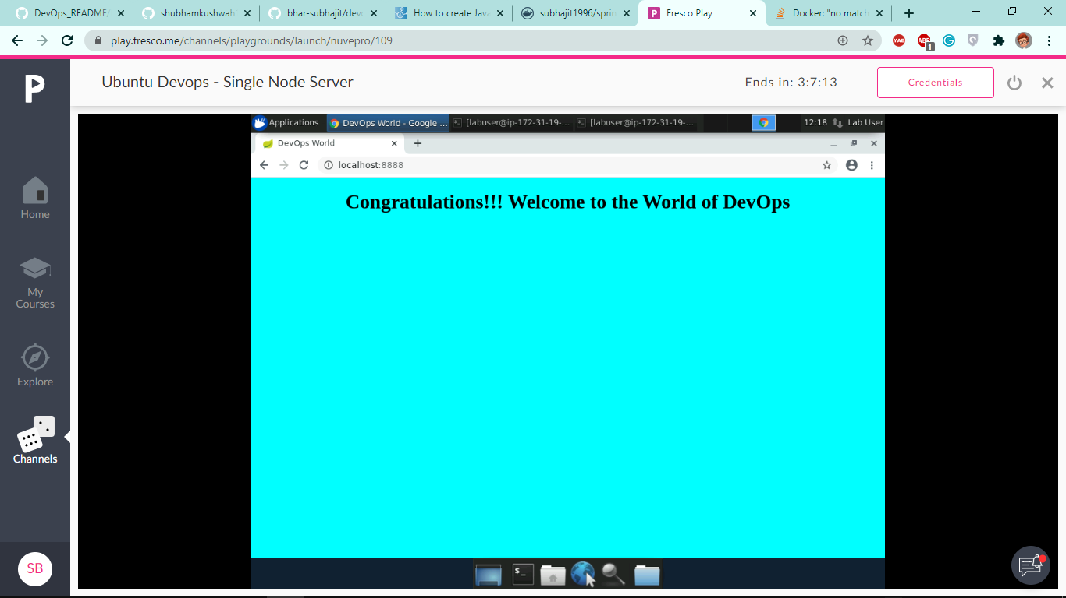

(app running on a different machine from the pulled docker image)

2. Creating Docker Image of Dynamic Java Project (war file).

**Docker Hub Repository : subhajit1996/dynamic-java-app:1.0.0**

* Dockerfile:

FROM tomcat:8.0

MAINTAINER "subhoanindian@gmail.com"

COPY ./target/dynamic-java-project.war /usr/local/tomcat/webapps/

* docker build -t $imageName:tagName

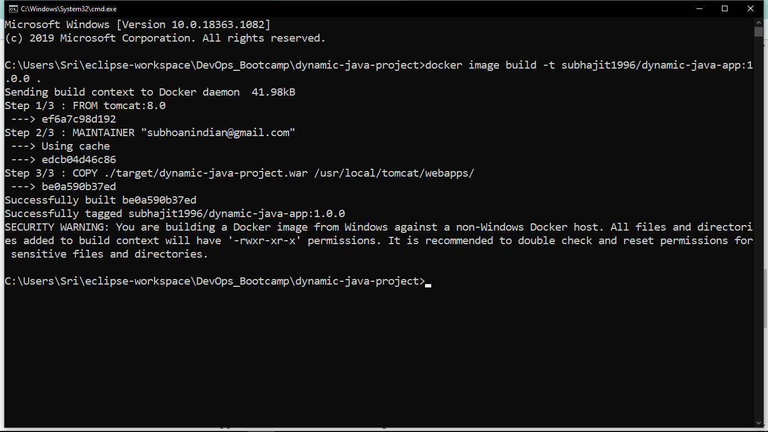

* docker image ls

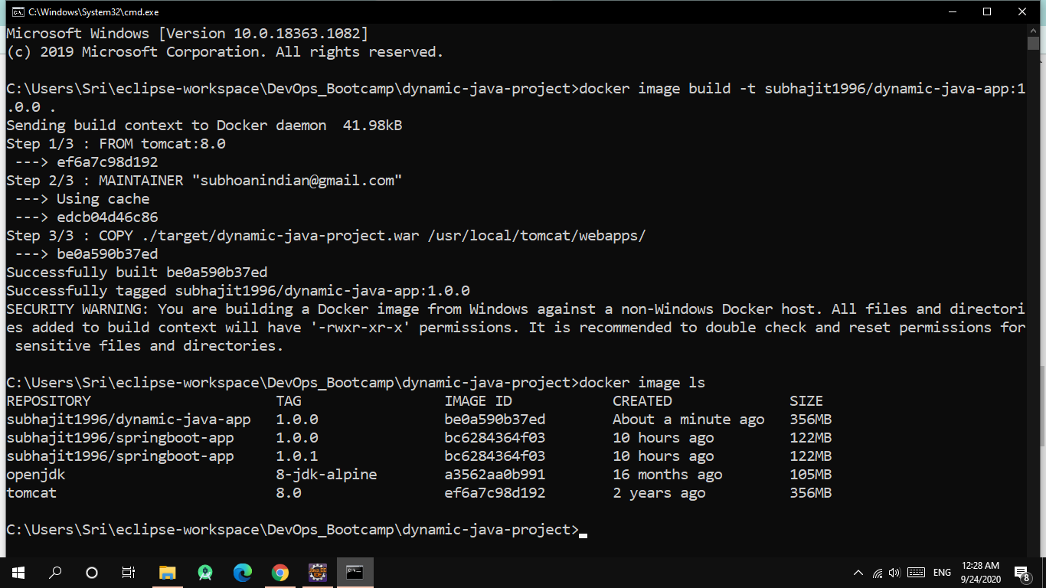

* docker push

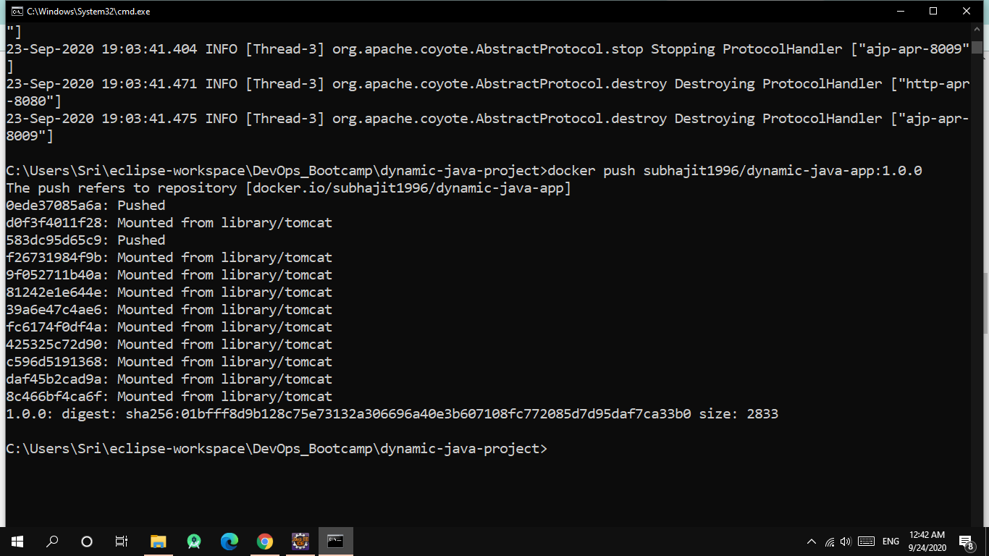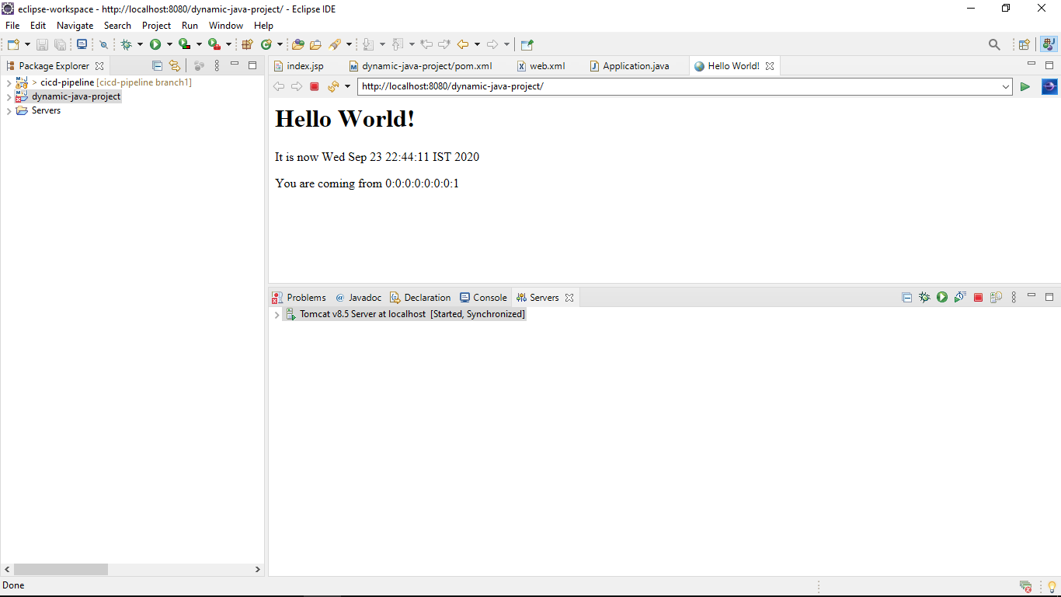

(project running on tomcat server)

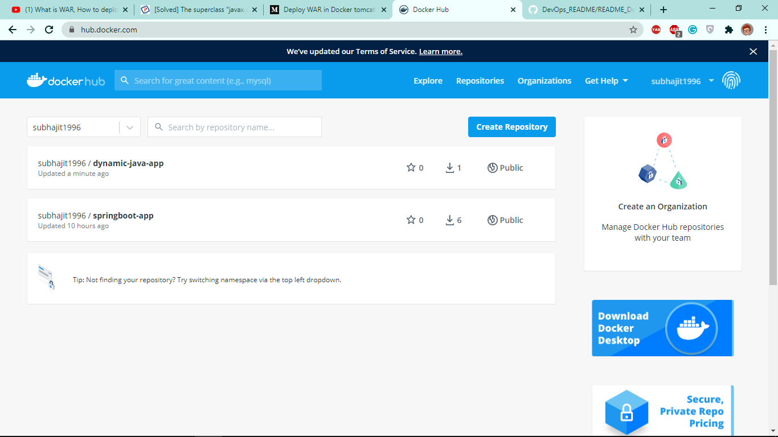

(docker images on docker-hub)